Enhancing biochar properties through chemical modification and evaluating its efficiency in soil application
W.M.H.Lakmalª, R. Thivyatharsan^{*, a}, R.B.T.M. Piyasingheª
ª: Faculty of Agriculture, Eastern University, Sri Lanka
Corresponding Author Email: thivyatharsanr@esn.ac.lk

Abstract
Biochar is a carbon-rich material which obtained from the pyrolysis of biomass in the absence of oxygen. It could increase the nutrient retention, water-holding capacity (WHC), cation exchange capacity and improve soil structure. This study aimed to improve rice husk, wood chips and coconut shells-derived biochar by modifying it with acid (H₂SO₄), base (NaOH) and graphene oxide (GO), and examining their influences over the growth of okra. Biochar was made by drying the feedstocks at 105°C and pyrolyzing them at different temperatures: 400°C for rice and wood, and 600°C for coconut shells. Bulk density, porosity, WHC, pH, ash, and carbon content were determined. The results showed that the type of feedstock and modification had a significant effect on biochar properties and okra growth. Coconut shell biochar had the highest carbon content (80.8%), and wood chip biochar had better porosity and WHC (270.0-310.0%). Modification increased carbon content and WHC; GO increased hygroscopicity and plant growth. Pot culture studies showed that all the treatments increased okra growth, and GO-modified rice husk biochar supported the highest growth of okra plants (~70.0 cm) by week five, highlighting the importance of feedstock selection and modifications to improve soil and crop productivity.
Keywords: Biochar, feedstock modification, pyrolysis, soil amendment

Introduction
Biochar is a kind of charcoal that is developed from diverse types of organic materials, such as wood chips, agricultural waste and other kinds of biomass feedstock. It is a vital soil amendment due to their multifunctional and eco-friendly role. which is developed from diverse types of organic materials, such as wood chips, agricultural waste, and other kinds of biomass feedstock. It’s produced by pyrolysis, creating very high surface areas with strong porosity, hence an excellent material (Varkolu et al., 2025). Maintaining a balance between environmental sustainability and productivity is the main target of modern agriculture to feed the increasing population with nutritious food (Azad et al., 2020). However, high-yielding crops that employ improved varieties, fertilizers, irrigation and pest control measures are required since soil fertility is being threatened by climate change. Maintaining soil fertility truly requires a combination of synthetic fertilizers and organic matter. (Bai et al., 2023).The properties of biochar, specific surface area, pore structure and chemical composition are greatly affected by the type of raw material used (biomass source) and the production condition such as temperature and residence time during pyrolysis (Yaashikaa et al., 2020). Biochar improves the physical (moisture level, oxygen content, and water holding capacity (WHC)), chemical (sequestration of carbon and immobilization of pollutants), and biological (microbe’s abundance, activity, and diversity) properties of soil. This makes the soil more fertile and able to store carbon. It also helps in the removal of various contaminants from soil and water systems (Murtaza et al., 2024). However, pristine biochar is unable to show specific and high nutrient adsorption capability due to its limited adsorption sites and low surface functionality (Akhil et al., 2021). In such context, biochar is usually modified or functionalized using various modification agents, including alkali, acids, metal oxides, and oxidizing agents; this treated biochar manifest improved surface properties and novel structures (Aftab et al., 2022). Generally, functionalization techniques for biochar can be considered into three main modification types such as biological, chemical, and physical (Lahum et al., 2023).
Chemical modification techniques encompass oxidizing treatments, soaking in acids and bases, magnetization, loading with carbon nanomaterials and doping using clay minerals, organic surfactants, non-metallic elements and layered double hydroxides (Enaime et al., 2020). These modifications not only enhance the physical properties of the biochar but also affect the chemical properties such as surface functional groups, elemental distribution, zeta potential, electron transfer capacity, and cation exchange capacity due to the effect on porosity and enrichment of biochar surface with O-containing functional groups, especially carboxyl ones (Murtaza et al., 2024). The key problem in biochar application is the lack of comparative studies evaluating biochar derived from different biomass feedstocks and subjected to various chemical modifications under uniform conditions. (Irshad et al., 2022). Biochar’s physicochemical properties such as pH, porosity, cation exchange capacity, and ash content are strongly influenced by both feedstock type and pyrolysis parameters. Most existing research has focused on single feedstocks like rice husk or wood waste, limiting the generalizability of findings across diverse soil types and agricultural systems (Konuko, 2024). Although acid and alkali chemical modifications have been developed to enhance biochar surface functionality and nutrient retention, their relative effectiveness remains inadequately compared (Sharma et al., 2022). Moreover, innovative modifications like graphene oxide (GO) have shown promising improvements in biochar properties, yet their effects on soil-plant interactions require further study (Murtaza et al.,2023). There is also a shortage of integrated research connecting biochar’s physicochemical traits with plant growth outcomes, especially in linking parameters like porosity and WHC to root development and nutrient dynamics (Khan et al., 2024). Comparative data on pristine versus chemically modified biochar are scarce, restricting understanding of optimal biochar-feedstock-modification combinations. Notably, evidence on biochar’s influence on sensitive vegetable crops like okra is limited despite the crop’s sensitivity to soil moisture and nutrient availability. This research aim to determine the physical and chemical properties of biochar produced from paddy husk, wood chip, and coconut shells before and after modification with sulfuric acid (H₂SO₄), sodium hydroxide (NaOH), and (GO) and compare the efficiency of pristine, acid-modified, base-modified, and GO-modified biochar on the growth performances of okra (Abelmoschus esculentus L.) under controlled conditions and also identify the most suitable biochar feedstock and modification treatment for enhancing okra growth based on plant response.
Methodology
The research was conducted at the Agricultural Engineering research laboratory and farm of the Faculty of Agriculture, Eastern University Sri Lanka, located in Batticaloa district, a low country dry zone with sandy soil texture, annual rainfall of 1400-1682 mm, and temperatures between 26-32°C. Agricultural residues such as paddy husk, wood chip, and coconut shells were collected locally. Each feedstock was oven-dried at 105°C to constant weight, then pyrolyzed under limited oxygen conditions using a muffle furnace (CE MODELO HD-230) at 400°C for paddy husk and sawdust, and 600°C for coconut shell, for 15 minutes. The resulting biochar was cooled in a desiccator, ground to pass a 1.5 mm mesh sieve, and stored in airtight polyethylene bags.
Chemical Modifications: Acid modification employed dilute sulfuric acid (H₂SO₄) treatment at 80°C for 3 hours with stirring, followed by washing to neutral pH and drying. Base modification involved sodium hydroxide (NaOH) treatment with reaction, oven drying, followed by heat treatment at 500°C for 2 hours and washing. GO was synthesized via modified Hummers method and biochar were coated by suspending with GO solution with stirring for 3 hours, filtering, washing, and drying (Shahriary & Athawale, 2014).
Determination of physical properties
The physical properties of both pristine and chemically modified biochar samples were analyzed. The following parameters were determined:
Bulk density
Bulk density of biochar was determined using the tapped volume method. 2g of each biochar sample was weighed using an electronic balance and transferred into a graduated cylinder. The cylinder was gently tapped repeatedly until no further reduction in volume was observed. Bulk density was then calculated using the following formula (Khater et al., 2024):
$$Bulk density \left(g {cm}^{-3}\right)=\frac{Mass of biochar (g)}{Tapped volume ({cm}^{3})}………Equation 1$$
Porosity
Porosity of biochar was calculated indirectly using bulk density and particle density values. Bulk density was determined by tapped volume method, while particle density was obtained using ethanol displacement method. Porosity was then calculated as the percentage of pore space using the following formula (Kabir et al., 2023):

$$Porosity=$$
$$\left(1-\frac{Bulk density}{Particle density}\right)x100…..Equation 2$$
Particle density
Particle density of biochar was determined using the liquid displacement method with ethanol as the displacement medium. A 5ml volume of ethanol was initially measured into a graduated cylinder. Then, 0.5 g of biochar was carefully added, and the increase in volume was recorded. Particle density was calculated using the following formula (Ahmad et al., 2022):
$$Particle density \left({gcm}^{-3}\right)=$$
$$\frac{Mass of biochar \left(g\right)}{Displced volume \left({cm}^{3}\right)}……….Equation 3$$
Water holding capacity
Water holding capacity of biochar was determined using the gravimetric method. Filter papers were placed in funnels, and 5g of each biochar type was weighed using an electronic balance and placed on the filter paper. The samples were saturated with distilled water and allowed to drain until excess water was removed. The saturated biochar samples were then weighed, oven dried at 105 ⁰C until constant weight, and re-weighed. WHC was calculated using the following formula (Batista et al., 2018):
$$WHC= \frac{saturated biochar Weight \left(g\right)-Dry weight (g)}{Oven dried weight (g)}..Equ 4$$
pH
The pH of biochar was determined using the biochar-water suspension method. A 5g sample of each biochar type was weighed and placed in separate beakers. To each beaker, 50ml of distilled water was added, and the suspensions were stirred thoroughly. The pH (HANNA HI-9813-6) meter was calibrated using standard buffer solutions before measurement. The electrode probe was then immersed in each suspension, and the pH value displayed on the digital meter was recorded (Mobarak et al., 2024).
Ash content
Ash content of biochar was determined using the muffle furnace method. One gram of oven-dried biochar from each feedstock type was accurately weighed and placed in ceramic crucibles. The crucibles were then heated in a muffle furnace at 550 °C for 1 hour to ensure complete combustion of the organic matter. After cooling to room temperature in a desiccator, the remaining ash residue was weighed. Ash content was calculated using the following formula (Hadey et al., 2022):
$$Ash content \left(\%\right)=$$
$$\frac{Weight of ash (g)}{Initial weight of dry biochar (g)}×100..Eq 5$$
Crbon content
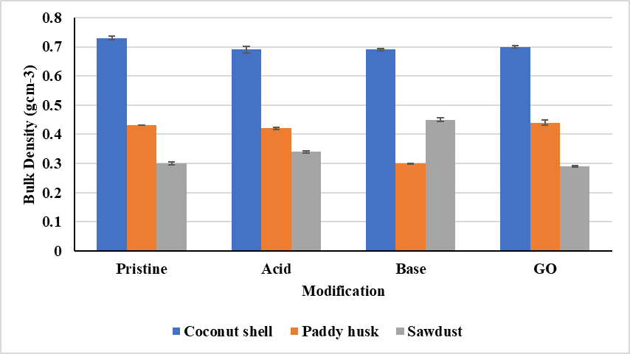
Carbon content of biochar was determined using the Loss on Ignition (LOI) method. The procedure followed was similar to that used for ash content determination. One gram of oven-dried biochar from each feedstock type was weighed and placed in ceramic crucibles. The samples were heated in a muffle furnace at 550 °C for 1 hour. After cooling in a desiccator, the crucibles were reweighed. The carbon content was calculated using the following formula (Lehmann & Joseph, 2015):
$$C content \left(\%\right)= \frac{Biochar Initial weight \left(g\right)-Ash weight (g)}{Initial weight of dry biochar (g)}…E 6$$
A pot experiment was arranged in a Completely Randomized Design (CRD) with 13 treatments including pristine and modified biochar at 10 t/ha equivalent applied to individual polybags filled with prepared soil. Okra (Abelmoschus esculentus L.) seeds were sown one per polybag, with standard agronomic practices including irrigation, fertilization, and hand weeding. Plant height, number of leaves, branches and yield were monitored over five weeks. The effects of feedstock type and modification method were evaluated using two-way ANOVA; treatment means were separated using Tukey's HSD at p < 0.05 using Minitab 17 software.
Results
Physical and chemical properties of biochar
Bulk density
Table 1 shows the bulk density of the biochar made from coconut shell, paddy husk, and wood chip after different chemical modifications. Coconut shell biochar has the significantly (p<0.05) highest bulk density in all the treatments, which was between 0.69 and 0.73 gcm⁻³. Acid and base modifications slightly reduced the bulk density of coconut shell biochar from its pristine form. The significantly (p<0.05) lowest bulk density, 0.30 ± 0.001 gcm⁻³, for paddy husk biochar was observed after treatment with the NaOH base. The bulk density of wood chip biochar increased after its base modification to 0.45 ± 0.007 gcm⁻³. The ANOVA analysis presented in Table 1 showed the treatments significantly differed from one another at p<0.05.
Figure 1: Bulk density of biochar before and after modification

Particle density
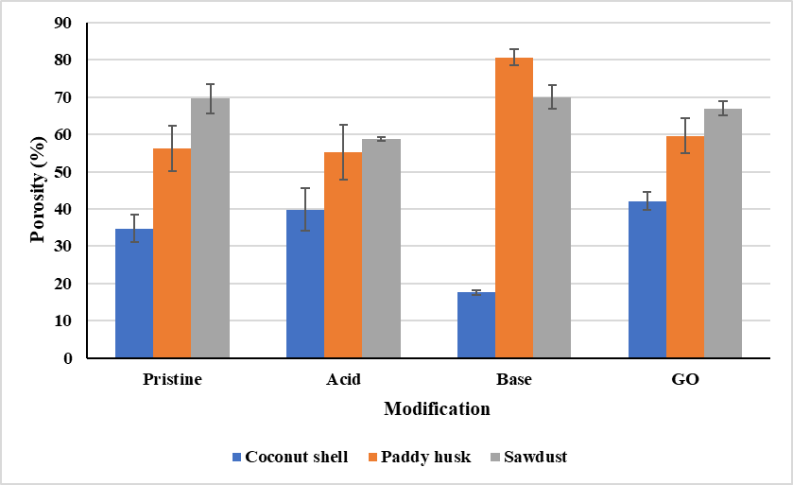
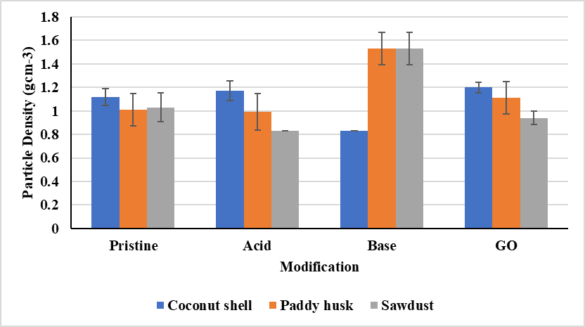
Table 1 shows that particle density for biochar derived from coconut shell, paddy husk, and wood chip was significantly different (p<0.05) among the treatments. Base modification in paddy husk and sawdust biochar resulted in the highest particle density, up to 1.53 gcm⁻³. The low value, 0.83 gcm⁻³ was recorded for base-modified coconut shell biochar. Generally, pristine and acid-treated samples showed particle densities between 0.83 and 1.20 g cm⁻³, while GO-modified biochar had intermediate densities, only slightly higher than the acid-treated samples.
Figure 2: Particle density of biochar before and after modification
Porosity
Table 1 presents the porosity (%) of biochar derived from coconut shell, paddy husk, and wood chip under pristine, acid-modified, base-modified, and GO-modified treatments. Wood chip biochar samples showed the significantly (p<0.05) highest porosity overall, from 58.0% to 70.0%, followed by paddy husk biochar within a porosity range of 55.0-81.0%. Coconut shell biochar consistently registered the significantly (p<0.05) lowest porosity values, between 18.0% and 42.0%. In chemical modifications, base (NaOH) treatment significantly enhanced porosity in paddy husk biochar up to 80.6 % while decreasing it in coconut shell biochar down to 17.5 %. Acid modification slightly decreased the porosity of sawdust and paddy husk biochar, whereas GO treatment marginally increased the porosity of all feedstocks except that of paddy husk, with marginal decreases. Statistical analysis, as presented in Table 1, confirmed that at p<0.05, there was a difference in the samples’ porosity with respect to feedstock and their respective modifications.
Figure 3: Porosity of biochar before and after modification
pH
Table 1 illustrates the pH of biochar from coconut shell, paddy husk, and wood chip for pristine, acid-modified, base-modified, and GO-modified treatments. The pH ranged from 7.6 to 9.7. Pristine biochar was strongly alkaline, with pH values above 9.0 for all feedstocks. Acid modification significantly (p<0.05) reduced pH in the range of 7.6 to 7.9, reflecting the addition of acidic functional groups and removal of basic minerals. Base modification reverted the pH to values ranging between 9.5 and 9.6, indicating neutralization under NaOH treatment. The pH of GO-modified biochar fell within intermediate values between 8.1 and 9.2. Significant differences in pH among different treatments were obtained (p<0.05); however, pH varied slightly across feedstocks (Table 1).

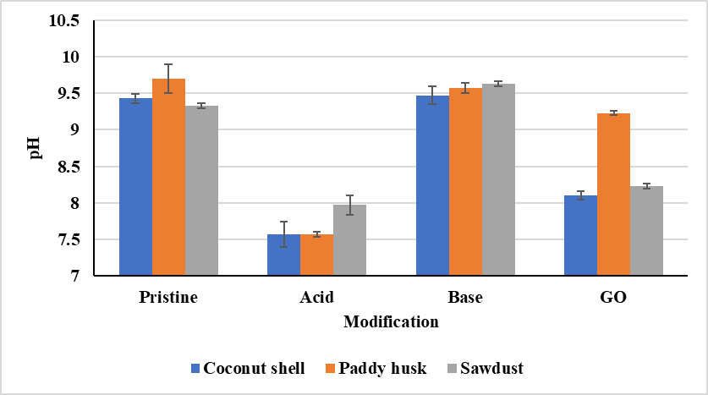
Figure 4: pH of biochar before and after modification
Water holding capacity
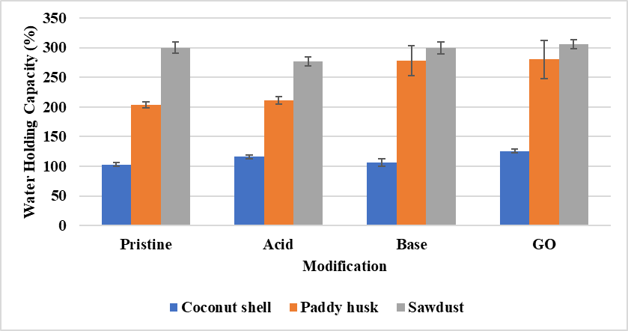
Table 1 shows the WHC (%) of coconut shell, paddy husk, and sawdust biochar under pristine, acid-modified, base-modified, and GO treatments. The WHC was significantly (p<0.05) highest for wood chip biochar (approximately between 270.0% and 310.0%) and second for paddy husk biochar (from approximately 200.0% to 280.0%), while coconut shell biochar showed the lowest WHC (approximately between 100.0% and 125.0%). Base and GO treatments showed great improvements in WHC for paddy husk and sawdust biochar, with the WHC of paddy husk increasing from 203.0% to 280.0%. In contrast, the WHC of sawdust biochar was high across all treatments and showed only moderate improvements with modification. Slightly improved WHC was observed for coconut-shell biochar across treatments. The statistical data presented in Table 1 showed significant differences (p < 0.05) among treatments and feedstocks.
Figure 5: Water holding capacity of biochar before and after modification
Ash content (%)
Table 1 illustrates the ash content (%) of biochar derived from coconut shell, paddy husk, and wood chip under pristine, acid-modified, base-modified, and GO-treated conditions. Among three feedstocks, paddy husk had the significantly (p<0.05) highest ash content, having values close to 44.0% under pristine and acid modification, a sharp drop to about 7.0% after base modification, and the highest content (>45%) after GO modification. Wood chip biochar showed a moderate level, reaching up to about 25.0% under acid modification and coming down between 7.0% and 12.0% for base and GO treatments. Coconut shell biochar always showed significantly (p<0.05) low ash content (1.0-5.0%) for all treatments, with only a marginal increase following base modification. The statistical analysis presented in Table 1 showed there is a significant difference among feedstocks and treatments (p < 0.05).
Carbon content
Table 1 shows that Carbon content (%) of biochar from coconut shell, paddy husk, and wood chip under pristine, acid-modified, base-modified, and graphene oxide treatments. It can be observed that coconut shell biochar had the significantly (p<0.05) high carbon content among these three feedstocks, including approximately 73.0% in the pristine state and about 82.0% after base modification, with its carbon content remaining relatively stable under GO treatment. Sawdust biochar began with around 63.0% in the pristine state, increasing markedly to nearly 80.0% after base modification and retaining high levels after treatment with GO. Paddy husk biochar always had the significantly (p<0.05) lowest carbon content, averaging around 52.0% in all treatments, with small increases after acid modification. According to Table 1, significant differences exist among all feedstocks and treatments at p < 0.05.

Growth parameters
Compared to the control (soil only), the biochar treatment consistently improved okra growth parameters; height, leaf number and branch number. GO-amended rice husk biochar led to vegetative growth, producing the tallest plants (~70.0 cm by week 5), the highest leaf number (~37.0 leaves) and the most branches (~5.67). Base-modified coconut shell biochar and base-modified wood chip biochar also supported strong growth performance. Okra pod yield measurements were variable: In the first harvest, unmodified coconut shell, acid-modified coconut shell, base-modified sawdust and control recorded relatively higher means pod yield of 22.5g, while GO-modified rice husk recorded zero. In the second harvest, the highest mean yield was 61.2g for acid-modified coconut shell, followed by 43.2g for GO-modified coconut shell, 40.6g for base-modified coconut shell and 47.8g for acid-modified wood chip, indicating a significant improvement in yield. The zero yield at first harvest of GO-modified rice husk may indicate delayed fruiting despite better vegetative growth, which may reflect some growth-yield trade-off and/or experimental reason. Acid-and-base-modified biochar, especially coconut shell and sawdust biochar, improved yield across treatments, complementing their effects on growth parameters associated with biochar. Control treatment consistently showed low growth and fair yield, reinforcing the role of biochar in okra productivity.
Discussion
The main physiochemical properties of biochar derived from wood chips, coconut shells and rice husk are changed by both chemical modification techniques and the feedstock type (Ajien et al., 2023). The compact, lignin-rich structure of coconut shell biochar tends to give it a high bulk density (Duan et al., 2025). Although wood chip and rice husk biochar have low bulk densities, base modification often improves them by increasing porosity and removing silica (Amin et al., 2020). Changes in particle density indicate changes in microstructure. Pretreatment improves the density of more cellulose-rich feedstocks of rice husks, and wood chip, but reduces the density of coconut shell biochar through mineral dissolution and pore expansion (Thakur et al., 2025). While lignin-dense coconut shell biochar exhibits restricted pore formation, fibrous paddy husk and wood chip biochar show increased porosity, particularly following base modification. Porosity is a function of feedstock composition trends (Daud & Ali,2004). The beneficial effect of biochar as a soil amendment is influenced by chemical treatments that introduce acidic groups that drop pH in acid modifications or increase alkalinity in base modifications (Dai et al., 2014). Compared to more hydrophobic coconut shell biochar, wood chip and rice husk biochar show high WHC, which is greatly improved by base and GO modifications. The WHC is strongly interacts with the pore and surface chemistry (Li et al.,2023). Because of the presence of aromatic carbon in coconut shell biochar, it has low ash content while rice husk and wood chip biochar have high ash content due to the presence of minerals, which can be reduced by basic modification and slightly increased by acid modification (Leksungnoen et al., 2019).These trends are observed in the carbon content, where wood chip has moderate but improved carbon after base modification, rice husk has low fixed carbon due to mineral interferences, and coconut shell biochar having the largest fixed carbon component due to its lignin-rich composition (Hoang et al., 2024). Thus, base modification optimally improves the carbon content and porosity of cellulose-rich feedstock materials, and the presence of coconut shell charcoal makes it the best material for carbon sequestration and stable soil processing (Gichuki, 2022). Rice husk and wood chip biochar are the best material for enhancing soil aeration, WHC, and nutrient availability through improved porosity and mineral content (Haque et al., 2021). These results highlight the significance of proper choice of nutrient and chemical treatment combinations that match specific soil management goals and crop requirements. Biochar enhanced soil properties; nutrient retention, moisture availability and microbial habitat, which in turn improved vegetative growth and yield of okra plants. Chemical modification, mainly acid and base treatments, enhanced nutrient availability and uptake efficiency, leading to significantly higher yields during the second harvesting period. Although GO modification optimized vegetative growth, mainly through the use of rice husk biochar, but didn’t increase in root yield, indicating that the modifications may differentially affect phenology or reproductive allocation (Goh Ling Ling,2024). The nutrient source affects the quality of the biochar. Lignin-rich coconut shell biochar supports sustained growth and yield, while biochar based on wastes such as rice husk promotes root growth but may require further optimization for yield (Gopal et al.,2024). In general, nutrient stock selection and chemical modification are synergistically related to achieve a balance between vegetative growth and formation in okra crops (Kumari,2016). This confirms the importance of tailored biochar amendments to achieve optimal agronomic performance.
Conclusion
This research demonstrated the different characteristics of biochar in terms of nutrient storage and modification. Coconut shell biochar has a high carbon content and is long-lasting, but has low porosity. Wood chip biochar has good porosity and WHC. Rice husk biochar, which has a high silica and ash content, can be improved upon chemical modifications, especially with base and GO treatments. Chemical modifications make biochar more functional: base treatment increases porosity and nutrient retention, GO improves its water and nutrient retention capacity, and acid treatment slightly reduces porosity. The modified biochar improved okra growth, and among them, GO-modified rice husk biochar performed best in plant height. Coconut shell biochar is suitable for long-term carbon storage. Overall, optimizing nutrient stocks and modifying biochar improves soils for better sustainable agriculture.
References
Acharya, N., Vista, S. P., Shrestha, S., Neupane, N., & Pandit, N. R. (2022). Potential of biochar-based organic fertilizers on increasing soil fertility, available nutrients, and okra productivity in slightly acidic sandy loam soil. Nitrogen, 4(1), 1-15. https://doi.org/10.3390/nitrogen4010001
Aftab, Z. E. H., Aslam, W., Aftab, A., Shah, A. N., Akhter, A., Fakhar, U., ... & Khalid, U. (2022). Incorporation of engineered nanoparticles of biochar and fly ash against bacterial leaf spot of pepper. Scientific Reports, 12(1), 8561.https://doi.org/10.1038/s41598-022-10795-8
Ahmad Bhat, M., Bhat, A. R., Lone, A. H., & Nazir, R. (2022). Application of biochar for improving physical, chemical, and biological properties of soils. Sustainability, 14(17), 11104. https://doi.org/10.3390/su141711104
Ajien, A., Idris, J., Md Sofwan, N., Husen, R., & Seli, H. (2023). Coconut shell and husk biochar: A review of production and activation technology, economic, financial aspect and application. Waste Management & Research, 41(1), 37-51.
https://doi.org/10.1177/0734242X221127167
Akhil, D., Lakshmi, D., Kartik, A., Vo, D. V. N., Arun, J., & Gopinath, K. P. (2021). Production, characterization, activation and environmental applications of engineered biochar: a review. Environmental Chemistry Letters, 19(3), 2261-2297. https://doi.org/10.1007/s10311-020-01167-7
Amin, M., Ahmad, M., Farooqi, A., Hussain, Q., Ahmad, M., Al-Wabel, M. I., & Saleem, H. (2020). Arsenic release in contaminated soil amended with unmodified and modified biochars derived from sawdust and rice husk. Journal of Soils and Sediments, 20(9), 3358-3367. https://doi.org/10.1007/s11368-020-02661-9
Azad, N., Behmanesh, J., Rezaverdinejad, V., Abbasi, F., & Navabian, M. (2020). An analysis of optimal fertigation implications in different soils on reducing environmental impacts of agricultural nitrate leaching. Scientific Reports, 10(1), 7797. https://doi.org/10.1038/s41598-020-64856-x
Bai, J., Song, J., Chen, D., Zhang, Z., Yu, Q., Ren, G., ... & Feng, Y. (2023). Biochar combined with N fertilization and straw return in wheat-maize agroecosystem: Key practices to enhance crop yields and minimize carbon and nitrogen footprints. Agriculture, Ecosystems & Environment, 347, 108366. https://doi.org/10.1016/j.agee.2023.108366
Batista, E. M., Shultz, J., Matos, T. T., Fornari, M. R., Ferreira, T. M., Szpoganicz, B., ... & Mangrich, A. S. (2018). Effect of surface and porosity of biochar on water holding capacity aiming indirectly at preservation of the Amazon biome. Scientific Reports, 8(1), 10677. https://doi.org/10.1038/s41598-018-28794-z
Dai, Z., Wang, Y., Muhammad, N., Yu, X., Xiao, K., Meng, J., ... & Brookes, P. C. (2014). The effects and mechanisms of soil acidity changes, following incorporation of biochars in three soils differing in initial pH. Soil Science Society of America Journal, 78(5), 1606-1614. https://doi.org/10.2136/sssaj2013.08.0340
Daud, W. M. A. W., & Ali, W. S. W. (2004). Comparison on pore development of activated carbon produced from palm shell and coconut shell. Bioresource technology, 93(1), 63-69. https://doi.org/10.1016/j.biortech.2003.09.015
Duan, H., Liu, Q., He, Y., Shen, Z., Han, X., Xu, S., & Yu, J. (2025). Enhanced asphalt fume suppression through cellulose-and lignin-rich biochar: A structure-property relationship. Construction and Building Materials, 495, 143655. https://doi.org/10.1016/j.conbuildmat.2025.143655
Duncan, R. R., & Baligar, V. C. (1990). Genetics, breeding, and physiological mechanisms of nutrient uptake and use efficiency: an overview. Crops as enhancers of nutrient use, 3-35.
El-Sharkawy, M., El-Naggar, A. H., Al-Huqail, A. A., & Ghoneim, A. M. (2022). Acid-modified biochar impacts on soil properties and biochemical characteristics of crops grown in saline-sodic soils. Sustainability, 14(13), 8190. https://doi.org/10.3390/su14138190
Enaime, G., Baçaoui, A., Yaacoubi, A., & Lübken, M. (2020). Biochar for wastewater treatment—conversion technologies and applications. Applied Sciences, 10(10), 3492. https://doi.org/10.3390/app10103492
Gichuki, J. (2022). Development of Cellulose-Based Superabsorbent Hydrogels from Coconut Fiber (Doctoral dissertation, JKUAT-COPAS).
Goh Ling Ling, E. (2024). Effect of combined fertilizer and rice husk biochar on rice yield, nitrogen content, grain quality and water productivity under aerobic rice cultivation in Hungary (Doctoral dissertation, Magyar Agrár-és Élettudományi Egyetem).
Gopal, M., Gupta, A., Shahul Hameed, K., Sathyaseelan, N., Khadeejath Rajeela, T. H., & Thomas, G. V. (2020). Biochars produced from coconut palm biomass residues can aid regenerative agriculture by improving soil properties and plant yield in humid tropics. Biochar, 2(2), 211-226. https://doi.org/10.1007/s42773-020-00043-5
Hadey, C., Allouch, M., Alami, M., Boukhlifi, F., & Loulidi, I. (2022). Preparation and characterization of biochars obtained from biomasses for combustible briquette applications. The Scientific World Journal, 2022(1), 2554475. https://doi.org/10.1155/2022/2554475
Haque, A. N. A., Uddin, M. K., Sulaiman, M. F., Amin, A. M., Hossain, M., Solaiman, Z. M., & Mosharrof, M. (2021). Biochar with alternate wetting and drying irrigation: A potential technique for paddy soil management. Agriculture, 11(4), 367. https://doi.org/10.3390/agriculture11040367
Hoang, T. D., Van Anh, N., Yusuf, M., Ali S. A, M., Subramanian, Y., Hoang Nam, N., ... & K Azad, A. (2024). Valorization of Agriculture Residues into Value‐Added Products: A Comprehensive Review of Recent Studies. The Chemical Record, 24(8), e202300333. https://doi.org/10.1002/tcr.202300333
Irshad, M. K., Noman, A., Wang, Y., Yin, Y., Chen, C., & Shang, J. (2022). Goethite modified biochar simultaneously mitigates the arsenic and cadmium accumulation in paddy rice (Oryza sativa) L. Environmental research, 206, 112238. https://doi.org/10.1016/j.envres.2021.112238
Islam, M. A., Mobarak, M. H., Rimon, M. I. H., Al Mahmud, M. Z., Ghosh, J., Ahmed, M. M. S., & Hossain, N. (2024). Additive manufacturing in polymer research: Advances, synthesis, and applications. Polymer Testing, 132, 108364. https://doi.org/10.1016/j.polymertesting.2024.108364
Kabir, E., Rahman, S., Hossain, M. T., et al. (2023). Biochar as a tool for the improvement of soil and environment. Frontiers in Environmental Science, 11, 1324533. https://doi.org/10.3389/fenvs.2023.1324533
Khan, S., Irshad, S., Mehmood, K., Hasnain, Z., Nawaz, M., Rais, A., ... & Ibrar, D. (2024). Biochar production and characteristics, its impacts on soil health, crop production, and yield enhancement: A review. Plants, 13(2), 166. https://doi.org/10.3390/plants13020166
Khater, E. I., El-Sayed, S. M., & El-Sayed, H. A. (2024). Evaluation and characterization of biochar and briquettes derived from various agricultural residues. Environmental Science and Pollution Research, 31(5), 1–15.
Konuko, M. (2024). Mass Flow Analysis and Characterization of Selected Agricultural Wastes for Gasification (Doctoral dissertation, University of Nairobi).
Kumari, M. (2016). Phyto-Chemical dynamics and postharvest quality in okra. Bihar Agricultural University.
Lahum, Y., Fuakubun, F., & Sopandi, T. (2023). Valorization of chicken feather into organic liquid fertilizer through two species of Bacillus bacteria fermentation. Asian Journal of Agriculture and Biology, 2023(04). https://doi.org/10.35495/ajab.2022.148
Lehmann, J., & Joseph, S. (2015). Biochar for Environmental Management: Science, Technology and Implementation (2nd ed.). Routledge.
Leksungnoen, P., Wisawapipat, W., Ketrot, D., Aramrak, S., Nookabkaew, S., Rangkadilok, N., & Satayavivad, J. (2019). Biochar and ash derived from silicon-rich rice husk decrease inorganic arsenic species in rice grain. Science of the total Environment, 684, 360-370. https://doi.org/10.1016/j.scitotenv.2019.05.247
Li, Z., Zheng, Z., Li, H., Xu, D., Li, X., Xiang, L., & Tu, S. (2023). Review on rice husk biochar as an adsorbent for soil and water remediation. Plants, 12(7), 1524. https://doi.org/10.3390/plants12071524
Murtaza, G., Ahmed, Z., Eldin, S. M., Ali, B., Bawazeer, S., Usman, M., ... & Tariq, A. (2023). Biochar-Soil-Plant interactions: A cross talk for sustainable agriculture under changing climate. Frontiers in Environmental Science, 11, 1059449. https://doi.org/10.3389/fenvs.2023.1059449
Murtaza, G., Ahmed, Z., Valipour, M., Ali, I., Usman, M., Iqbal, R., ... & Tariq, A. (2024). Recent trends and economic significance of modified/functionalized biochars for remediation of environmental pollutants. Scientific Reports, 14(1), 217. https://doi.org/10.1038/s41598-023-50623-1
Shahriary, L., & Athawale, A. A. (2014). Graphene oxide synthesized by using modified hummers approach. Int. j. renew. energy environ. eng, 2(01), 58-63.
Sharma, R. K., Singh, T. P., Mandal, S., Azad, D., & Kumar, S. (2022). Chemical treatments for biochar modification: opportunities, limitations and advantages. In Engineered biochar: fundamentals, preparation, characterization and applications (pp. 65-84). Singapore: Springer Nature Singapore. https://doi.org/10.1007/978-981-19-2488-0_5
Thakur, A., Kumar, A., & Somya, A. (2025). Forestry and Agricultural Residues-Based Wastes: Fundamentals, Classification, Properties, and Applications. In Biomass Wastes for Sustainable Industrial Applications (pp. 95-139). CRC Press.
Varkolu, M., Gundekari, S., Omvesh, Palla, V. C. S., Kumar, P., Bhattacharjee, S., & Vinodkumar, T. (2025). Recent advances in biochar production, characterization, and environmental applications. Catalysts, 15(3), 243. https://doi.org/10.3390/catal15030243
Yaashikaa, P. R., Kumar, P. S., Varjani, S., & Saravanan, A. J. B. R. (2020). A critical review on the biochar production techniques, characterization, stability and applications for circular bioeconomy. Biotechnology reports, 28, e00570. https://doi.org/10.1016/j.btre.2020.e00570

Table 1 Effect of feedstock and modification on physical and chemical properties of biochar
Feedstock Type | Modification Type | Bulk Density (g/cm³) | Particle Density (g/cm³) | Porosity (%) | pH | Ash Content (%) | Carbon Content (%) | Water-Holding Capacity (%)
Coconut shell | Pristine | 0.73±0.006ª | 1.12±0.072^{ab} | 0.35±0.037d^{e} | 9.43±0.067ª | 1.00±0.577^{ef} | 72.00±2.08^{ab} | 102.77±2.86^{d}
 | Acid-modified | 0.69±0.011^{b} | 1.17±0.083^{ab} | 0.40±0.056^{cd} | 7.57±0.176^{c} | 0.00±0.000^{f} | 77.33±1.86^{ab} | 116.03±3.29^{d}
 | Base-modified | 0.69±0.0.005^{b} | 0.83±0.000^{b} | 0.18±0.006e | 9.47±0.120ª | 5.67±2.85de | 80.67±3.93^{aa} | 105.80±6.20^{d}
 | GO-modified | 0.70±0.003^{b} | 1.20±0.046^{ab} | 0.42±0.024^{cd} | 8.10±0.058^{b} | 2.67±0.333^{def} | 78.33±1.20ª | 125.50±3.40^{d}
Paddy husk | Pristine | 0.43±0.000^{cd} | 1.01±0.136^{ab} | 0.56±0.060^{bc} | 9.7±0.200ª | 44.33±0.333ª | 51.00±1.73^{d} | 203.00±4.92^{c}
 | Acid-modified | 0.30±003^{d} | 0.99±0.155^{b} | 0.55±0.073^{bcd} | 7.57±0.033^{c} | 43.67±0.333ª | 54.67±0.33^{cd} | 210.97±6.33^{bc}
 | Base-modified | 0.30±0.01^{f} | 1.53±0.139ª | 0.81±0.021ª | 9.57±0.067ª | 6.33±0.667^{d} | 50.33±2.40^{d} | 277.6±25.5^{ab}
 | GO-modified | 0.44±0.09^{cd} | 1.11±0.139ª | 0.60±0.048^{bc} | 9.23±0.033ª | 46.00±0.577ª | 54.00±0.58^{cd} | 280.3±32.3ª
Sawdust | Pristine | 0.30±0.005^{f} | 1.03±0.121^{ab} | 0.70±0.039^{ab} | 9.33±0.033ª | 7.33±1.20^{cd} | 63.33±1.45^{bcd} | 299.87±9.11ª
 | Acid-modified | 0.34±0.004e | 0.83±0.000^{b} | 0.59±0.005^{bc} | 7.97±0.133^{bc} | 24.33±0.333^{b} | 68.33±2.03^{abc} | 276.37±7.83^{ab}
 | Base-modified | 0.45±0.007^{c} | 1.53±0.139ª | 0.70±0.031^{ab} | 9.63±0.033ª | 11.67±0.667^{c} | 80.33±6.17ª | 299.70±9.98ª
 | GO-modified | 0.29±0.003^{f} | 0.94±0.056^{b} | 0.67±0.018^{ab} | 8.23±0.033^{b} | 6.67±0.882^{cd} | 75.33±5.04^{ab} | 305.63±7.62ª
Values are indicated in the table are means ± standard error
Two-way ANOVA was performed followed by mean separation by Tukey’s test at P =0.05 (n=3). Mean that do not share a letter are significantly different at P <0.05

