Development and implementation of “EcoRoute” mobile application for smart waste collection practices
U.P.N.T. Udawaththaª, R. Thivyatharsan^{*, a}, R.B.T.M. Piyasingheª
ª: Faculty of Agriculture, Eastern University, Sri Lanka
Corresponding Author Email: thivyatharsanr@esn.ac.lk

Abstract
The EcoRoute mobile app introduces an innovative approach to solid waste management by using mobile technology to improve the efficiency and organization of waste collection services in the Ampara region of Sri Lanka. The system was designed to enhance route planning, ensure timely waste collection, and strengthen municipal service management. Developed using a hybrid cloud model, the application integrates a Flutter-based mobile platform with a Firebase database to enable real-time data management. Key features include live vehicle tracking, collector scheduling, resident feedback options, and role-based access for households and waste collectors to ensure secure and smooth information flow. Following implementation, the system showed significant improvements: awareness of collection schedules increased to 94.6%, missed collections decreased by 87.1%, and open burning was reduced from 83.3% to 2.7%. Additionally, 96.8% of residents reported that odor and pest issues were resolved. Overall, EcoRoute proved to be an effective and scalable solution for cleaner and more sustainable municipal waste management.
Keywords: Smart waste management, EcoRoute, mobile application, system architecture

Introduction
The issue of waste management is a serious problem worldwide, especially due to rapid urbanization, industrialization, and changes in consumer behavior. In 2023, the world produced an estimated 2.3 billion tons of waste, and it is projected to rise to 3.8 billion tons by 2050 (Udayantha, and Wattegama, 2025). The issue of poor waste management, such as dumping and burning waste, poses a serious threat to the health of the population and the environment (Knutsson et al., 2021). The issue of waste management is a serious problem in cities worldwide, which are overwhelmed by waste. Moreover, the issue of waste management in developing countries such as Sri Lanka is a problem that hinders progress in important areas such as recycling and composting, which are important in reducing the negative effects of poor waste management practices (Bandara et al., 2010). In developing countries, the issue of waste management is a problem that is becoming prominent due to the rapid growth of cities and the population. For instance, people in Sri Lanka produce an estimated 0.64 kg of waste per day, which amounts to 4.8 billion metric tons per year. However, to solve these problems, it is advised to enhance public education, encourage waste reduction and recycling, and adopt alternative approaches like waste-to-energy and composting, besides updating policies to meet zero-waste targets (Lorenz ,2024)). The nation is facing serious problems regarding waste management, leading to debates on improved practices and policies. Improper waste management is a serious source of environmental and health hazards, which affects the entire planet. The problem involves different types of waste, such as solid, hazardous, medical, and liquid waste, each having different problems. The environmental impacts are extensive, resulting in air and water pollution, soil contamination, and loss of biodiversity. Improper waste management and open burning result in the release of dangerous pollutants like dioxins and nitrogen oxides, leading to respiratory and cardiovascular diseases among the inhabitants living nearby (Mir et al., 2023). Moreover, the contamination from improperly disposed waste threatens the nearby water bodies and agricultural lands, further increasing health risks and food insecurity, particularly among the vulnerable groups (Yuan and Zoongrana, 2025).
The effects of poor waste management on the health of people are especially felt by marginalized sections of society, such as indigenous populations, who are more vulnerable to infection by diseases due to their proximity to polluted sites. For instance, the improper disposal of biomedical waste has been associated with an outbreak of skin and gastrointestinal diseases (Jakhar et al., 2023). The improper handling of hazardous waste makes the spread of diseases such as hepatitis and HIV easier, which further puts pressure on health care systems in regions where access to medical care is already a problem (Gebrekidan et al., 2024). In addition, socio-economic inequalities in waste management further widen health gaps and create difficulties for affected communities in dealing with health emergencies caused by pollution (Gutberlet & Uddin, 2018). Despite the growing awareness of sustainable waste management practices, there are still many challenges that industrial establishments encounter in their efforts to dispose of waste effectively. As emphasized by Srivastava et al. (2022), the lack of effective enforcement of environmental laws and regulations, as well as the lack of economic motivation, are some of the factors that make it difficult for industries to comply with the necessary environmental standards. This has resulted in the continued pollution of soil and groundwater, air, and ecosystems, which ultimately results in rising costs of cleanup and remediation (Srivastava et al., 2022).Moreover, the presence of waste in the community can also affect the quality of life of the community members and can create social inequalities, as marginalized communities have the tendency to dispose of their waste improperly and suffer from the consequences (Hidalgo et al., 2024). Especially in developing nations like Sri Lanka, mobile technology has become increasingly crucial in facilitating the waste management system. Through mobile applications, the waste management system can be optimized by the waste management service providers and the community, and data analytics can be used to improve the utilization of the system. The role of mobile technology in this industry is significant due to its ability to lower costs and promote sustainable practices among the community members, especially in light of the pressing environmental concerns.
Conventional waste management systems may experience inefficiencies in their operations, including a lack of proper communication about waste collection and schedules, causing dissatisfaction among the public and a lack of confidence in waste management services (mcallister, 2015). The introduction of a mobile application that enables real-time monitoring of waste collection trucks and the use of feedback systems by the community presents an effective and novel approach to enhance the efficiency and effectiveness of waste management services (Fheili & Marrouch, 2025). Moreover, shortening the time spent in bins can enable municipalities to enhance air quality and minimize the carbon footprint of waste collection processes (Shadbahr et al., 2022; Couth & Trois, 2010). Additionally, these systems can create a culture of environmentalism among the community, enhance healthy community behavior, and minimize the number of illegal dumping cases (Nguyen et al., 2023; Leknoi et al., 2024). This will enable the optimization of routes, minimize delays, and enhance waste collection schedule adherence. Moreover, the application encourages community participation in waste management services through the submission of missed collection reports and feedback, thus promoting accountability and responsiveness among waste management service providers (Cruz et al., 2024). Overall, integrating a mobile application in waste management not only improves operational efficiency but also promotes public health and fosters community participation, positioning it as an essential tool for modernizing waste collection services and achieving sustainable urban environments (Cruz et al., 2024).The objectives of this research were to create and assess an intuitive mobile application that enables waste collectors to update their routes, schedules, and real-time locations, to improve the effectiveness of household waste collection, and to evaluate the app's performance in reducing environmental pollution and hazardous disposal practices such as open burning and pit dumping.
Methodology
Study area and population
The study was conducted in an urban area of Ampara, where municipal waste collection services are available but carried out irregularly. The research was focused on two key groups that form the target population:
Households – Residents who use municipal or private waste collection services
Waste collectors – Personnel responsible for waste collection, including both municipal workers and private sector staff
Research Design
This study was designed to evaluate how household waste collection efficiency and communication in the Ampara urban area could be improved through the introduction of the EcoRoute app. The research followed a pre- and post-evaluation framework, where data were collected from the same group of participants before and after the introduction of the mobile application.
The approach allowed to compare existing waste collection practices with the changes that occurred following the implementation of the EcoRoute system. By observing real households and waste collectors within their normal working environment, the study ensured that the results reflected genuine behavioral and operational improvements rather than controlled or artificial conditions.
The research process was carried out in three main stages:
- Baseline Study (Before Implementation): A structured survey was conducted among selected households and all waste collectors to identify existing problems such as irregular collection, communication gaps, and environmental issues related to poor waste disposal practices.
- System Implementation (Intervention Period): The EcoRoute mobile application was introduced along selected waste collection routes. Both households and waste collectors used the app over two weeks to provide real-time updates and improve coordination in waste collection activities.
- Follow-up Study (After Implementation): The same survey was administered again after the app had been in use. The responses were compared with the baseline data to identify improvements in household waste disposal behavior, collection efficiency, communication, and satisfaction levels.
Population parameters
The study population parameters within the urban area are documented as follows:
- Total Routes: 5 waste collection routes
- Households per Route (Approximate): 900 households per route
- Total Waste Collectors: 10 personnel
- Total Trucks: 5 tractors

Probability Sampling and Sample Size Justification
To ensure the quantitative findings are statistically justifiable and generalizable to the broader population, a probability sampling technique is utilized, supported by a formal sample size calculation.
Probability sampling strategy (Households)
The study uses Stratified Random Sampling to select the household participants, ensuring proportional representation across the geographical segments.
- Stratification: The total population of households is divided into five strata based on the existing waste collection routes.
- Case Area Selection: Three (3) routes are randomly selected from the five available routes to define the operational case area for the intervention.
- Random Selection: Within these three selected routes, individual households are selected using a simple random sampling procedure to eliminate selection bias.
Sample size calculation
The sample size is determined using Cochran's Formula to ensure a 90% Confidence Level and an acceptable margin of error.
Table 1: Corchan's formula variable values
Variable | Value | Description
Z | 1.645 | Z-score corresponding to a 90% Confidence Level.
P | 0.6 | Estimated population proportion (set to maximize variability).
E | 0.057 | Margin of Error (acceptable error rate).
N | 2,700 | Total estimated household population across the 3 selected routes (900 *3).
Calculation:
- Initial Sample Size
Cochran’s Formula: $n = [Z² × p(1-p)] / E²$
$Z = 1.645 (90\%$ Confidence$)$
$p = 0.6 ($max variability$)$
$E = 0.057 ($Margin of Error$)$
$$n = [1.645² × 0.6 × (1-0.6)] / 0.057² = 199$$
Applying the rule of thumb,
Apply the adjustment if your initial sample size $(n)$ exceeds $5\%$ of the total population. $(N)$
$$\frac{n}{N}=\frac{199}{2700}=0.0737 \left(7.37\%\right)$$
- Finite Population Correction (Adjusted Sample Size):
$$n / [1 +\{\frac{n-1}{N}\}]$$
$$= 199 / [1 +\{\frac{199-1}{2700}\}] ≈ 185$$
Per Route: $185/ 3 ≈ 62$
The final required sample size is 185 households, distributed equally across the three randomly selected routes (185/3 = 62 households per route).
Operational Sample (Census Inclusion)
All 10 waste collectors and all 5 trucks are included in the study. This constitutes a Census inclusion for the operational data, ensuring a comprehensive evaluation of the app's field functionality and impact on all operational staff.
Data Collection Instruments
Data was collected using a single instrument to capture descriptive metrics:
Structured Questionnaires (Surveys): Administered to the 185 sampled households and 10 waste collectors in both the pre- and post-intervention phases. These forms were captured metrics related to:
Household Behavior: Frequency of timely waste placement, awareness of collection schedules, and reported issues with pests/odors.
Collector Efficiency: reported communication issues, and perceived safety/ease of work.
Satisfaction: User satisfaction (Likert scale) with the collection service and the mobile application.
Data Analysis Methods
The data analysis followed a Mixed-Methods Approach which analyze both quantitative and qualitative data to ensure a comprehensive evaluation of the "EcoRoute" application. The study was employed descriptive statistical methods to quantify changes to provide rich contextual explanations.
Quantitative Data Analysis
The quantitative data collected from the Structured Questionnaires (Surveys) using the Likert scale (N=185 households, N=10 collectors) were analyzed using Statistical Product and Service Solutions (SPSS) software. Since the analysis focused purely on describing the collected data and the magnitude of change, only Descriptive Statistics was used:
Frequencies and Percentages: These will be calculated to show the distribution of responses (e.g., the percentage of participants who "Agree" or "Strongly Agree") before and after the intervention. The shift in these frequencies will be the primary evidence used to demonstrate a change in household behavior.
System Architecture
The hybrid mobile-based route alert system for efficient household waste collection in Ampara Urban Area employs a modular, cloud-centric architecture that integrates three core components: a Flutter-based mobile application, Firebase cloud backend, and collector/administrator interfaces. This architecture aligns with established patterns observed in mobile waste collection systems, where “most included studies describe a modular system architecture centered on a client-server model” (Magalhaes et al., 2025; Kumar et al., 2022; Keerti et al., 2025).
Hybrid Application Structure
The system utilizes Flutter with Dart programming language to develop a cross-platform hybrid application, enabling deployment across both Android and ios platforms while maintaining a single codebase. The research indicates that “mobile applications were present in 7 studies, with 3 specifically mentioning Android apps” and that systems often use “cross-platform with Flutter” for development (Malolos et al., 2025). The hybrid architecture provides cost-effective development and maintenance while ensuring consistent user experience across different mobile platforms.
The application follows a three-tier architecture:
- Presentation Layer: Flutter-based UI components designed in Figma
- Business Logic Layer: Dart-based application logic and Firebase integration
- Data Layer: Firestore database with real-time synchronization capabilities

Data Flow Architecture
Data flow within the system follows established patterns where “residents submit waste reports or pickup requests via the mobile application” and “this data is transmitted to the cloud backend, where it is processed and routed to collectors and administrators” (Kumar et al., 2022; Wijendra et al., 2022; Asefa et al., 2022).
Block Diagram Description
The system block diagram illustrates the interaction between three primary components:

Figure 1: Block diagram description of App
Mobile Application Component: Serves as the primary interface for residents and collectors, developed using Flutter with Dart. The application handles user authentication through Firebase Auth, displays route information via Google Maps API integration, and manages real-time notifications.
Firestore Backend Component: Functions as the central data hub, managing user authentication, storing route information, feedback data, and notification logs. Firebase provides “real-time data synchronization and structured storage for user reports, collection schedules, and system logs” (Kitole et al., 2024; Hannan et al., 2020).
User Interaction Layer: Facilitates communication between residents, waste collectors, and system administrators through role-based interfaces. The system implements “role-based access control models, ensuring secure access for different user types (residents, collectors, administrators)” (Malolos et al., 2025).
Functional Requirements
Authentication and User Management
The system implements Firebase Authentication to provide secure login functionality for two user categories: residents and collectors. Authentication supports email/password combinations with secure session management and automatic token refresh capabilities.
Route Alert and Update System
Core functionality includes real-time route updates where collectors can modify collection schedules, and residents receive immediate notifications of changes. Research shows that “scheduling or route optimization was a primary function in 6 studies” and “real-time monitoring or status updates were found in 6 studies” (Kumar et al., 2022; Wijendra et al., 2022).
Feedback and Tracking System
Residents can submit feedback regarding collection services, report missed collections, and track collection status. This functionality addresses the finding that “reporting or complaint features were present in 3 studies” (Kumar et al., 2022; Wijendra et al., 2022).
Environmental Impact
These functional requirements directly contribute to improved waste collection efficiency by reducing missed collections, optimizing route planning, and enhancing communication between stakeholders. In the context of urban agriculture in Ampara, efficient waste collection supports environmental hygiene by preventing waste accumulation that could contaminate agricultural areas and water sources.
Non-Functional Requirements
Performance Requirements
The system must support concurrent users with response times under 3 seconds for data retrieval and under 1 second for notification delivery. Firebase’s cloud infrastructure provides scalable performance capabilities to meet these requirements.
Usability Requirements
The interface must be intuitive for users with varying technical literacy levels, supporting the Sinhala, Tamil and English languages. UI/UX design follows material design principles implemented through Flutter’s widget system.
General Features of App (Appendix 1)
These features are used for initial access and general information:
Splash Screen & Onboarding (Screens "slash screen" )
- The app's title is EcoRute.
- The welcome message explains the goal: "Making waste collection smarter, cleaner, and easier. Get real-time updates, track waste collection vehicles, and help keep your community clean and green!".
- The purpose is to improve the efficiency of waste collection, reduce environmental pollution, allow collectors to update daily collection routes, and help households dispose of waste at the right time.
- The "Get Started" button moves the user forward.
User Selection (Screen "4th")
- Users choose their role upon initial entry: Waste Collector (for registration) or Householder (to see the schedule).
- There is also a direct option to view the Live Location of the waste collection truck.
Sign In / Sign Up (Screens "5th" to "6th")
- Sign In: Users (both collectors and households) can log in using their Phone number and Password.
- Sign Up (Collector): Collectors must register, providing details like Phone number, Name, Password, Organization Name (Municipal Council, Private Company), Collector ID or Employee Code, Vehicle Number, and NIC Number. This comprehensive sign-up process facilitates tracking and authentication, essential for their role in updating routes.
Waste Collector Features
These screens are dedicated to enabling waste collectors to update and manage their collection schedule and routes in real-time, a core objective of the research.
- Update Today Schedule (Screen "7th")
  - Collectors can input the Date (today) and specify the routes they plan to cover.
  - The "Next" button likely leads to confirming or submitting the daily schedule update.
- Update Week Schedule (Screen "8th")
  - This feature allows collectors to set their schedule for the week ahead, specifying the Date and Routes for collection.
  - The "Save" and "Done" buttons are used to store the updated weekly schedule.
- Today Schedule (Screen "9th")
  - This screen displays the Date and Routes that the collector has currently scheduled for the day.
  - The presence of a "Week Schedule" button allows the collector to quickly navigate to view or update the full week's plan.

Householder Features
These features are designed to provide real-time information and alerts to residents, addressing the problem of ineffective communication and improving timely waste disposal.
- Week Schedule (Screen "10th")
  - This screen displays the entire week's Schedule with individual buttons for each day (Monday through Sunday).
  - Clicking a day button (e.g., Tuesday) allows the household user to see the specific collection details for that day.
- Daily Schedule Detail (Screen "11th")
  - Displays the specific collection details for a selected day (e.g., Monday).
  - Shows the Date and the scheduled Routes for the day.
  - This provides clear information on when the waste will be collected, allowing households to avoid leaving waste outside for extended periods.
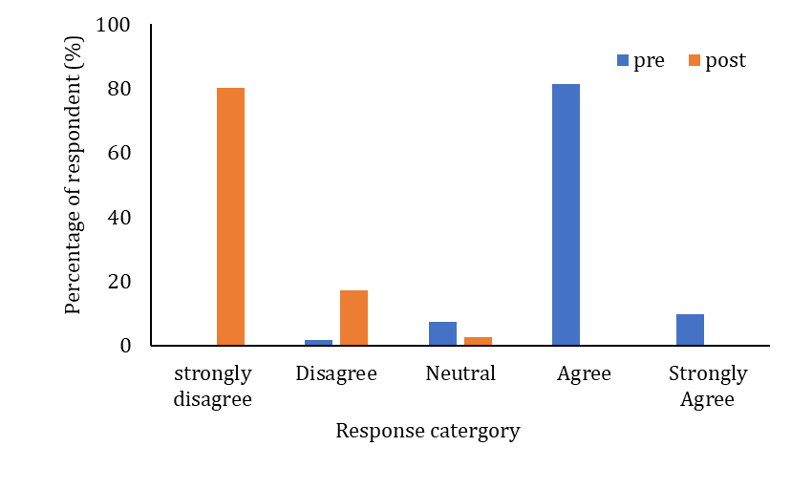
- Live Location of Waste Collectors (Screens "4th" and "12th")
  - This feature is accessible directly from the main user selection screen ("4th") and has a dedicated map view ("12th").
  - It shows the Live Location of the waste collectors on a map (e.g., centered on Ampara in the example).
  - This real-time vehicle tracking is crucial for householders to know exactly when to put out their waste, encouraging prompt disposal and reducing environmental exposure.
Figure 2: Perception of waste collection schedule knowledge
Results
The implementation of the EcoRoute mobile alert system has successfully tackled the issues identified at the beginning of the research and has resulted in a significant improvement in all the key performance indicators. The intervention has demonstrated that non-compliant waste services can be transformed into an efficient public service by filling the gaps in communication and operations.
Addressing the Communication Crisis and Ensuring Schedule Certainty
Before the intervention, there was a significant information gap, with 90.9% of the 185 households surveyed expressing a high level of uncertainty about whether they would be able to receive collection service on a specific day. This persistent communication problem resulted in instability in waste collection and loss of community trust. After the introduction of the mobile app, 80.1% of the surveyed group strongly disagreed with the statement that they did not know the schedule, a complete reversal of the previous situation. Moreover, while 39.2% of the group found it easier to remember fixed schedules, 95.7% of respondents agreed or strongly agreed that the reminders made it easier to manage the schedule through the app.
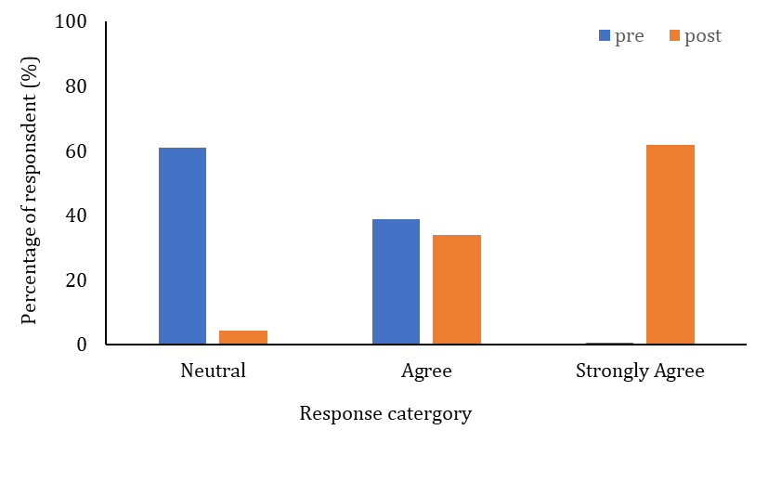
Figure 3: Ease of remembering the waste collection schedule
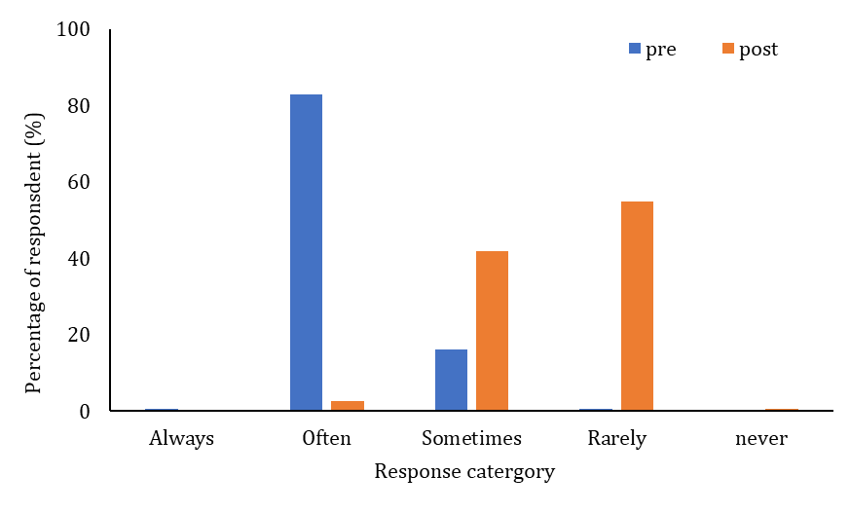
Enhancements in Service Reliability
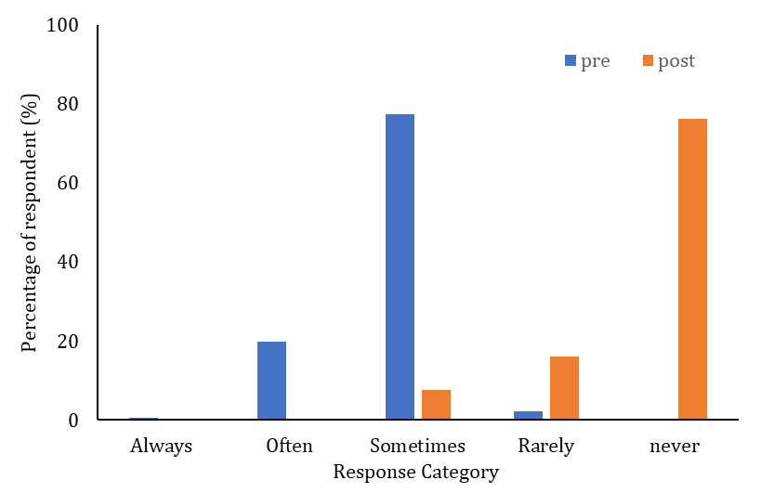
Before the study, one of the factors that contributed to dissatisfaction among residents was missed pickups, with 96.7% of the respondents stating that the truck did not arrive at least some of the time on the scheduled day of pickup. The success of the real-time tracking functionality in resolving the issue of missed pickups was evident, as 76.3% of the residents stated that the truck “never” failed to arrive on the scheduled day of pickup after the intervention.
Figure 4: Frequency of missed collection

Effect on environmental sanitation and hazardous waste disposal
The most significant effect of the intervention was the decrease in environmentally damaging waste disposal. At the start of the intervention, 83.3% of the population confessed to burning mixed waste “often” or “always” as a strategy to cope with the irregular service provision. However, at the end of the intervention, the percentage of the population that regularly practiced open burning was reduced to 2.7%. The system essentially abolished the penalty for self-managing waste through incineration by providing regular and predictable service provision. This had a significant effect on the perception of the population regarding environmental sanitation; 98.4% of the population found odor and pest nuisances to be
extremely severe, whereas 96.8% found them to be none or somewhat severe.
Figure 5: Open burning of mixed waste
Public satisfaction and collector observations
Public satisfaction with the communication system also experienced a universal change, shifting from 99% of the respondents being dissatisfied with the system to 81.2% of the respondents being “very satisfied” with the new system. The qualitative observations carried out by the 10 waste collectors also supported the results, indicating that the app was helpful for flexible communication with the households. However, a technical limitation was also identified among the older waste collectors who had difficulty coping with smartphone technology. Nevertheless, the workflow was streamlined, and there was an improvement in the efficiency of municipal waste management operations in Ampara.
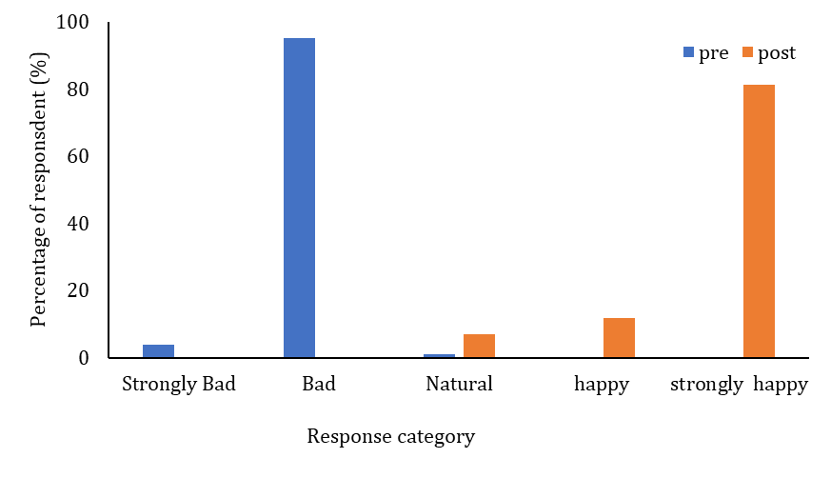
Discussion
Figure 6: Satisfaction with the communication system by mobile app
The evidence that has been gathered in this research is conclusive in its support of the original hypothesis, proving that the deployment of a mobile application providing real-time updates is indeed an effective means of improving the timeliness and relevance of domestic waste disposal practices. The virtual eradication of the communication crisis and the revolutionary change in disposal practices provide conclusive evidence that the theoretical foundation for the relevance of transparency and real-time information as the primary drivers of service reliability in this field is sound. While the hypothesis has been proven correct, it is clear from this research that there is a crucial "technological adoption barrier" that could be identified to explain any problems with operation: older waste disposal personnel had problems with the smartphone interface. This would seem to suggest that, while the technology is highly effective in operation for the end-user, the internal validity of the operation of the system is partially dependent on the technological awareness of the staff, which could potentially affect the effectiveness of the application unless used in conjunction with staff training.
To make sure that the findings are statistically valid and can be generalized, the study adopted a Stratified Random Sampling approach and Cochran’s Formula to make sure that there were no biases in the sampling process and that a representative sample size of 185 households was achieved. Nevertheless, there are some possible threats to internal validity, which include the fact that the intervention phase of the study lasted only two weeks. This may pose a possible threat of the "novelty effect," whereby the respondents may have behaved better because of the novelty of the technology and not necessarily because of a behavior change. Furthermore, the approach adopted in the questionnaires using the Likert scale method may pose a possible threat of imprecision in measurement, which may be attributed to the subjective nature of self-reported satisfaction and nuisance. The margin of error was set at 0.057, which, although acceptable, indicates a possible variability in the quantitative response.
The validity of these results is supported by the existing literature, which points out that 70% of the waste in cities in developing countries is left uncollected because of the inefficiencies that EcoRoute was meant to address. The changeover in public satisfaction from general dissatisfaction to near-universal happiness is consistent with the findings of Cruz et al. (2024), who found that technology increases public participation. Moreover, the findings of the results regarding the decrease in open burning challenge the conventional wisdom that this practice is a constant cultural tradition, and instead support the findings of Kitole et al. (2024), which suggest that improper disposal is often a rational reaction to systemic failure rather than a lack of environmental concern.
The relevance of the results is based on the significance of the behavioral change that can be quantified and measured in relation to the disposal of dangerous waste. The study has ensured that the service is reliable, and this has been successful in eliminating the systemic reward of open burning, which was a low-cost option for residents who had irregular services. The study highlights that incorporating digital communication is critical in promoting environmental cleanliness and the achievement of United Nations Sustainable Development Goals (SDGs) 11 and 12 in rapidly growing cities.
Conclusion
The EcoRoute system is a good example that proves the municipal waste management process can be transformed from an irregular and unreliable process into a stable municipal service using simple and integrated mobile technology. The main result of this research is that the so-called “communication crisis” in urban sanitation is basically an information transparency problem, which can be easily solved by creating feedback cycles between the collectors and the residents. From a professional and practical perspective, this research proves that cloud-focused hybrid apps are highly effective in areas with traditional infrastructure, providing a scalable and cost-effective solution to expensive automated hardware such as smart bins with sensors. From a research perspective, this research provides a critical behavioural finding: dangerous behaviours such as open burning isd often reactive to service failure rather than fixed cultural practices; once service delivery is guaranteed through real-time tracking, residents will naturally turn to appropriate disposal. The relevance of these results is based on their potential to directly improve urban environmental and health standards. Looking ahead, the success of this intervention suggests that a country-wide implementation in Sri Lanka is possible. The implications of this intervention suggest that the next generation of this technology should be designed to leverage AI predictive analytics capabilities to predict waste production and further optimize waste collection routes, while also addressing the technology adoption challenges faced by the municipal staff.
References
Asefa, E. M., Barasa, K. B., & Mengistu, D. A. (2022). Application of geographic information system in solid waste management. IntechOpen. https://doi.org/10.5772/intechopen.103773
Bandara, N., Patrick, J., & Hettiaratchi, J. P. A. (2010). Environmental impacts with waste disposal practices in a suburban municipality in Sri Lanka. International Journal of Environment and Waste Management, 6(1/2). https://doi.org/10.1504/IJEWM.2010.033987
Couth, R., & Trois, C. (2010). Carbon emissions reduction strategies in Africa from improved waste management: A review. Waste Management, 30(11), 2336–2346. https://doi.org/10.1016/j.wasman.2010.04.013
Cruz, M., Santos, R., & Delgado, P. (2024). Digital tools and public accountability in urban waste systems. Journal of Sustainable Urban Development, 18(2), 134–149. https://doi.org/10.1080/14729679.2024.1507831
Fheili, M. I., & Marrouch, W. (2025). Determinants of improper versus proper waste disposal practices by households: Evidence from greater Cairo’s urban slums. Cleaner Waste Systems, 100410. https://doi.org/10.1016/j.clwas.2025.100410
Guerrero, L. A., Maas, G., & Hogland, W. (2013). Solid waste management challenges for cities in developing countries. Waste Management, 33(1), 220–232. https://doi.org/10.1016/j.wasman.2012.09.008
Gutberlet, J., & Uddin, S. M. N. (2018). Household waste and health risks affecting waste pickers and the environment in low- and middle-income countries. International Journal of Occupational and Environmental Health, 23(4), 299–310. https://doi.org/10.1080/10773525.2018.1484996
Gutberlet, J., & Uddin, S. M. N. (2018). Household waste and health risks affecting waste pickers and the environment in low- and middle-income countries. International Journal of Occupational and Environmental Health, 23(4), 299–310. https://doi.org/10.1080/10773525.2018.1484996
Hannan, M. A., Begum, R. A., Al-Shetwi, A. Q., Ker, P. J., Al Mamun, M. A., Hussain, A., Basri, H., & Mahlia, T. M. I. (2020). Waste collection route optimisation model for linking cost saving and emission reduction to achieve sustainable development goals. Sustainable Cities and Society, 62, 102393. https://doi.org/10.1016/j.scs.2020.102393
Hidalgo-Crespo, J. A., Velastegui-Montoya, A., Soto, M., Rivas, J. L. A., Zwolinski, P., Riel, A., & Rivas-García, P. (2024). Improving urban waste management: A comprehensive study on household waste generation and spatial patterns in the Grand Guayaquil Metropolitan Area. Waste Management & Research, 42(10), 918–931. https://doi.org/10.1177/0734242X241262714
Jakhar, R., Samek, L., & Styszko, K. (2023). A comprehensive study of the impact of waste fires on the environment and health. Sustainability, 15(19), 14241. https://doi.org/10.3390/su151914241
Kaza, S., Yao, L., Bhada-Tata, P., & Van Woerden, F. (2018). What a waste 2.0: A global snapshot of solid waste management to 2050. World Bank. https://doi.org/10.1596/978-1-4648-1329-0
Keerti, P., Ruchitha, K., Krishna, R. V., & Tabassum, N. (2025). IoT-based GPS vehicle tracking and monitoring system. International Research Journal on Advanced Engineering and Management (IRJAEM), 3(5), 2164–2169. https://doi.org/10.47392/IRJAEM.2025.0342
Kitole, F., Mrema, G., & Ndlovu, T. (2024). Behavioral responses to systemic waste management failures in developing cities. Environmental Management Review, 32(1), 55–72. https://doi.org/10.1016/emr.2024.01.004
Knutsson, S. G., Asplund, T., Höst, G., & Schönborn, K. J. (2021). Public perceptions of waste management in Sri Lanka: A focus group study. Sustainability, 13(23), 12960. https://doi.org/10.3390/su132312960
Kumari, T., & Raghubanshi, A. S. (2022). Waste management practices in the developing nations: Challenges and opportunities. In Waste management and resource recycling in the developing world. Elsevier. https://doi.org/10.1016/B978-0-323-90463-6.00017-8
Leknoi, U., Painmanakul, P., Chawaloesphonsiya, N., Wimolsakcharoen, W., Samritthinanta, C., & Yiengthaisong, A. (2024). Building sustainable community: Insight from successful waste management initiative. Resources, Conservation & Recycling Advances, 24, 200238. https://doi.org/10.1016/j.rcradv.2024.200238
Lorenz, C. (2024). Studies on optimization problems with dynamically arriving information. https://doi.org/10.48676/unibo/amsdottorato/12266
Magalhães, E. J. L., Fernandes, M. A., Viana, M. R. P., Martins, M. C. C. e, Lago, E. C., Barbosa, D. A., Corrêa Feitosa, L. G., & Ramos, C. V. (2021). Health and work conditions of garbage collectors: A cross-sectional study. The Open Nursing Journal, 15, 319–330. https://doi.org/10.2174/1874434602115010319
Malolos, C. F., Maga-ao, M. A. D., Cea, A. P., Magallanes, S. C., Diamante, J. T., Venturillo, R., ... & Gonzales, B. J. (2025). Implementation of Area-Specific Action Plans (ASAP) for community-based MPAs in Cagayancillo, Palawan, Philippines: funded versus not funded. THE PALAWAN SCIENTIST, 17(1), 1-7. https://doi.org/10.69721/TPS.J.2025.17.1.01
McAllister, J. (2015). Factors influencing solid-waste management in the developing world [Master’s report, Utah State University]. All Graduate Plan B and Other Reports, Spring 1920 to Spring 2023 (No. 528). Utah State University Digital Commons. https://doi.org/10.26076/2c24-5944
Mir, R. A., Mantoo, A. G., Sofi, Z. A., & Bhat, D. A. (2023). Types of environmental pollution and its effects on the environment and society. In Geospatial analytics for environmental pollution modeling (pp. 1–31). Springer. https://doi.org/10.1007/978-3-031-45300-7_1
Nguyen, A. T., Nguyen, N., Phung, P., & Nguyễn, Y.-K. (2023). Residents’ waste management practices in a developing country: A social practice theory analysis. Environmental Challenges, 13, 100770. https://doi.org/10.1016/j.envc.2023.100770
Shadbahr, J., Ebadian, M., Gonzales-Calienes, G., Kannangara, M., Ahmadi, L., & Bensebaa, F. (2022). Impact of waste management and conversion technologies on cost and carbon footprint: Case studies in rural and urban cities. Renewable and Sustainable Energy Reviews, 168, 112872. https://doi.org/10.1016/j.rser.2022.112872
Srivastava, R. R., Rajak, D. K., Ilyas, S., & Kim, H. (2022). Challenges, regulations, and case studies on sustainable management of industrial waste. Minerals, 13(1), 51. https://doi.org/10.3390/min13010051
Tennakoon, S. M. A. V. S., Udayantha, U. L. I., & Wattegama, W. G. E. J. (2025). Waste management research in Sri Lanka: Exploring trends, identifying gaps, and gaining key insights through bibliometric analysis. Management Dynamics in the Knowledge Economy, 13(1), 20–37. https://doi.org/10.2478/mdke-2025-0002
Wijendra, D., De Silva, D. I., Gunawardhena, N. M., Wijayarathna, S. M., & Aluthwaththage, J. H. (2022, December). A mobile based garbage collection system. In 2022 3rd International Informatics and Software Engineering Conference (IISEC) (pp. 1-6). https://doi.org/10.1109/IISEC56263.2022.999826
Wilson, D. C., Rodic, L., Scheinberg, A., Velis, C. A., & Alabaster, G. (2015). Comparative analysis of solid waste management in 20 cities. Waste Management & Research, 33(3), 237–254. https://doi.org/10.1177/0734242X14565236
World Bank. (2018). What a waste 2.0: A global snapshot of solid waste management to 2050. World Bank. https://doi.org/10.1596/978-1-4648-1329-0
Yuan, Q., & Zoungrana, A. (2025). Systematic review of environmental and human health risk assessments in municipal solid waste management. Discover Sustainability, 6, 930. https://doi.org/10.1007/s43621-025-01544-8

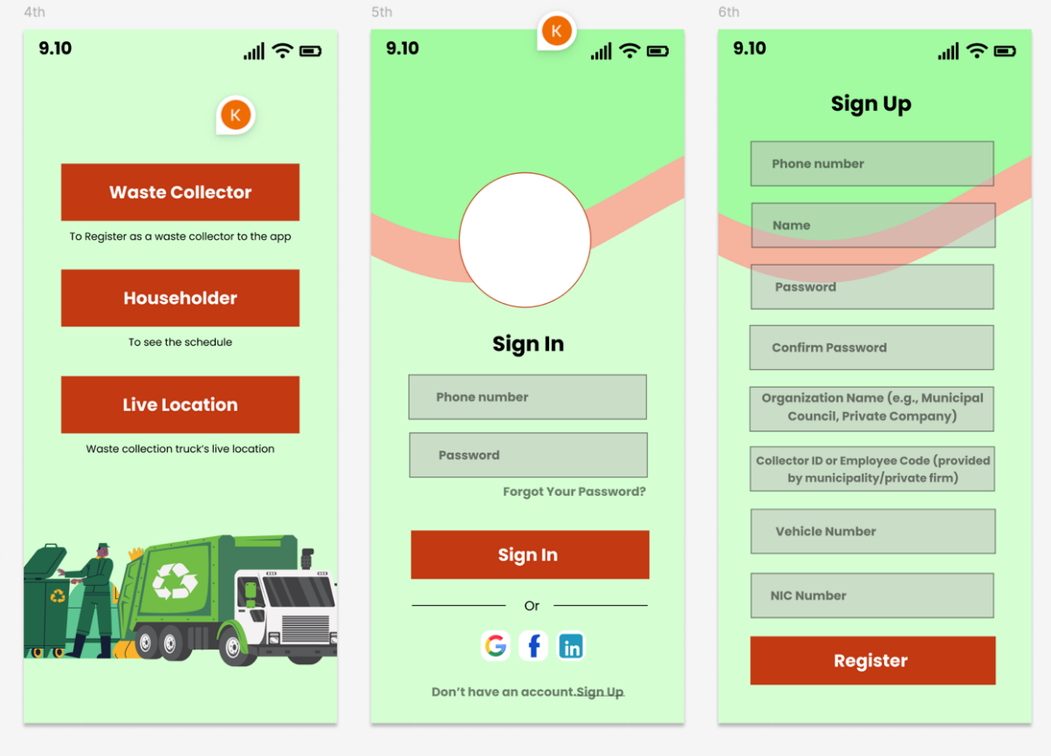
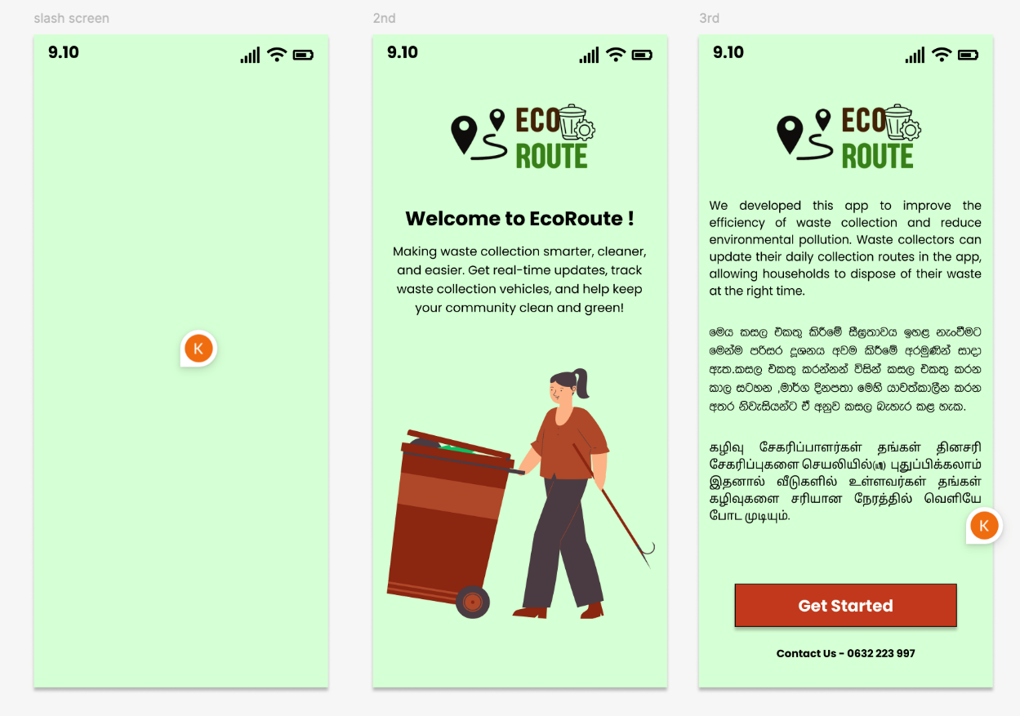
Appendix 1:
