Emerging Soil Nutrient Monitoring Technologies: A Review

Kok Yeow You¹*, Chen Son Yue², Cheong Yew Chong³, Cheng Seong Khe⁴, Samuel Chan Hsin Chlen⁵, Kah Meng Leong⁶, and Adeline Sneha⁷
¹Faculty of Electrical Engineering, Universiti Teknologi Malaysia, 81310, Skudai, Johor, Malaysia; kyyou@fke.utm.my
²Department of Physical Science, Faculty of Applied Sciences, Tunku Abdul Rahman University of Management and Technology, Jalan Genting Kelang, 53300 Kuala Lumpur, Malaysia; yuecs@tarc.edu.my
³Department of Bioscience, Faculty of Applied Sciences, Tunku Abdul Rahman University of Management and Technology, Jalan Genting Kelang, 53300 Kuala Lumpur, Malaysia; chongcy@tarc.edu.my
⁴Department of Fundamental and Applied Sciences, Universiti Teknologi PETRONAS, 32610 Seri Iskandar, Perak, Malaysia; chengseong.khe@utp.edu.my
⁵Department of Psychology and Counselling, Southern University College, 81300, Skudai, Johor, Malaysia; hcchan@sc.edu.my
⁶Department of Electrical & Electronic Engineering, Southern University College, 81300, Skudai, Johor, Malaysia;
kmleong@sc.edu.my
⁷School of Technology, Asia Pacific University of Technology & Innovation, 57000 Kuala Lumpur, Wilayah Persekutuan Kuala Lumpur; adeline.john@apu.edu.my

Abstract
This paper reviews emerging real-time soil nutrient monitoring systems, including those integrated with machine learning (ML) and wireless communication technologies. Soil nutrients are critical for crop productivity, with fertilization schedules often optimized to meet market-driven harvest timelines. Timely crop maturity is essential to prevent shipment delays, and fertilizer quality strongly affects plant growth. Over-application can lead to soil pollution, whereas under-application reduces yield. Therefore, a precise, user-friendly, robust, and cost-effective nutrient monitoring system is essential for supporting global agricultural productivity. In this study, the advantages and limitations of existing nutrient measurement and monitoring techniques are comprehensively evaluated. As an example, variations in NPK nutrient content (nitrogen, phosphorus, and potassium) in organic-based fertilizer were analyzed using both a pH meter and a microwave plasma atomic emission spectrometer.

1. INTRODUCTION
Typically, fertilizer production at factories operates on a large scale, with finished products undergoing rigorous physical and chemical testing to verify compliance with predetermined specifications, particularly regarding (N), phosphorus (P), and potassium (K) and magnesium (Mg) percentages. Typically, mass-produced fertilizers have issues such as non-uniform mix of nutrients (NPK ratio mix), as shown in Figure 1. Therefore, before each fertilizer package manufactured by the fertilizer factory must go through a quantity control test.
In addition, the N, P, and K are classified as macronutrients for crops, which are typically formulated with specific nutrient blends to address the diverse requirements of different crops. Crops are generally classified into three groups, namely root and tuber crops, fruit and flower crops, and leafy vegetables, each requiring different nutrient compositions and NPK ratios. Typically, root and tuber crops such as potatoes, carrots, and radishes need higher potassium (K) levels. On the other hand, fruit and flower crops like tomatoes, chili, and strawberries benefit from higher phosphorus (P) to support flowering and fruiting. Leafy vegetables such as spinach, lettuce, and cabbage require higher nitrogen (N) to promote leaf growth.
In general, in spring, fertilizers with an N: P :K ratio of 16%: 6% :4% are often used, which promotes root growth and green lawns. In order to encourage the production of flowers and fruits, the ratio of N: P :K can be 3%: 20% :20%, where the nitrogen (N) content is low, while the phosphorus (P) and potassium (K) contents are high. For instance, in pineapple cultivation, optimal levels of nitrogen (15%), phosphorus (15%), and potassium (15%) are vital. Furthermore, pineapple growth at different stages requires different NPK ratios as tabulated in Table 1. These nutrient monitoring are crucial for ensuring healthy pineapple growth and timely maturity.

Table 1. Proposed N:P:K (and MgO) fertilizer ratio for Malaysian pineapple cultivation.
Crop | Age  (months after planting) | N: P: K (:MgO)
Crop | Age  (months after planting) | First suggestion | Second suggestion
Malaysian Pineapple | 1 to 3 months (Plant established) | 15 : 15: 15 | 15: 30: 15
Malaysian Pineapple | 4 to 5 months (Vegetative growth) | - | 28 : 14 : 18
Malaysian Pineapple | 6 to 9 months (Flowering) | 12: 12: 17 (:2) | 15 : 15 : 30
Malaysian Pineapple | 10 to 13 months (Fruit Growth) | - | 15 : 15 : 30

Hence, measuring essential macronutrients (N, P, K) in soil or fertilizer is crucial for agricultural management, yet current methods face challenges in sensitivity, accuracy, and practical application. To address this, various NPK measurement techniques exist, each with its own advantages and disadvantages. Direct methods or Chemical testing techniques is widely used to determine NPK content. However, traditional chemical testing methods like the Kjeldahl test (for nitrogen), dry ash method, ascorbic acid method (for phosphorus), flame photometry (for potassium), and Dumas method are both time-consuming and destructive.
Emerging non-destructive, and accurate indirect measurement technique is needed to monitor NPK in soil and fertilizers. Nowadays, many types of NPK fertility nutrient tester have been commercialized in the market. There are low-end of testers that cost tens of US dollars and some professional testers are expensive up to millions of US dollars, based on function (some are multi-functional), reliable, and accuracy of the tester. Current methods include electric conductivity (EC) probes, selective ion electrodes (ISEs), and spectroscopic techniques, such as infrared (IR), near-infrared (NIR), nuclear magnetic resonance (NMR), ultraviolet-visible (UV-Vis), atomic emission (AE), and atomic absorption (AA) spectroscopy. Each measurement technique operates within a specific frequency range, determined by the molecular interaction mechanisms of the fertilizer with different sensing sources across the electromagnetic spectrum, as shown in Figure 2.

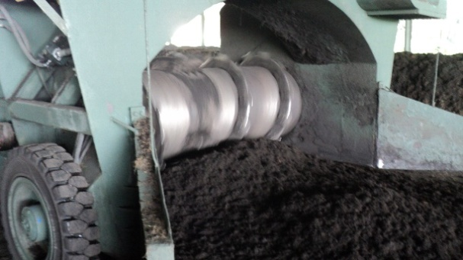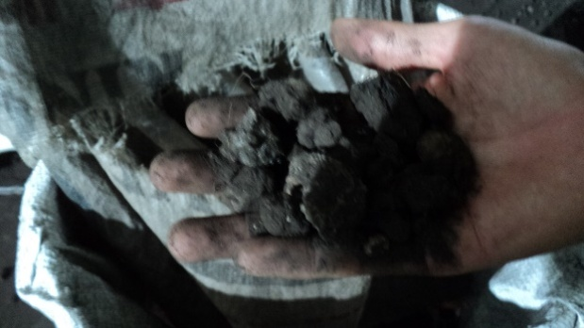
Figure 1. The process of fertilizer production in large-scale industry.

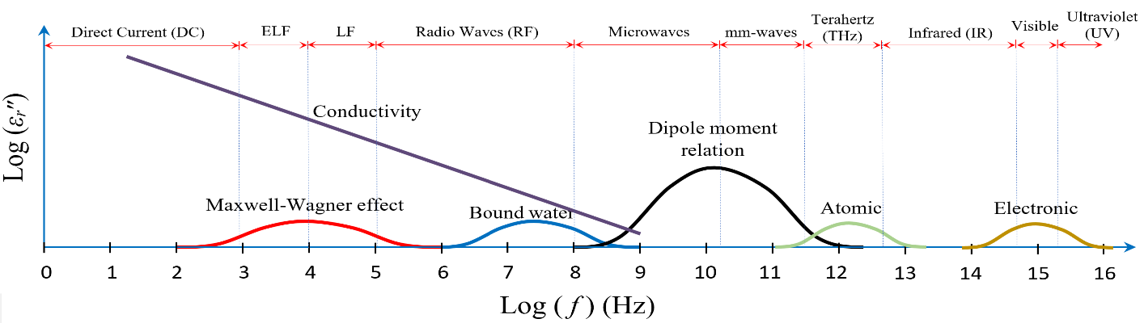
Note: ELF, LF, and mm-waves stand for extremely low frequencies, low frequencies, and millimeter-waves, respectively.
(a)
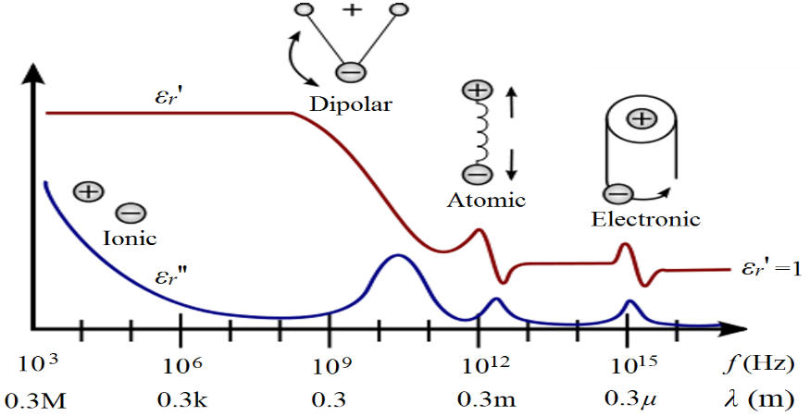
(b)

Figure 2. (a) Relationship between the molecular mechanism of specimen under test, loss factor, ε_{r}״, and operating frequency, f. (b) Frequency dependence of relative complex permittivity, ε_{r} = ε_{r}ʹ - j ε_{r}ʺ.
The development of efficient and accurate methods for monitoring NPK levels in fertilizers and soil aligns with Malaysia government policies focused on enhancing agricultural productivity and sustainability, such as 10-10 MySTIE framework to the Agriculture & Forestry Socio-economic Driver. By improving measurement techniques, governments can support initiatives aimed at optimizing fertilizer use, reducing environmental impact, and promoting precision agriculture. Effective NPK monitoring contributes to better resource management, reducing the risk of over-fertilization, and supporting sustainable agricultural practices. Integration of AI in agricultural sensing systems can also drive innovation and reduce costs, aligning with policies that encourage technological advancement and economic efficiency in the agriculture sector. In this paper, the direct methods (chemical test methods, such as Kjeldahl technique) and indirect methods (using optical and electrical measurement principles) will be described and compared in detail, including costs, facilities, advantages, disadvantages, and measurement principles/mechanisms.

2. DIRECT CHEMICAL TEST METHODS
2.1 Kjeldahl Method
The classical Kjeldahl method proposed by Johan Kjeldahl is one of the reference/standard methods for measuring nitrogen content in food, animal feed, and agricultural specimens (Sáez-Plaza et al., 2013). The basic classic apparatus of this method is shown in Figure 3. However, recently, there are lot of automatic Kjeldahl nitrogen analyzer has been commercialized to improve the sensitivity and accuracy of nitrogen measurement.

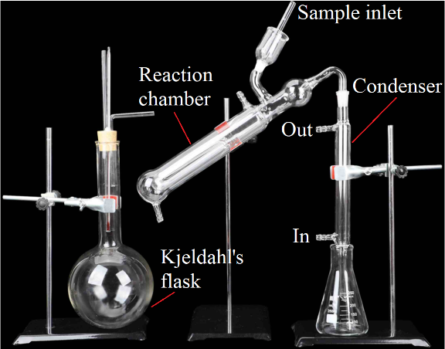
Figure 3. Basic classic Kjeldahl test apparatus.

As mentioned above, recently, the total N content in the fertilizer can easily be determined using automatic Kjeldahl nitrogen analyzer (Lombardo et al., 2017). In this study, the modern Kjeldahl test systems are used for monitoring NPK content in organic fertilizer, as shown in Figure 4. Basically, the measurement method is divided into three steps: wet digestion, distillation, and sum of nitrogen bound in ammonium is estimated.

Step 1: Wet Digestion Process
Briefly, an amount (0.6 g) of organic fertilizer is accurately weighed and digested in the Kjedahl digestion block as shown in Figure 4 (a) for 2 hours (Gerhardt, 2018).

Step 2: Distillation Process
Up to 40 ml of distilled water and 70 ml of 32 % sodium hydroxide are added in the distillation step (Gerhardt, 2020).

Step 3: Nitrogen (N) Content Estimation
The distillate collected is then titrated with 0.1 M hydrochloric acid using methyl red and bromocresol green as indicator as shown in Figure 4 (b). The total N content in the fertilizer samples is expressed as % N and it is calculated according to the formula as:

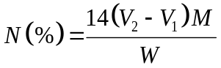 (1)

where V₂ and V₁ are the volumes (mL) of HCl in specimen under test and control, respectively. Whereas, M and W are the molarity (mol L⁻¹) of HCl and the weight (mg) of specimen, respectively.

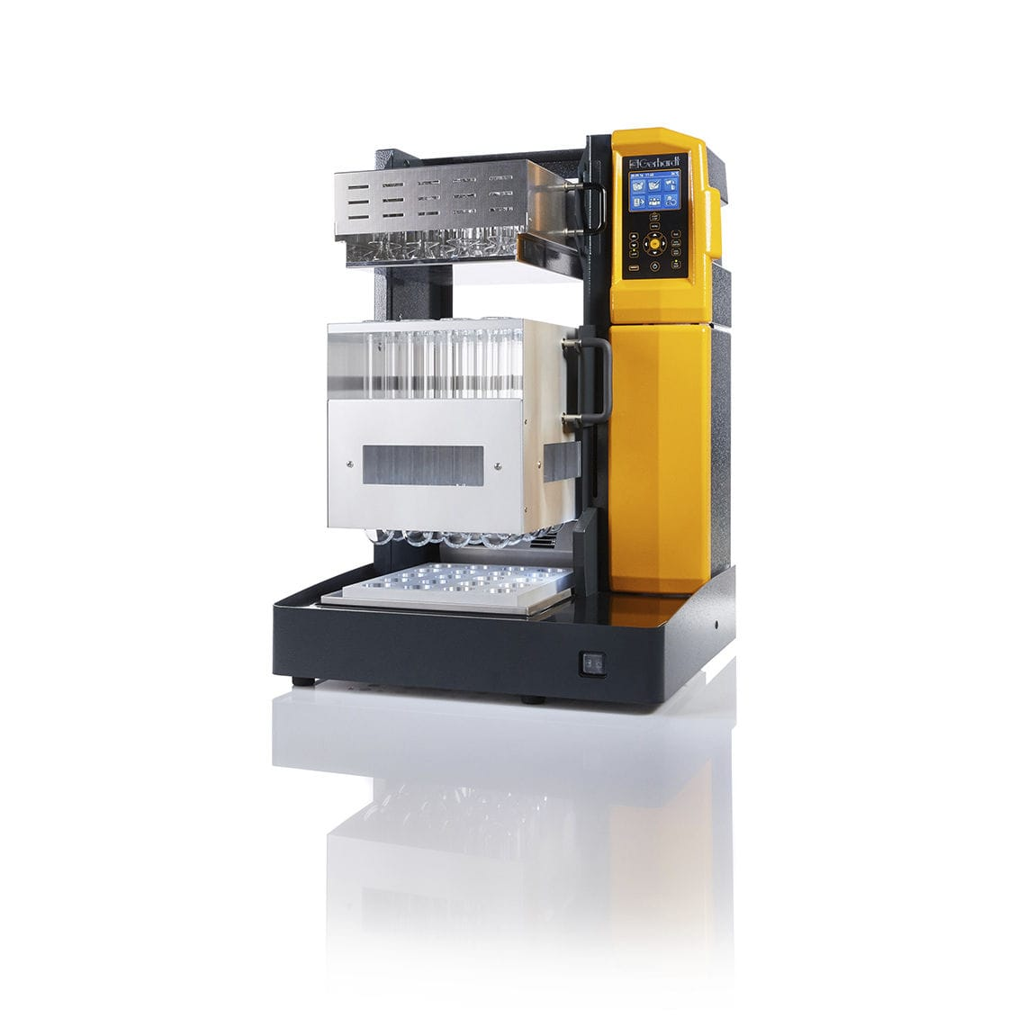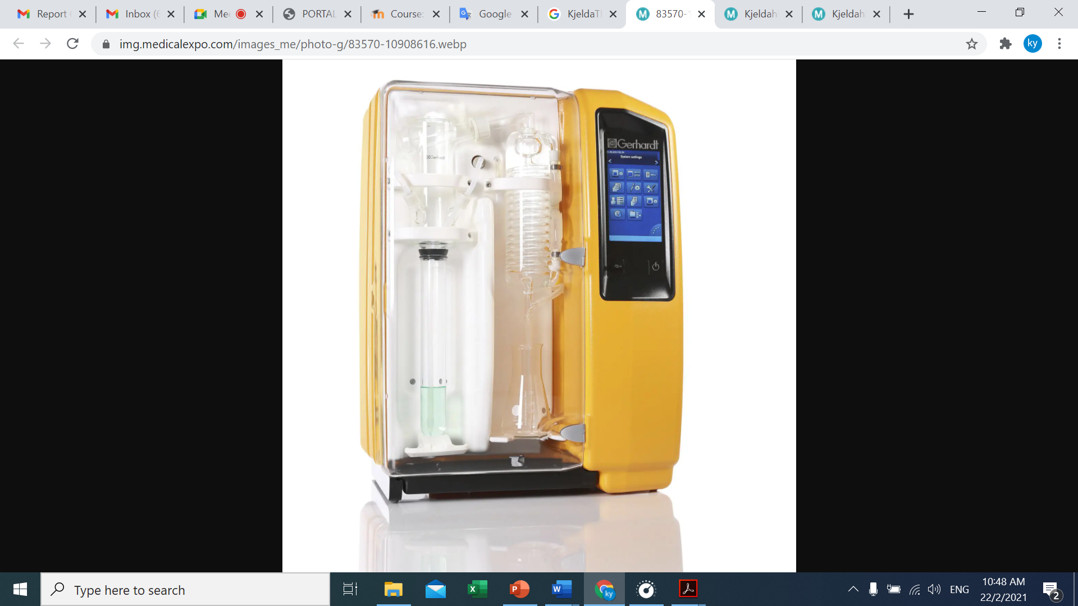
- (b)
Figure 4. (a) Kjeldahl digestion system. (b) Kjeldahl distillation system.

2.2 Dumas Method
Besides kjeldahl method, there are other methods for total nitrogen determination in agricultural products, such as dumas method proposed by Jean-Baptiste Dumas in 1826. By Dumas test, a small amount dried soil or fertilizer sample is heated in a nitrogen-analysis instrument to convert all nitrogen compounds into gases, which are purified and quantified by the detector to determine the sample’s nitrogen content.

3. INDIRECT TEST METHODS
An efficient method for non-destructive and precise monitoring of NPK in fertilizers is imperative (Muñoz et al., 2013; Potdar et al., 2021; Maria Khaydukova et al., 2021; Silva et al., 2023; Sneha Dattatreya et al., 2024). Various NPK fertility nutrient testers are available in the market, ranging from low-cost options to high-end, multi-functional devices costing several hundred thousands of dollars. Each type of tester and measurement technique has its own advantages and disadvantages.
3.1 Electric Conductivity (EC) Probes
An electric conductivity (EC) probes made of three or five metal electrodes are the simplest, cost-effective, rapid, and most commonly used sensor for on-site NPK content monitoring (Elena Baldi et al., 2020; Maria Khaydukova et al., 2021; Md Reazul Islam et al., 2023). It is known that inorganic minerals in fertilizer product contains high ions and cause a high value of the corresponding potential (Sánchez-Monedero et al., 2001).These probes measure the DC conductivity value of the soil, which correlates with the NPK content. The DC potential value depends on the amount of NPK in the soil. However, they may lack sensitivity to small NPK amounts in dry fertilizer or soil and can be prone to errors due to non-uniform electrode surfaces in contact with different soil textures, unless tailored for specific soil types.

3.2 Ion Selective Electrodes
An ion selective electrode (ISE) test method is an indirect test method to determine the activity of specific ions in aqueous solution by measuring the electrical potential, E (Joseph V. Sinfield et al., 2010; Zhai et al., 2022). Sometimes, the ion selective electrode is called specific ion electrode (SIE). The relationship between measured potential, E (in unit V) and specific ion concentration, C (in unit mg/L) in the solution under test is given as Nernst equation:
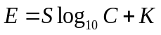 (2)
where values of K and S depend on the ion elements being measured as well as the electrode structure. The unknown S and K can be determined from plot curve of E versus log₁₀ C. Fertilizer products containing different amounts of ions will cause the difference in exited conductivity in the fertilizer (Yagüe & Quílez, 2012; Chen et al., 2021). Typically, nitrogen (N) in fertilizers is present as nitrate (NO₃⁻) or ammonium (NH₄⁺), while potassium (K) appears as potassium ions (K⁺), and magnesium (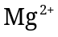). In contrast, phosphorus (P) is generally found in the form of phosphate ions (PO₄³⁻). Indirectly, the inorganic nutrient content in fertilizer is capable of correlating with measured potential.
For instance, calibration curve for nitrogen ion can be obtained by preparing several nitrogen solutions with known concentration, C and the corresponding potential, E is measured. However, as known that ISEs use selective membranes as a sensing head to allow the desired ions to enter and exit (special ions to be measured). Thus, each type of ISE is only able to measure certain ions. In fact, in practice, no membrane totally allows only one type of ion in the solution to pass through, so sometimes more than one type of ion can pass through the membrane. In addition, for a solution with a higher concentration, the interaction between ions in the solution tends to reduce the mobility of the ions, hence the concentration near the membrane will be lower than the actual concentration in the bulk specimen under test. All above issues will result in inaccurate measurements using ISE.

3.3 Spectroscopy Methods
There are several types of spectroscopic measurement techniques, including nuclear magnetic resonance (NMR) (Sørensen et al., 2015), infrared (IR) spectroscopy, near-infrared (NIR) spectroscopy (He et al., 2005; Lin et al., 2018; Arpit Rawankar et al., 2018; Mustaqimah et al., 2024; Xu et al., 2024), ultraviolet-visible (UV-Vis) spectroscopy (Silva et al., 2019; Potdar et al., 2021; Silva et al., 2023), microwave plasma atomic emission (MPAE) spectroscopy, and atomic absorption (AA) spectroscopy (Yang et al., 2002; Marcos André Bechlin et al., 2014). Among these IR, NIR, and UV-Vis are classified as optical spectroscopic methods, whereas MPAE represents a microwave-based spectroscopic technique. Both optical and microwave spectroscopy operate on similar fundamental principles, an electromagnetic wave interacts with the soil or fertilizer sample, and resulting response is analyzed to extract intrinsic fertilizer properties. These properties can then be correlated with the NPK content present in soil/fertilizer. In optical spectroscopy, the key material parameter is the complex refractive index, n = n′ – jn″, which describes how light propagates, reflects and attenuates within the soil or fertilizer. In microwave spectroscopy, the corresponding parameter is the relative complex permittivity, εᵣ = ε_{r}′ – jε_{r}″, which characterizes polarization and energy dissipation at lower frequencies (You, 2016). The relationship between complex refractive index, n (optical) and relative complex permittivity, ε_{r} (microwave) is given as n² = ε_{r}. Differentiations between microwave and optical (infrared) methods are the application of operating frequency (Microwave: 300 MHz to 300 GHz; Infrared: 300 GHz to 430 THz) and excited source as shown in Figure 4.
Figure 5 shows the response of the relative complex permittivity, ε_{r} from Radio frequencies (RF) to Ultraviolet frequencies. At microwave frequencies (300 MHz to 300 GHz), ε_{r}ʹ and ε_{r}ʺ show the reaction caused by dipole relaxation phenomena of the substance in soil/fertilizer. On the other hand, at infrared frequencies, ε_{r}ʹ and ε_{r}ʺ exhibit a significant reaction due to the resonant occurring between the molecular vibration of the substance and the infrared frequency. The NPK content of fertilizer or soil is determined based on the absorbance and reflectance of the fertilizer/soil on the monochromatic light source when exposed to the source. Molecules of each element N, P, K resonate at a certain wavelength and exhibit significant resonance absorption effects at that wavelength. The wavelength ranges of source used by IR, NIR, UV, and Vis spectroscopy are 700-1000 nm, 780–2500 nm, 200-400 nm, and 380 nm to 780 nm, respectively. Unfortunately, various ions of N, P, and K has the same spectral characteristics and overlap of some wavelengths (Potdar et al., 2021). Furthermore, this type of NPK measurement technique requires good environmental control and is less suitable for on-site measurements. Often, the technique also requires personnel with skills in using test equipment.
For instance, as known that the vibration frequency, f of water molecules is approximately 30 THz (Wavelength, λ = 10 μm). When the frequency of the irradiated far-infrared rays is same as the vibration frequency range of molecular motion of water, molecules group of water becomes less and water molecules motion become fast due to the resonance absorption effect. Therefore, the irradiated far infrared sensor is normally used for moisture measurements and the characterization of substance (Different substances have different vibrational molecular frequencies). Up to 30 THz, atomic polarization and electronic polarization are exited in the fertilizer sample which are the main mechanisms used in near-infrared spectroscopy (NIR) and ultraviolet-visible spectroscopy test methods, respectively.

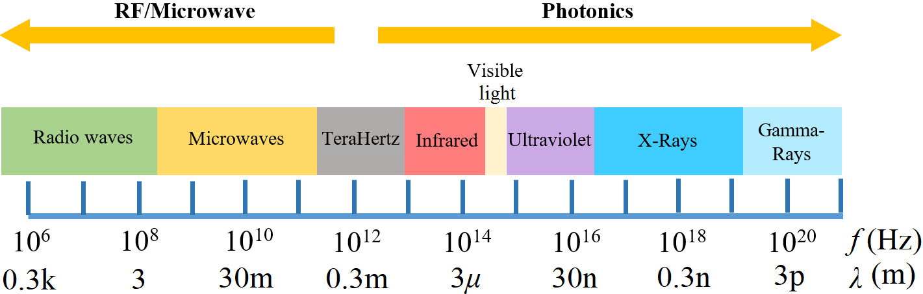

Figure 5. Electromagnetic spectrum.

3.3.1 Nuclear Magnetic Resonance (NMR) Spectroscopy
In nuclear magnetic resonance (NMR) spectroscopy, the fertilizer sample is positioned in a magnetic field, which causes certain nuclei to align with or against the field. When a radio-frequency (RF) is applied, these nuclei are excited from their equilibrium state and driven into resonance. As the nuclei relax back to their original alignment, they emit characteristic RF signals. The emitted signals is detected with sensitive radio receivers and generate an NMR spectrum. The spectrum is used to quantify specific nuclei associated with nutrient components. Normally, version of ¹⁵N, ³¹P, ³⁹K, and ¹³C NMR spectroscopy are used to monitor the nutrient in fertilizer or soil. For instance, ¹⁵N NMR spectroscopy is implemented to examine specimen under test containing the ¹⁵N nucleus.

3.3.2 Ultraviolet-Visible (UV-Vis) Spectroscopy (P and K Contents Test)
The UV–Vis spectroscopic module operates by measuring the interaction between ultraviolet light and the fertilizer sample. The sample is exposed to UV light within the wavelength range of 200–400 nm, and the absorption of light of the sample is measured. According to Beer’s law, the absorbance, A of the sample is given as:
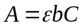 (3)
where ε is the molar absorptivity of the element dissolved in the specimen solution and b is the length of light path in specimen, respectively. On the other hand, C is the concentration of the element in the specimen solution. Once ε and b are known, the concentration, C can be determined from the measured absorbance, A.
In practise, the absorbance, A is measured in term of light intensity, I. The relationship between A and I can be expressed in logarithm form:
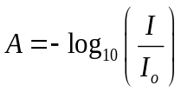 (4)
where I₀ and I are the intensity of incident light in a sample cuvette and the intensity of transmitted light. The Beer-Lambert law states that absorbance increases with both concentration, C and path length, b. A calibration curve is used to determine how absorbance varies with concentration. The UV-Vis spectrophotometer measures the strength of light passing through the sample compares it to light intensity through reference specimen using a photodiode for signal processing. Typical, molecules with electrons that are easily excited absorb at longer wavelengths.

3.3.3 Near-Infrared (NIR) Spectroscopy (P and K Contents Test)
Far-infrared radiating ceramics are made of twenty or more inorganic compounds and trace metals or specific natural ores in different proportions, and then calcined at a high temperature of 1200 ºC to 1600 ºC, so that the ceramics can emit far-infrared rays of a specific wavelength. For instance, as known that the vibration wavelength, λ of water molecules is approximately 10 μm. When the wavelength of the irradiated far-infrared rays is same as the vibration wavelength range of molecular motion of water, molecules group of water becomes less and water molecules motion become fast due to the resonance absorption effect. The commercial near-infrared (NIR) spectrophotometer is shown in Figure 6.
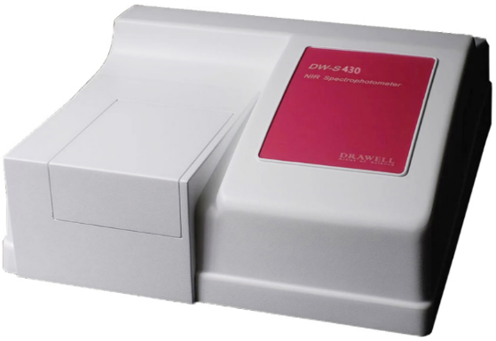
Figure 6. DRAWELL DW-S430 Near-infrared (NIR) spectrophotometer.

3.3.4 Microwave Plasma Atomic Emission Spectroscopy (P and K Contents Test)
Besides IR, NIR, UV, and Vis spectroscopy, an atomic emission spectroscopy (AE) and atomic absorption spectroscopy (AA) are the another spectroscopy test method for N, P, and K detection (Yang et al., 2002). The basic AE measurement principle is based on the emission spectrum produced by the atom/molecule of the N, P, or K element in the fertilizer once the atom/molecule excited by external energy, such as microwave plasma. Different atoms/molecules of the element emit radiation (light) with different wavelengths. The number of atoms/molecules of the element is determined by the intensity of its emitted radiation. On the other hand, the AA spectroscopy method is based on absorption of light by N, P, or K ions. Although the P or K measurement using expensive commercial spectrometer is simple, there are even some steps that need to be done before the fertilizer sample can be tested with the spectrometer.
In this study, the microwave plasma atomic emission spectrometer (Agilent 4210 model) is also introduced in order to test the phosphorus (P) or potassium (K) contents, as shown in Figure 7. The basic measurement principle is based on the emission spectrum produced by the atom/molecule of the P or K element in the fertilizer once the atom/molecule excited by external energy, such as microwave plasma. Different atoms/molecules of the element emit radiation (light) with different wavelengths. The number of atoms/molecules of the element is determined by the intensity of its emitted radiation. Although the P/K measurement using commercial spectrometer is simple, there are even some steps that need to be done before the fertilizer sample can be tested with the spectrometer.

Step 1: Preparation of Standard Test Solutions
Up to 4.56 g and 1.91 g of Na₂H₂PO₄ and KCl were measured separately to prepare two stock solutions of 1000 mgL⁻¹ consisting of each element in 1000 mL volumetric flasks. Deionized water was used to dissolve the salts and made up to the volume of 1000 mL. These stock solutions were further diluted 200 and 1000 times to prepare stock solutions of 5 mg L⁻¹ and 1 mgL⁻¹ for P and K, respectively. From the newly prepared stock solutions, a series of standard solutions (100 mL each) with the concentrations of 50, 100, 200, 400, and 1000 µgL⁻¹ (for P) and 10, 50, 100, 200, and 500 µgL⁻¹ (for K) were prepared and they were used to obtain the calibration curves of signal intensity as a function of concentration of P and K standards, respectively, as tabulated in Table 2. The limit of detection (LOD) and limit of quantitation (LOQ) are determined according to the formulae of 3.3 s/S and 10 s/S, respectively (Lee et al., 2015).

Table 2. Analytical characteristics of the MP-AES method
Element | Concentration range, x (µg/L) | Regression equation | r² | LOD  (µg/L) | LOQ  (µg/L)
Phophorus (P) | 1000 - 20000 | y = 0.0653x + 1029.1 | 0.9912 | 1853.50 | 5616.66
Potassium (K) | 10 - 5000 | y = 2.6231x + 119.79 | 0.9996 | 36.78 | 111.45
Note: x is the concentration of respective metal element (µg/L); y is the signal intensity of respective metal element; r² is the square of regression coefficient; LOD standard for limit of detection; LOQ standard for limit of quantification.
Step 2: Preparation of Fertilizer Samples
The digestion of fertilizer samples are modified from the method described by Yang et al. (2002) and each sample is conducted in triplicate. Briefly, 0.5 g of the fertilizer sample was digested with 9 mL of HNO₃ and 3 mL of HCl in a beaker at 80 ºC for 1 h until a clear solution is obtained. The digested fertilizer is cooled to room temperature and filtered through a syringe filter to remove undissolved materials. The clear solution of the digested fertilizer is diluted 10-fold with deionized water before MP-AES analyses.
Step 3: P and K Measurements Using Microwave Plasma Atomic Emission Spectrometer
The quantitation of P and K in the fertilizers are conducted using an Agilent 4210 MP-AES microwave plasma atomic emission spectrometer as shown in Figure 7. The instrument was equipped with a liquid nitrogen Dewar which was used to provide nitrogen gas to run the microwave-induced plasma. The sample introduction is composed of an SPS4 auto-sampler, solvent-resistant tubing, a double-pass cyclonic spray chamber, and an inert Flow Blurring nebulizer (OneNeb). The system is controlled through MP Expert software.

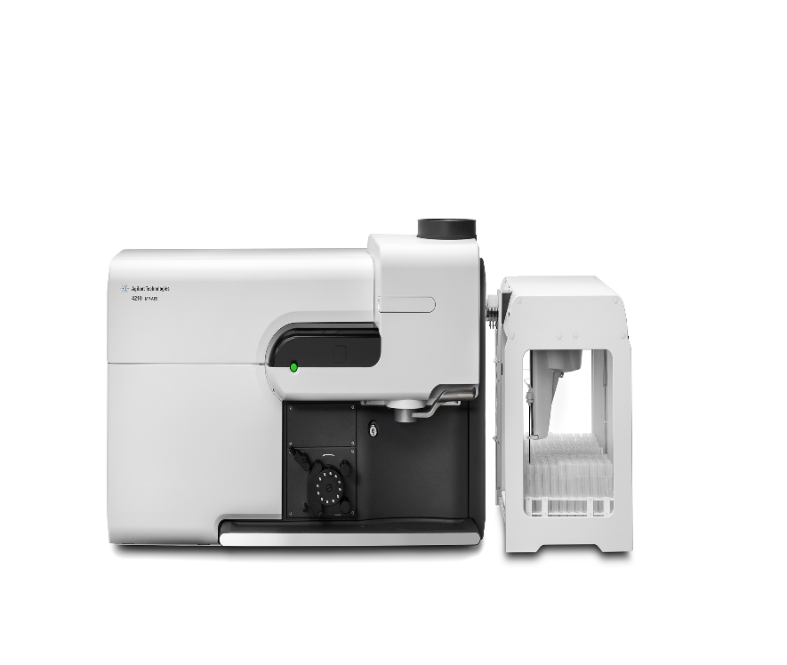

Figure 7. Agilent 4210 MP-AES microwave plasma atomic emission spectrometer.

3.3 LED/Fiber-Optic Light Sensing Techniques
Recently, a simple and cost-efficient LED-based sensing method, commonly referred to as colorimetry, has been proposed to measure NPK content based on the color absorption characteristics of wet fertilizer/soil sample (Liu et al., 2016; Regalado & Cruz, 2016). The measurement system consists of three or more LEDs as a light source, such as red, green, and blue color light. The reason is that N, P and K exhibit stronger absorption in the blue (~470 nm), green (~530 nm), and red (~650 nm) chromatic light, respectively (Masrie et al., 2017; 2018). The integration of LEDs as emitters/light sources and photodiodes as detectors forms a simple spectroscopic setup for directly detecting NPK nutrients. Typically, N, K, and P correspond to red, blue, and green wavelengths, respectively. This method exhibits significant measurement tolerance, resulting in output NPK content measurements typically categorized as "low", "medium", and "high," making it less suitable for detecting small changes in NPK content. For example, Yusof et al. (2016) reported that P shows its highest absorption peaks between 800 nm to 970 nm. In fact, the absorption wavelengths of soils containing N, P, and K are also different depending on the use of different chemical reagents and the type of soil as well as moisture content in the soil (Yusof et al., 2016; Kim et al., 2009). The measurement tolerance of this method is large, hence the detected NPK con-tent is usually classified as "low", "medium" or "high"(Ramane et al., 2015; Masrie et al., 2017; Fonacier et al., 2019).
Figure 8 illustrates the operating principle of the fiber-optic NPK sensor. LEDs of different colours emit light of equal initial intensity through the transmitting fibers. When the probe is immersed in the fertilizer or soil solution, the amount of the reflected light depends on the NPK content. The central receiving fiber collects the reflected light, and the phototransistor converts it into an electrical signal. By comparing the measured current with reference values stored in the microcontroller, the system estimates the NPK levels and displays the required nutrient quantities on an LCD for easy monitoring.

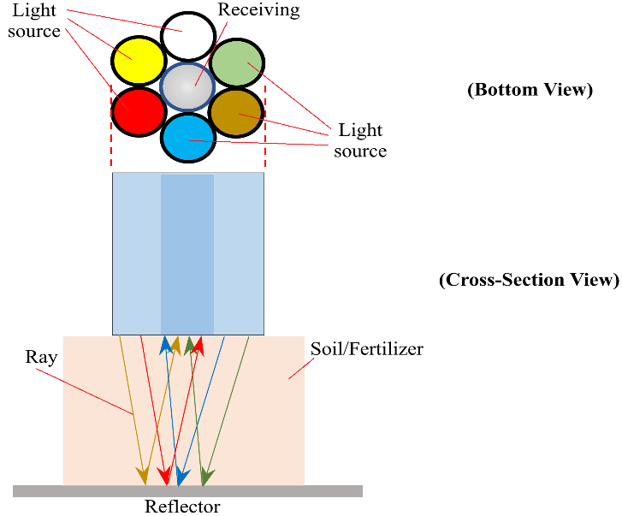
Figure 8. Principle of optic fiber-based sensor.

3.4 Microwave Sensing
Microwave sensing is an emerging technique for real-time, non-destructive, and precision measurement of N, P, and K content in fertilizers and soil. Its operating principle is based on how microwave electromagnetic waves interact with the relative complex permittivity, ε_{r} = ε_{r}ʹ - j ε_{r}ʺ of fertilizer/soil (as described in Section Introduction). The real part, ε_{r}ʹ correlates to polarization molecules and moisture in the fertilizer/soil, and the imaginary part, ε_{r}ʺ relates to ionic movement and conductivity of NPK in the fertilizer/soil. The nitrogen (NO₃⁻ / NH₄⁺) and potassium (K⁺) are present in ionic form, which strongly influences imaginary part, ε_{r}ʺ when exposed to microwave fields.
In microwave sensing, a sensor operating within microwave frequency range is used to measure the reflection coefficient, S₁₁, the transmission coefficient, S₂₁ or both, when the sensor head is in contact with the fertilizer or soil (You et al., 2013). Transmission, S₂₁ measurements may be performed in either the time-domain or the frequency-domain. In addition, microwave resonate sensors can detect NPK content by measuring shifts in resonant frequency, Δf and changes in the quality factor, Q (Lim et al., 2026). These parameters (S₁₁, S₂₁, Δf, and Q) correlate with NPK concentrations and can be analyzed using polynomial regression, ANN/ML algorithms, or PSO/GA optimization techniques. However, there several limitations in NPK monitoring by microwave sensor, such as:
(a) | P detection is weaker due to low solubility of phosphate. P usually exists as insoluble phosphate (PO₄³⁻) and has limited ionic mobility and cause weaker microwave interaction.
(b) | Moisture strongly affects permittivity; must be accounted for.
(c) | Soil heterogeneity can introduce variability.
(d) | Requires calibration models for different soil/fertilizer types.

3.5 PH Test
In this work, the pH of the raw fertilizer is directly measured using the Hanna HI98127 pH tester. While, for fertilizer solution pH test, the fertilizer solution is prepared by adding deionized water in the ratio of 1:10 (1g : 10 mL) and the solution is left for 2 hours for maximum salts dissolution (Sánchez-Monedero et al., 2001). The pH of the prepared solution is tested using pH tester. The pH values are noted when the readings are stabilized.

4. ORGANIC-BASED FERTILIZER SPECIMENS
Up to 36 samples with different NPK ratios of the raw oil palm-based fertilizer samples are provided by Green Plant Organic Fertilizer manufacturer. The fertilizer samples are divided into two groups, namely group A without containing 2% MgO and group B with 2% MgO, respectively, as listed in Table 3. It should be noted that the nutrient contents (NPK) in the fertilizer are initially notified by the manufacturer. All raw oil palm-based fertilizer samples obtained from Green Plant Organic Fertilizer manufacturer are verified using third-party measurement techniques, specifically the pH test (Described in 3.5), Kjeldahl method (Described in Section 2.1) and microwave plasma atomic emission spectrometry (MP-AES) (Described in Section 3.3.4).
Table 3. Raw fertilizer sourced from Green Plant Organic Fertilizer manufacturer
Group
A (without 2% MgO) |  |  |  | B (with 2% MgO)
Sample | N (%) | P (%) | K (%) | Sample | N (%) | P (%) | K (%)
N1 | 1.5 | ~1.2 | ~3.15 | N1 | 1.5 | ~1.2 | ~3.15
N2 | 2.5 | ~1.2 | ~3.15 | N2 | 3.0 | ~1.2 | ~3.15
N3 | 3.5 | ~1.2 | ~3.15 | N3 | 5.0 | ~1.2 | ~3.15
N4 | 4.5 | ~1.2 | ~3.15 | N4 | 7.0 | ~1.2 | ~3.15
N5 | 5.5 | ~1.2 | ~3.15 | N5 | 10.0 | ~1.2 | ~3.15
N6 | 6.5 | ~1.2 | ~3.15 | N6 | 12.0 | ~1.2 | ~3.15
P1 | ~2.0 | 1.0 | ~3.15 | P1 | ~2.0 | 1.0 | ~3.15
P2 | ~2.0 | 2.0 | ~3.15 | P2 | ~2.0 | 3.0 | ~3.15
P3 | ~2.0 | 3.0 | ~3.15 | P3 | ~2.0 | 5.0 | ~3.15
P4 | ~2.0 | 4.0 | ~3.15 | P4 | ~2.0 | 7.0 | ~3.15
P5 | ~2.0 | 5.0 | ~3.15 | P5 | ~2.0 | 10.0 | ~3.15
P6 | ~2.0 | 6.0 | ~3.15 | P6 | ~2.0 | 12.5 | ~3.15
K1 | ~2.0 | ~1.2 | 3.0 | K1 | ~2.0 | ~1.2 | 3.0
K2 | ~2.0 | ~1.2 | 4.0 | K2 | ~2.0 | ~1.2 | 6.0
K3 | ~2.0 | ~1.2 | 5.0 | K3 | ~2.0 | ~1.2 | 9.0
K4 | ~2.0 | ~1.2 | 6.0 | K4 | ~2.0 | ~1.2 | 12.0
K5 | ~2.0 | ~1.2 | 7.0 | K5 | ~2.0 | ~1.2 | 15.0
K6 | ~2.0 | ~1.2 | 8.0 | K6 | ~2.0 | ~1.2 | 17.0
5. RESULTS AND DISCUSSION
The raw oil palm residual mixture naturally contains a small amount of inorganic elements. The comparison of inorganic elements in each type of residual, as reported in the literature (Gurmit et al., 1989; Su et al., 2022), studied raw oil palm residual, and manufacturer labeling is listed in the Table 4. It should be noted that the studied raw oil palm residual is a mixture of various parts, such as empty fruit bunch (EFB), (MF), Palm frond (PF), Palm trunk (PT), palm kernel shell (PKS), and palm oil mill effluent (POME). The NPK content of inorganic elements in group A and group B fertilizer samples, measured using the Kjeldahl method and the MP-AES method, is listed in Table 5 and Table 6.

Table 4. Inorganic composition of raw oil palm residual (weight %)
Ele-ment | Literature (Gurmit et al., 1989; Su et al., 2022) |  |  |  |  | This study
Ele-ment | Empty fruit bunch (EFB) | Palm kernel shell (PKS) | Mesocarp fiber (MF) | Palm frond (PF) | Palm trunk (PT) | Raw palm residual (Kjeldahl & MP-AES) | Manufacturer labeling
N | 0.56 – 0.88 | 0.36 – 0.70 | 1.09 – 3.12 | 0.19 – 0.71 | 0.40 – 0.44 | 1.12 ± 0.17 | 1.95 – 2.04
P | ~0.1 | – | – | – | – | 0.82 ± 0.06 | 1.2 – 1.26
K | ~2.5 | – | – | – | – | 3.76 ± 0.70 | 3.14 – 3.17
P₂O₅ | 1.12 – 4.29 | 0.98 – 10.21 | 1.58 – 7.48 | 2.43 – 9.20 | 5.37 – 8.71 | 1.88 | –
K₂O | 39.98 – 53.73 | 1.29 – 10.38 | 1.99 – 15.55 | 8.29 – 39.81 | 24.50 – 44.50 | 4.53 | –
MgO | 3.68 – 8.75 | 1.77 – 14.36 | 4.20 – 50.83 | 1.93 – 16.00 | 1.15 – 15.60 | – | –

Table 5. NPK contents and pH of the palm oil organic fertilizer samples without containing 2% MgO.
Samples | pH |  | Nitrogenª  (%) | Phophorusª |  | Potassiumª |  | N+P+K  (%)
Samples |  |  | Nitrogenª  (%) | P (%) | P₂O₅ (%) | K (%) | K₂O (%) | N+P+K  (%)
Samples | Solid | Solution
Set A (N1) | 7.4 | 8.61 | 0.79 ± 0.09 | 0.11 ± 0.00 | 0.25 | 5.13 ± 0.39 | 6.18 | 6.0
Set A (N2) | 8.7 | 7.41 | 1.73 ± 0.11 | 0.16 ± 0.03 | 0.37 | 5.42 ± 0.11 | 6.53 | 7.3
Set A (N3) | 8.5 | 7.09 | 2.38 ± 0.18 | 0.03 ± 0.00 | 0.07 | 4.80 ± 0.21 | 5.78 | 7.2
Set A (N4) | 8.4 | 6.89 | 2.89 ± 0.34 | 0.04 ± 0.00 | 0.09 | 5.18 ± 0.78 | 6.24 | 8.1
Set A (N5) | 8.6 | 6.82 | 3.69 ± 0.16 | 0.01 ± 0.00 | 0.02 | 5.79 ± 0.80 | 6.98 | 9.5
Set A (N6) | 8.5 | 6.78 | 5.18 ± 0.34 | 0.24 ± 0.13 | 0.55 | 5.47 ± 0.59 | 6.59 | 10.9
Set A (P1) | 7.4 | 9.06 | 1.45 ± 0.47 | 0.08 ± 0.00 | 0.18 | 4.85 ± 0.55 | 5.84 | 6.4
Set A (P2) | 7.5 | 8.62 | 1.49 ± 0.12 | 0.61 ± 0.14 | 1.40 | 5.42 ± 1.11 | 6.53 | 7.5
Set A (P3) | 7.8 | 7.99 | 1.26 ± 0.74 | 3.21 ± 0.31 | 7.35 | 5.43 ± 0.84 | 6.54 | 9.9
Set A (P4) | 7.5 | 7.85 | 1.21 ± 0.84 | 1.81 ± 0.59 | 4.14 | 5.41 ± 0.95 | 6.52 | 8.4
Set A (P5) | 7.9 | 7.54 | 0.00 | 2.91 ± 0.53 | 6.66 | 4.90 ± 0.61 | 5.90 | 7.8
Set A (P6) | 7.7 | 7.66 | 1.49 ± 0.17 | 4.13 ± 0.56 | 9.45 | 7.03 ± 0.50 | 8.47 | 12.7
Set A (K1) | 7.8 | 9.44 | 1.54 ± 0.18 | 0.22 ± 0.09 | 0.50 | 6.00 ± 0.76 | 7.23 | 7.8
Set A (K2) | 8.2 | 9.14 | 1.49 ± 0.34 | 0.25 ± 0.09 | 0.57 | 8.26 ± 0.42 | 9.95 | 10.0
Set A (K3) | 7.9 | 8.64 | 1.49 ± 0.52 | 0.24 ± 0.04 | 0.55 | 9.35 ± 0.60 | 11.27 | 11.1
Set A (K4) | 7.7 | 8.34 | 1.35 ± 0.16 | 0.23 ± 0.05 | 0.53 | 10.27 ± 0.69 | 12.37 | 11.9
Set A (K5) | 8.0 | 8.21 | 1.35 ± 0.32 | 0.16 ± 0.04 | 0.37 | 12.49 ± 0.82 | 15.05 | 14.0
Set A (K6) | 7.9 | 8.07 | 1.35 ± 0.04 | 1.13 ± 0.34 | 2.59 | 16.20 ± 0.65 | 19.52 | 18.7
ª Results are expressed as mean ± % RSD for triplicate analysis. The calculation of % N, % P₂O₅ and % K₂O were based on the conversion factors of % N = 1.00 × % N, % P = 0.437 × % P₂O₅ and % K = 0.83 × % K₂O, respectively.
Table 6. NPK contents of the palm oil organic fertilizer samples (Set B) with containing 2% MgO.
Samples | pH |  | Nitrogenª  (%) | Phophorusª |  | Potassiumª |  | N+P+K+ P₂O₅+ K₂O  (%)
Samples |  |  | Nitrogenª  (%) | P (%) | P₂O₅ (%) | K (%) | K₂O (%) | N+P+K+ P₂O₅+ K₂O  (%)
Samples | Solid | Solution
Set B (N1) | 8.0 | 8.41 | 0.98 ± 0.08 | 0.29 ± 0.03 | 0.66 | 5.61 ± 0.21 | 6.8 | 14.3
Set B (N2) | 8.7 | 7.64 | 0.00 | 0.19 ± 0.01 | 0.43 | 5.20 ± 0.67 | 6.3 | 12.1
Set B (N3) | 8.9 | 6.90 | 3.97 ± 0.62 | 0.24 ± 0.06 | 0.55 | 4.87 ± 0.43 | 5.9 | 15.5
Set B (N4) | 8.8 | 6.95 | 6.02 ± 0.86 | 0.07 ± 0.00 | 0.16 | 4.36 ± 0.74 | 5.3 | 15.9
Set B (N5) | 8.5 | 7.21 | 9.75 ± 1.04 | 0.73 ± 0.09 | 1.67 | 1.99 ± 0.77 | 2.4 | 16.5
Set B (N6) | 8.2 | 7.91 | 15.17 ± 1.16 | 0.18 ± 0.03 | 0.41 | 3.77 ± 0.15 | 4.5 | 24.0
Set B (P1) | 8.0 | 8.68 | 1.54 ± 0.17 | 0.38 ± 0.02 | 0.87 | 5.78 ± 0.95 | 7.0 | 15.6
Set B (P2) | 7.9 | 8.35 | 1.31 ± 0.08 | 1.35 ± 0.43 | 3.09 | 5.82 ± 1.05 | 7.0 | 18.6
Set B (P3) | 8.1 | 8.13 | 1.21 ± 0.06 | 3.33 ± 0.21 | 7.62 | 6.00 ± 0.29 | 7.2 | 25.4
Set B (P4) | 8.2 | 7.90 | 1.49 ± 0.24 | 4.42 ± 0.13 | 10.11 | 6.06 ± 0.91 | 7.3 | 29.4
Set B (P5) | 8.2 | 7.78 | 1.31 ± 0.54 | 7.02 ± 0.33 | 16.06 | 6.13 ± 0.41 | 7.4 | 37.9
Set B (P6) | 8.5 | 7.86 | 1.07 ± 0.07 | 10.72±0.62 | 24.53 | 6.38 ± 0.00 | 7.7 | 50.4
Set B (K1) | 8.2 | 8.81 | 1.35 ± 0.66 | 0.26 ± 0.00 | 0.59 | 5.60 ± 0.27 | 6.8 | 14.6
Set B (K2) | 8.2 | 8.45 | 0.00 | 0.30 ± 0.07 | 0.69 | 10.87 ± 0.40 | 13.1 | 25.0
Set B (K3) | 8.1 | 8.08 | 1.21 ± 0.13 | 0.79 ± 0.02 | 1.81 | 16.87 ± 0.58 | 20.3 | 41.0
Set B (K4) | 8.1 | 8.09 | 1.31 ± 0.69 | 0.18 ± 0.05 | 0.41 | 20.17 ± 0.32 | 24.3 | 46.4
Set B (K5) | 8.0 | 8.09 | 1.26 ± 0.16 | 0.38 ± 0.01 | 0.87 | 22.49 ± 0.54 | 27.1 | 52.1
Set B (K6) | 8.2 | 7.87 | 1.17 ± 0.34 | 0.44 ± 0.07 | 1.01 | 22.57 ± 0.65 | 27.2 | 52.4
N:P:K = 5%: 5%: 10% |  | 6.86 | 2.99 ± 0.74 | 4.04 ± 0.14 | 9.24 | 11.56 ± 0.59 | 13.93 | -
N:P:K = 12%: 12%: 17% |  | 6.52 | 0.51 ± 0.33 | 14.05 ± 0.88 | 32.15 | 17.54 ± 0.95 | 21.13 | -
Raw organic residual | 6.7 | 7.93 | 1.12 ± 0.17 | 0.82 ± 0.06 | 1.88 | 3.76 ± 0.70 | 4.53 | -
ª Results are expressed as mean ± %RSD for triplicate analysis. The calculation of % N, % P₂O₅ and % K₂O were based on the conversion factors of % N = 1.00 × % N, % P = 0.437 × % P₂O₅ and % K = 0.83 × % K₂O, respectively.

The pH of fertilizers in both a nearly dry state (< 20% moisture) and in solution has been measured. Both measurements yield significantly different pH values. It has been found that the pH of dry fertilizers is independent of the NPK content as shown by the pH values listed in Tables 5 and 6. This is likely due to the inactivity of the inorganic elements in nearly dry fertilizers, which prevents the pH meter from detecting changes in pH between fertilizers with different N, P, or K contents. The pH measurements for all fertilizer solution samples in groups A and B , as listed in Tables 5 and 6, are re-plotted in Figures 9 (a) and (b).
The pH values appear to be closely related to the N, P, and K contents. Nearly all samples display alkalinity (pH > 7). However, when the N content exceeds 4%, the samples exhibit weak acidity, and when the N content exceeds approximately 9%, the pH returns to alkaline, as shown in Figure 9 (b). Therefore, predicting the N content for samples N1-N6 in group B based on pH changes is unsuitable due to the ambiguity in N content ranging from 1% to 12%. The relationship between pH and NPK content has been modeled using the regression method, as detailed in Table 7. Overall, the pH measurements exhibit a clear trend when correlated with N, P, and K content (in %), achieving a fitting coefficient of r² > 0.96. Overall, the pH value of Set B samples (with 2% MgO) are higher than Set A (without 2% MgO), since the MgO is an alkaline element.

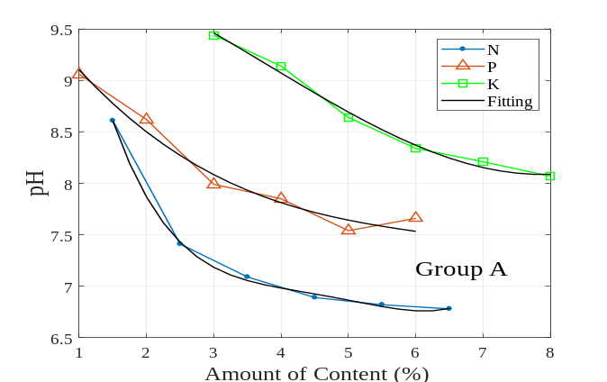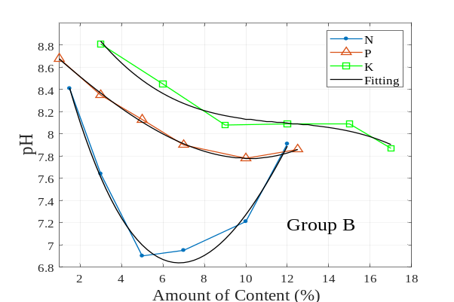
- (b)
Figure 9. pH of the (a) group A and (b) group B fertilizer solutions.

Table 7. Regression polynomial model of pH with respect to N, P, and K content.

Group | Element | pH | r²
A | N  (1.5 to 6.5 %) | 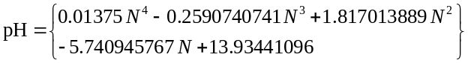 | 0.99874
A | P  (1.0 to 6.0 %) | 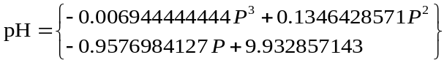 | 0.97526
A | K  (3.0 to 8.0 %) | 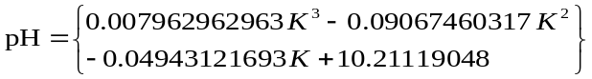 | 0.99173
B | N  (1.5 to 12.0 %) | 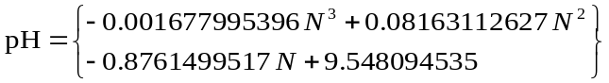 | 0.98462
B | P  (1.0 to 12.5 %) | 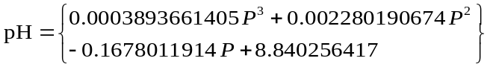 | 0.99833
B | K  (3.0 to 17.0 %) | 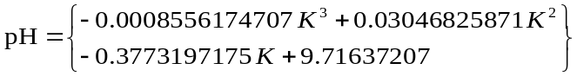 | 0.96416

6. CONCLUSION
Emerging NPK monitoring techniques are thoroughly reviewed, and their practical applications are demonstrated and explained. Recently, the application of artificial intelligence (AI) has significantly expanded into various fields, including precision agriculture (Arpit Rawankar et al., 2020; Md Reazul Islam et al., 2023; Oumnia Ennaji et al., 2023; Tanmay Thorat et al., 2023; Sneha Dattatreya et al., 2024; Hirushan Sajindra et al., 2024; Xu et al., 2024). This AI-enable NPK monitoring system reduces the complexity of agricultural sensing equipment, as well as the associated costs and manpower requirements.

Acknowledgements
This work is supported by Public Private Research Network (PPRN) Grant (R.J130000.7823.4L423) and Green Plant Organic Fertilizer Sdn. Bhd.

References
Ajay Kumar Patel, Jayanta Kumar Ghosh, Shivam Pande, Sammer Usmangani Sayyad, (2020). Deep-learning-based approach for estimation of fractional abundance of nitrogen in soil from hyperspectral data. IEEE Journal of Selected Topics in Applied Earth Observations and Remote Sensing, 13, 6495–6511.
Arpit Rawankar, Mayurkumar Nanda, Hemant Jadhav, Prem Lotekar, Rahul Pawar, Libin Sibichan, Akshay Pangare, (2018). Detection of N, P, K fertilizers in agricultural soil with NIR laser absorption technique. International Journal of Scientific & Engineering Research, 9 (3), 22–23.
Chong, M. Y., Wendy Ng, P. Q., Denny Ng, K. S., Lam, H. L., David Lim, L. K., Law, K. H., (2017). A mini review of palm based fertiliser production in Malaysia. Chemical Engineering Transactions, 61, 1585–1590.
Elena Baldi, Maurizio Quartieri, Enrico Muzzi, Massimo Noferini, Moreno Toselli, (2020). Use of in situ soil solution electric conductivity to evaluate mineral N in commercial orchards: preliminary results. Horticulturae, 2020 (6), 39.
Gerhardt. (2018). KJELDATHERM, TURBOTHERM and VAPODEST: The ideal Kjeldahl system for any laboratory. Germany: Gerhardt Analytical Systems, 1–11.
Gerhardt. (2020). VAPODEST 300: Advanced steam distillation. Germany: Gerhardt Analytical Systems, 1–2.
Gregory, A. P., Clarke, R. N., (2012). Tables of the Complex Permittivity of Dielectric Reference Liquids at Frequencies up to 5 GHz. NPL Report MAT 23.
Gurmit, S., Manoharan, S., Toh, T. S., (1989). United plantations approach to palm oil mill by-product management and utilization. In: PORIM International Palm Oil Development Conference, pp. 225–234.
He, Y., Song, H. Y., Pereira, A. G., Gόmez, A. H., (2005). Measurement and analysis of soil nitrogen and organic matter content using near-infrared spectroscopy techniques. Journal of Zhejiang University Science, 6B (11), 1081–1086.
Hirushan Sajindra, Thilina Abekoon, Jayakody, J. A. D. C. A., Upaka Rathnayake, (2024). A novel deep learning model to predict the soil nutrient levels (N, P, and K) in cabbage cultivation. Smart Agricultural Technology, 7, 100395.
Joseph V. Sinfield, Daniel Fagerman, Oliver Colic, (2010). Evaluation of sensing technologies for on-the-go detection of macro-nutrients in cultivated soils. Computers and Electronics in Agriculture, 70 (2010), 1–18.
Khasim, N., Ismail, S., & Raja Omar, R. Z. (2006). Integration of pineapple (Sarawak variety) with oil palm planted in double avenue planting system. MPOB Information Series, MPOB TT No. 311.
Khairunnisa binti Mohd Yusof, Suhaila binti Isaak, Nor Hafizah binti Ngajikin, Nurfatihah binti Che Abd Rashid, (2016). LED based soil spectroscopy. Buletin Optik, 2016 (3), 1–7.
Holden, M. and Tracey, M. V. (1948). The effect of fertilizers on the levels of nitrogen, phosphorus, protease, and pectase in healthy tobacco leaves. Biochemical Journal, 43(1): 147–151.
Kulkarni, M. Y., Warhade, K. K., & Bahekar, S. (2014). Primary nutrients determination in the soil using UV spectroscopy. International Journal of Emerging Engineering Research and Technology, 2(2), 198–204.
Lim, Z. Y., Mun, H. K., Kwan, B. H., You, K. Y. (2026). Real-time liquid fertilizer concentration measurement based on planar microwave sensor. Journal of Engineering Science and Technology, 21(1), 154–165.
Lombardo, S., Pandino, G., & Mauromicale, G. (2017). Mineral profile of two glove artichoke cultivars as affected by NPK fertilizer regimes. Food Research International, 100, 95 – 99.
Lee, S., Yoo, M., Shin, D., (2015). The identification and quantification of biogenic amines in Korean turbid rice wine, Makgeolli by HPLC with mass spectrometry detection. LWT-Food Science and Technology, 62, 350–356.
Lin, Z. D., Wang, R. J., Wang, Y. B., Wang, L. S., Lu, C. P., Liu, Y., Zhang, Z. Y., Zhu, L. K., (2018). Accurate and rapid detection of soil and fertilizer properties based on visible/near-infrared spectroscopy. Applied Optics, 57(18), D69–D73 (2018).
Liu, R. T., Tao, L. Q., Liu, B., Tian, X. G., Mohammad MA, Yang, Y., Ren, T. L., (2016). A miniaturized on-chip colorimeter for detecting NPK elements. Sensors, 16 (8), 1234.
Lombardo, S., Pandino, G., Mauromicale, G., (2017). Mineral profile of two glove artichoke cultivars as affected by NPK fertilizer regimes. Food Research International, 100, 95–99.
Marcos André Bechlin, Felipe Manfroi Fortunato, Ricardo Moutinho da Silva, Edilene Cristina Ferreira, José Anchieta Gomes Neto, (2014). A simple and fast method for assessment of the nitrogen–phosphorus–potassium rating of fertilizers using high-resolution continuum source atomic and molecular absorption spectrometry. Spectrochimica Acta Part B, 101 (2014), 240–244.
Maria Khaydukova, Dmitry Kirsanov, Subrata Sarkar, Subhankar Mukherjee, Julia Ashina, Nabarun Bhattacharyya, Somdeb Chanda, Rajib Bandyopadhyay, Andrey Legin, (2021). One shot evaluation of NPK in soils by “electronic tongue”. Computers and Electronics in Agriculture, 186 (2021), 106208.
Masayuki Yokota, Takuya Okada, Ichirou Yamaguchi, (2007). An optical sensor for analysis of soil nutrients by using LED light sources. Measurement Science and Technology, 18 (2007), 2197–2201.
Masrie, M., Rosli, A. Z. M., Sam, R., Janin, Z., Nordin, M. K., (2018). Integrated optical sensor for NPK nutrient of soil detection. In: Proceedings of the 5th IEEE International Conference on Smart Instrumentation, Measurement and Applications (ICSIMA), pp. 1–4.
Masrie, M., Rosman, M. S. A., Sam, R., Janin, Z., (2017). Detection of nitrogen, phosphorus, and potassium (NPK) nutrients of soil using optical transducer. In: Proceedings of the 4th IEEE International Conference on Smart Instrumentation, Measurement and Applications (ICSIMA), pp. 1–4.
Md Reazul Islam, Khondokar Oliullah, Md Mohsin Kabir, Munzirul Alom, Mridha, M. F., (2023). Machine learning enabled IoT system for soil nutrients monitoring and crop recommendation. Journal of Agriculture and Food Research, 14 (2023), 100880.
Md Shawon Mahmud, Khim Phin Chong, (2021). Formulation of biofertilizers from oil palm empty fruit bunches and plant growth-promoting microbes: A comprehensive and novel approach towards plant health. Journal of King Saud University-Science, 33 (2021), 101647.
Mihaljey, Ž. A., Jakšić, S. M., Prica, N. B., Ćupić, Ž. N., & Živkov-Baloš, M. M. (2015). Comparison of the kjeldahl method, dumas method and NIR method for total nitrogen determination in meat and meat products. Journal of Agroalimentary Processes and Technologies, 21(4), pp. 365–370.
Monteiro-Silva, F., Jorge, P. A. S., Martins, R. C., (2019). Optical sensing of nitrogen, phosphorus and potassium: a spectrophotometrical approach toward smart nutrient deployment. Chemosensors, 7, 51.
Munoz-Huerto, R. F., Guevara-Gonzalez, R. G., Contreras-Medina, L. M., Torres-Pacheco, I., Prado-Olivarez, J., & Ocampo-Velazquez, R. V. (2013). A review of methods for sensing the nitrogen status in plants: advantages, disadvantages and recent advances. Sensors, 13(8), 10823–10843.
Mustaqimah, Devianti, Agus Arip Munawar, Sufardi Sufardi, (2024). Capability of short Vis-NIR band tandem with machine learning to rapidly predict NPK content in tropical farmland: A case study of Aceh Province agricultural soil dry land, Indonesia. Case Studies in Chemical and Environmental Engineering, 9 (2024), 100711.
Nahrul Hayawin, Z., Abdul Khalil, H. P. S., Jawaid, M., Hakimi Ibrahim, M., Astimar, A. A., (2010). Exploring chemical analysis of vermicompost of various oil palm fibre wastes. Environmentalist, 30, 273–278.
Oumnia Ennaji, Leonardus Vergütz, Achraf El Allali, (2023). Machine learning in nutrient management: a review. Artificial Intelligence in Agriculture, 9 (2023), 1–11.
Phil Kim, (2017). MATLAB Deep Learning with Machine Learning, Neural Networks and Artificial Intelligence. Apress, New York.
Rafael F. Muñoz-Huerta, Ramon G. Guevara-Gonzalez, Luis M. Contreras-Medina, Irineo Torres-Pacheco, Juan Prado-Olivarez, Rosalia V. Ocampo-Velazquez, (2013). A review of methods for sensing the nitrogen status in plants: advantages, disadvantages and recent advances. Sensors, 13, 10823–10843.
Ramane, D. V., Patil, S. S., & Shaligram, A. D. (2015). Detection of NPK nutrients of soil using fiber optic sensor. International Journal of Research in Advent Technology, 66–70.
Potdar R. Potdar, Mandar M. Shirolkar, Alok J. Verma, Pravin S. More, Atul Kulkarni, (2021). Determination of soil nutrients (NPK) using optical methods: a mini review. Journal of Plant Nutrition, 44 (12), 1826–1839.
Rigor G. Regalado, Jennifier C. Dela Cruz, (2016). Soil pH and nutrient (nitrogen, phosphorus and potassium) analyser using colorimetry. In: 2016 IEEE Region 10 Conference (TENCON), 22–25.
Sáez-Plaza, P., Navas, M. J., Wybraniec, S., Michalowski, T., Asuero, A. G., (2013). An overview of the kjeldahl method of nitrogen determination. Part II. Sample preparation, working scale, instrumental finish, and quality control. Critical Reviews in Analytical Chemistry, 43 (4), 224 –272.
Sánchez-Monedero, M. A., Roig, A., Paredes, C., Bernal, M. P., (2001). Nitrogen transformation during organic waste composting by the Rutgers system and its effects on pH, EC and maturity of the composting mixtures. Bioresource Technology, 78 (3), 301–308.
Sørensen, M. K., Jensen, O., Bakharev, O. N., Nyord, T., Nielsen, N. C., (2015). NPK NMR sensor: online monitoring of nitrogen, phosphorus, and potassium in animal slurry. Analytical Chemistry, 87 (13), 6446–6450.
Silva, F. M., Queirósc, C., Pinhoa, T., Boaventura, J., Santosa, F., Barroso, T. G., Pereira, M. R., Cunha, M., Martins, R. C., (2023). Reagent-less spectroscopy towards NPK sensing for hydroponics nutrient solutions. Sensors and Actuators: B. Chemical, 395 (2023), 134442.
Silva, F. M., Jorge, P. A. S., & Martins, R. C. (2019). Optical sensing of nitrogen, phosphorus and potassium. Chemosensors, 7(51), 1 – 16.
Sneha Dattatreya, Abdul Naim Khan, Kanjalochan Jena, Gaurav Chatterjee, (2024). Conventional to modern methods of soil NPK sensing: a review. IEEE Sensors Journal, 24 (3), 2367–2380.
Stogryn, A. P., Bull, H. T., Rubayi, K., Iravanchy, S., (1995). The Microwave Permittivity of Sea and Fresh Water, Gen. Corp. Aerojet, Azusa, Ca.
Su, G. C., Mohd Zulkifli, N. W., Ong, H. C., Shaliza Ibrahim, Bu, Q., Zhu, R. N., (2022). Pyrolysis of oil palm wastes for bioenergy in Malaysia: a review. Renewable and Sustainable Energy Reviews, 164 (2022), 112554.
Sunset, 2004. A crash course in fertilizers. Sunset Publishing Corporation. https://www.sunset.com/garden/garden-basics/crash-course-fertilizers.
Tao H. H, Snaddon, J. L., Slade, E. M., Caliman, J. P., Widodo, R. H., Suhardi and Willis, K. J., (2017). Long-term crop residue application maintains oil palm yield and temporal stability of production. Agronomy for Sustainable Development, 37(33): 1–8.
Tanmay Thorat, Patle, B. K., Sunil Kumar Kashyap, (2023). Intelligent insecticide and fertilizer recommendation system based on TPF-CNN for smart farming. Smart Agricultural Technology, 3 (2023), 100114.
Thirumala Akash, K., Upendra, R. S., Mohammed Riyaz Ahmed, R., Deepika Nayak, Sagam Bhaskar, Yuktha Dabke, (2022). Fertilizer quality assessment methods for sustainable agriculture. In: Third International Conference on Smart Technologies in Computing, Electrical and Electronics (ICSTCEE), pp. 1–4.
Xu, S. X., Zhao, Y. C., Wang, Y. Y., (2024). Optimizing machine learning models for predicting soil pH and total P in intact soil profiles with visible and near-infrared reflectance (VNIR) spectroscopy. Computer and Electronics in Agriculture, 218 (2024), 108643.
Yang, W. M., Rhonda, L. B., Thomas, P. M., (2002). Determination of phosphorus in fertilizers by inductively coupled plasma atomic emission spectrometry. Journal of AOAC International, 85 (6), 1241–1246.
You, K. Y., (2016). RF Coaxial Slot Radiators: Modeling Measurements and Applications. Artech House, London.
You, K. Y., Lee, C. Y., Then, Y. L., Chen Chong, S. H., You, L. L., Abbas, Z., Cheng, E. M., (2013). Precise moisture monitoring for various soil types using handheld microwave-sensor meter. IEEE Sensors Journal, 13 (7), 2563–2570.
You, K. Y., Sim, M. S., Abdullah, S. N., (2021). Emerging Microwave Technologies for Agricultural and Food Processing. In: Precision Agriculture Technologies for Food Security and Sustainability, pp. 91–148.
Zhai, J., Luo, B., Li, A., Dong, H., Jin, X., Wang, X., (2022). Unlocking all-solid ion selective electrodes: prospects in crop detection. Sensors, 22, 554.

