ANTIFUNGAL ACTIVITY OF SELECTED PLANT EXTRACTS AGAINST Colletotrichum gloeosporioides CAUSING BANANA ANTHRACNOSE

A. R. F. Lufna, Department of Agricultural Biology, Faculty of Agriculture, Eastern University, Sri Lanka
lufnaaaauytt@gmail.com
K. Prasannath, Department of Agricultural Biology, Faculty of Agriculture, Eastern University, Sri Lanka
prasannathk@esn.ac.lk
V. Prasannath, Department of Biosystems Technology, Faculty of Technology, Eastern University, Sri Lanka]
vanithap@esn.ac.lk

ABSTRACT
At present, there is a widespread requirement for environmentally friendly agriculture to produce quality, healthy food and to increase nutritional value. Efforts are underway to develop a sustainable crop production system using organic fungicides and botanicals from natural resources to reduce the use of synthetic fungicides for postharvest disease control. The present study evaluated the efficacy of various plant extracts in inhibiting Colletotrichum gloeosporioides, a fungus that causes banana anthracnose. The selected plant extracts, such as Piper longum, Acorus calamus, garlic and lemon, were investigated in this experiment along with a control. The banana variety Kathali was used in this study. The experiments were laid out in Completely Randomized Design. Mycelial inhibition percentage was recorded 8 days after inoculation. The findings showed that A. calamus exhibited the highest mycelial inhibition percentage (100%) among the plant extracts tested. Further, the least concentration of methanolic A. calamus extract for a complete inhibition of C. gloeosporioides was 2%. Meanwhile, the lowest concentration of aqueous A. calamus extract for a complete inhibition of C. gloeosporioides was 10%. Therefore, A. calamus could be used as an alternative to synthetic fungicides to combat C. gloeosporioides infection on banana. Hence, this treatment could be an ecologically acceptable non-fungicidal approach for managing postharvest anthracnose disease of banana.
KEYWORDS: Piper longum extract, Acorus calamus extract, Garlic extract, Lemon extract, Postharvest disease

INTRODUCTION
One of the most important fruit crops that is grown extensively in Sri Lanka is the banana. It contributes almost 16% of the world's fruit supply, making it the second-largest stable food producer after major cereals (Acevedo et al., 2021). The minerals in bananas are extremely abundant, particularly potassium (Kanazawa and Sakakibara, 2000). Banana production currently occupies over 60,000 ha of land in Sri Lanka (Perera, 2017). Typically, bananas are harvested before they ripen and kept at relatively low temperatures throughout transportation and market processes. They may be more susceptible to diseases due to long-distance transport and market storage times. The genus Colletotrichum includes fungal species that are responsible for anthracnose diseases in a variety of vegetable and fruit crops, including banana (Cannon et al., 2012). The primary causative agent of banana anthracnose is Colletotrichum musae. Because of anthracnose and crown rot disease, Sri Lanka's annual banana production is reduced by 20%, or about 80,964 metric tons (Anthony et al., 2004). Despite the fact that Sri Lanka has 29 cultivars of banana (Chamara et al., 2000), the majority of commercial banana varieties are susceptible to postharvest losses due to anthracnose (Adikaram, 1986; Perera et al., 1999). Whereas "Seeni kathali" or "Seeni kesel" is anthracnose resistant, "Ambon" (De Costa et al., 1997), "Puli kathali" or "Ambul kesel” (Abayasekara et al., 2013) are extremely susceptible. However, C. gloeosporioides, C. acutatum, and C. siamense have also been linked to banana anthracnose. Several strategies have been used to reduce the incidence of anthracnose in banana fruits and plants. Among them are agricultural techniques like crop rotation, burning infected fruits to lower inoculum levels, applying suitable fungicides, keeping fields clean, and using resistant varieties (Oliveira et al., 2016). Fruit postharvest diseases are typically treated with chemical fungicides, such as sorbic acid, benlate (benomyl), thiabendazole, chlorothalonil, triazoles, strobilurin, and imidazoles, applied by dipping or spraying techniques (Jinasena et al., 2011). The United States Environmental Protection Agency has classified benomyl as a potential human carcinogen that can also function as a chronic and reproductive toxin, according to the benomyl fact sheet (Rouabhi, 2010). Though postharvest fruit diseases are controlled commercially with fungicides like imidazole and carbendazim, there is a growing global trend to minimize these diseases as much as possible. This is mostly because of their negative effects and the development of resistant mutants during long-term, indiscriminate use among the pathogens against these compounds (Perera and Karunaratne, 2000). Several fungicides leave a significant amount of non-selective residue that lowers the quality of the fruit (Lopez-Fernandez et al., 2012). Additionally, fungicides have the potential to destroy a variety of beneficial organisms, and their poisonous forms may remain in the soil (Hayes and Laws, 1991). Consequently, consumer demand is increasing for fruit that has been treated non-chemically for postharvest pathogens (De Costa and Erabadupitiya, 2005). As a result, there is strong resistance from consumers who are concerned about these residues and their possible harmful effects on humans.
Managing postharvest disease in bananas has become fairly challenging, and there is a greater need to develop an innovative strategy to reduce the prevalence of diseases using safe agents that don't endanger human health, safety, or the environment. Natural plant extracts are becoming more and more popular among scientists worldwide due to their biodegradability, ease of handling, affordability, accessibility, safety for human health, and environmental friendliness. Some plant extracts, such as Piper longum (long pepper), Acorus calamus (sweet flag), garlic, and lemon, have high antifungal properties. Thus, the main aim of this study was to determine the efficacy of different plant extracts, such as P. longum, A. calamus, garlic, and lemon, in controlling the anthracnose disease of banana under in vitro conditions.

MATERIALS AND METHODS
Experimental site
The experiment was carried out in the laboratory of the Department of Agricultural Biology, Faculty of Agriculture, Palachcholai, Eastern University, Sri Lanka, from August to November 2023 to assess the effectiveness of some locally available plant extracts against C. gloeosporioides, which causes banana anthracnose. These extracts were made from P. longum rhizome, A. calamus rhizome, lemon peels, and garlic cloves.
Collection of banana samples
Anthracnose-infected banana samples (variety Kathali) were collected from different shops.
Microscopic observation of C. gloeosporioides
A thin layer of anthracnose-infected lesion was prepared on the slide before being examined under a microscope. A few drops of lactophenol cotton blue stain were then added to the thin layer of anthracnose lesion. The slide was then examined under a microscope. A high-power microscope was utilized for clear observation. According to the observed conidial morphology, C. gloeosporioides was identified.
Isolation of fungal pathogen
Anthracnose lesions of banana peel were selected and cut into small pieces. Five pieces were taken. Pieces were surface sterilized by using 70% ethanol for one minute. Then, they were rinsed with sterile distilled water to remove excess ethanol. Then, they were air-dried. Dried samples were placed on the surface of the potato dextrose agar (PDA) plates using sterile forceps. Plates were kept at ambient temperature (28–30 ℃).
Pure culturing of C. gloeosporioides
Subculturing was carried out to get pure cultures of C. gloeosporioides. For that purpose, a scalpel was dipped in 70% ethanol and heated. After air drying the scalpel, a piece of fungal culture from the edge of the fastest-growing mycelia of the mother culture was taken. It was inoculated into new PDA plates. PDA plates were incubated at room temperature (28–30 ℃).
Experiment 1 - Determination of best plant extract
Treatment structure
T1 – Piper longum extract
T2 – Acorus calamus extract
T3 – Garlic extract
T4 – Lemon extract
T5 – Control
Experimental design
The experiment was carried out in Completely Randomized Design (CRD) with five treatments and four replicates (a total of 20 PDA plates were used) under in vitro conditions.
Preparation of methanolic plant extracts
To prepare the plant extracts, the necessary amount of healthy parts of each plant (long pepper, sweet flag, garlic, and lemon) was taken. Plant pieces were dried in the sun until they reached a constant weight. To make dry powders, the dried parts were chopped and ground using a grinder. Then the dry powders were sieved. Then, 30 g of dry powder of each plant material was taken. Dry powders of plant materials were extracted with 350 ml of methanol (100%) using Soxhlet apparatus for eight hours. Then, the methanolic plant extracts were subjected to rotary evaporation in rotary evaporator. After that, the extracts were shade-dried until completely dry and kept in airtight bottles at room temperature.
Culturing of C. gloeosporioides on PDA medium amended with different plant extracts
One millilitre of plant extract concentrate was volumerized up to 100 ml with distilled water. Plant extracts were mixed at 10% concentration with PDA media. Around 20 ml of PDA mixture was poured into each Petri dish. Then it was allowed to solidify. After that, C. gloeosporioides disc was placed on the PDA medium.
Experiment 2 – Determining the least concentration of methanolic extract of A. calamus
Treatment structure
T1 – 10% Acorus calamus methanolic extract
T2 – 8% Acorus calamus methanolic extract
T3 – 6% Acorus calamus methanolic extract
T4 – 4% Acorus calamus methanolic extract
T5 – 2% Acorus calamus methanolic extract
T6 – 1% Acorus calamus methanolic extract
T7 – 0.5% Acorus calamus methanolic extract
T8 – Control
Experimental design
The experiment was carried out in CRD with eight treatments and three replicates (a total of 24 PDA plates were used) under in vitro conditions.
Culturing of C. gloeosporioides on PDA medium amended with different concentrations of A. calamus methanolic extract
One millilitre of A. calamus methanolic extract concentrate was volumerized up to 100 ml with distilled water. The plant extract was mixed with PDA media at concentrations of 10%, 8%, 6%, 4%, 2%, 1%, and 0.5%. After 20 ml of PDA mixture was poured into each Petri dish, it was allowed to solidify. After that, C. gloeosporioides disc was placed on the PDA medium.
Experiment 3 – Determining the least concentration of aqueous extract of A. calamus
Treatment structure
T1 – 10% Acorus calamus aqueous extract
T2 – 8% Acorus calamus aqueous extract
T3 – 6% Acorus calamus aqueous extract
T4 – 4% Acorus calamus aqueous extract
T5 – 2% Acorus calamus aqueous extract
T6 – 1% Acorus calamus aqueous extract
T7 – 0.5% Acorus calamus aqueous extract
T8 – Control
Experimental design
The experiment was carried out in CRD with eight treatments and three replicates (a total of 24 PDA plates were used) under in vitro conditions.
Culturing of C. gloeosporioides on PDA medium amended with different concentrations of A. calamus aqueous extract
One millilitre of A. calamus aqueous extract concentrate was volumerized up to 100 ml with distilled water. The plant extract was mixed with PDA media at concentrations of 10%, 8%, 6%, 4%, 2%, 1%, and 0.5%. After 20 ml of PDA mixture was poured into each Petri dish, it was allowed to solidify. After that, C. gloeosporioides disc was placed on the PDA medium.
Data collection and analysis
In the above three experiments, when the growth of the control treatment reached the periphery, the horizontal and vertical diameters of C. gloeosporioides in all treatments were measured. Mycelial inhibition percentage was calculated using the following formula (Singh and Tripathi, 1999).
Percentage inhibition of mycelial growth= $\frac{\text{dc-dt}}{\text{dc}}\text{ × 100}$
Where,
dc – average diameter of fungal colony in control
dt – average diameter of fungal colony in treatment
Data on mycelial inhibition percentage were subjected to arcsine square root transformation in order to stabilize variance. Using Minitab 19 statistical software, analysis of variance (ANOVA) was used to determine the significance of treatment effects on the measured variables. The Tukey’s test was used at 5% significant level to compare the treatment means with the control group.

RESULTS AND DISCUSSION
Effects of different methanolic plant extracts on mycelial inhibition of C. gloeosporioides
The effects of different methanolic plant extracts, P. longum extract, A. calamus extract, garlic extract and lemon extract, on mycelial inhibition of C. gloeosporioides at 8th day after inoculation were summarized in Table 1. As per the results, there was a significant (P<0.05) difference in mycelial inhibition percentage among the plant extracts. A. calamus showed the highest mycelial inhibition percentage (100%) among the treatments, and P. longum showed the lowest mycelial inhibition percentage. Further, the garlic extract showed a higher mycelial inhibition percentage (42.35%) next to A. calamus extract. Figure 1 shows the mycelial growth of C. gloeosporioides cultured on the media amended with various methanolic plant extracts.
Table 1: Effect of treatments on the mycelial inhibition percentage
Treatments | Mycelial inhibition (%) at day 8
T1 | 16.21 ± 5.55^{d}
T2 | 100.00 ± 0.0ª
T3 | 45.25 ± 8.65^{b}
T4 | 32.46 ± 5.14^{c}
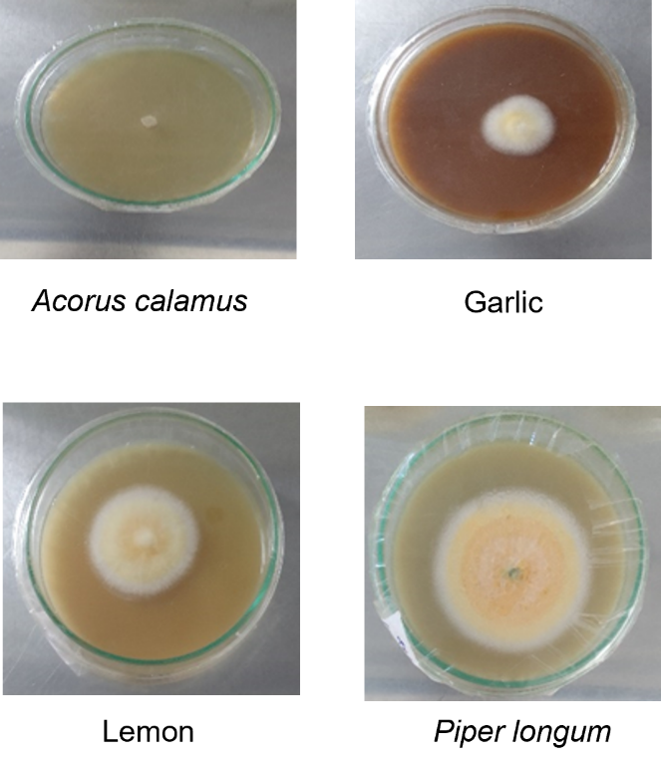
Figure 1. Colony growth of C. gloeosporioides on the culture media incorporated with methanolic extracts of various plants.
Effects of different concentrations of A. calamus methanolic extract on mycelial inhibition of C. gloeosporioides
The effects of different concentrations, 10%, 8%, 6%, 4% and 2%, 1% and 0.5% of A. calamus methanolic extract on mycelial inhibition of C. gloeosporioides at 8th day after inoculation were summarized in Table 2. Results showed that there was a significant (P<0.05) difference in mycelial inhibition percentage among the concentrations. Further, there were no significant (P˃0.05) differences between 10%, 8%, 6%, 4% and 2% of A. calamus extract. Among the treatments, 10%, 8%, 6%, 4% and 2% extracts showed the highest mycelial inhibition percentage (100%), whereas 0.5% extract showed the lowest mycelial inhibition percentage.
According to the results, the least concentration of the methanolic extract of A. calamus required for a complete inhibition of C. gloeosporioides was 2%. Figure 2 shows mycelial growth of C. gloeosporioides cultured on the media incorporated with various concentrations of the methanolic extract of A. calamus.
Table 2: Effects of different concentrations of A. calamus methanolic extract on mycelial inhibition percentage of C. gloeosporioides
Treatments | Mycelial inhibition (%) at day 8
10% | 100 ± 0.0ª
8% | 100 ± 0.0ª
6% | 100 ± 0.0ª
4% | 100 ± 0.0ª
2% | 100 ± 0.0ª
1% | 46.62 ± 7.44^{b}
0.5% | 39.44 ± 6.00^{b}
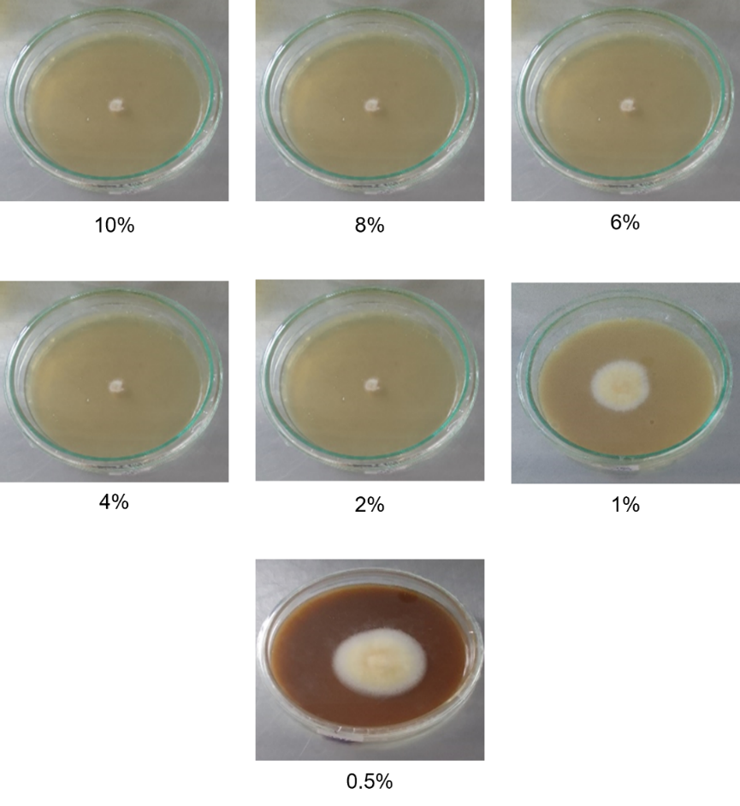

Figure 2. Colony growth of C. gloeosporioides on the culture media incorporated with various concentrations of methanolic extract of A. calamus.
Effects of different concentrations of A. calamus aqueous extract on mycelial inhibition percentage of C. gloeosporioides
The effects of different concentrations, 10%, 8%, 6%, 4% and 2%, 1% and 0.5% of A. calamus aqueous extract on mycelial inhibition percentage of C. gloeosporioides at 8th day after inoculation were summarized in Table 3. As per the results, there was a significant (P<0.05) difference in mycelial inhibition percentage among the concentrations. Among the treatments, 10% extract showed the highest mycelial inhibition percentage (100%), whereas 0.5% extract showed the lowest mycelial inhibition percentage. Figure 3 shows mycelial growth of C. gloeosporioides cultured on the media incorporated with various concentrations of the aqueous extract of A. calamus.
Table 3: Effects of different concentrations of A. calamus aqueous extract on mycelial inhibition percentage of C. gloeosporioides
Treatments | Mycelial inhibition (%) at day 8
10% | 100 ± 0.0ª
8% | 76.71 ± 2.94^{b}
6% | 70.31 ± 2.80^{bc}
4% | 64.02 ± 1.07^{cd}
2% | 59.63 ± 1.35^{cd}
1% | 53.14 ± 3.00^{d}
0.5% | 38.54 ± 10.78e
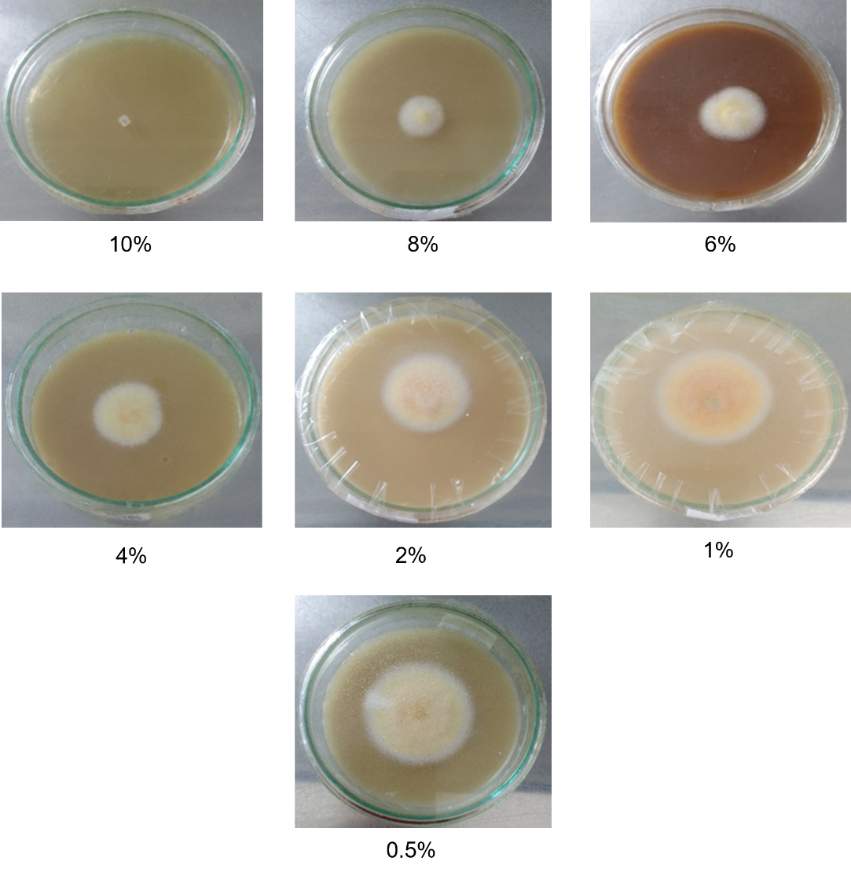
Figure 3. Colony growth of C. gloeosporioides on the culture media incorporated with various concentrations of aqueous extract of A. calamus.
According to the results of the above three experiments, A. calamus exhibited a higher mycelial inhibition percentage than the other plant extracts. Several pharmacological aspects of A. calamus include antibacterial, insecticidal, and antiulcerative (Pandit et al., 2011). It is a very potent adaptogenic drug. The main bioactive substances present in A. calamus are β-aserone, flavonoid, monoterpene, quinone, sesquiterpene and phenylpropanoid (Patra and Mitra, 1981). Heme peroxidase is synthesized by the rhizomes of A. calamus. Owing to the presence of this enzyme, A. calamus extract has antifungal properties (Ghosh, 2006). Therefore, A. calamus shows a higher mycelial inhibition percentage.
Natural products from Thai medicinal plants are well known as promising sources for developing alternatives to conventional fungicides, since some of their metabolites have been shown to possess antimicrobial activity against plant and human pathogens (Divya et al., 2011). Farmers usually apply fungicides to control these pathogens; however, repeated applications of fungicides have resulted in the development of pathogen resistance (Thind, 2012). Hence, there is an urgent need to find an effective, safe and eco-friendly strategy to replace synthetic fungicides.
Metabolites of A. calamus have been reported to display various biological activities (Kumar et al., 2015). Due to its various biological activities, investigations of metabolites from its leaves and rhizomes were conducted and reported (Dong et al., 2011). Crude A. calamus extracts have been reported to display broad antimicrobial activity toward a variety of plant and human pathogens (Bhuvaneswari and Balasundaram, 2006). These extracts are highly biodegradable, have varied modes of action, are less toxic to humans, are non-pollutant, and are readily available in the environment. A. calamus is reported to have antifungal activity against filamentous fungi Microsporum gypseum, Trichophyton rubrum and Penicillium marneffei (Phongpaichit et al., 2005).
Further, according to the results, garlic extract can also be considered an alternative for banana anthracnose management. Allicin, diallyl disulfide (DADS), and diallyl trisulfide are among the main organosulfur compounds found in garlic extracts. Many studies have found that garlic biochemicals have antimicrobial properties (Yousuf et al., 2010).
According to the results, methanolic extracts are more efficient than water extracts. Methanol is a good solvent for extraction, and it is frequently used in biology because of its polarity. It is capable of extracting both lipophilic and hydrophilic molecules. The other advantage is that it can be removed easily at room temperature because it is highly volatile (Qu et al., 2019). Therefore, a minimum concentration of 2% methanolic extract was required to achieve complete inhibition of C. gloeosporioides. Water extraction is less efficient than methanol extraction. Water is considered the greenest solvent. Nonetheless, the water solubility of natural products is still an incredibly challenging issue. Indeed, it is nearly impossible to solubilize or to extract many natural products properly using solely water due to their low solubility in this solvent (Lajoie et al., 2022). Therefore, a minimum concentration of 10% aqueous extract was required for the complete inhibition of C. gloeosporioides.
CONCLUSIONS
Anthracnose is a major postharvest disease causing significant reduction in the quality and quantity of banana production globally, including Sri Lanka. Chemical fungicides are currently used extensively to control fungal diseases. It has been noted that the widespread use of chemical fungicides has an adverse effect on human health. There has always been an attempt to replace inorganic fungicides with organic fungicides from natural sources to reduce the postharvest diseases of commercially important crops. Plant extracts are abundant in Sri Lanka and considered a renewable resource.
The experiment was conducted to determine the efficacy of plant extracts against postharvest diseases in the banana variety Kathali. The overall results revealed that the A. calamus methanolic extract was significantly effective for inhibiting the banana anthracnose fungus, C. gloeosporioides. Further, 2% was the lowest concentration of A. calamus methanolic extract for a complete inhibition of C. gloeosporioides. As well as, 10% was the lowest concentration of A. calamus aqueous extract for completely inhibiting the growth of C. gloeosporioides.

ACKNOWLEDGEMENT
The authors wish to acknowledge the AGRHI Project of the ERASMUS+ programme for funding the publication fee of this article.

REFERENCES
Abayasekara, C. L., Adikaram, N. K. B., Wanigasekara, U. W. N. P. and Bandara, B. M. R. (2013). Phyllosticta musarum infection-induced defences suppress anthracnose disease caused by Colletotrichum musae in banana fruits cv ‘Embul’. The Plant Pathology Journal. 29(1):77.
Acevedo, S. A., Carrillo, Á. J. D., Flórez-López, E. and Grande-Tovar, C. D. (2021). Recovery of Banana Waste-Loss from Production and Processing: A Contribution to a Circular Economy. Molecules. 26(17):5282.
Adikaram, N. K. B. (1986). A survey of postharvest losses in some fruits and vegetables and the fungi associated with them. Ceylon Journal of Science (Biological Science), 19:1-10.
Anthony, S., Abeywickrama, K., Dayananda, R., Wijeratnam, S. and Arambewela, L. (2004). Fungal pathogens associated with banana fruit in Sri Lanka, and their treatment with essential oils. Mycopathologia. 157:91-97.
Bhuvaneswari, R. and Balasundaram, C. (2006). Traditional Indian herbal extracts used in vitro against growth of the pathogenic bacteria Aeromonas hydrophila. Islrle J. Aquac. 58:89-96.
Cannon, P. F., Damm, U., Johnston, P. R. and Weir, B. S. (2012). Colletotrichum: current status and future directions. Studies in Mycology. 73(1):181-213.
Chamara, D., Illeperuma, K., Galappatty, P. T. and Sarananda, K. H. (2000). Modified atmosphere packaging of Kolikuttu banana at low temperature. Journal of Horticultural Science and Biotechnology. 75(1):92-96.
De Costa, D. M. and Erabadupitiya, H. R. U. T. (2005). An integrated method to control postharvest diseases of banana using a member of the Burkholderia cepacia complex. Postharvest Biology and Technology. 36:31-39.
De Costa, D. M., Amaradasa, B. S. and Wegiriya, R. N. B. P. M. R. C. L. (1997). Antagonists of Colletotrichum musae associated with banana fruit skin. Journal of the National Science Foundation of Sri Lanka. 25(2):95-104.
Divya, G., Gajalakshmi, S., Mythili, S. and Sathiavelu, A. (2011). Pharmacological Activities of Acorus calamus: A review. Asian J Biochem Pharm Res. 1(4):57-64.
Dong, C., Zhu, W., Gao, M., Zhao, L. F., Huang, J. Y. and Zhao, Y. Q. (2011). Diurnal fluctuations in oxygen release from roots of Acorus calamus Linn in a modeled constructed wetland. Journal of Environmental Science and Health, Part A. 46(3):224-229.
Ghosh, M. (2006). Antifungal properties of haem peroxidase from Acorus calamus. Annals of Botany. 98(6):1145-1153.
Hayes, W. J. and Laws, E. R. (1991). Handbook of pesticide toxicology. In: L. Magos, ed. Volume 1: General Principles. San Diego: Academic Press. 1576 pp.
Jinasena, D., Pathirathna, P., Wickramarachchi, S. and Marasinghe, E. (2011). Use of chitosan to control anthracnose on “Embul” banana. In: International Conference on Asia Agriculture and Animal. Vol. 13, pp. 56-60.
Kanazawa, K. and Sakakibara, H. (2000). High content of dopamine, a strong antioxidant, in cavendish banana. Journal of Agricultural and Food Chemistry. 48(3):844-848.
Kumar, A., Sharma, S. and Verma, G. (2015). Insecticidal and genotoxic potential of Acorus calamus rhizome extract against Drosophila melanogaster. Asian Journal of Pharmaceutical and Clinical Research. 8(4):113-116.
Lajoie, L., Fabiano-Tixier, A. S. and Chemat, F. (2022). Water as Green Solvent: Methods of Solubilisation and Extraction of Natural Products-Past, Present and Future Solutions. Pharmaceuticals. 15(12):1507.
López-Fernández, O., Rial-Otero, R., González-Barreiro, C. and Simal-Gándara, J. (2012). Surveillance of fungicidal dithiocarbamate residues in fruits and vegetables. Food Chemistry. 134(1):366-374.
Oliveira, T. Í. S., Rosa, M. F., Cavalcante, F. L., Pereira, P. H. F., Moates, G. K., Wellner, N., Mazzetto, S. E., Waldron, K. W. and Azeredo, H. M. (2016). Optimization of pectin extraction from banana peels with citric acid by using response surface methodology. Food Chemistry. 198:113-118.
Pandit, S., Mukherjee, P. K., Ponnusankar, S., Venkatesh, M. and Srikanth, N. (2011). Metabolism mediated interaction of α-asarone and Acorus calamus with CYP3A4 and CYP2D6. Fitoterapia. 82(3):369-374.
Patra, A. and Mitra, A. K. (1981). Constituents of Acorus calamus: structure of acoramone. Carbon-13 NMR spectra of cis-and trans-asarone. Journal of Natural Products. 44(6):668-669.
Perera, O. D. A. and Karunaratne, A. M. (2000). Response of bananas to postharvest acid treatments. Journal of Horticultural Science and Biotechnology. 76(1):70-76.
Perera, T. (2017). Sri Lankan fresh fruit and vegetable sector, Sri Lanka. Sri Lanka Export Development Board (EDB).
Phongpaichit, S., Pujenjob, N., Rukachaisirikul, V. and Ongsakul, M. (2005). Antimicrobial activities of the crude methanol extract of Acorus calamus Linn. Songklanrimpangin J. Sci. Technol. 27(Suppl. 2):517-523.
Qu, H., He, S. and Su, H. (2019). Efficient preparation of kaolinite/methanol intercalation composite by using a Soxhlet extractor. Scientific Reports. 9(1). 8351.
Rouabhi, R. (2010). Introduction and toxicology of fungicides. In: O. Carisse, ed. Fungicides. London: IntechOpen. pp. 363-382.
Singh, J. and Tripathi, N.N. (1999). Inhibition of storage fungi of black gram (Vigna mungo) by some essential oils. Flavour Fragrance J. 14:1-4.
Thind, T. S. (2012). Fungicide resistance in crop protection: Risk and management. CABI. 284 pp.
Yousuf, S., Ahmad, A., Khan, A., Manzoor, N. and Khan, L. A. (2010). Effect of diallyldisulphide on an antioxidant enzyme system in Candida species. Canadian Journal of Microbiology. 56(10):816–821.

