Advancing Smart Agriculture: Integrating IoT Systems in the AgrhiOne Platform
Bryan Chen Yi Fei, Ts. Suresh Gobee, Dr. Adeline Sneha John Chrisastum, Ts. Dr. Maythem Kamal Abbas Al-Adilee

Bryan Chen Yi Fei, APcore (Asia Pacific Centre of Robotics Engineering) Asia Pacific University of Technology & Innovation Kuala Lumpur, Malaysia
bryanchen0091@gmail.com

Suresh Gobee, APcore (Asia Pacific Centre of Robotics Engineering) Asia Pacific University of Technology & Innovation Kuala Lumpur, Malaysia
suresh.gobee@apu.edu.my

Adeline Sneha John Chrisastum, Asia Pacific University of Technology & Innovation Kuala Lumpur, Malaysia
adeline.john@apu.edu.my

Maythem K. Abbas, Asia Pacific University of Technology & Innovation Kuala Lumpur, Malaysia
maythem.abbas@utp.edu.my

ABSTRACT
Modern agriculture stands at a critical juncture, facing the dual imperatives of exponentially increasing global food production and mitigating the severe environmental impacts of climate change. Traditional farming methodologies, characterized by resource-intensive practices, manual monitoring, and reactive decision-making, are increasingly insufficient to meet these escalating demands. In response to these systemic vulnerabilities, precision agriculture has evolved through the integration of the Internet of Things (IoT) and Artificial Intelligence (AI), heralding the advent of Agriculture 4.0. This comprehensive analysis explores the architecture, implementation, and operational efficacy of the AgrhiOne platform, a holistic digital farming ecosystem developed to consolidate disparate agricultural technologies into a singular, unified command center. By leveraging multi-tiered cloud-edge computing topologies, AgrhiOne processes high-fidelity telemetry from WiFi-enabled microcontrollers and long-range LoRaWAN networks, ensuring robust data acquisition across diverse hydroponic and soil-based environments. The synthesis of these cutting-edge technologies within the AgrhiOne ecosystem not only revitalizes agricultural education and research but also establishes a highly scalable, economically viable blueprint for sustainable, high-yield food production.

KEYWORDS:
AgrhiOne, Precision Agriculture, Internet of Things, LoRaWAN, Artificial Intelligence, Cloud-Edge Computing.

Introduction
Agriculture is in the midst of a major digital transformation and this is commonly referred to as Agriculture 4.0. Combining Internet of Things (IoT) tools and Artificial Intelligence (AI), the modern facilities will be able to track the development of the plant and optimize the total food production altogether. [1] Smart farming methods can be used to collect data throughout various crop harvests with a lot of valuable metrics to aid in the daily operations decision-making and analysis of the growth, as well as in early disease detection.
Concurrently, traditional land-based farming confronts severe limitations, including the rapid depletion of arable land, unpredictable climatic variations, widespread water scarcity, and a shrinking agricultural labour force exacerbated by urbanization and generational disinterest in farming professions. [2] These compounding pressures threaten the stability of the global food supply chain and highlight the inherent inefficiencies of conventional farming practices, which frequently rely on manual environmental monitoring, intuition-based resource allocation, and highly reactive disease management strategies.
To circumvent these systemic vulnerabilities, the agricultural industry must undergo a profound paradigm shift toward sustainable intensification, a strategy aimed at maximizing crop yields while systematically minimizing environmental degradation and resource consumption. [3]
Due to this functional gap, farmers continue to use manual inspections immensely. To make sure that crops grow well, workers have to inspect them by hand in various growing racks and estimate possible yields and earnings. This is a very labour-intensive process that is subject to human error and which does not offer real-time and precise counts of plants. [4] Precision agriculture, fundamentally underpinned by the fourth industrial revolution (Industry 4.0), offers a viable and necessary approach. By seamlessly integrating cyber-physical systems, digital sensor networks, and advanced data analytics, precision agriculture transforms farming from a stochastic, weather-dependent endeavour into a highly deterministic, data-driven science.

Architectural Foundations: The Cloud-Edge Collaborative Framework
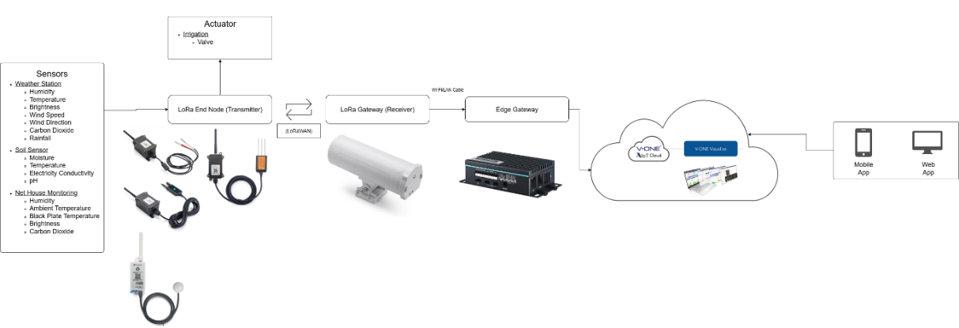
Figure 1 LoRaWAN IoT to AgrhiOne flowchart
The Portable Hydroponics and Soil Monitoring Device is a versatile, IoT-based system designed to track essential plant growth conditions in real-time across both vertical hydroponic towers and soil-based autopots. It utilizes specialized sensors to measure water quality (pH, electrical conductivity, and temperature) and a 3-in-1 soil probe to monitor soil health (moisture, temperature, and conductivity). Powered by an ESP32 LoRa microcontroller, the device wirelessly transmits this data through a LoRa Gateway to the cloud, where AgrhiOne software visualizes the metrics on user-friendly mobile and web dashboards. Its key advantage is its high portability, allowing farmers to easily move a single unit between multiple towers or pots, which provides a cost-effective and flexible solution for maintaining optimal crop environments.
The operational efficacy, scalability, and reliability of any smart agriculture platform are fundamentally contingent upon the robustness of its underlying system architecture. The AgrhiOne system employs a sophisticated, multi-tiered cloud-edge collaborative topology that meticulously balances the immediate, low-latency processing needs of local field sensors with the heavy computational and storage requirements of long-term data analytics.
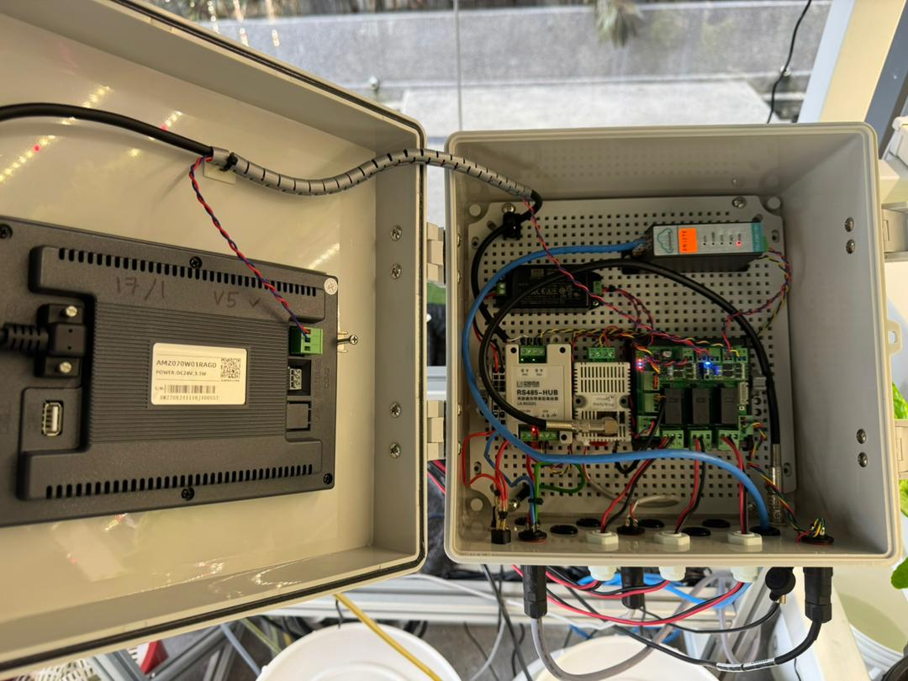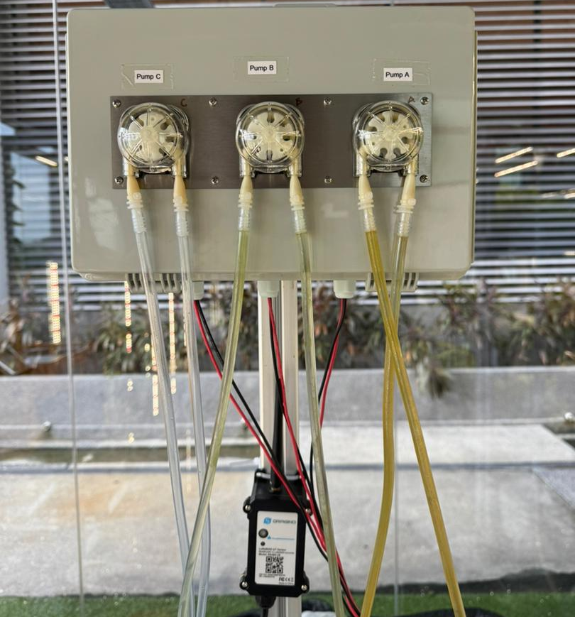
Figure 2 NFT Dosing System
The exponential surge in agricultural data generated by the widespread deployment of high-frequency IoT sensors inherently strains traditional, purely cloud-based frameworks. High communication latency, bandwidth bottlenecks, and connectivity constraints which particularly prevalent in remote or rural farming environments which is strictly cloud-dependent systems vulnerable to critical failures. [5] To systematically mitigate these risks, AgrhiOne adopts an architecture clearly delineated into distinct operational layers: the terminal perception layer, the edge intelligence layer, the cloud coordination layer, and the application interface.
The terminal perception layer comprises the physical sensors, probes, and microcontrollers distributed directly across the crops and soil beds, tasked with continuous data acquisition. The edge intelligence layer involves localized gateways and high-performance microcontrollers that perform immediate data filtering, localized inference, and critical hardware actuation without necessitating a continuous round-trip to the cloud server. This localized processing ensures that immediate environmental threats, such as sudden temperature spikes or localized flooding, can be addressed autonomously by the edge nodes in real-time.
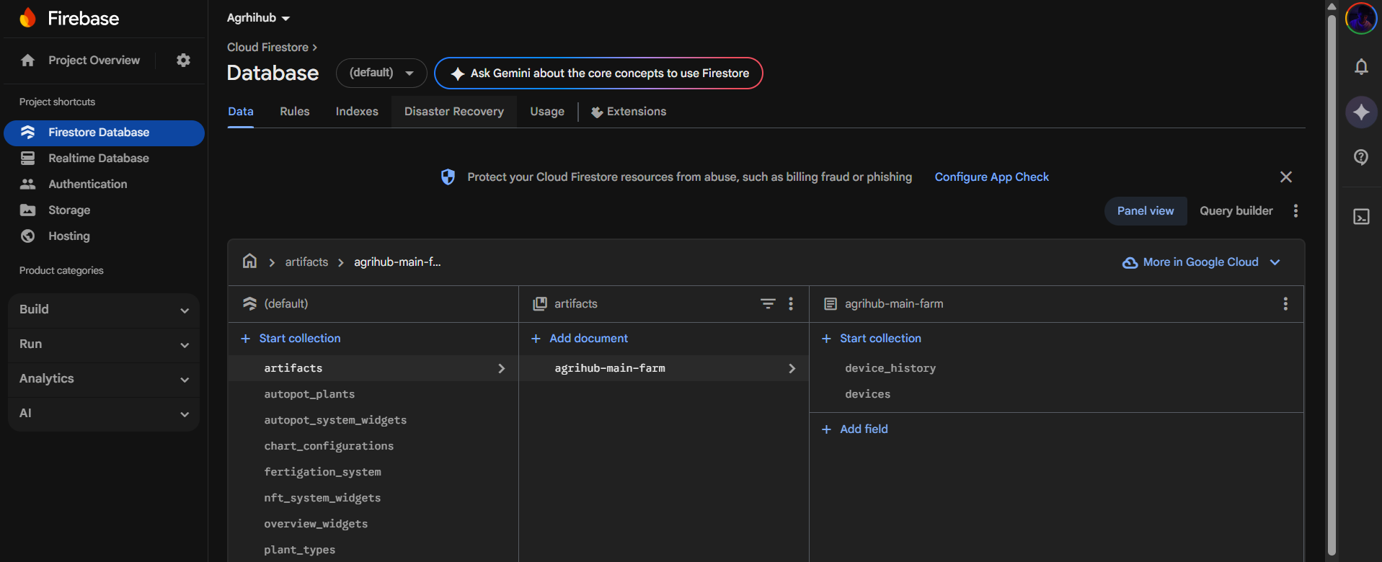
Figure 3 Firebase Setup of AgrhiOne system
The cloud coordination layer, securely hosted on platforms such as Firebase Firestore, serves as the central, immutable repository for historical data archiving, complex AI model retraining, and global system synchronization. This layered architecture guarantees that the latest field conditions are perpetually available to the user while maintaining system integrity during intermittent network outages.
At the heart of the AgrhiOne platform's application layer lies a dynamic, highly adaptable Content Management System (CMS) tailored specifically for botanical lifecycle tracking. Agriculture is fundamentally a biological process characterized by distinct, chronological developmental phases. The AgrhiOne CMS allows agronomists and researchers to execute full Create, Read, Update, and Delete operations to define highly customized "plant types" within the database.
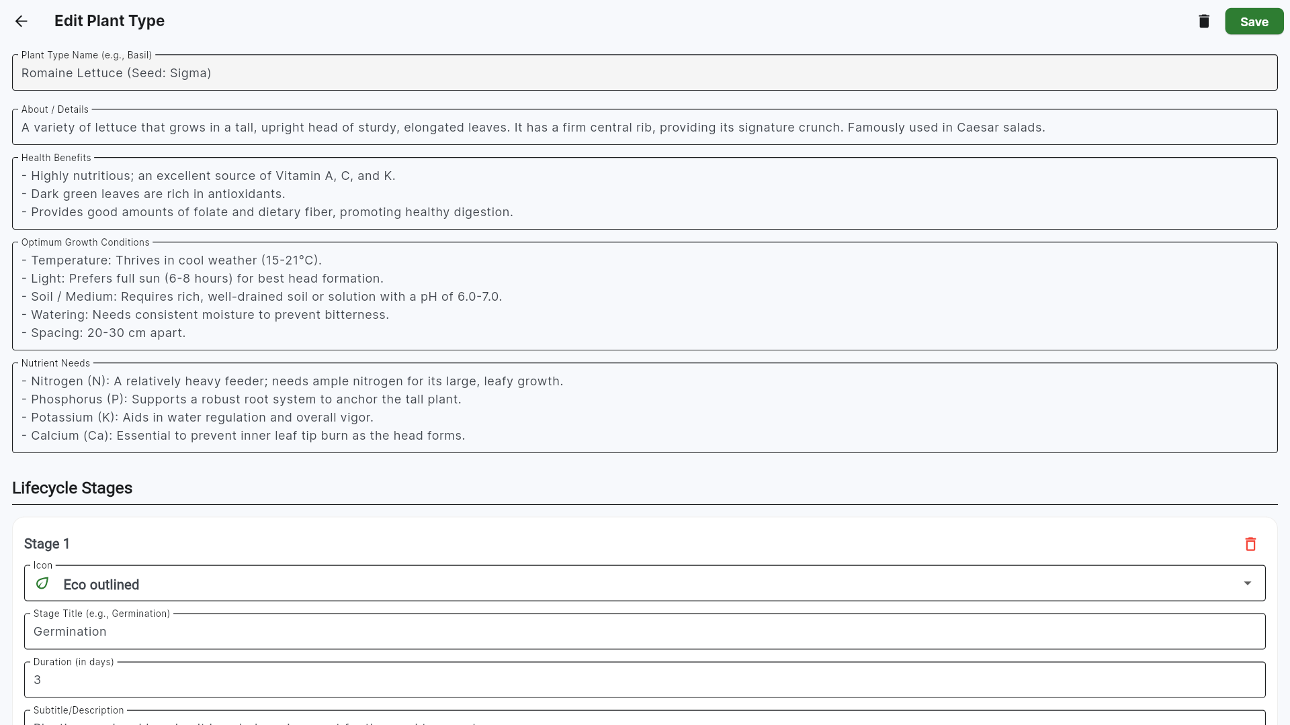
Figure 4 Plant Types CMS Interface
This dynamic lifecycle editor empowers users to stratify the growth of a specific crop into custom, multi-stage plans such as germination, early vegetative growth, leafy expansion, head formation, and the optimal harvest stage. For each discrete phase, the user defines the anticipated duration, specific nutritional requirements, and environmental parameter thresholds. The software subsequently generates comprehensive visual timelines, providing both detailed vertical breakdowns and high-level horizontal tracking charts, translating complex biological schedules into an intuitive, user-friendly interface. This centralized tracking hub ensures that every plant in the facility is monitored against its ideal developmental trajectory, automatically flagging deviations that may indicate environmental stress.

Multisensory IoT Networks: Wi-Fi and LoRaWAN Integration
The foundation of modern precision agriculture is constructed upon continuous, high-fidelity data acquisition across a multitude of environmental and chemical parameters. The AgrhiOne ecosystem achieves this unprecedented level of monitoring through the deployment of an extensive Internet of Things network, strategically utilizing both WiFi and LoRaWAN communication protocols to ensure maximal spatial coverage, redundancy, and energy efficiency. [3]
Table 1 Hardware Components of AgrhiOne Ecosystem
Parameter Monitored | Sensor Technology and Subsystem | Primary Application Environment | Transmission Protocol
Ambient Temperature & Humidity | LHT65 | Greenhouse Air Space | Wi-Fi (802.11 b/g/n)
Soil Moisture, Temperature, & Conductivity | 3-in-1 RS-485 Probe | Autopots / Soil Beds | LoRaWAN / Wi-Fi
Acidity (pH) Levels | Multi-parameter Probe | Hydroponic Nutrient Reservoirs | LoRaWAN / Wi-Fi
Electrical Conductivity (EC) | Submersible EC Probe | Hydroponic Nutrient Reservoirs | LoRaWAN / Wi-Fi
Water Level and Distance | DDS20-LB/LS | Hydroponic Holding Tanks | LoRaWAN / Wi-Fi
For localized, high-bandwidth data transmission within structured, indoor greenhouse environments, AgrhiOne deploys IoT sensor nodes to capture precise environmental metrics. These nodes are equipped with an array of precision sensors, including the Dragino LHT65 Temperature & Humidity sensor for highly calibrated ambient temperature and humidity readings, achieving an accuracy of ±0.5°C and ±5% relative humidity respectively. Additionally, the WQS-LB -- LoRaWAN Water Quality Sensor Converter is utilized for measuring Total Dissolved Solids (TDS) in hydroponic reservoirs, operating by measuring the electrical conductivity of the water using immersed probes to output analog signals representing the TDS level in parts per million (ppm).
Instead of relying on decentralized microcontrollers for cloud communication, the system routes this localized telemetry to a central Raspberry Pi. Acting as the core edge-computing hub, the Raspberry Pi executes custom Python scripts to decode the incoming analog and digital sensor payloads, drives local displays for immediate on-site readings, and streams the telemetry securely to the Firebase Realtime Database. The utilization of Firebase ensures highly reliable, time-stamped data synchronization between the physical field environment and the AgrhiOne cloud dashboard, achieving data transmission reliability rates exceeding ninety-nine percent. This seamless integration facilitates real-time data visualization through responsive Plotly charts, animated gauges, and historical spline area graphs, allowing farm operators to conduct granular trend analyses over custom temporal ranges.

Core Feature Analysis: AgrhiOne
The platform's extensive capabilities are built on four strong and fundamentally interlocked pillars, which focuses on a key imperative of the contemporary agricultural purpose.
1. Advanced Data Visualization & Monitoring
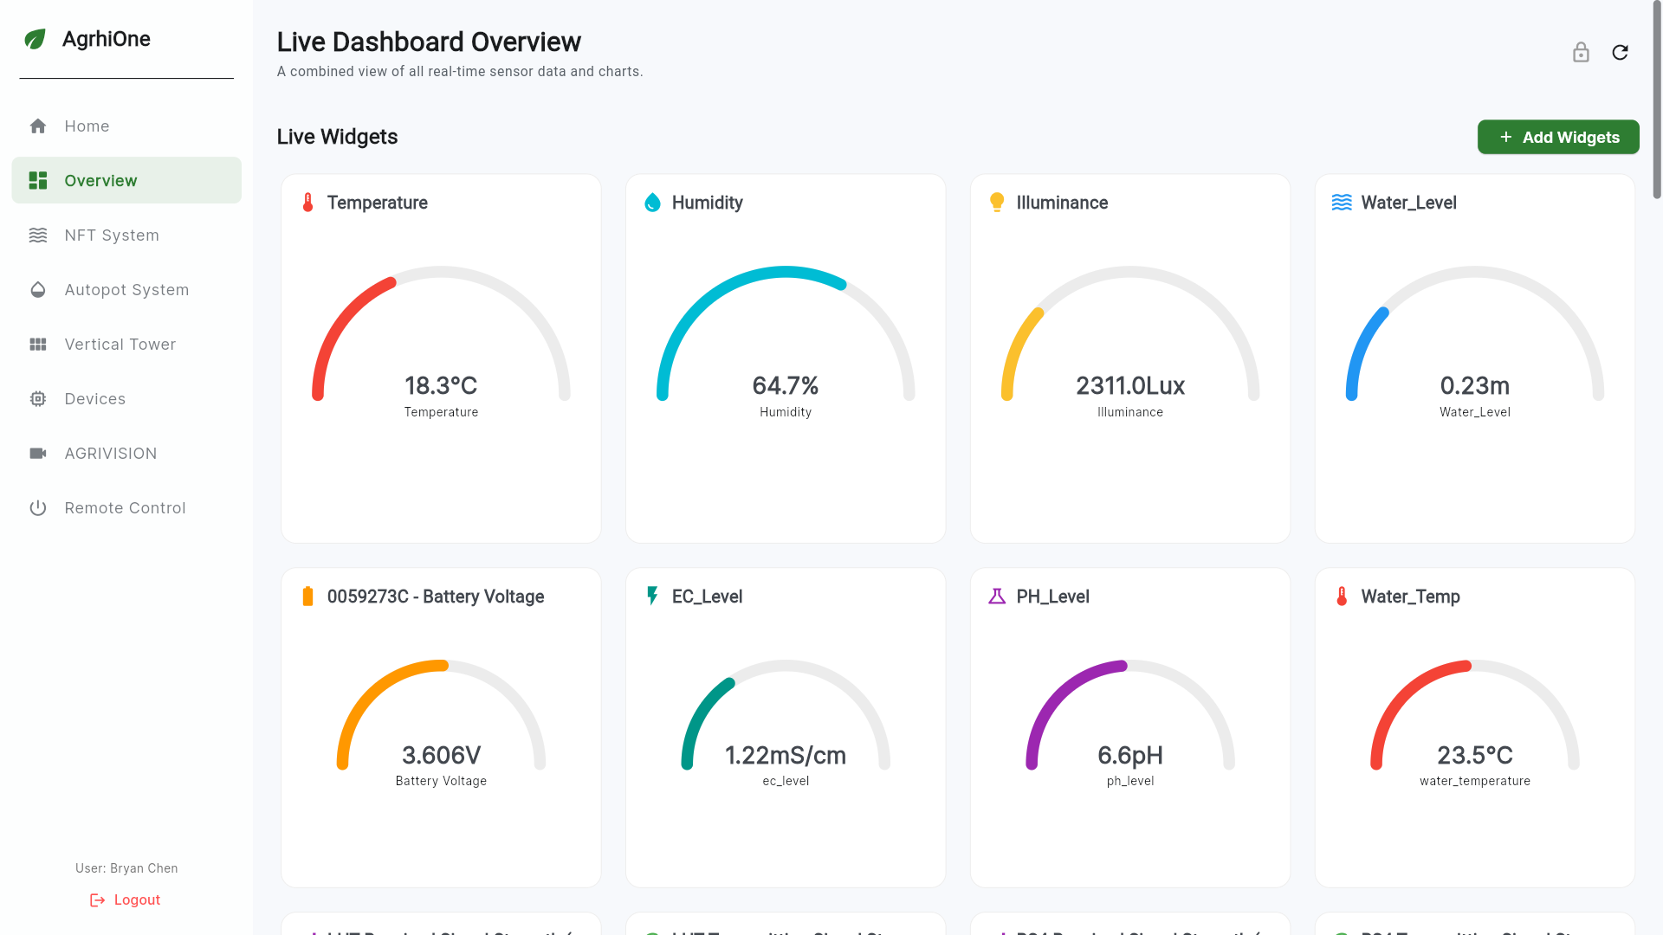
Figure 5 Image of Overview Dashboard in AgrhiOne Software
The core of AgrhiOne is based on its capability of converting raw sensor data to sophisticated insights which are actionable. It does not deliver the users with plain figures but offers a dynamic and interactive data exploration space. This charting engine should be easily scalable, meaning that the visualization styles could be easily expanded in the future with the additional styles being added with the bare minimum of effort. Its user interface is very interactive, and it allows the user to filter the information and effortlessly use the interface between the graphic charts and the raw data tables. This is accompanied by animated gauges, which give an immediate and crystal-clear view of the prevailing environmental conditions which are aesthetically pleasing.
Key Visualization Features:
- Multiple Chart Types: Supports a wide variety of visualizations, including Line, Spline Area, Bar, Scatter, and Doughnut charts.
- Interactive Controls: Users can filter data by time (Day, Week, Month), select custom date ranges, and switch between charts and data tables.
- Animated Gauges: Provides a clear, immediate view of live sensor data with smooth, animated transitions.
2. Remote Hardware Control & Automation
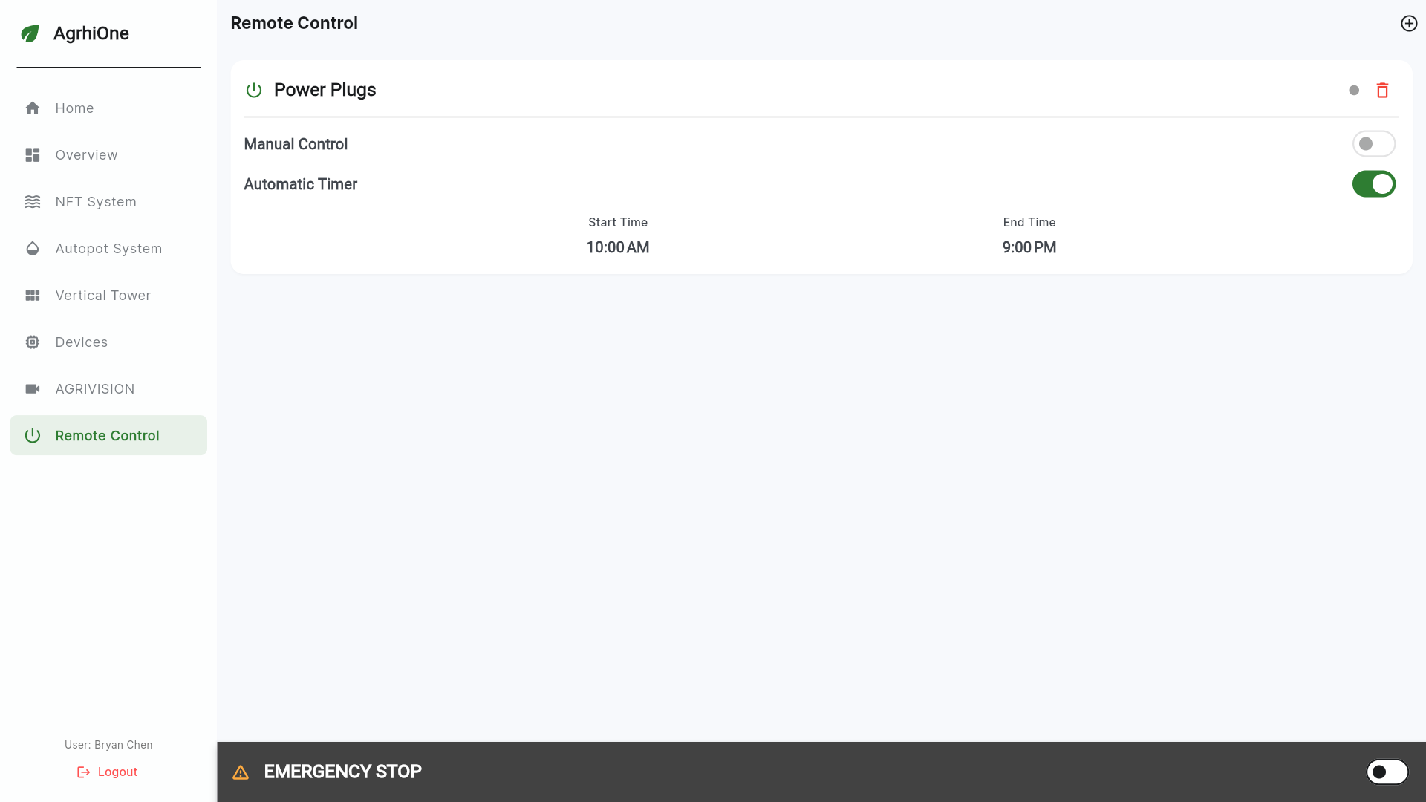
Figure 6 Image of Remote-Control Page in AgrhiOne Software
The platform offers users direct, real-time control over the physical environment. Through a dedicated remote-control interface, users can manage and configure physical power sockets and the devices connected to them. As safety is an element of any system that communicates with the real physical hardware, AgrhiOne uses a vital Emergency Stop feature. In this system-wide master switch, there is always a fail-safe to turn off the power to all the devices connected to this system-wide master switch instantly regardless of the schedule of power and any other manually command.
Key Control Features:
- Socket Management: An interface to configure and control physical power outlets and connected hardware.
- Dual Control Modes: Supports both immediate manual on/off control and automated daily scheduling.
- Emergency Stop: A critical, system-wide safety feature to instantly cut power to all hardware in case of an emergency.

3. Plant Database & Content Management (CMS)
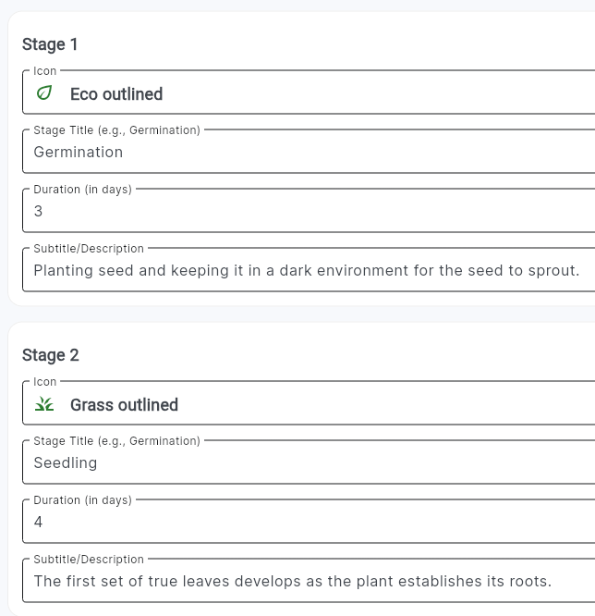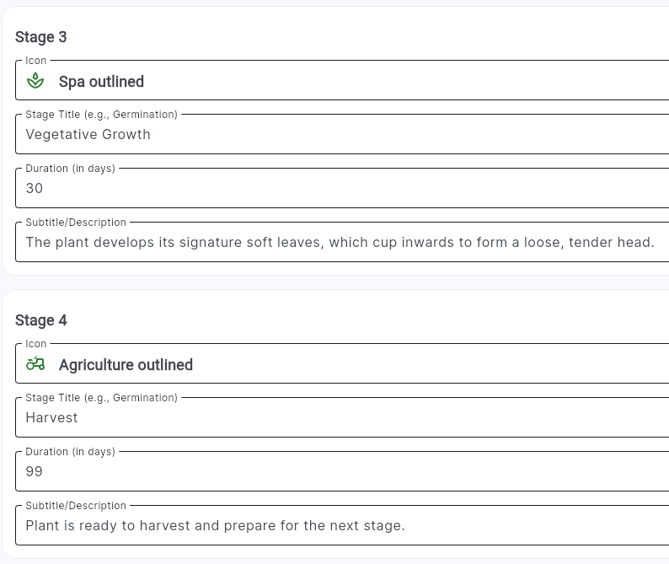
Figure 7 Image of Plant Types CMS Interface
At its heart, AgrhiOne is a powerful knowledge management tool, featuring a complete Content Management System (CMS) that allows users to create and manage a detailed, living database of plants. The most powerful aspect of this CMS is the fact that it has an active lifecycle editor, where individual users can stratify custom multi-stage plans of growth to every plant. In every level, the users are allowed to assign a name, anticipated time, notes, and a distinct icon, which is virtually a standardized, reusable design of the successful cultivation.

Key CMS Features:
- Full CRUD Operations: Allows users to Create, Read, Update, and Delete "plant type" definitions.
- Dynamic Lifecycle Editor: Enables the creation of custom, multi-stage growth plans, specifying duration, descriptions, and icons for each phase.

4. Crop Lifecycle Management & Tracking
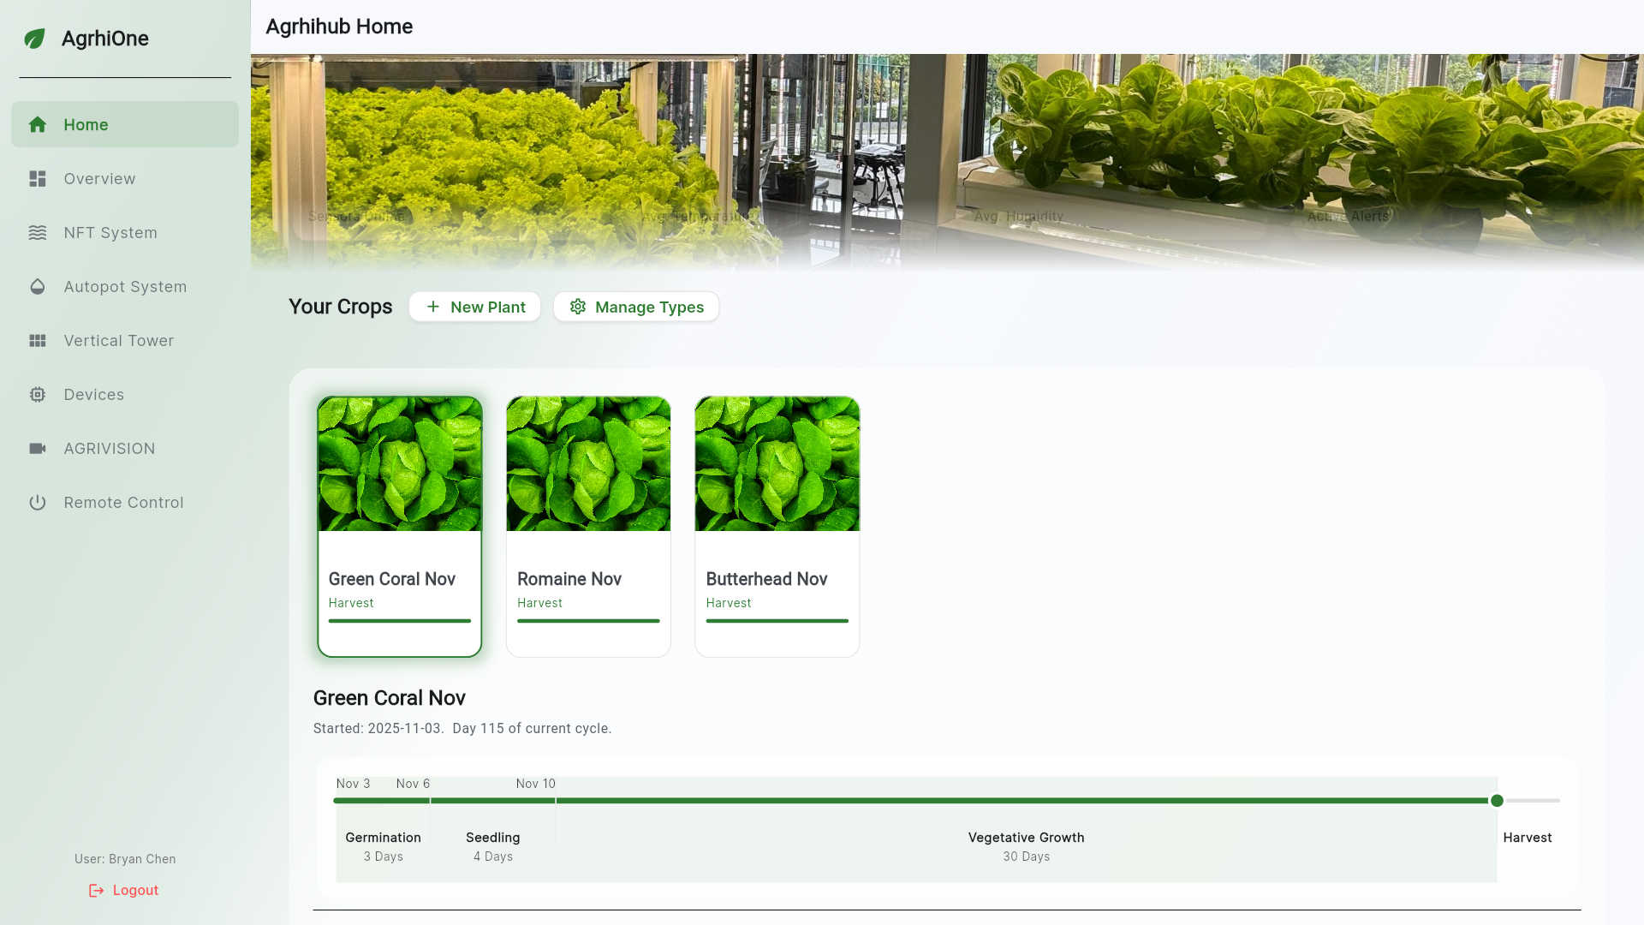
Figure 8 Image of Crop Lifecycle Tracking in AgrhiOne Software
The platform excels at monitoring the journey of a crop analysis throughout its cultivation period until it produces a harvest based on the information structured in its CMS. The homage page would be the central location, and it would show all the crops at the place and visualize the progression of the crops as per the lifecycle plans is set. The system is incapable of not just offering a detailed vertical timeline, but it also enables a high-level horizontal chart that shows the progress of a plant. To go into the details, the user can get a rich content consolidated in a detailed screen which covers the type of plant, its individual growing needs and the data on the existing cycle in which the particular crop is being managed thus giving the user a complete holistic picture of a particular crop.

Key Tracking Features:
- Centralized Tracking Hub: The home page displays all active crops and visualizes their progress.
- Visual Timelines: Provides both detailed vertical and high-level horizontal timelines of the plant lifecycle.
- Detailed Plant View: A dedicated screen offers rich content on the plant type and its specific growth cycle data.

Future Research Directions
AgrhiOne platform should focus on enhancing the scalability, security, and autonomy of its integrated systems. One critical area is the advancement of on-device Artificial Intelligence and edge computing to enable faster, localized decision-making in complex agricultural environments, thereby reducing reliance on continuous cloud connectivity. Additionally, integrating blockchain technologies could facilitate secure, decentralized data governance and the creation of scalable IoT-based carbon markets to promote sustainable farming practices. Further exploration into the comprehensive deployment of Agentic AI is also essential, particularly focusing on federated learning, explainable AI, and trust calibration mechanisms to ensure transparent and safe human-machine collaboration.

Conclusion
The transition from traditional, manual farming methodologies to digitized, precision agriculture is an absolute necessity in the face of escalating global food demands, diminishing arable land, and severe environmental constraints. The AgrhiOne system exemplifies the immense, transformative potential of integrating disparate technological domains such as the Internet of Things and advanced artificial intelligence—into a cohesive, highly scalable, and exceptionally functional platform. By centralizing high-fidelity data acquisition from localized Wi-Fi nodes and long-range LoRaWAN networks, AgrhiOne provides farm operators with an unprecedented level of environmental visibility, successfully overcoming the connectivity challenges inherent in both dense greenhouses and expansive open fields.
Furthermore, the robust architectural design of AgrhiOne, characterized by its cloud-edge collaborative framework, establishes a resilient foundation for future innovations. As the agricultural sector increasingly embraces the paradigms of Digital Twins and Agentic Artificial Intelligence, platforms like AgrhiOne will inevitably evolve from reactive monitoring tools into proactive, fully autonomous decision-making entities.

References:

[1] | R. Ganapathy, “Hydroponics: current trends in sustainable crop production,” 30 September 2023. [Online]. Available: https://pmc.ncbi.nlm.nih.gov/articles/PMC10625363/.
[2] | R. Ajit Singh, C. Sushabhan, S. Abhinav, N. Pankaj and S. Gautam, “Empowering vertical farming through IoT and AI-Driven technologies: A comprehensive review,” August 2024. [Online]. Available: https://pmc.ncbi.nlm.nih.gov/articles/PMC11328057/.
[3] | R. Khadijah, T. Rahul and R. Sudip, “Enhancing Hydroponic Farming Productivity Through IoT-Based Multi-Sensor Monitoring System,” 1 January 2024. [Online]. Available: https://www.scitepress.org/Papers/2024/127413/127413.pdf.
[4] | P. Hemlata, G. Parth, M. Singh Manas and M. Abhinav, “AI-Powered Seed Viability Assessment in Hydroponic Systems: A Comparative Review of Computer Vision and Deep Learning Approaches,” 27 September 2025. [Online]. Available: https://ieeexplore.ieee.org/abstract/document/11281089.
[5] | G. Ran, Z. Hongyang, L. Gang and H. Jiamin, “Edge Computing-Enabled Smart Agriculture: Technical Architectures, Practical Evolution, and Bottleneck Breakthroughs,” 26 August 2025. [Online]. Available: https://www.mdpi.com/1424-8220/25/17/5302.

