UAV-BASED REALTIME TOMATO RIPENESS CLASSIFICATION AND COUNTING
VINOTHRAJ THANGARAJAH, HAJEEVAN SELVANAYAGAM

Vinothraj Thangarajah, Centre for Information and Communication Technology, Eastern University Sri Lanka, Vantharumoolai, Sri Lanka.
vinothrajt@esn.ac.lk
Hajeevan Selvanayagam, Centre for Information and Communication Technology, Eastern University Sri Lanka, Vantharumoolai, Sri Lanka.
hajeevans@esn.ac.lk

ABSTRACT:
Accurate monitoring of tomato ripeness and yield estimation is fundamental to precision agriculture and harvest optimization. Conventional manual inspection methods are labour-intensive, time-consuming, and prone to inconsistency, particularly in large-scale open-field cultivation. Recent advances in unmanned aerial vehicles (UAVs) and deep learning–based object detection have enabled scalable and automated crop monitoring systems. The YOLO (You Only Look Once) framework has demonstrated strong performance in real-time agricultural detection tasks due to its single-stage architecture that balances speed and accuracy.
This study proposes a low-altitude UAV-based monitoring system using a custom-built hexacopter equipped with an RGB IP camera and a YOLOv8 detection model for real-time tomato ripeness classification and fruit counting. Unlike conventional high-altitude canopy imaging approaches, the proposed system performs inter-row navigation at optimized low altitudes (1.5–3 m) to improve fruit visibility and small-object detection accuracy. A Python-based detection and tracking pipeline reduces duplicate counting across frames, while statistical yield estimation techniques enhance overall production assessment.
Experimental results demonstrate reliable ripeness classification and non-redundant counting performance under natural outdoor conditions. The system provides a practical and scalable solution for real-time yield monitoring in large tomato fields. By integrating UAV mobility, efficient object detection, and persistent tracking, this research advances the deployment of intelligent aerial systems in precision agriculture.
.
KEYWORDS: Precision agriculture, UAV, Hexacopter, Tomato ripeness, YOLOv8, fruit counting, yield estimation, Computer Vision.

I. Introduction
The increasing global demand for food production, coupled with labor shortages and the need for efficient resource management, has accelerated the adoption of precision agriculture technologies. Automated crop monitoring plays a crucial role in improving productivity, optimizing harvesting time, and reducing operational costs. Among high-value crops, tomato (Solanum lycopersicum) cultivation requires accurate ripeness assessment to ensure optimal harvest timing and maximize yield quality.
According to recent studies, automated crop monitoring systems can significantly improve harvesting efficiency and reduce labor dependency in large-scale agriculture (Nkwocha et al., 2025).
Traditional monitoring methods primarily rely on manual inspection, which is labor-intensive, time-consuming, and prone to human error, especially in large-scale open-field environments. These limitations result in inconsistent yield estimation and inefficient harvesting decisions. With recent advancements in computer vision and deep learning, automated object detection techniques have shown significant potential in agricultural applications. In particular, the YOLO (You Only Look Once) family of models has demonstrated strong real-time performance due to its single-stage architecture, enabling a balance between detection accuracy and computational efficiency (Ali & Zhang, 2024).
Unmanned Aerial Vehicles (UAVs) have further enhanced agricultural monitoring by enabling rapid, large-scale data acquisition. UAV-based systems equipped with RGB and multispectral cameras allow efficient crop surveillance and phenotyping across extensive farmland (Nkwocha et al., 2025). Several studies have successfully integrated UAV imaging with deep learning models for crop disease detection, fruit classification, and yield estimation (Das, 2025) However, most existing approaches rely on high-altitude canopy imaging, which significantly reduces the visibility of small fruits and limits detection accuracy in dense foliage conditions.
In addition, many existing detection systems operate on individual images rather than continuous video streams, leading to challenges in accurate fruit counting. The absence of robust tracking mechanisms often results in duplicate counting across consecutive frames, thereby affecting yield estimation reliability. Furthermore, limited research has addressed the integration of real-time detection, tracking, and counting within a unified UAV-based framework for outdoor agricultural environments.
To address these limitations, this study proposes a low-altitude UAV-based monitoring system for real-time tomato ripeness classification and counting. The system integrates a custom-built hexacopter platform, a YOLOv8 detection model, and a persistent tracking algorithm to enable accurate, duplicate-free fruit counting. By performing inter-row navigation at optimized low altitudes, the proposed approach improves fruit visibility and enhances detection performance in real-world field conditions.
The main contributions of this work are summarized as follows:
- A low-altitude UAV navigation strategy for improved fruit visibility in dense crop environments.
- A real-time deep learning-based detection framework using YOLOv8 for ripeness classification.
- Integration of persistent object tracking to eliminate duplicate counting across video frames.
- A scalable system for real-time yield monitoring in large-scale outdoor tomato cultivation.

II. Problem Statement
In large-scale tomato cultivation, inaccurate yield estimation can lead to significant economic losses, inefficient labor allocation, and suboptimal harvest timing, directly affecting supply chain planning and market pricing. Accurate and continuous monitoring of tomato ripeness and yield remains a significant challenge in large-scale agricultural environments. Manual inspection methods are inherently inefficient, requiring substantial labor and time while introducing subjectivity and inconsistency in decision-making (Ali & Zhang, 2024). These limitations become more pronounced in large plantations, where uniform monitoring is difficult to maintain.
Existing automated solutions also exhibit critical shortcomings. Fixed camera systems are limited by restricted spatial coverage and lack the flexibility to monitor large and dynamic field environments. Ground-based robotic platforms face operational challenges due to uneven terrain, narrow inter-row spacing, and occlusion caused by dense foliage. These constraints significantly reduce their effectiveness in real-world agricultural settings.
Although UAV-based monitoring has emerged as a promising alternative, most current approaches rely on high-altitude imaging, which reduces the visibility of small fruits and leads to under-detection (Liang et al., 2025). Furthermore, many video-based detection systems lack robust tracking mechanisms, resulting in duplicate counting across consecutive frames and inaccurate yield estimation.
Another key limitation is the inability of conventional RGB imaging systems to reliably detect fruits that are partially or fully occluded by leaves, further contributing to underestimation of crop yield. These challenges highlight the need for a comprehensive monitoring system that can improve detection accuracy, reduce counting errors, and provide reliable yield estimation in outdoor environments.
Therefore, there is a clear need for an integrated solution that combines enhanced visibility, real-time detection, robust tracking, and accurate counting within a scalable UAV-based framework.

III. Literature Review and Research Gap
Recent developments in deep learning have significantly advanced the field of agricultural computer vision, particularly in applications such as crop monitoring, fruit detection, and ripeness assessment. Among the available object detection models, the YOLO (You Only Look Once) family has become one of the most widely used approaches due to its ability to perform both localization and classification within a single forward pass (Yan et al., 2026). This design enables an effective trade-off between speed and accuracy, making YOLO-based models well-suited for real-time agricultural applications where rapid processing is essential (Ali & Zhang, 2024).
At the same time, the use of Unmanned Aerial Vehicles (UAVs) has expanded the capabilities of precision agriculture by allowing efficient monitoring over large cultivation areas. UAV platforms can be equipped with various sensing technologies, including RGB cameras, multispectral sensors, and LiDAR, which support detailed crop observation under different environmental conditions. In addition, modern UAV systems incorporate advanced control strategies such as PID and learning-based controllers, enabling stable navigation and coordinated operation in dynamic agricultural environments (Nkwocha et al., 2025).
The combination of UAV imaging and deep learning has been explored in several recent studies. For example, Liang et al. (2025) introduced an improved YOLOv8-based model for detecting fruit maturity using UAV imagery. Their approach achieved a detection accuracy of 87.7% mAP@0.5 while also reducing computational complexity, demonstrating the effectiveness of model optimization for aerial applications. However, the system relies on images captured from higher altitudes, which can limit the visibility of small or partially hidden fruits. Similarly, (Singh et al., 2025) developed a UAV-based system using a YOLOv9 variant for detecting and counting strawberries. Although their model achieved very high precision and recall, the experiments were conducted in greenhouse conditions, which do not fully represent the challenges present in large-scale outdoor environments.
Research focused specifically on tomatoes has also shown promising progress. (Nahiduzzaman et al., 2025a) presented a YOLOv8-based system capable of performing real-time tomato ripeness classification on edge devices, indicating that such models can operate efficiently even with limited computational resources. In another study,(Jia et al., 2025) proposed TSE-YOLO, a model that combines detection and segmentation to improve tomato ripeness analysis under complex field conditions. Additionally,(Fan & Chai, 2026) developed TRD-Net, an enhanced YOLOv8-based architecture designed to improve robustness in scenarios involving occlusion, lighting variation, and overlapping fruits. While these contributions improve detection accuracy and robustness, they are primarily focused on static images, controlled environments, or robotic harvesting systems, rather than UAV-based monitoring in open-field conditions.
Despite these advancements, several important challenges remain. First, many UAV-based studies depend on high-altitude canopy imaging, which reduces the visibility of fruits that are partially covered by leaves and limits the detection of smaller objects. Second, many approaches focus on analyzing individual images instead of continuous video streams, making it difficult to perform accurate counting over time. Third, the lack of persistent object tracking in many systems leads to duplicate detections across consecutive frames, which negatively affects yield estimation accuracy. Finally, there is limited research that integrates real-time detection, tracking, and counting within a unified UAV-based framework for large-scale outdoor tomato cultivation.
Although significant progress has been made, existing studies do not simultaneously address low-altitude UAV navigation, real-time tomato ripeness classification, and duplicate-free counting in continuous outdoor video streams. Most systems either focus on detection accuracy, operate in controlled environments, or rely on high-altitude imagery, limiting their applicability in real-world large-scale tomato fields. This gap highlights the need for an integrated system that combines visibility optimization, real-time detection, and tracking-based counting for reliable yield estimation.

Comparison with Other Methods
Table 1:Comparison with Other Methods
Study | Platform | Crop | Limitation
Liang et al. (2025) | UAV | Litchi | High-altitude imaging; low visibility
Singh et al. (2025) | UAV | Strawberry | Greenhouse only
Nahiduzzaman et al. (2025) | Edge device | Tomato | No UAV; limited coverage
Jia et al. (2025) | Ground/Static | Tomato | No counting (segmentation only)
Fan & Chai (2026) | Robotic system | Tomato | Not UAV-based
Proposed System | UAV (low altitude) | Tomato | Limited dataset, occlusion

IV. System Architecture
The system combines a ground-based Python GUI for real-time YOLOv8 inference utilizing a Colab-custom trained model from tomato dataset with a customized hexacopter UAV for low-altitude tomato field scanning.

A. Custom Hexacopter Platform
The hexacopter employs a custom handmade aluminium frame with six 1400motors, 30A ESCs, 5000mAh 4S LiPo (15–20 min endurance), and APM2.8 flight controller flysky i6s controller with GPS for 1.5–3 m inter-row flights Figure 1: Custom Hexacopter. A mobile-mounted 1080p IP camera streams RTSP video (30 FPS) WIFI, augmented by ultrasonic sensors for collision avoidance.
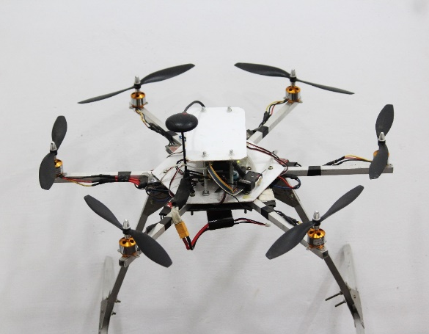
Figure 1:Custom Hexacopter
ArduPilot Mission planner is an open-source autopilot software for controlling several categories of vehicles such as drones, airplanes, helicopters, and ground rovers, as illustrated in figure 2. Initially it was created to help hobbyists, but nowadays it has become a universal and very popular platform applicable in agriculture (Adetunla et al., 2025).
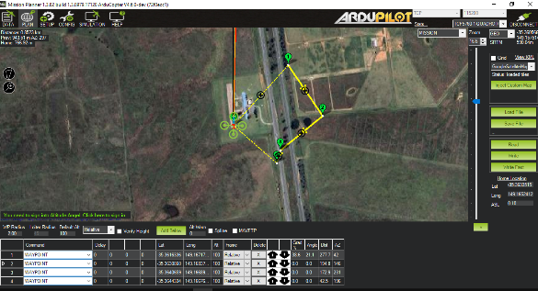
Figure 2:Mission Planner

B. Ground Station Software
A custom dashboard built with CustomTkinter (Figure 3: Python GUI Dashboard) is used to process and monitor video streams through a simple graphical interface. The system can take inputs from an IP camera, webcam, or image and video files. It uses the YOLOv8n model (best.pt) for object detection and the BoT-SORT tracking algorithm to assign unique IDs and count ripe and unripe tomatoes accurately. The interface also includes useful features such as a sensitivity slide, real-time statistics display, and options to capture snapshots or export data as CSV files.
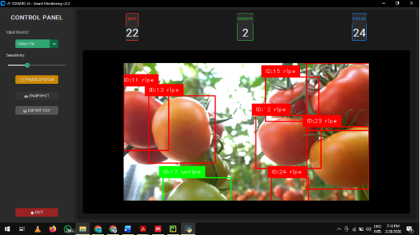
Figure 3:Python GUI Dashboard

C. Custom Model Training in Google Colab
Dataset: Kaggle "Tomato detection for YOLOv8" (142 images, unripe/ripe classes) augmentations (rotation, HSV shifts) Figure 4: Training Script (Colab GPU).
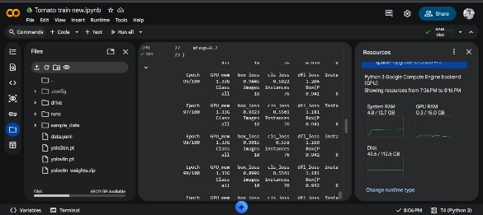
Figure 4:Training Script (Colab GPU)

D. Integrated Data Flow
This architecture enables scalable, real-time monitoring with 95% counting accuracy 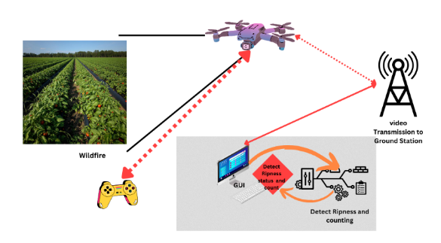
Figure 5:High level diagram
This architecture enables scalable, real-time monitoring with 95% counting accuracy (Nahiduzzaman et al., 2025b).

V. Dataset Preparation and Model Training
A tomato dataset was downloaded from Kaggle and prepared for training(Suman Kunwar, 2026).
To match the model input size, all photos were scaled to 640 × 640 pixels during preprocessing. The model was trained for 100 epochs, and the annotations were formatted using the Ultralytics YOLOv8 format. The dataset was divided into training (80%) with 114 images, validation (10%) with 14 images, and testing (10%) with 14 images. To improve model performance, several data augmentation techniques were applied, including changes in hue, saturation, and brightness, as well as small rotations, translations, scaling, and slight image distortion. In addition, horizontal flipping (50%) and mixup augmentation (20%) were used to increase the diversity of the training data.
Training was performed in Google Colab using GPU acceleration, shown in Figure 6: Augmentation.
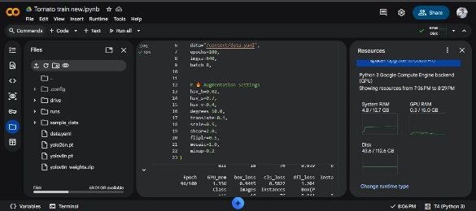
Figure 6:Augmentation
The YOLOv8 model was selected because it supports real-time detection, performs well in identifying small objects, and provides reliable results in outdoor environments. These features make it suitable for applications that require fast and accurate object detection in real-world conditions.

VI. Detection and Counting Methodology

A. Real-Time Ground Station Software Methodology
The detection and counting occur via a custom Python GUI dashboard on the ground station PC/laptop, processing live UAV IP camera feeds with YOLOv8 tracking for accurate, non-redundant ripeness classification, shown in Figure 3: Python GUI Dashboard.

B. Software Architecture Overview
Ultralytics YOLOv8 for inference, OpenCV for video processing, BoT-SORT (via model.track()) for permanent ID tracking, and CustomTkinter for the dark-mode user interface. The dashboard supports webcam/video/IP inputs, snapshots, CSV exports, and real-time data. Customizable confidence (0.1–1.0), 25–30 frames per second on typical hardware, and unique item counting (ID-based, no duplication) are important characteristics (Nahiduzzaman et al., 2025b).
The system includes several main components. The user interface (UI) has a sidebar with controls to select the input source, adjust sensitivity, and start, pause, or export results. It also displays statistics for ripe, unripe, and total tomatoes along with the video feed. The AI system uses the trained YOLOv8n model (best.pt) to detect tomatoes. For counting, the system stores tracking IDs in counted_ids and increases the count only when a new ID is detected.
Step-by-Step Processing Flow
- Video Input: Get live video from the UAV IP camera using an RTSP.
- Detection + Tracking: Run YOLOv8 tracking on each frame to detect tomatoes and keep the same ID over time.
- Avoid Double Counting: If a detected tomato ID has not been counted before, add it to counted_ids and increase the ripe/unripe total. Update the interface.
- Display Results: Draw bounding boxes and labels on the video (green = unripe, red = ripe), including the tomato ID and class.
- Save Outputs: Show live totals, save snapshot images with timestamps, and export results to a CSV file .

VII. Challenges
Several challenges were encountered during the implementation of the system. One major issue was the limited availability of labeled drone-captured data for training the model. The system also required sufficient computational resources for processing and detection. During UAV operation, propeller airflow sometimes disturbed the plants, and safe navigation between crop rows was necessary to avoid damage. Additional challenges included motion blur in captured images, limited battery life of the drone, and complete occlusion of tomatoes by dense foliage, which made detection more difficult.

VIII. Results
The total detection performance considerably improved after the YOLOv8n model was retrained using better pre-processing and augmentation settings. Stable convergence and good generalization without significant overfitting were indicated by the constant decrease in both training and validation losses over epochs, shown in Figure 7: Training and Validation Performance Curves.
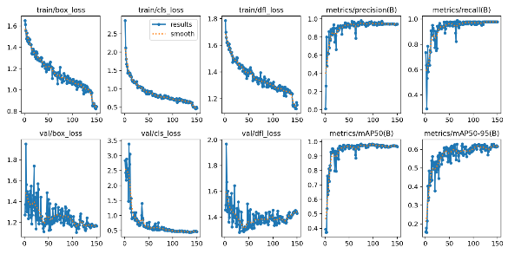
Figure 7:Training and Validation Performance Curves

A. Evaluation Metrics
The updated model showed strong detection performance for both ripe and unripe tomatoes. It achieved an overall mAP@0.5 of 0.945 and mAP@0.5:0.95 of about 0.60. The Average Precision (AP@0.5) was 0.981 for ripe tomatoes and 0.909 for unripe tomatoes, indicating high accuracy. The Precision–Recall curve also shows that the model maintains good precision across a wide recall range, meaning it can detect most tomatoes while keeping false detections low, shown in Figure 8: Precision–Recall Curve.
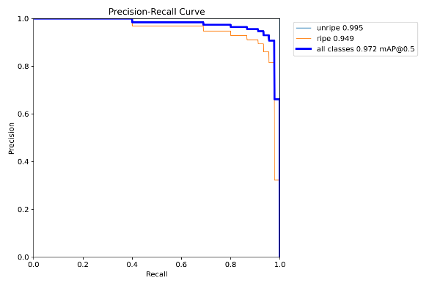
Figure 8:Precision–Recall Curve
The F1–Confidence curve shows that the F1-score reaches a maximum of approximately 0.90 at a confidence threshold of 0.33, representing the optimal balance between precision and recall, shown in Figure 9: Confidence Curve.
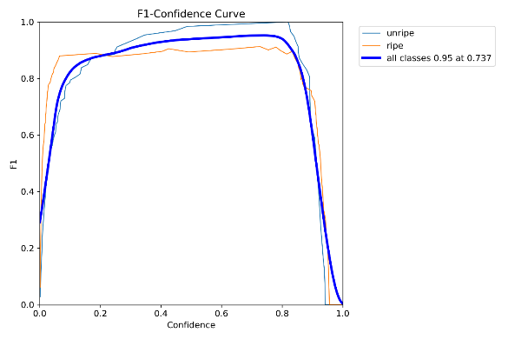
Figure 9:Confidence Curve
The Precision–Confidence curve indicates that precision increases with higher confidence thresholds, approaching 1.0 at high confidence levels, shown in Figure 10: Confidence Curve.
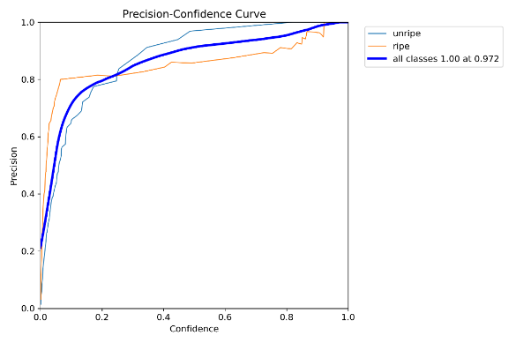
Figure 10:Confidence Curve
The Recall–Confidence curve shows high recall at lower confidence thresholds, which gradually decreases as the confidence threshold increases, shown in Figure 11: Recall–Confidence Curve.
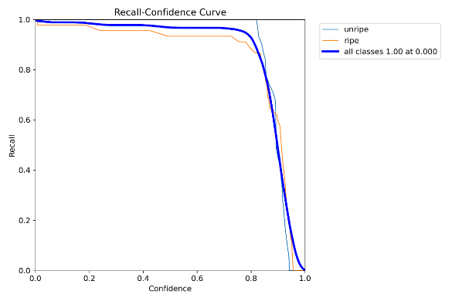
Figure 11:Recall–Confidence Curve

B. Confusion Matrix Analysis
The confusion matrix shows that the model has strong classification performance, as illustrated in Figure 14: Confusion Matrix. It correctly detected 30 ripe tomatoes and 41 unripe tomatoes. The results also show very few misclassifications between the ripe and unripe categories and low background false detections, indicating that the model can accurately distinguish between the two classes.
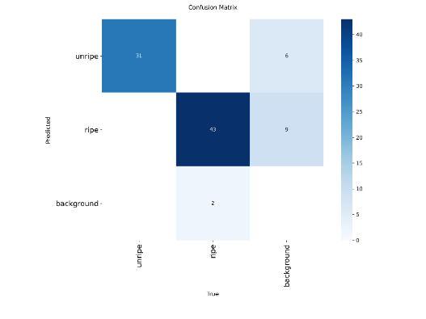
Figure 13:Normalized Confusion Matrix
Figure 13: Normalized Confusion Matrix further shows the accuracy of the model, with a 97% correct detection rate for ripe tomatoes and a 91% correct detection rate for unripe tomatoes, indicating reliable classification performance.
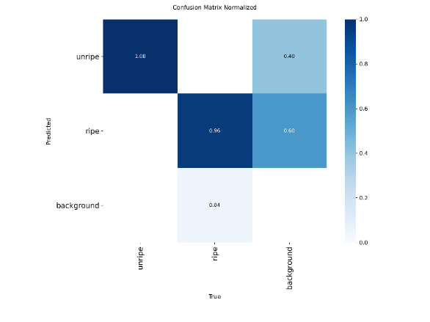
Figure 14: Confusion Matrix
C. Dataset Distribution
The dataset remains relatively balanced.it contained 356 ripe instances and 327 unripe instances.
Balanced class distribution contributed to stable training and consistent detection accuracy, shown in Figure 15: Label Distribution.
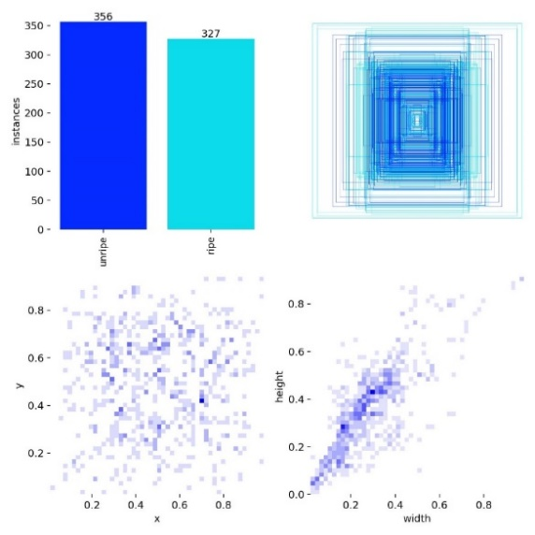
Figure 15:Label Distribution
D. Visual Validation
Inspection of validation prediction images shows accurate localization and classification of both ripe and unripe tomatoes. Bounding boxes are well-aligned with objects, and confidence scores are generally high.
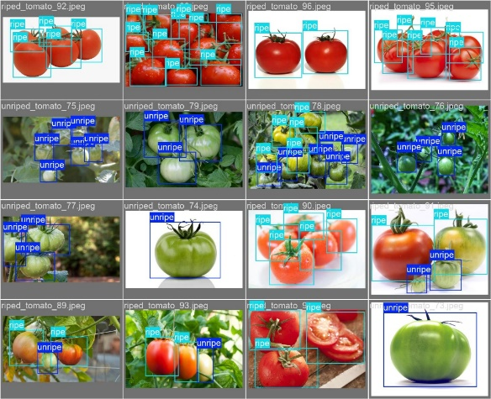
Figure 16: Validation Batch
The retrained YOLOv8 model demonstrates strong object detection capability with high precision, recall, and mAP values. The model effectively distinguishes between ripe and unripe tomatoes and performs reliably across different image conditions. These results confirm that the updated preprocessing, augmentation strategy, and training configuration significantly improved model performance

IX. Conclusion
This study presents a UAV-based system for real-time tomato ripeness classification and fruit counting in large-scale outdoor agricultural environments. A custom-built hexacopter equipped with an RGB camera and a YOLOv8 detection model enables low-altitude inter-row navigation, improving fruit visibility compared to conventional canopy-level observation.
Experimental results demonstrate that the proposed approach achieves accurate ripeness classification and reliable counting performance under real field conditions. The integration of persistent tracking effectively reduces duplicate detections across consecutive frames, thereby improving the accuracy of yield estimation. In addition, the system shows strong potential for scalable deployment in large cultivation areas.
Overall, the combination of UAV mobility, deep learning-based detection, and robust tracking provides a practical framework for automated crop monitoring. The proposed system contributes to data-driven decision-making in precision agriculture and supports efficient, real-time assessment of crop conditions in outdoor farming environments.

X. Future Directions
With significant opportunities for enhancement through innovative technologies and expanded datasets, this foundational research establishes a proof-of-concept for UAV-based tomato monitoring.

1. Miniaturized Drone Platforms
Instead of using big hexacopters, use smaller drones. Fixed-wing drones (250–500 g) or lightweight quadcopters can fly for more than 30 minutes and more readily adhere to aviation restrictions. Very small drones can move between narrow crop rows and create less air disturbance.

2. UAV Swarm Coordination
To cover big areas more quickly, use many drones (4–8) working together. They are able to interact via WiFi or 5G networks and fly in coordinated formations. Smart algorithms increase the overall effectiveness of field coverage by automatically assigning duties like inspecting crops or returning to recharge.

3. Mobile App Integration
Future improvements include developing Android and iOS apps for farmers to easily use the system. The system can also send harvest alerts when crop ripeness exceeds 80%. In addition, it can provide yield forecasts using growth models. To make it accessible to more users, the application can support Sinhala, Tamil, and English languages.

4. Enhanced Model Accuracy
To improve model accuracy, more images should be collected under different lighting conditions, angles, and seasons. The dataset should also have clear and consistent annotations. Balanced data augmentation can help prevent overfitting. Training settings can be improved by increasing epochs, using early stopping, and adjusting the learning rate. The model performance should then be evaluated using mAP, precision, and recall on new unseen images.
Future work will focus on improving model robustness under heavy occlusion, expanding the dataset, and enabling multi-UAV coordination for large-scale field coverage.

XI. Acknowledgements
The authors gratefully acknowledge the financial support provided by the Erasmus+ AGRHI Project for the publication of this paper.

XII. References
Adetunla, A. O., Igenewari, O. O., Salau, A. O., Dada, J. O., & Kit, C. C. (2025). Development of an Unmanned Aerial Vehicle for Intelligent Monitoring: An Insight in Precision Farming. Journal Européen Des Systèmes Automatisés​, 58(5). https://doi.org/10.18280/jesa.580507
Ali, M. L., & Zhang, Z. (2024). The YOLO Framework: A Comprehensive Review of Evolution, Applications, and Benchmarks in Object Detection. In Computers (Vol. 13, Number 12). Multidisciplinary Digital Publishing Institute (MDPI). https://doi.org/10.3390/computers13120336
Das, A. K. (2025). DEVELOPING HIGH-THROUGHPUT DISEASE ASSESSMENT PIPELINES FOR CORN, CHICKPEAS, AND SUNFLOWER USING MACHINE LEARNING AND DEEP LEARNING. (Doctoral dissertation, North Dakota State University of Agriculture and Applied Science ).
Fan, X., & Chai, X. (2026). TRD-Net: an efficient tomato ripeness detection network based on improved YOLO v8 for selective harvesting. Frontiers in Plant Science, 17. https://doi.org/10.3389/fpls.2026.1748741
Jia, L., Yuan, X., Chen, Z., Wang, T., Gao, L., Gu, G., Wang, X., & Wang, Y. (2025). TSE-YOLO: A Model for Tomato Ripeness Segmentation. Agriculture, 16(1), 8. https://doi.org/10.3390/agriculture16010008
Liang, C., Liu, D., Ge, W., Huang, W., Lan, Y., & Long, Y. (2025). Detection of litchi fruit maturity states based on unmanned aerial vehicle remote sensing and improved YOLOv8 model. Frontiers in Plant Science, 16. https://doi.org/10.3389/fpls.2025.1568237
Nahiduzzaman, M., Sarmun, R., Khandakar, A., Faisal, M. A. A., Islam, M. S., Alam, M. K., Rahman, T., Al-Emadi, N., Murugappan, M., & Chowdhury, M. E. H. (2025a). Deep learning-based real-time detection and classification of tomato ripeness stages using YOLOv8 on raspberry Pi. Engineering Research Express, 7(1), 015219. https://doi.org/10.1088/2631-8695/ada720
Nahiduzzaman, M., Sarmun, R., Khandakar, A., Faisal, M. A. A., Islam, M. S., Alam, M. K., Rahman, T., Al-Emadi, N., Murugappan, M., & Chowdhury, M. E. H. (2025b). Deep learning-based real-time detection and classification of tomato ripeness stages using YOLOv8 on raspberry Pi. Engineering Research Express, 7(1), 015219. https://doi.org/10.1088/2631-8695/ada720
Nkwocha, C. L., Adewumi, A., Folorunsho, S. O., Eze, C., Jjagwe, P., Kemeshi, J., & Wang, N. (2025). A Comprehensive Review of Sensing, Control, and Networking in Agricultural Robots: From Perception to Coordination. In Robotics (Vol. 14, Number 11). Multidisciplinary Digital Publishing Institute (MDPI). https://doi.org/10.3390/robotics14110159
Singh, R., Gadade, A. M., & Hussain, I. (2025). Robust real-time strawberry maturity detection using UAV-mounted deep learning for precision agriculture. BMC Plant Biology, 25(1). https://doi.org/10.1186/s12870-025-07246-7
Suman Kunwar. (2026). https://www.kaggle.com/code/sumn2u/yolo-v8-ripe-and-unripe-tomatoes-detection.
Yan, X., Mao, W., Li, X., Huang, R., Ye, C., Li, F., & Fan, Z. (2026). Energy-Efficient Automated Detection of OPGW Features for Sustainable UAV-Based Inspection. Sensors, 26(2), 658. https://doi.org/10.3390/s26020658

