AI Vision-based Cucumber Detection and Inspection for Autonomous Agricultural Robots
Ahmed Mohammed Ahmed Greynoon, Suresh Gobee, Vinesh Thiruchelvam, Arun Seeralan Balakrishnan

Ahmed Mohammed Ahmed Greynoon, APcore (Asia Pacific Center of Robotics Engineering) Asia Pacific University of Technology & Innovation Kuala Lumpur, Malaysia greynoon1@gmail.com
Suresh Gobee, APcore (Asia Pacific Center of Robotics Engineering) Asia Pacific University of Technology & Innovation Kuala Lumpur, Malaysia suresh.gobee@apu.edu.my
Vinesh Thiruchelvam, Asia Pacific University of Technology & Innovation Kuala Lumpur, Malaysia
dr.vinesh@apu.edu.my
Arun Seeralan Balakrishnan, School of Engineering, Asia Pacific University of Technology & Innovation, Kuala Lumpur, Malaysia
arun@apu.edu.my

ABSTRACT
The increasing demand for efficient and sustainable agricultural production has accelerated the development of intelligent robotic systems for crop monitoring and inspection. This study presents an AI vision-based cucumber detection and inspection system integrated into an autonomous agricultural robot. A YOLOv8 instance segmentation model was developed to detect cucumbers and classify their growth stage and health condition across six categories. Unlike conventional bounding box-only detectors, the proposed approach produces pixel-level segmentation masks, enabling shape-aware detection under occlusion, overlapping foliage, and varying illumination. A dataset of 703 annotated images was used for training and evaluation. The model achieved a Precision of 83.8%, Recall of 75.0%, and mAP@0.5 of 78.6% on the test set. The perception module was integrated within a ROS 2-based architecture to enable depth-assisted 3D localization for robotic interaction, confirming the feasibility of deploying instance segmentation models for practical crop inspection and autonomous agricultural applications.

KEYWORDS: AI vison, Instance segmentation, YOLOv8, Cucumber detection, Autonomous inspection, Crop health classification, Agricultural robotics
Introduction
The agricultural sector is undergoing rapid transformation due to increasing global food demand, rising labour costs, and the need for sustainable production practices. Traditional manual crop monitoring and inspection are labour-intensive, time-consuming, and often inconsistent, particularly in high-value crops such as cucumbers grown in greenhouse and field environments. Visual assessment of crop condition, including fruit presence, ripeness, and health, still relies heavily on human judgement, which can lead to variability in quality control and reduced operational efficiency. As a result, there is a growing interest in adopting intelligent robotic systems to support precision agriculture and reduce dependence on manual labour.
Recent advancements in artificial intelligence (AI) and computer vision have enabled the development of automated crop detection and inspection systems. AI vision techniques, especially deep learning-based models, have demonstrated strong capability in detecting fruits, identifying growth stages, and assessing crop health under varying lighting and environmental conditions. These capabilities make AI vision a key component in modern smart farming, where accurate and real-time visual information is essential for monitoring crop quality and optimizing agricultural operations.
Despite these advancements, many existing agricultural robotic systems focus on isolated functionalities such as fruit detection, navigation, or robotic manipulation rather than emphasizing robust vision-based inspection in real agricultural settings. Furthermore, performance is often affected by challenges such as occlusion, illumination changes, and plant structure complexity, particularly in unstructured farm environments. This highlights the need for practical AI vision systems that can operate reliably when integrated with mobile agricultural platforms.
This paper presents an AI vision-based cucumber detection and inspection system deployed on an autonomous agricultural robot. The primary focus of this work is the development and evaluation of the vision module for accurate cucumber detection and condition assessment, while autonomous navigation is incorporated as a supporting capability for field mobility. The robotic arm is included as part of the overall system architecture but is not the main scope of investigation.
The main contributions of this study include the design of an AI vision framework for cucumber detection and inspection, integration with an autonomous agricultural robotic platform, and experimental validation in an agricultural-like environment to support sustainable and precision farming applications.

Related Works
Existing research on agricultural robotics primarily focuses on vision, system integration, and operational limitations in automated crop detection and inspection
AI Vision for Crop Inspection
Recent studies highlight the critical role of AI vision in agricultural robotics, particularly for accurate crop detection and inspection in controlled environments such as greenhouses. Deep learning-based object detection models, especially YOLO architectures, have shown strong performance in recognizing cucumbers under greenhouse conditions. For instance, colour-channel pretraining integrated with an enhanced YOLOv5 model improved cucumber detection accuracy by leveraging colour-specific features; however, its robustness may be limited under varying illumination conditions where colour cues become inconsistent [1].
Beyond basic detection, several researchers have explored fruit maturity classification to support intelligent harvesting decisions. Multi-class ripeness detection using YOLO and SSD networks demonstrated the ability to classify fruit maturity stages effectively, enabling more precise harvesting timing and quality monitoring [2]. Nevertheless, many existing approaches focus mainly on classification tasks and do not integrate inspection outputs into a unified robotic system for real-time agricultural deployment.
In addition to fruit detection and ripeness assessment, recent advancements in deep learning have extended toward plant health monitoring. Studies on wilted cucumber leaf detection in real greenhouse environments indicate that vision-based models can simultaneously evaluate crop health and growth conditions, suggesting the feasibility of combining quality inspection with fruit detection in a single AI vision framework [3]. Despite this progress, health evaluation is still rarely integrated as part of a comprehensive harvesting or inspection system.
Furthermore, advanced perception approaches incorporating structured light sensing and deep learning, such as enhanced YOLOv5-based recognition frameworks, have demonstrated improved detection accuracy under occlusion and complex fruit structures [4]. These methods enhance spatial localization and detection reliability, highlighting the importance of robust vision systems for agricultural applications where occlusion, lighting variation, and irregular crop shapes remain significant challenges.
Machine Vision Systems
Machine vision is a key perception element in agricultural robots, allowing accurate crop detection, localization, and inspection in complex farm environments. Research shows that performance depends heavily on algorithm design, sensor choice, and robustness to lighting variations and occlusion [5]. Earlier methods based on colour, shape, and texture segmentation are increasingly replaced by deep learning models such as YOLO, SSD, and MobileNet, which offer higher accuracy and real-time performance. These approaches are well suited for irregular crop shapes and partially occluded fruits in both greenhouse and field conditions.
Benchmarking studies also highlight that well-structured perception pipelines improve detection consistency and fault tolerance in autonomous harvesting. Beyond 2D vision, RGB-D perception enhances fruit recognition and ripeness estimation in outdoor settings. This study combined deep learning detection with depth estimation, improving spatial localization and maturity analysis [6]. Integrating depth and geometric cues reduces errors from sunlight and noisy data, resulting in more reliable fruit recognition in dynamic agricultural environments.
Agricultural Robotics Context
The growing use of robotics in controlled environment agriculture, including greenhouses and hydroponic systems, is mainly driven by labour shortages, operational inefficiencies, and the demand for consistent crop production [7]. These structured environments offer stable layouts and repetitive crop arrangements, making them suitable for vision-based robotic monitoring and inspection. However, achieving fully autonomous harvesting and inspection remains difficult due to challenges such as occlusion, narrow crop rows, and variability in plant growth.
Integrated robotic systems in hydroponic settings highlight the importance of combining AI vision with mobile robotic platforms for real-world deployment. This study reported that deep learning detection models can maintain high accuracy under varying lighting when supported by depth sensing and robotic integration [8]. Despite this progress, many agricultural robots still separate perception, navigation, and manipulation modules, which limits system efficiency. This gap emphasizes the need for unified, vision-focused frameworks that enhance accurate crop detection and inspection in autonomous greenhouse and hydroponic applications.

Hardware
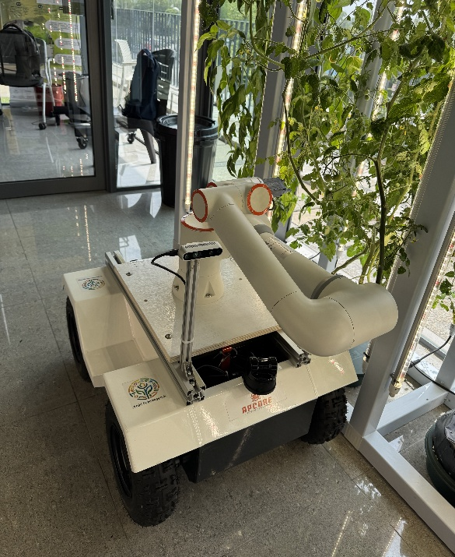
The proposed robotic harvesting platform integrates mobile navigation, AI-based perception, and robotic manipulation into a single autonomous system. The platform consists of a differential-drive mobile base, an onboard computing unit, vision and LiDAR sensors, and a 6-DOF robotic arm for harvesting operations.
Figure 1 Fully assembled robotic harvesting platform
The robotic arm is mounted centrally on the mobile platform to ensure stable manipulation during navigation. The RGB camera is positioned on an elevated bracket to provide an unobstructed field of view, while the LiDAR sensor is installed at the front of the platform for 360-degree environmental scanning. The computing and power subsystems are housed within the base enclosure.

Wiring Diagram
The robotic platform is powered by a 24V, 100 Ah battery that serves as the primary energy source for both mobility and manipulation subsystems. A centralized power distribution architecture was implemented to ensure stable voltage regulation, load separation, and protection for high-current and sensitive components.
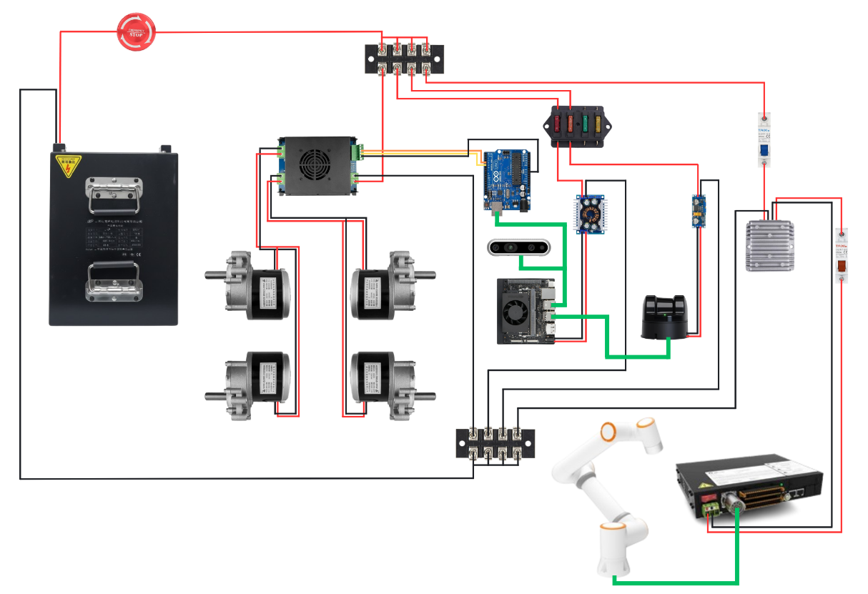
Figure 2 Electrical wiring and power distribution
The positive terminal of the 24V battery is first connected to a main power switch, enabling complete system isolation for safe startup and shutdown. From the main switch, power is routed to dual terminal busbars configured as positive and negative distribution rails. These busbars allow structured distribution of the supply voltage into four independent power lines, each dedicated to specific subsystems. The negative battery terminal is directly connected to the ground busbar, establishing a common reference for all components in the system.
The first power line from the positive busbar supplies a YS800 dual-channel brushed motor driver rated at 100A. This driver powers four 24V, 350 W brushed DC motors 18.7A nominal per motor responsible for platform locomotion. The left pair of drive motors are connected in parallel to the M1 output channel, while the right pair are connected to the M2 output channel. This configuration enables differential drive control, where independent speed control of left and right motor groups allows turning and trajectory control. The motor driver is interfaced with an Arduino microcontroller, which provides PWM and directional control signals. The Arduino receives high-level movement commands from the Jetson Orin Nano and translates them into low-level motor control signals.
The second power line from the busbar routes through a fused distribution box to protect sensitive electronic components. From this fuse box, power is supplied to a DC-DC step-down converter that regulates 24V down to 19V maximum 2.73A, which powers the NVIDIA Jetson Orin Nano. The Jetson serves as the primary computing unit of the robotic system. It executes AI-based perception algorithms, including the YOLOv8 instance segmentation model for cucumber detection and classification. It also coordinates navigation, decision-making, and communication between subsystems.
The Jetson interfaces directly with:
- The Intel RealSense D435i camera for depth-based vision and 3D position estimation.
- The Arduino microcontroller for motor control signalling.
- The LiDAR sensor for localization and mapping.
The RealSense camera is powered through the Jetson’s regulated supply, ensuring synchronized operation between perception and processing modules.
The third power line from the fused distribution system supplies a dedicated DC-DC step-down converter that converts 24V to 12V, 1A output for the Unitree L2 LiDAR sensor. The LiDAR provides 360-degree environmental scanning for mapping, localization, and obstacle detection. Its regulated power supply ensures stable sensor operation, which is critical for AMCL-based localization and navigation stack performance.
The fourth power line from the positive busbar supplies the robotic manipulation subsystem. This line first passes through a 63 A miniature circuit breaker (MCB) to provide high-current protection. Following the MCB, a DC-DC step-up converter increases the voltage from 24V to 48V, 20A output to meet the power requirements of the robotic arm controller. An additional 20A MCB is installed downstream of the converter to provide secondary protection for the arm control electronics. The robotic arm controller executes trajectory commands generated by MoveIt and handles joint actuation during picking operations.

Block Diagram
Figure 3 illustrates the high-level signal flow and control architecture of the robotic harvesting platform. The diagram highlights the interaction between sensing modules, computation units, motor control hardware, and the robotic arm subsystem.
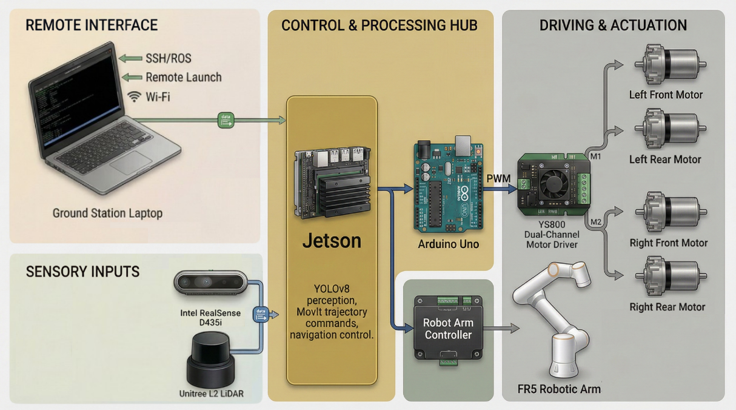
Figure 3 System control and data flow architecture
The NVIDIA Jetson Orin Nano serves as the central processing unit of the system. It is responsible for executing AI perception algorithms, navigation processes, and high-level decision logic.
The Jetson receives input from:
- Unitree L2 LiDAR, which provides environmental scanning data for mapping, localization, and obstacle detection.
- Intel RealSense D435i RGB-D camera, which supplies colour and depth data for AI-based fruit detection and 3D position estimation.
- Remote launch interface via shh, enabling wireless system initialization and monitoring.
All perception and decision-making processes are executed onboard the Jetson, including YOLOv8 instance segmentation and target selection logic.
High-level velocity and navigation commands generated by the Jetson are transmitted to an Arduino Uno microcontroller. The Arduino acts as a low-level motor interface, converting command signals into PWM and directional control signals. These signals are sent to the YS800 dual-channel brushed motor driver, which controls four DC motors arranged in a differential drive configuration:
- Left front and left rear motors are connected to Channel M1
- Right front and right rear motors are connected to Channel M2
Independent control of left and right motor groups enables forward motion, turning, and path tracking. This separation between high-level computation (Jetson) and real-time motor control (Arduino) ensures stable locomotion and reduces computational load on the main processor.
For harvesting operations, the Jetson communicates directly with the robot arm controller. Once a valid “Harvest Healthy” target is identified and its 3D coordinates are computed, the Jetson transmits the target pose to the arm controller. The arm controller executes motion planning and joint actuation for the FR5 robotic arm. Feedback regarding task execution is returned to the Jetson, allowing logging and decision updates.

Methodology
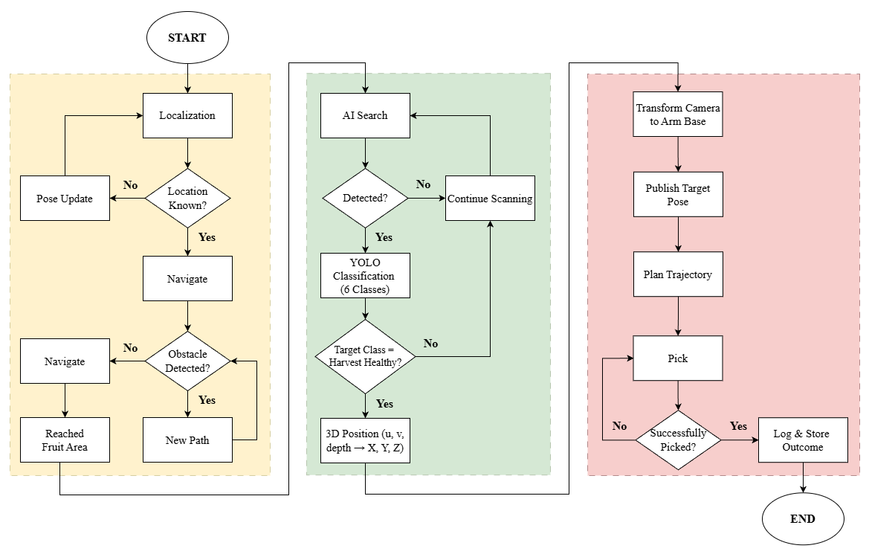
Figure 4 Overall system workflow
Figure 4 proposed framework integrates autonomous navigation, AI-based perception, and robotic manipulation within a ROS 2 environment. While the system includes mobility and actuation components, the primary focus of this study is the AI vision subsystem responsible for cucumber detection and inspection.
Autonomous navigation is achieved using Adaptive Monte Carlo Localization (AMCL), which estimates the robot’s pose within a pre-built map using LiDAR data. The navigation stack generates paths toward designated fruit zones while incorporating obstacle avoidance through real-time local planning. Upon reaching the target cultivation area, the perception module is activated for visual inspection and fruit identification. This navigation layer provides spatial positioning support but is not the central contribution of this work.
The AI perception subsystem employs a YOLOv8 instance segmentation model trained to classify six cucumber growth-stage and health conditions. Unlike traditional bounding box–only detectors, the instance segmentation framework outputs both object masks and bounding boxes, enabling shape-aware detection under occlusion and varying lighting conditions. During operation, the camera continuously scans the environment. When no object is detected, scanning continues. Upon detection, the model assigns one of the six predefined classes. A logical filter selects only the “Harvest Healthy” category for manipulation, eliminating the need for separate ripeness or health evaluation rules. For valid targets, the segmentation mask and bounding box centre pixel coordinates (u, v) are extracted. Depth information is retrieved from the RGB-D sensor at the corresponding pixel location. Using intrinsic camera parameters and the pinhole camera model, the 2D image coordinates and depth value are projected into 3D spatial coordinates (X, Y, Z) in the camera reference frame. This geometric transformation enables accurate spatial localization of the fruit for downstream manipulation.
The computed 3D fruit position is transformed from the camera coordinate frame to the robotic arm base frame using extrinsic calibration and ROS TF transformations. The target pose is then published to MoveIt for motion planning. MoveIt utilizes sampling-based planners such as RRT-Connect to generate a collision-free trajectory while considering joint limits, kinematic constraints, and environmental obstacles. Once a valid trajectory is computed, it is executed by the arm controller to perform the picking action. Task success is verified, and the system resumes scanning for subsequent harvesting cycles.
The integrated system was evaluated in a greenhouse-like environment to verify module coordination and operational feasibility. The primary quantitative evaluation presented in this paper focuses on the AI perception module, while the navigation and manipulation components serve to demonstrate practical deployment capability.

Testing and Results
Experimental Setup
The proposed AI vision system was evaluated using a YOLOv8 instance segmentation model (YOLOv8-seg) trained through the Roboflow platform for cucumber detection and inspection. Instance segmentation was selected to provide both object localization and shape-aware perception, which is beneficial for agricultural inspection and potential robotic interaction. The trained model was tested on real cucumber images captured in agricultural-like conditions, including natural lighting, partial occlusion by leaves, and varying fruit orientations. The evaluation focused on detection accuracy, segmentation reliability, and multi-class inspection capability under realistic environmental conditions.
Dataset and Training Configuration
A total of 703 annotated cucumber images were used for training, validation, and testing. The dataset was labelled using polygon masks under an instance segmentation framework in Roboflow to enable precise shape detection. The dataset was divided into 615 training images, 59 validation images, and 29 testing images to ensure unbiased model evaluation.
The dataset was structured into six inspection-oriented classes: Early Healthy, Early Unhealthy, Fruiting Healthy, Fruiting Unhealthy, Harvest Healthy, and Harvest Unhealthy. This class design allows the model to perform not only object detection but also growth-stage and health condition classification, which is essential for agricultural inspection systems. The images include real cucumber samples with variations in scale, lighting, occlusion, and background complexity, reflecting practical deployment scenarios in agricultural environments.
Model Performance Evaluation
The performance of the YOLOv8-seg model was evaluated using standard object detection metrics, including Precision, Recall, and mean Average Precision (mAP@0.5). The trained model achieved a Precision of 83.8%, Recall of 75.0%, and mAP@0.5 of 78.6% on the test set. The relatively high precision indicates that the model produces accurate detections with minimal false positives, which is critical for reliable crop inspection and monitoring tasks.
The recall value of 75.0% suggests that the model is capable of detecting the majority of cucumbers in the scene, although some instances may be missed due to occlusion, overlapping foliage, and early-stage visual ambiguity. Class-wise evaluation further shows higher Average Precision for Harvest Healthy and Fruiting Healthy classes, while lower performance in the Early Unhealthy class is likely due to limited unhealthy samples and less distinctive visual features during early growth stages. Despite the relatively small test set size, the obtained mAP score demonstrates stable detection performance for a real agricultural dataset.

Table 1 Class-wise Average Precision (mAP@0.5) for cucumber growth stage and health classification
Class | Validation AP (%) | Test AP (%)
All Classes | 79.0 | 88.0
Early Healthy | 76.0 | 85.0
Early Unhealthy | 51.0 | 85.0
Fruiting Healthy | 86.0 | 91.0
Harvest Healthy | 91.0 | 89.0
Harvest Unhealthy | 89.0 | 90.0

Table 1 presents the class-wise Average Precision for both validation and test sets. The results indicate that the model achieved the highest performance in Fruiting Healthy and Harvest Healthy classes, demonstrating strong capability in detecting mature cucumbers with clearer visual features. Although the Early Unhealthy class showed lower validation performance (51.0%), the test set results improved significantly to 85.0%, suggesting better generalization when exposed to unseen samples. This variation is likely due to limited unhealthy samples and less distinctive visual characteristics during early growth stages.
Detection Results and Analysis
Qualitative analysis of the segmentation outputs demonstrates that the proposed YOLOv8-seg model successfully detects cucumbers across multiple growth stages and health conditions under realistic environmental settings. As shown in Figure 5 (a)–(d), the model generates both bounding boxes and pixel-level segmentation masks, enabling shape-aware detection and improved visual interpretation of individual cucumber instances. This segmentation capability enhances boundary clarity, particularly in scenes involving partial occlusion, overlapping foliage, and visually complex backgrounds that are common in agricultural environments.
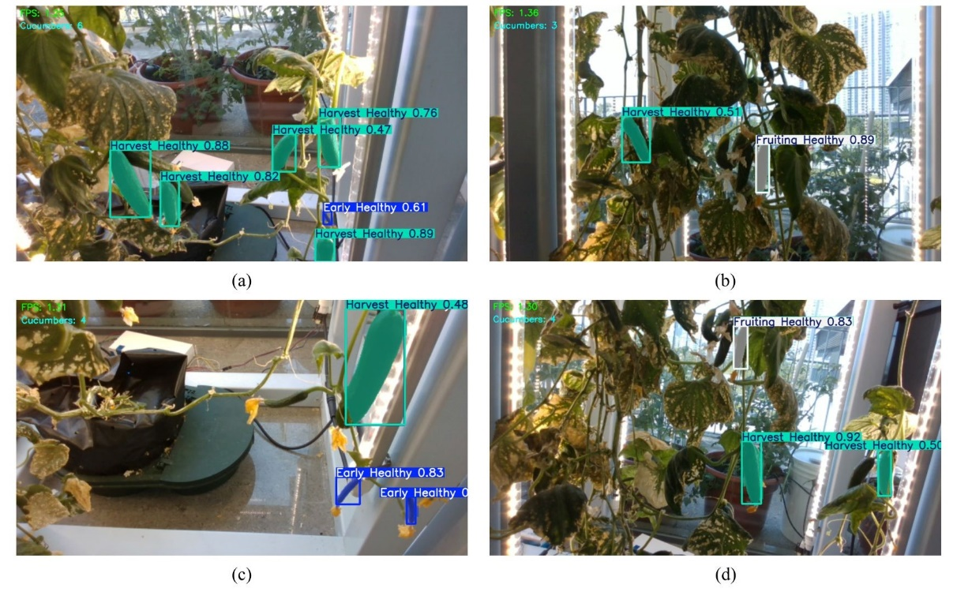
Figure 5 Segmentation Detection Results
Across all four scenarios, consistent localization and segmentation behaviour can be observed despite variations in illumination, object scale, plant density, and viewing angles. In dense foliage scenes, the model maintains stable instance separation, while in close-range views it produces well-defined object contours. Higher confidence scores are frequently observed for Fruiting Healthy and Harvest Healthy classes, indicating that cucumbers at more advanced growth stages exhibit stronger visual features for model discrimination. Comparatively lower confidence values in certain early-stage or less distinctive samples are likely influenced by limited dataset diversity and subtler visual characteristics.
Compared to conventional bounding box-only detectors, the segmentation masks provide richer spatial detail by outlining the actual object geometry within the scene. This is particularly relevant for inspection and robotic harvesting applications, where accurate boundary estimation can support grasp planning and interaction safety. Furthermore, the multi-class labelling framework enables simultaneous assessment of both growth stage and health condition, extending the system beyond simple object detection toward more informative agricultural monitoring.
The model training process was analysed using loss functions and evaluation metrics to assess convergence behaviour and learning stability. Figure 6 presents the training dynamics, including loss evolution and detection metrics across epochs.
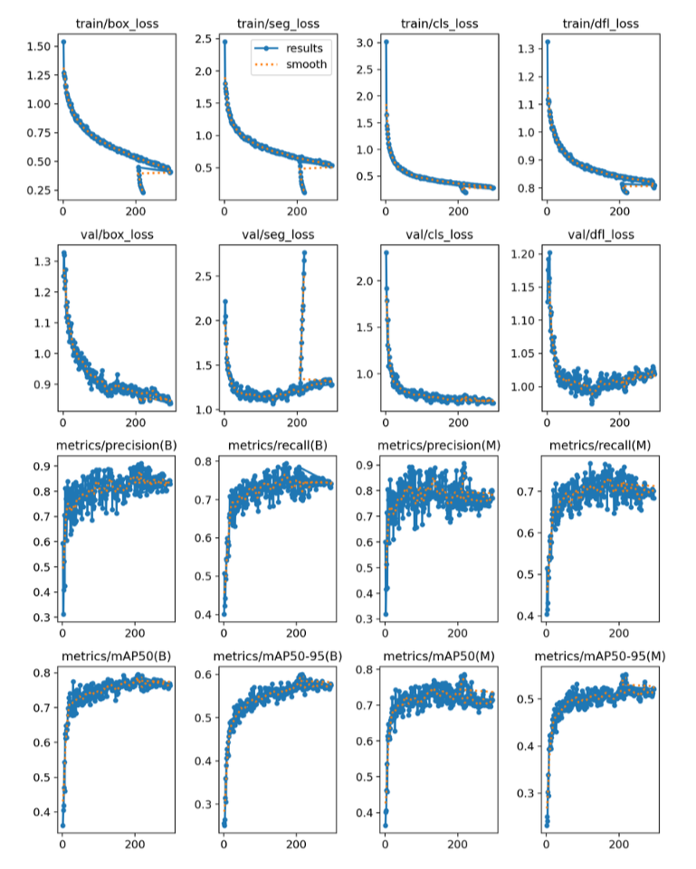
Training performance curves indicate stable convergence throughout the optimization process. The consistent reduction of box, segmentation, and classification losses suggests effective feature learning and class separation. Precision, recall, and mAP metrics exhibit progressive stabilization, confirming that the model achieved reliable detection performance without signs of divergence or overfitting.
Figure 6 Training and validation performance curves of the YOLOv8-seg model
A quantitative summary of detection performance is provided in Figure 7, which illustrates class-wise average precision results on the validation and test sets.
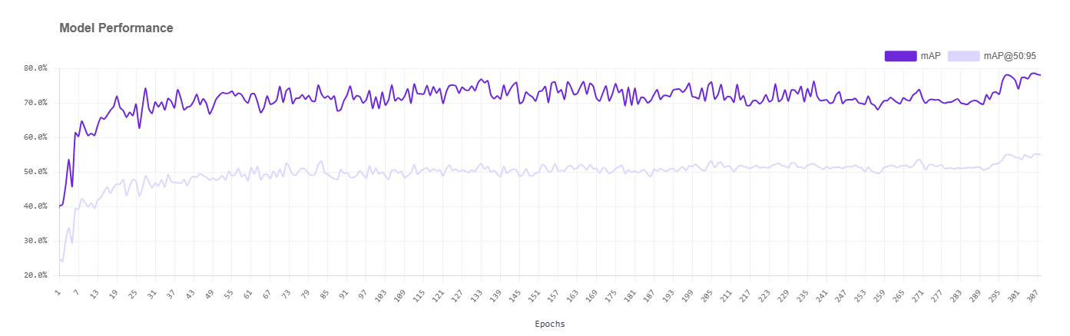
Figure 7 YOLOv8-seg model performance
Despite the promising detection performance, several limitations should be acknowledged. The relatively small test dataset and class imbalance, particularly for unhealthy samples, may contribute to variability in class-wise metrics. Additionally, evaluation was conducted under limited environmental conditions. Broader validation across diverse lighting and greenhouse scenarios would further strengthen model generalization. Future work should prioritize dataset expansion and robustness evaluation on embedded robotic platforms.
Overall, the results confirm that the proposed AI vision system achieves reliable multi-class cucumber detection and instance segmentation using real-world image data, supporting its applicability in agricultural inspection and robotic harvesting contexts.

Conclusion
This study presented an AI vision-based cucumber detection and inspection system integrated into an autonomous agricultural robotic platform. The primary contribution lies in the development and evaluation of a YOLOv8 instance segmentation model capable of performing multi-class growth-stage and health classification under realistic agricultural conditions. By combining bounding box detection with pixel-level segmentation masks, the proposed approach enables shape-aware perception, improving object boundary estimation in scenes involving occlusion, foliage overlap, and varying illumination.
Experimental results demonstrate that the model achieved strong detection performance, with high precision and stable mAP values across validation and test datasets. Class-wise analysis indicates particularly robust performance for Fruiting Healthy and Harvest Healthy categories, reflecting the model’s ability to distinguish visually mature cucumbers. Although performance variability was observed in certain early-stage or unhealthy classes, overall results confirm the feasibility of deploying instance segmentation for practical crop inspection tasks. Training convergence analysis further verified stable optimization behaviour without signs of overfitting.
Beyond perception, the system architecture integrates navigation, depth-based 3D localization, and robotic manipulation within a unified ROS 2 framework. This demonstrates the practical applicability of the vision module in real robotic harvesting scenarios, extending its relevance beyond isolated image-based evaluation.
Future work will focus on expanding the dataset to improve class balance, particularly for unhealthy samples, and evaluating performance across broader greenhouse and field environments. Additional improvements may include model optimization for faster inference on embedded hardware, integration of temporal tracking for improved robustness, and enhanced calibration between the camera and robotic arm to support more precise grasp planning. These advancements will further strengthen the reliability and scalability of AI-driven agricultural inspection systems.

References

[1] | N. Wang, T. Qian, J. Yang, L. Li, Y. Zhang and X. Zheng, "An Enhanced YOLOv5 Model for Greenhouse Cucumber Fruit," p. 15, 2022.
[2] | P. Kamat, S. Gite, H. Chandekar, L. Dlima and B. Pradhan, "Multi-class fruit ripeness detection using YOLO and SSD object detection models," Discover Applied Sciences, p. 17, 2025.
[3] | M. Chen, S. Zhang, X. Zhai, P. Hu, Z. Wang, H. Zhu, Z. Li, F. Wang, Z. Han, F. Zhang, M. Wei and Y. Shi, "Intelligent detection of wilted cucumber leaves with deep learning model in real greenhouse conditions," Industrial Crops & Products, p. 13, 2025.
[4] | Q. Zhang and W.-H. Su, "Real-Time Recognition and Localization of Apples for Robotic Picking Based on Structural Light and Deep Learning," Smart Cities, p. 18, 2023.
[5] | X. Xiao, Y. Jiang and Y. Wang, "Key Technologies for Machine Vision for Picking Robots: Review and Benchmarking," Machine Intelligence Research, p. 15, 2025.
[6] | T. Yoshida, T. Kawahara and T. Fukao, "Fruit recognition method for a harvesting robot with RGB-D cameras," ROBOMECH Journal, p. 10, 2022.
[7] | Sanchez-Molina, J.A.; Rodriguez, F.; Moreno, J.C.; Sanchez-Hermosilla, J.; Gimenez, A., "Robotics in greenhouses. Scoping review," Computers and Electronics in Agriculture, p. 21, 2024.
[8] | H. A. Khan, U. Farooq, S. R. Saleem, U.-u. Rehman, M. N. Tahir, T. Iqbal, M. J. M. Cheema, M. A. Aslam and S. Hussain, "Design and development of machine vision robotic arm for vegetable crops in hydroponics," Smart Agricultural Technology, p. 11, 2024.

