Emerging Soil Nutrient Monitoring Technologies: A Review

Kok-Yeow You
Faculty of Electrical Engineering, Universiti Teknologi Malaysia, 81310, Skudai, Johor, Malaysia; kyyou@fke.utm.my
Chen-Son Yue
Faculty of Applied Sciences, Tunku Abdul Rahman University of Management and Technology, Jalan Genting Kelang, 53300 Kuala Lumpur, Malaysia; yuecs@tarc.edu.my
Cheong-Yew Chong
Faculty of Applied Sciences, Tunku Abdul Rahman University of Management and Technology, Jalan Genting Kelang, 53300 Kuala Lumpur, Malaysia; chongcy@tarc.edu.my
Cheng-Seong Khe
Department of Fundamental and Applied Sciences, Universiti Teknologi PETRONAS, 32610 Seri Iskandar, Perak, Malaysia; chengseong.khe@utp.edu.my
Samuel Chan Hsin Chlen
Department of Psychology and Counselling, Southern University College, 81300, Skudai, Johor, Malaysia; hcchan@sc.edu.my

Kah-Meng Leong
Department of Electrical & Electronic Engineering, Southern University College, 81300, Skudai, Johor, Malaysia; kmleong@sc.edu.my
Adeline Sneha
School of Technology, Asia Pacific University of Technology & Innovation, 57000 Kuala Lumpur, Wilayah Persekutuan Kuala Lumpur; adeline.john@apu.edu.my

ABSTRACT:
This paper reviews emerging real-time soil nutrient monitoring systems, including those integrated with machine learning (ML) and wireless communication technologies. Soil nutrients are critical for crop productivity, with fertilization schedules often optimized to meet market-driven harvest timelines. Timely crop maturity is essential to prevent shipment delays, and fertilizer quality strongly affects plant growth. Over-application can lead to soil pollution, whereas under-application reduces yield. Therefore, a precise, user-friendly, robust, and cost-effective nutrient monitoring system is essential for supporting global agricultural productivity. In this study, the advantages and limitations of existing nutrient measurement and monitoring techniques are comprehensively evaluated. As an example, variations in NPK nutrient content (nitrogen, phosphorus, and potassium) in organic-based fertilizer were analyzed using both a pH meter and a microwave plasma atomic emission spectrometer.
KEYWORDS:
Soil nutrients, microwave sensors, microwave measurement techniques, spectroscopy methods, NPK monitoring, optical sensors, machine learning, organic fertilizer, oil palm residuals, electromagnetic spectrum.

Introduction :
Typically, fertilizer production at factories operates on a large scale, with finished products undergoing rigorous physical and chemical testing to verify compliance with predetermined specifications, particularly regarding (N), phosphorus (P), and potassium (K) and magnesium (Mg) percentages. Typically, mass-produced fertilizers have issues such as non-uniform mix of nutrients (NPK ratio mix), as shown in Fig. 1. Therefore, before each fertilizer package manufactured by the fertilizer factory must go through a quantity control test.
In addition, the N, P, and K are classified as macronutrients for crops, which are typically formulated with specific nutrient blends to address the diverse requirements of different crops. Crops are generally classified into three groups, namely root and tuber crops, fruit and flower crops, and leafy vegetables, each requiring different nutrient compositions and NPK ratios. Typically, root and tuber crops such as potatoes, carrots, and radishes need higher potassium (K) levels. On the other hand, fruit and flower crops like tomatoes, chili, and strawberries benefit from higher phosphorus (P) to support flowering and fruiting. Leafy vegetables such as spinach, lettuce, and cabbage require higher nitrogen (N) to promote leaf growth.
In general, in spring, fertilizers with an N: P :K ratio of 16%: 6% :4% are often used, which promotes root growth and green lawns. In order to encourage the production of flowers and fruits, the ratio of N: P :K can be 3%: 20% :20%, where the nitrogen (N) content is low, while the phosphorus (P) and potassium (K) contents are high. For instance, in pineapple cultivation, optimal levels of nitrogen (15%), phosphorus (15%), and potassium (15%) are vital. Furthermore, pineapple growth at different stages requires different NPK ratios as tabulated in Table 1. These nutrient monitoring are crucial for ensuring healthy pineapple growth and timely maturity.
Table 1. Proposed N:P:K (and MgO) fertilizer ratio for Malaysian pineapple cultivation.
Crop | Age  (months after planting) | N: P: K (:MgO)
Crop | Age  (months after planting) | First suggestion | Second suggestion
Malaysian Pineapple | 1 to 3 months (Plant established) | 15: 15: 15 | 15: 30: 15
Malaysian Pineapple | 4 to 5 months (Vegetative growth) | - | 28: 14: 18
Malaysian Pineapple | 6 to 9 months (Flowering) | 12: 12: 17 (:2) | 15: 15: 30
Malaysian Pineapple | 10 to 13 months (Fruit Growth) | - | 15: 15: 30
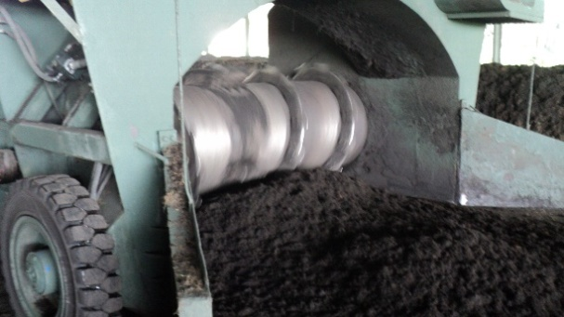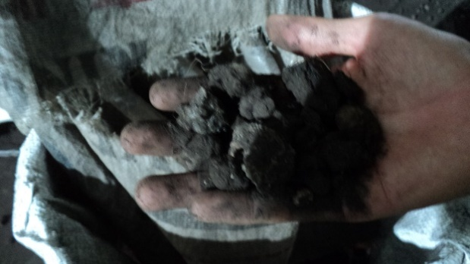
Fig. 1. The process of fertilizer production in large-scale industry.
Accurate measurement of essential macronutrients (N, P, K) in soil and fertilizers is critical for effective agricultural management; however, existing methods face limitations in sensitivity, accuracy, and practicality. Although widely used, conventional chemical techniques, such as the Kjeldahl, Dumas, dry ash, ascorbic acid, and flame photometry methods, are typically time-consuming and destructive.
Accurate, non-destructive indirect measurement techniques are increasingly needed to monitor NPK in soil and fertilizers. Various NPK nutrient testers are now commercially available, ranging from low-cost devices costing tens of US dollars to high-end professional instruments priced in the millions, depending on their functionality, reliability, and measurement accuracy. Current methods include electric conductivity (EC) probes, selective ion electrodes (ISEs), and spectroscopic techniques, such as infrared (IR), near-infrared (NIR), nuclear magnetic resonance (NMR), ultraviolet-visible (UV-Vis), atomic emission (AE), and atomic absorption (AA) spectroscopy. Each measurement technique operates within a specific frequency range, determined by the molecular interaction mechanisms of the fertilizer with different sensing sources across the electromagnetic spectrum, as shown in Fig. 2.
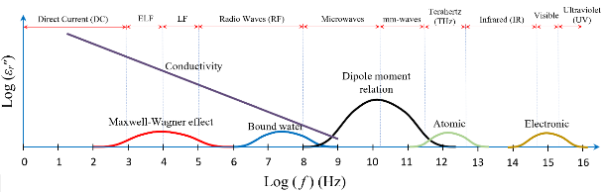
Note: ELF, LF, and mm-waves stand for extremely low frequencies, low frequencies, and millimeter-waves, respectively.
(a)
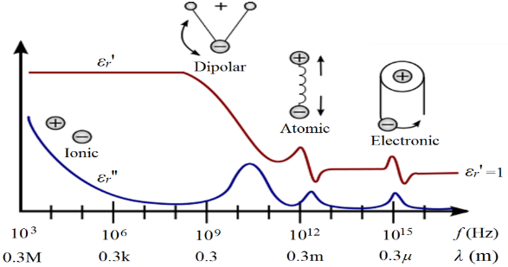
(b)
Fig. 2. (a) Correlation between the molecular mechanism of specimen under test, loss factor, ε_{r}״, and operating frequency, f. (b) Frequency dependence of relative complex permittivity, ε_{r} = ε_{r}ʹ - j ε_{r}ʺ.
Effective NPK monitoring contributes to better resource management, reducing the risk of over-fertilization, and supporting sustainable agricultural practices. Integration of AI in agricultural sensing systems can also drive innovation and reduce costs, aligning with policies that encourage technological advancement and economic efficiency in the agriculture sector. In this book chapter, the direct methods (chemical test methods, such as Kjeldahl technique) and indirect methods (using optical and electrical measurement principles) will be described and compared in detail, including costs, facilities, advantages, disadvantages, and measurement principles/mechanisms.
Direct Chemical Test Methods :
Kjeldahl Method
The classical Kjeldahl method proposed by Johan Kjeldahl is one of the reference/standard methods for measuring nitrogen content in food, animal feed, and agricultural specimens (Sáez-Plaza et al., 2013). The basic classic apparatus of this method is shown in Fig. 3. However, recently, there are lot of automatic Kjeldahl nitrogen analyzer has been commercialized to improve the sensitivity and accuracy of nitrogen measurement.

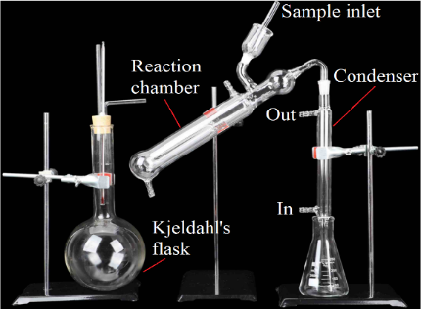
Fig. 3. Basic classic Kjeldahl test apparatus.

As mentioned above, recently, the total N content in the fertilizer can easily be determined using automatic Kjeldahl nitrogen analyzer (Lombardo et al., 2017). In this study, the modern Kjeldahl test systems are used for monitoring NPK content in organic fertilizer, as shown in Fig. 4. Basically, the measurement method is divided into three steps: wet digestion, distillation, and sum of nitrogen bound in ammonium is estimated.
Step 1: Wet Digestion Process
Briefly, an amount (0.6 g) of organic fertilizer is accurately weighed and digested in the Kjedahl digestion block as shown in Fig. 4 (a) for 2 hours (Gerhardt, 2018).

Step 2: Distillation Process
Up to 40 ml of distilled water and 70 ml of 32 % sodium hydroxide are added in the distillation step (Gerhardt, 2020).

Step 3: Nitrogen (N) Content Estimation
The distillate collected is then titrated with 0.1 M hydrochloric acid using methyl red and bromocresol green as indicator as shown in Fig. 4 (b). The total N content in the fertilizer samples is expressed as % N and it is calculated according to the formula as:
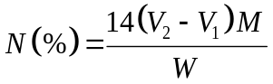 (1)

where V₂ and V₁ are the volumes (mL) of HCl in specimen under test and control, respectively. Whereas, M and W are the molarity (mol L⁻¹) of HCl and the weight (mg) of specimen, respectively.

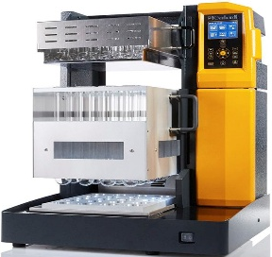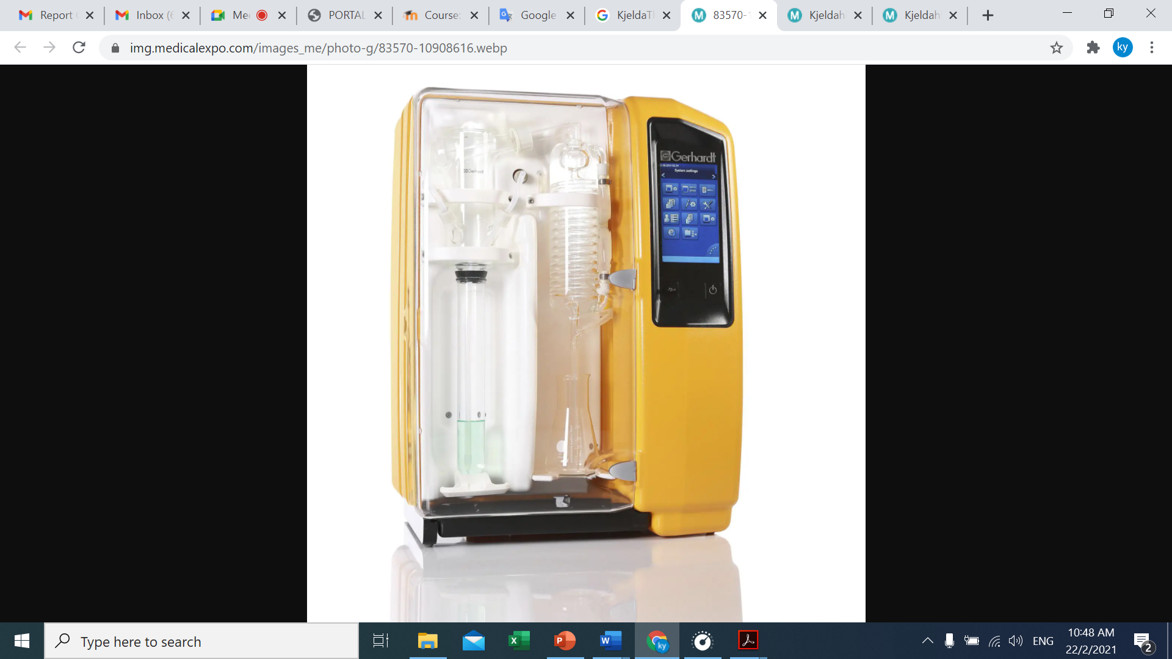
- (b)

Fig. 4. (a) Kjeldahl digestion system. (b) Kjeldahl distillation system.
Dumas Method
Besides kjeldahl method, there are other methods for total nitrogen determination in agricultural products, such as dumas method proposed by Jean-Baptiste Dumas in 1826. By Dumas test, a small amount dried soil or fertilizer sample is heated in a nitrogen-analysis instrument to convert all nitrogen compounds into gases, which are purified and quantified by the detector to determine the sample’s nitrogen content.
Indirect Test Methods :
An efficient method for non-destructive and precise monitoring of NPK in fertilizers is imperative (Muñoz et al., 2013; Potdar et al., 2021; Maria Khaydukova et al., 2021; Silva et al., 2023; Dattatreya et al., 2024). Various NPK fertility nutrient testers are available in the market, ranging from low-cost options to high-end, multi-functional devices costing several hundred thousands of dollars. Each type of tester and measurement technique has its own advantages and disadvantages.
Electric Conductivity (EC) Probes
An electric conductivity (EC) probes made of three or five metal electrodes are the simplest, cost-effective, rapid, and most commonly used sensor for on-site NPK content monitoring (Baldi et al., 2020; Maria Khaydukova et al., 2021; Islam et al., 2023). It is known that inorganic minerals in fertilizer product contains high ions and cause a high value of the corresponding potential (Sánchez-Monedero et al., 2001). These probes measure the DC conductivity value of the soil, which correlates with the NPK content. The DC potential value depends on the amount of NPK in the soil. However, they may lack sensitivity to small NPK amounts in dry fertilizer or soil and can be prone to errors due to non-uniform electrode surfaces in contact with different soil textures, unless tailored for specific soil types.
Ion Selective Electrodes
An ion selective electrode (ISE) test method is an indirect test method to determine the activity of specific ions in aqueous solution by measuring the electrical potential, E (Joseph V. Sinfield et al., 2010; Zhai et al., 2022). Sometimes, the ion selective electrode is called specific ion electrode (SIE). The relationship between measured potential, E (in unit V) and specific ion concentration, C (in unit mg/L) in the solution under test is given as Nernst equation:
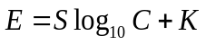 (2)

where values of K and S depend on the ion elements being measured as well as the electrode structure. The unknown S and K can be determined from plot curve of E versus log₁₀ C. Fertilizer products containing different amounts of ions will cause the difference in exited conductivity in the fertilizer (Yagüe & Quílez, 2012; Chen et al., 2021). Typically, nitrogen (N) in fertilizers is present as nitrate (NO₃⁻) or ammonium (NH₄⁺), while potassium (K) appears as potassium ions (K⁺), and magnesium (Mg²⁺). In contrast, phosphorus (P) is generally found in the form of phosphate ions (PO₄³⁻). Indirectly, the inorganic nutrient content in fertilizer is capable of correlating with measured potential.
For example, a calibration curve for nitrogen ions is obtained by preparing standard solutions of known concentration C and measuring the corresponding potential E. However, because ISEs rely on selective membranes that allow only target ions to pass, each ISE can measure only specific ions, and even then, the membranes are never perfectly selective. Other ions may still penetrate the membrane, and at high concentrations, ion–ion interactions hinder mobility, reducing the effective ion concentration near the membrane to differ from the true bulk value. These factors collectively lead to measurement inaccuracies when using ISEs.
Spectroscopy Methods
There are several types of spectroscopic measurement techniques, including nuclear magnetic resonance (NMR) (Sørensen et al., 2015), infrared (IR) spectroscopy, near-infrared (NIR) spectroscopy (He et al., 2005; Lin et al., 2018; Rawankar et al., 2018; Mustaqimah et al., 2024; Xu et al., 2024), ultraviolet-visible (UV-Vis) spectroscopy (Silva et al., 2019; Potdar et al., 2021; Silva et al., 2023), microwave plasma atomic emission (MPAE) spectroscopy, and atomic absorption (AA) spectroscopy (Yang et al., 2002; Marcos André Bechlin et al., 2014).
Among these IR, NIR, and UV-Vis are classified as optical spectroscopic methods, whereas MPAE represents a microwave-based spectroscopic technique. Both optical and microwave spectroscopy operate on similar fundamental principles, an electromagnetic wave interacts with the soil or fertilizer, and resulting response is analyzed to extract intrinsic fertilizer properties. These properties can then be correlated with the NPK content present in soil/fertilizer.
In optical spectroscopy, the key material parameter is the complex refractive index, n = n′ – jn″, which describes how light propagates, reflects and attenuates within the soil or fertilizer. In microwave spectroscopy, the corresponding parameter is the relative complex permittivity, εᵣ = ε_{r}′ – jε_{r}″, which characterizes polarization and energy dissipation at lower frequencies (You, 2016). The relationship between n (optical) and ε_{r} (microwave) is given as n² = ε_{r}. The primary distinctions between microwave and optical (infrared) techniques arise from their operating frequency ranges (300 MHz to 300 GHz for microwave and 300 GHz to 430 THz for infrared) and the nature of their excitation sources, as shown in Fig. 4.
Fig. 5 shows the response of the ε_{r} from Radio frequencies (RF) to Ultraviolet frequencies. At microwave frequencies, variations in ε_{r}ʹ and ε_{r}ʺ arise from dipole relaxation processes occurring within the soil or fertilizer material. While, at infrared frequencies, ε_{r}ʹ and ε_{r}ʺ exhibit a significant reaction due to the resonant occurring between the molecular vibration of the substance and the infrared frequency. The NPK content of fertilizer or soil is determined based on the absorbance and reflectance of the fertilizer/soil on the monochromatic light source when exposed to the source. Molecules of each element N, P, K resonate at a certain wavelength and exhibit significant resonance absorption effects at that wavelength. The wavelength ranges of source used by IR, NIR, UV, and Vis spectroscopy are 700-1000 nm, 780–2500 nm, 200-400 nm, and 380 nm to 780 nm, respectively. Unfortunately, various ions of N, P, and K has the same spectral characteristics and overlap of some wavelengths (Potdar et al., 2021). Furthermore, this type of NPK measurement technique requires good environmental control and is less suitable for on-site measurements. Often, the technique also requires personnel with skills in using test equipment.
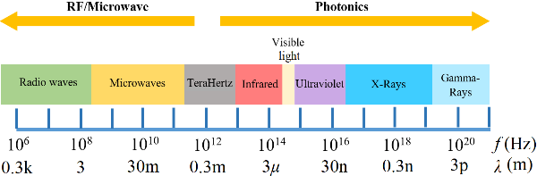
Fig. 5. Electromagnetic spectrum.
Nuclear Magnetic Resonance (NMR) Spectroscopy Methods
In nuclear magnetic resonance (NMR) spectroscopy, the fertilizer sample is positioned in a magnetic field, which causes certain nuclei to align with or against the field. When a radio-frequency (RF) is applied, these nuclei are excited from their equilibrium state and driven into resonance. As the nuclei relax back to their original alignment, they emit characteristic RF signals. The emitted signals is detected with sensitive radio receivers and generate an NMR spectrum. The spectrum is used to quantify specific nuclei associated with nutrient components. Normally, version of ¹⁵N, ³¹P, ³⁹K, and ¹³C NMR spectroscopy are used to monitor the nutrient in fertilizer or soil. For instance, ¹⁵N NMR spectroscopy is implemented to examine specimen under test containing the ¹⁵N nucleus.
Ultraviolet-Visible (UV-Vis) Spectroscopy (P and K Contents Test)
The UV–Vis spectroscopic module operates by measuring the interaction between ultraviolet light and the fertilizer sample. The sample is exposed to UV light within the wavelength range of 200–400 nm, and the absorption of light of the sample is measured. According to Beer’s law, the absorbance, A of the sample is given as:
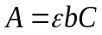 (3)

where ε is the molar absorptivity of the element dissolved in the specimen solution and b is the length of light path in specimen, respectively. While, C is the concentration of the element in the specimen solution. Once ε and b are known, the concentration, C can be determined from the measured absorbance, A. In practise, the absorbance, A is measured in term of light intensity, I. The relationship between A and I can be expressed in logarithm form:

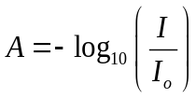 (4)
where I₀ and I are the intensity of incident light in a sample cuvette and the intensity of transmitted light. The Beer-Lambert law states that absorbance increases with both concentration, C and path length, b. A calibration curve is used to determine how absorbance varies with concentration. The UV-Vis spectrophotometer measures the strength of light passing through the sample compares it to light intensity through reference specimen using a photodiode for signal processing.
Near-Infrared (NIR) Spectroscopy (P and K Contents Test)
Far-infrared radiating ceramics are made of twenty or more inorganic compounds and trace metals or specific natural ores in different proportions, and then calcined at a high temperature of 1200 ºC to 1600 ºC, so that the ceramics can emit far-infrared rays of a specific wavelength. For instance, water molecules vibrate near 10 µm, far-infrared radiation in this range enhances molecular motion through resonance absorption. The commercial near-infrared (NIR) spectrophotometer is shown in Fig. 6.

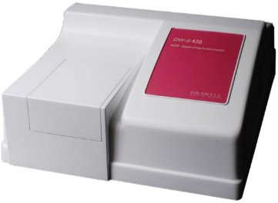
Fig. 6. DRAWELL DW-S430 Near-infrared (NIR) spectrophotometer.
Microwave Plasma Atomic Emission Spectroscopy (P and K Contents Test)
Besides IR, NIR, UV, and Vis spectroscopy, atomic emission (AE) and atomic absorption (AA) spectroscopy are also widely used for N, P, and K detection (Yang et al., 2002). In AE spectroscopy, atoms or molecules of N, P, or K are excited, such as by microwave plasma, and emit light at characteristic wavelengths, with emission intensity indicating their concentration. In contrast, AA spectroscopy measures the absorption of light by N, P, or K ions. Although commercial spectrometers provide straightforward P and K measurements, several sample-preparation steps are still required before fertilizer analysis can be performed.In this study, a microwave plasma atomic emission spectrometer (Agilent 4210) is used to measure P and K, as shown in Fig. 7. The technique is based on emission spectra generated when atoms are excited by microwave plasma, with elemental concentration determined from emission intensity. Although the method is straightforward, sample preparation is still required prior to measurement.

Step 1: Preparation of Standard Test Solutions
Precisely 4.56 g of Na₂H₂PO₄ and 1.91 g of KCl were weighed separately to prepare two stock solutions, each with a concentration of 1000 mgL⁻¹, in 1000 mL volumetric flasks. The salts were dissolved in deionized water and diluted to the 1000 mL mark. These stock solutions were then further diluted, 200-fold for phosphorus and 1000-fold for potassium, to obtain working solutions of 5 mgL⁻¹ (P) and 1 mgL⁻¹ (K), respectively. From the freshly prepared stock solutions, a series of 100 mL standard solutions were prepared with concentrations of 50, 100, 200, 400, and 1000 µgL⁻¹ for P, and 10, 50, 100, 200, and 500 µgL⁻¹ for K. These standards were used to generate calibration curves relating signal intensity to the concentrations of P and K, as summarized in Table 2. The limit of detection (LOD) and limit of quantitation (LOQ) are determined according to the formulae of 3.3 s/S and 10 s/S, respectively (Lee et al., 2015).

Step 2: Preparation of Fertilizer Samples
The fertilizer digestion procedure was adapted from Yang et al. (2002), and each sample was processed in triplicate. In brief, 0.5 g of fertilizer was digested with 9 mL of HNO₃ and 3 mL of HCl in a beaker at 80 °C for 1 h until a clear solution was obtained. The digest was then cooled to room temperature, filtered through a syringe filter to remove any remaining solids, and subsequently diluted tenfold with deionized water prior to MP-AES analysis.

Step 3: P and K Measurements Using Microwave Plasma Atomic Emission Spectrometer
The quantification of P and K in the fertilizer samples was performed using an Agilent 4210 MP-AES microwave plasma atomic emission spectrometer, as shown in Fig. 7. The instrument was equipped with a liquid nitrogen Dewar to supply nitrogen gas for sustaining the microwave-induced plasma. The sample introduction system consisted of an SPS4 autosampler, solvent-resistant tubing, a double-pass cyclonic spray chamber, and an inert Flow Blurring nebulizer (OneNeb). Instrument operation and data acquisition were controlled using the MP Expert software.
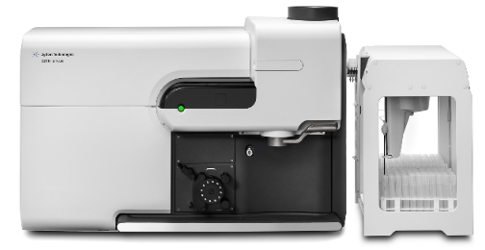
Fig. 7. Agilent 4210 MP-AES microwave plasma atomic emission spectrometer.

Table 2. Analytical characteristics of the MP-AES method.
Element | Concentration range, x (µg/L) | Regression equation | r² | LOD  (µg/L) | LOQ  (µg/L)
P | 1000 - 20000 | y = 0.0653x + 1029.1 | 0.9912 | 1853.5 | 5616.7
K | 10 - 5000 | y = 2.6231x + 119.79 | 0.9996 | 36.8 | 111.5
Note: x is the concentration of respective metal element (µg/L); y is the signal intensity of respective metal element; r² is the square of regression coefficient; LOD standard for limit of detection; LOQ standard for limit of quantification.

LED/Fiber-Optic Light Sensing Techniques:
Recently, a simple and cost-efficient LED-based sensing method, commonly referred to as colorimetry, has been proposed to measure NPK content based on the color absorption characteristics of wet fertilizer/soil sample (Liu et al., 2016; Regalado & Cruz, 2016). The measurement system consists of three or more LEDs as a light source, such as red, green, and blue color light. The reason is that N, P and K exhibit stronger absorption in the blue (~470 nm), green (~530 nm), and red (~650 nm) chromatic light, respectively (Masrie et al., 2017; 2018). The integration of LEDs as emitters/light sources and photodiodes as detectors forms a simple spectroscopic setup for directly detecting NPK nutrients. Typically, N, K, and P correspond to red, blue, and green wavelengths, respectively. In fact, the absorption wavelengths of soils containing N, P, and K are also different depending on the use of different chemical reagents and the type of soil as well as moisture content in the soil (Yusof et al., 2016; Kim et al., 2009). The measurement tolerance of this method is large, hence the detected NPK con-tent is usually classified as "low", "medium" or "high", making the method unsuitable for detecting small concentration changes. Fig. 8 illustrates the operating principle of the fiber-optic NPK sensor. LEDs of different colours emit light through transmitting fibers, and the reflected light, dependent on the NPK content in the soil or fertilizer solution, is collected by a central receiving fiber. The phototransistor converts the light into an electrical signal, which is processed by a microcontroller to estimate NPK levels and display the results on an LCD.
Microwave Sensing :
Recently, a microwave sensing is an emerging technique for real-time, non-destructive, and precision measurement of N, P, and K content in fertilizers and soil. Its operating principle is based on how microwave interact with the ε_{r} = ε_{r}ʹ - j ε_{r}ʺ of fertilizer/soil.
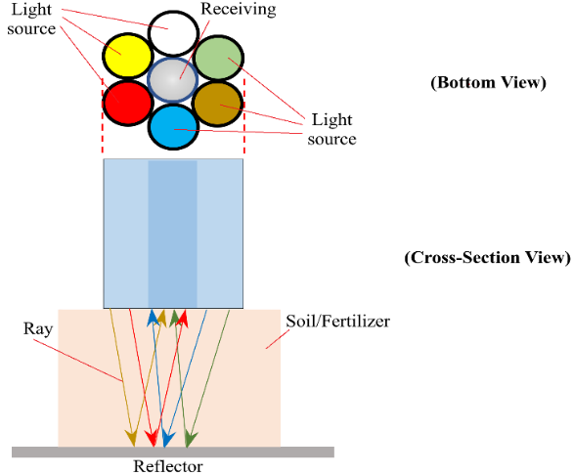
Fig. 8. Principle of optic fiber-based sensor.
The real part, ε_{r}ʹ correlates to polarization molecules and moisture in the fertilizer/soil, and the imaginary part, ε_{r}ʺ relates to ionic movement and conductivity of NPK in the fertilizer/soil. The nitrogen (NO₃⁻ / NH₄⁺) and potassium (K⁺) are present in ionic form, which strongly influences imaginary part, ε_{r}ʺ when exposed to microwave fields.
In microwave sensing, a sensor operating within microwave frequency range is used to measure the reflection coefficient, S₁₁, the transmission coefficient, S₂₁ or both, when the sensor head is in contact with the fertilizer or soil (You et al., 2013). Transmission, S₂₁ measurements may be performed in either the time-domain or the frequency-domain. In addition, microwave resonate sensors can detect NPK content by measuring shifts in resonant frequency, Δf and changes in the quality factor, Q (Lim et al., 2026). These parameters (S₁₁, S₂₁, Δf, and Q) correlate with NPK concentrations and can be analyzed using polynomial regression, ANN/ML algorithms, or PSO/GA optimization techniques. However, there several limitations in NPK monitoring by microwave sensor, such as:

(a) | P detection is weaker due to low solubility of phosphate. P usually exists as insoluble phosphate (PO₄³⁻) and has limited ionic mobility and cause weaker microwave interaction.
(b) | Moisture strongly affects permittivity; must be accounted for.
(c) | Soil heterogeneity can introduce variability.
(d) | Requires calibration models for different soil/fertilizer types.
PH Test :
In this work, the pH of the raw fertilizer is directly measured using the Hanna HI98127 pH tester. While, for fertilizer solution pH test, the fertilizer solution is prepared by adding deionized water in the ratio of 1:10 (1g : 10 mL) and the solution is left for 2 hours for maximum salts dissolution (Sánchez-Monedero et al., 2001). The pH of the prepared solution is tested using pH tester. The pH values are noted when the readings are stabilized.
Organic-Based Fertilizer Specimens :
Up to 36 samples with different NPK ratios of the raw oil palm-based fertilizer samples are provided by Green Plant Organic Fertilizer manufacturer. The fertilizer samples are divided into two groups, namely group A without containing 2% MgO and group B with 2% MgO, respectively, as listed in Table 3. It should be noted that the nutrient contents (NPK) in the fertilizer are initially notified by the manufacturer. All raw oil palm-based fertilizer samples are verified using third-party measurement techniques, specifically the pH test, Kjeldahl method, and microwave plasma atomic emission spectrometry (MP-AES).
Results and Discussion :
The raw oil palm residual mixture naturally contains a small amount of inorganic elements. The comparison of inorganic elements in each type of residual, as reported in the literature (Gurmit et al., 1989; Su et al., 2022), studied raw oil palm residual, and manufacturer labeling is listed in the Table 4.
It should be noted that the studied raw oil palm residual is a mixture of various parts, such as empty fruit bunch (EFB), (MF), Palm frond (PF), Palm trunk (PT), palm kernel shell (PKS), and palm oil mill effluent (POME). The NPK content of inorganic elements in group A and group B fertilizer samples, measured using the Kjeldahl method and the MP-AES method, is listed in Table 5 and Table 6.
The pH of fertilizers in both a nearly dry state (< 20% moisture) and in solution has been measured. Both measurements yield significantly different pH values. It has been found that the pH of dry fertilizers is independent of the NPK content as shown by the pH values listed in Tables 5 and 6. This is likely due to the inactivity of the inorganic elements in nearly dry fertilizers, which prevents the pH meter from detecting changes in pH between fertilizers with different N, P, or K contents. The pH measurements for all fertilizer solution samples in groups A and B , as listed in Tables 5 and 6, are re-plotted in Figs. 9 (a) and (b). The pH values appear to be closely related to the N, P, and K contents. Nearly all samples display alkalinity (pH > 7). However, when the N content exceeds 4%, the samples exhibit weak acidity, and when the N content exceeds ~ 9%, the pH returns to alkaline, as shown in Fig. 9 (b). Therefore, predicting the N content for samples N1-N6 in group B based on pH changes is unsuitable due to the ambiguity in N content ranging from 1% to 12%. The relationship between pH and NPK content has been modeled using the regression method, as detailed in Table 7. Overall, the pH measurements exhibit a clear trend when correlated with N, P, and K content (in %), achieving a fitting coefficient of r² > 0.96. Overall, the pH value of Set B samples (with 2% MgO) are higher than Set A (without 2% MgO), since the MgO is an alkaline element.
Conclusion :
Emerging NPK monitoring techniques are thoroughly reviewed, and their practical applications are demonstrated and explained. Recently, the application of artificial intelligence (AI) has significantly expanded into various fields, including precision agriculture (Rawankar et al., 2020; Islam et al., 2023; Ennaji et al., 2023; Thorat et al., 2023; Dattatreya et al., 2024; Sajindra et al., 2024; Xu et al., 2024). This AI-enable NPK monitoring system reduces the complexity of agricultural sensing equipment, as well as the associated costs and manpower requirements.
Table 3. Raw fertilizer sourced from Green Plant Organic Fertilizer manufacturer.
Group A (without 2% MgO)
Sample | N (%) | P (%) | K (%)
N1 | 1.5 | ~1.2 | ~3.15
N2 | 2.5 | ~1.2 | ~3.15
N3 | 3.5 | ~1.2 | ~3.15
N4 | 4.5 | ~1.2 | ~3.15
N5 | 5.5 | ~1.2 | ~3.15
N6 | 6.5 | ~1.2 | ~3.15
P1 | ~2.0 | 1.0 | ~3.15
P2 | ~2.0 | 2.0 | ~3.15
P3 | ~2.0 | 3.0 | ~3.15
P4 | ~2.0 | 4.0 | ~3.15
P5 | ~2.0 | 5.0 | ~3.15
P6 | ~2.0 | 6.0 | ~3.15
K1 | ~2.0 | ~1.2 | 3.0
K2 | ~2.0 | ~1.2 | 4.0
K3 | ~2.0 | ~1.2 | 5.0
K4 | ~2.0 | ~1.2 | 6.0
K5 | ~2.0 | ~1.2 | 7.0
K6 | ~2.0 | ~1.2 | 8.0
Group B (with 2% MgO)
Sample | N (%) | P (%) | K (%)
N1 | 1.5 | ~1.2 | ~3.15
N2 | 3.0 | ~1.2 | ~3.15
N3 | 5.0 | ~1.2 | ~3.15
N4 | 7.0 | ~1.2 | ~3.15
N5 | 10.0 | ~1.2 | ~3.15
N6 | 12.0 | ~1.2 | ~3.15
P1 | ~2.0 | 1.0 | ~3.15
P2 | ~2.0 | 3.0 | ~3.15
P3 | ~2.0 | 5.0 | ~3.15
P4 | ~2.0 | 7.0 | ~3.15
P5 | ~2.0 | 10.0 | ~3.15
P6 | ~2.0 | 12.5 | ~3.15
K1 | ~2.0 | ~1.2 | 3.0
K2 | ~2.0 | ~1.2 | 6.0
K3 | ~2.0 | ~1.2 | 9.0
K4 | ~2.0 | ~1.2 | 12.0
K5 | ~2.0 | ~1.2 | 15.0
K6 | ~2.0 | ~1.2 | 17.0

Table 4. Inorganic composition of raw oil palm residual (weight %).
Ele-ment | Literature (Gurmit et al., 1989; Su et al., 2022) |  |  |  |  | This study
Ele-ment | Empty fruit bunch (EFB) | Palm kernel shell (PKS) | Mesocarp fiber (MF) | Palm frond (PF) | Palm trunk (PT) | Raw palm residual (Kjeldahl & MP-AES) | Manufacturer labeling
N | 0.56 –0.88 | 0.36 – 0.7 | 1.09 – 3.12 | 0.19 –0.71 | 0.40 – 0.44 | 1.12 ± 0.17 | 1.95 – 2.04
P | ~0.1 | – | – | – | – | 0.82 ± 0.06 | 1.2 – 1.26
K | ~2.5 | – | – | – | – | 3.76 ± 0.70 | 3.14 – 3.17
P₂O₅ | 1.12 –4.29 | 0.98 – 10.21 | 1.58 – 7.48 | 2.43 – 9.2 | 5.37 – 8.71 | 1.88 | –
K₂O | 39.98 –53.73 | 1.29 –10.38 | 1.99– 15.55 | 8.29– 39.8 | 24.50 – 44.5 | 4.53 | –
MgO | 3.68 –8.75 | 1.77 –14.36 | 4.20– 50.83 | 1.93 – 16 | 1.15 – 15.60 | – | –

Table 5. NPK contents and pH of the palm oil organic fertilizer samples without containing 2% MgO.
Samples | pH |  | Nitrogenª  (%) | Phophorusª |  | Potassiumª |  | N+P+K  (%)
Samples |  |  | Nitrogenª  (%) | P (%) | P₂O₅ (%) | K (%) | K₂O (%) | N+P+K  (%)
Samples | Solid | Solution
Set A (N1) | 7.4 | 8.61 | 0.79 ± 0.09 | 0.11 ± 0.00 | 0.25 | 5.13 ± 0.39 | 6.18 | 6.0
Set A (N2) | 8.7 | 7.41 | 1.73 ± 0.11 | 0.16 ± 0.03 | 0.37 | 5.42 ± 0.11 | 6.53 | 7.3
Set A (N3) | 8.5 | 7.09 | 2.38 ± 0.18 | 0.03 ± 0.00 | 0.07 | 4.80 ± 0.21 | 5.78 | 7.2
Set A (N4) | 8.4 | 6.89 | 2.89 ± 0.34 | 0.04 ± 0.00 | 0.09 | 5.18 ± 0.78 | 6.24 | 8.1
Set A (N5) | 8.6 | 6.82 | 3.69 ± 0.16 | 0.01 ± 0.00 | 0.02 | 5.79 ± 0.80 | 6.98 | 9.5
Set A (N6) | 8.5 | 6.78 | 5.18 ± 0.34 | 0.24 ± 0.13 | 0.55 | 5.47 ± 0.59 | 6.59 | 10.9
Set A (P1) | 7.4 | 9.06 | 1.45 ± 0.47 | 0.08 ± 0.00 | 0.18 | 4.85 ± 0.55 | 5.84 | 6.4
Set A (P2) | 7.5 | 8.62 | 1.49 ± 0.12 | 0.61 ± 0.14 | 1.40 | 5.42 ± 1.11 | 6.53 | 7.5
Set A (P3) | 7.8 | 7.99 | 1.26 ± 0.74 | 3.21 ± 0.31 | 7.35 | 5.43 ± 0.84 | 6.54 | 9.9
Set A (P4) | 7.5 | 7.85 | 1.21 ± 0.84 | 1.81 ± 0.59 | 4.14 | 5.41 ± 0.95 | 6.52 | 8.4
Set A (P5) | 7.9 | 7.54 | 0.00 | 2.91 ± 0.53 | 6.66 | 4.90 ± 0.61 | 5.90 | 7.8
Set A (P6) | 7.7 | 7.66 | 1.49 ± 0.17 | 4.13 ± 0.56 | 9.45 | 7.03 ± 0.50 | 8.47 | 12.7
Set A (K1) | 7.8 | 9.44 | 1.54 ± 0.18 | 0.22 ± 0.09 | 0.50 | 6.00 ± 0.76 | 7.23 | 7.8
Set A (K2) | 8.2 | 9.14 | 1.49 ± 0.34 | 0.25 ± 0.09 | 0.57 | 8.26 ± 0.42 | 9.95 | 10.0
Set A (K3) | 7.9 | 8.64 | 1.49 ± 0.52 | 0.24 ± 0.04 | 0.55 | 9.35 ± 0.60 | 11.27 | 11.1
Set A (K4) | 7.7 | 8.34 | 1.35 ± 0.16 | 0.23 ± 0.05 | 0.53 | 10.27 ± 0.69 | 12.37 | 11.9
Set A (K5) | 8.0 | 8.21 | 1.35 ± 0.32 | 0.16 ± 0.04 | 0.37 | 12.49 ± 0.82 | 15.05 | 14.0
Set A (K6) | 7.9 | 8.07 | 1.35 ± 0.04 | 1.13 ± 0.34 | 2.59 | 16.20 ± 0.65 | 19.52 | 18.7
ª Results are expressed as mean ± % RSD for triplicate analysis. The calculation of % N, % P₂O₅ and % K₂O were based on the conversion factors of % N = 1.00 × % N, % P = 0.437 × % P₂O₅ and % K = 0.83 × % K₂O, respectively.

Table 6. NPK contents of the palm oil organic fertilizer samples (Set B) with containing 2% MgO.
Samples | pH |  | Nitrogenª  (%) | Phophorusª |  | Potassiumª |  | N+P+K+ P₂O₅+ K₂O  (%)
Samples |  |  | Nitrogenª  (%) | P (%) | P₂O₅ (%) | K (%) | K₂O (%) | N+P+K+ P₂O₅+ K₂O  (%)
Samples | Solid | Solution
Set B (N1) | 8.0 | 8.41 | 0.98 ± 0.08 | 0.29 ± 0.03 | 0.66 | 5.61 ± 0.21 | 6.8 | 14.3
Set B (N2) | 8.7 | 7.64 | 0.00 | 0.19 ± 0.01 | 0.43 | 5.20 ± 0.67 | 6.3 | 12.1
Set B (N3) | 8.9 | 6.90 | 3.97 ± 0.62 | 0.24 ± 0.06 | 0.55 | 4.87 ± 0.43 | 5.9 | 15.5
Set B (N4) | 8.8 | 6.95 | 6.02 ± 0.86 | 0.07 ± 0.00 | 0.16 | 4.36 ± 0.74 | 5.3 | 15.9
Set B (N5) | 8.5 | 7.21 | 9.75 ± 1.04 | 0.73 ± 0.09 | 1.67 | 1.99 ± 0.77 | 2.4 | 16.5
Set B (N6) | 8.2 | 7.91 | 15.17 ± 1.16 | 0.18 ± 0.03 | 0.41 | 3.77 ± 0.15 | 4.5 | 24.0
Set B (P1) | 8.0 | 8.68 | 1.54 ± 0.17 | 0.38 ± 0.02 | 0.87 | 5.78 ± 0.95 | 7.0 | 15.6
Set B (P2) | 7.9 | 8.35 | 1.31 ± 0.08 | 1.35 ± 0.43 | 3.09 | 5.82 ± 1.05 | 7.0 | 18.6
Set B (P3) | 8.1 | 8.13 | 1.21 ± 0.06 | 3.33 ± 0.21 | 7.62 | 6.00 ± 0.29 | 7.2 | 25.4
Set B (P4) | 8.2 | 7.90 | 1.49 ± 0.24 | 4.42 ± 0.13 | 10.11 | 6.06 ± 0.91 | 7.3 | 29.4
Set B (P5) | 8.2 | 7.78 | 1.31 ± 0.54 | 7.02 ± 0.33 | 16.06 | 6.13 ± 0.41 | 7.4 | 37.9
Set B (P6) | 8.5 | 7.86 | 1.07 ± 0.07 | 10.72±0.62 | 24.53 | 6.38 ± 0.00 | 7.7 | 50.4
Set B (K1) | 8.2 | 8.81 | 1.35 ± 0.66 | 0.26 ± 0.00 | 0.59 | 5.60 ± 0.27 | 6.8 | 14.6
Set B (K2) | 8.2 | 8.45 | 0.00 | 0.30 ± 0.07 | 0.69 | 10.87 ± 0.40 | 13.1 | 25.0
Set B (K3) | 8.1 | 8.08 | 1.21 ± 0.13 | 0.79 ± 0.02 | 1.81 | 16.87 ± 0.58 | 20.3 | 41.0
Set B (K4) | 8.1 | 8.09 | 1.31 ± 0.69 | 0.18 ± 0.05 | 0.41 | 20.17 ± 0.32 | 24.3 | 46.4
Set B (K5) | 8.0 | 8.09 | 1.26 ± 0.16 | 0.38 ± 0.01 | 0.87 | 22.49 ± 0.54 | 27.1 | 52.1
Set B (K6) | 8.2 | 7.87 | 1.17 ± 0.34 | 0.44 ± 0.07 | 1.01 | 22.57 ± 0.65 | 27.2 | 52.4
N:P:K = 5%: 5%: 10% | - | 6.86 | 2.99 ± 0.74 | 4.04 ± 0.14 | 9.24 | 11.56 ± 0.59 | 13.93 | -
N:P:K = 12%: 12%: 17% | - | 6.52 | 0.51 ± 0.33 | 14.05 ± 0.88 | 32.15 | 17.54 ± 0.95 | 21.13 | -
Raw organic residual | 6.7 | 7.93 | 1.12 ± 0.17 | 0.82 ± 0.06 | 1.88 | 3.76 ± 0.70 | 4.53 | -
ª Results are expressed as mean ± %RSD for triplicate analysis. The calculation of % N, % P₂O₅ and % K₂O were based on the conversion factors of % N = 1.00 × % N, % P = 0.437 × % P₂O₅ and % K = 0.83 × % K₂O, respectively.
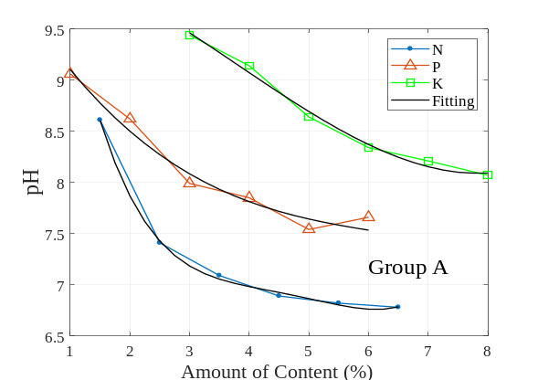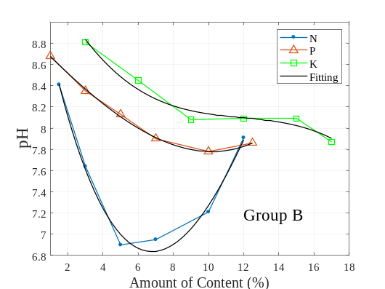
- (b)
Fig. 9. pH of the (a) group A and (b) group B fertilizer solutions.

Acknowledgements :
Table 7. Regression polynomial model of pH with respect to N, P, and K content.
Group | Element | pH | r²
A | N  (1.5-6.5 %) | 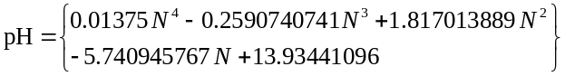 | 0.99874
A | P  (1.0-6.0 %) | 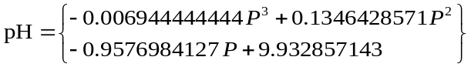 | 0.97526
A | K  (3.0-8.0 %) | 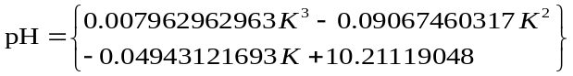 | 0.99173
B | N  (1.5-12.0 %) | 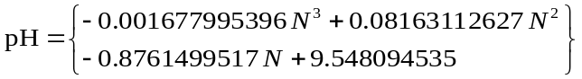 | 0.98462
B | P  (1.0-12.5 %) | 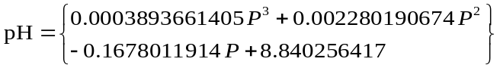 | 0.99833
B | K  (3.0-17.0 %) | 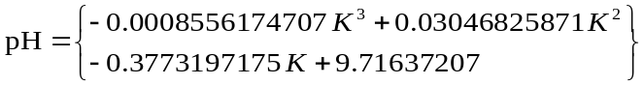 | 0.96416

This work is supported by Public Private Research Network (PPRN) Grant (R.J130000.7823.4L423) and Green Plant Organic Fertilizer Sdn. Bhd.
References :
Ajay Kumar Patel, Jayanta Kumar Ghosh, Shivam Pande, Sammer Usmangani Sayyad. (2020). Deep-learning-based approach for estimation of fractional abundance of nitrogen in soil from hyperspectral data. IEEE Journal of Selected Topics in Applied Earth Observations and Remote Sensing. 13: 6495–6511.
Baldi, E., Quartieri, M., Muzzi, E., Noferini, M. and Toselli, M. (2020). Use of in situ soil solution electric conductivity to evaluate mineral N in commercial orchards: preliminary results. Horticulturae. 2020 (6): 39.
Chong, M. Y., Wendy Ng, P. Q., Denny Ng, K. S., Lam, H. L., David Lim, L. K. and Law, K. H. (2017). A mini review of palm based fertiliser production in Malaysia. Chemical Engineering Transactions. 61: 1585–1590.
Dattatreya, S., Khan, A. N., Jena, K., and Chatterjee, G. (2024). Conventional to modern methods of soil NPK sensing: a review. IEEE Sensors Journal. 24 (3): 2367–2380.
Ennaji, O., Vergütz, L., and Achraf El Allali. (2023). Machine learning in nutrient management: a review. Artificial Intelligence in Agriculture. 9(2023): 1–11.
Gerhardt. (2018). KJELDATHERM, TURBOTHERM and VAPODEST: The ideal Kjeldahl system for any laboratory. Germany: Gerhardt Analytical Systems. 1–11.
Gerhardt. (2020). VAPODEST 300: Advanced steam distillation. Germany: Gerhardt Analytical Systems. 1–2.
Gregory, A. P. and Clarke, R. N., (2012). Tables of the Complex Permittivity of Dielectric Reference Liquids at Frequencies up to 5 GHz. NPL Report MAT 23.
Gurmit, S., Manoharan, S., and Toh, T. S. (1989). United plantations approach to palm oil mill by-product management and utilization. In: PORIM International Palm Oil Development Conference, pp. 225–234.
He, Y., Song, H. Y., Pereira, A. G., Gόmez, A. H. (2005). Measurement and analysis of soil nitrogen and organic matter content using near-infrared spectroscopy techniques. Journal of Zhejiang University Science. 6B: 1081–1086.
Holden, M., Tracey, M. V. (1948). The effect of fertilizers on the levels of nitrogen, phosphorus, protease, and pectase in healthy tobacco leaves. Biochemical Journal. 43(1): 147–151.
Islam, M. R., Oliullah, K., Kabir, M. M., Alom, M., and Mridha, M. F. (2023). Machine learning enabled IoT system for soil nutrients monitoring and crop recommendation. Journal of Agriculture and Food Research. 14 (2023): 100880.
Joseph V. Sinfield, Daniel Fagerman, Oliver Colic. (2010). Evaluation of sensing technologies for on-the-go detection of macro-nutrients in cultivated soils. Computers and Electronics in Agriculture. 70 (2010): 1–18.
Khasim, N., Ismail, S., & Raja Omar, R. Z. (2006). Integration of pineapple (Sarawak variety) with oil palm planted in double avenue planting system. MPOB Information Series, MPOB TT No. 311.
Khaydukova, M., Kirsanov, D., Sarkar, S., Mukherjee, S., Ashina, J., Bhattacharyya, N., Chanda, S., Bandyopadhyay, R., Legin, A. (2021). One shot evaluation of NPK in soils by “electronic tongue”. Computers and Electronics in Agriculture. 186 (2021): 106208.
Kulkarni, M. Y., Warhade, K. K. and Bahekar, S. (2014). Primary nutrients determination in the soil using UV spectroscopy. International Journal of Emerging Engineering Research and Technology. 2(2): 198–204.
Lim, Z. Y., Mun, H. K., Kwan, B. H. and You, K. Y. (2026). Real-time liquid fertilizer concentration measurement based on planar microwave sensor. Journal of Engineering Science and Technology. 21(1): 154–165.
Lombardo, S., Pandino, G. and Mauromicale, G. (2017). Mineral profile of two glove artichoke cultivars as affected by NPK fertilizer regimes. Food Research International. 100: 95 – 99.
Lee, S., Yoo, M. and Shin, D. (2015). The identification and quantification of biogenic amines in Korean turbid rice wine, Makgeolli by HPLC with mass spectrometry detection. LWT-Food Science and Technology. 62: 350–356.
Lin, Z. D., Wang, R. J., Wang, Y. B., Wang, L. S., Lu, C. P., Liu, Y., Zhang, Z. Y., Zhu, L. K. (2018). Accurate and rapid detection of soil and fertilizer properties based on visible/near-infrared spectroscopy. Applied Optics. 57(18): D69–D73 (2018).
Liu, R. T., Tao, L. Q., Liu, B., Tian, X. G., Mohammad MA, Yang, Y., Ren, T. L. (2016). A miniaturized on-chip colorimeter for detecting NPK elements. Sensors. 16 (8): 1234.
Lombardo, S., Pandino, G., Mauromicale, G., (2017). Mineral profile of two glove artichoke cultivars as affected by NPK fertilizer regimes. Food Research International. 100: 95–99.
Marcos André Bechlin, Felipe Manfroi Fortunato, Ricardo Moutinho da Silva, Edilene Cristina Ferreira, José Anchieta Gomes Neto. (2014). A simple and fast method for assessment of the nitrogen–phosphorus–potassium rating of fertilizers using high-resolution continuum source atomic and molecular absorption spectrometry. Spectrochimica Acta Part B. 101 (2014): 240–244.
Masrie, M., Rosli, A. Z. M., Sam, R., Janin, Z., Nordin, M. K., (2018). Integrated optical sensor for NPK nutrient of soil detection. In: Proceedings of the 5th IEEE International Conference on Smart Instrumentation, Measurement and Applications (ICSIMA). 1–4.
Masrie, M., Rosman, M. S. A., Sam, R., and Janin, Z. (2017). Detection of nitrogen, phosphorus, and potassium (NPK) nutrients of soil using optical transducer. In: Proceedings of the 4th IEEE International Conference on Smart Instrumentation, Measurement and Applications (ICSIMA). 1–4.
Mahmud, M. S. and Chong, K. P. (2021). Formulation of biofertilizers from oil palm empty fruit bunches and plant growth-promoting microbes: A comprehensive and novel approach towards plant health. Journal of King Saud University-Science. 33(2021): 101647.
Mihaljey, Ž. A., Jakšić, S. M., Prica, N. B., Ćupić, Ž. N., & Živkov-Baloš, M. M. (2015). Comparison of the kjeldahl method, dumas method and NIR method for total nitrogen determination in meat and meat products. Journal of Agroalimentary Processes and Technologies. 21(4): 365–370.
Mohd Yusof, K., Isaak, S., Ngajikin, N. H., and Che Abd Rashid, N. (2016). LED based soil spectroscopy. Buletin Optik. 2016 (3): 1–7.
Monteiro-Silva, F., Jorge, P. A. S., Martins, R. C. (2019). Optical sensing of nitrogen, phosphorus and potassium: a spectrophotometrical approach toward smart nutrient deployment. Chemosensors. 7: 51.
Munoz-Huerto, R. F., Guevara-Gonzalez, R. G., Contreras-Medina, L. M., Torres-Pacheco, I., Prado-Olivarez, J., & Ocampo-Velazquez, R. V. (2013). A review of methods for sensing the nitrogen status in plants: advantages, disadvantages and recent advances. Sensors. 13(8): 10823–10843.
Mustaqimah, Devianti, Agus Arip Munawar, Sufardi Sufardi. (2024). Capability of short Vis-NIR band tandem with machine learning to rapidly predict NPK content in tropical farmland: A case study of Aceh Province agricultural soil dry land, Indonesia. Case Studies in Chemical and Environmental Engineering. 9 (2024): 100711.
Nahrul Hayawin, Z., Abdul Khalil, H. P. S., Jawaid, M., Hakimi Ibrahim, M., and Astimar, A. A. (2010). Exploring chemical analysis of vermicompost of various oil palm fibre wastes. Environmentalist. 30: 273–278.
Phil Kim, (2017). MATLAB Deep Learning with Machine Learning, Neural Networks and Artificial Intelligence. Apress, New York.
Rafael F. Muñoz-Huerta, Ramon G. Guevara-Gonzalez, Luis M. Contreras-Medina, Irineo Torres-Pacheco, Juan Prado-Olivarez, Rosalia V. Ocampo-Velazquez, (2013). A review of methods for sensing the nitrogen status in plants: advantages, disadvantages and recent advances. Sensors. 13: 10823–10843.
Ramane, D. V., Patil, S. S., and Shaligram, A. D. (2015). Detection of NPK nutrients of soil using fiber optic sensor. International Journal of Research in Advent Technology. 66–70.
Rawankar, A., Nanda, M., Jadhav, H., Lotekar, P., Pawar, R., Sibichan, L., and Pangare, A. (2018). Detection of N, P, K fertilizers in agricultural soil with NIR laser absorption technique. International Journal of Scientific & Engineering Research. 9 (3): 22–23.
Potdar, P. R., Shirolkar, M. M., Verma, A. J., More, P. S., and Kulkarni, A. (2021). Determination of soil nutrients (NPK) using optical methods: a mini review. Journal of Plant Nutrition, 44 (12): 1826–1839.
Rigor G. Regalado, Jennifier C. Dela Cruz, (2016). Soil pH and nutrient (nitrogen, phosphorus and potassium) analyser using colorimetry. In: 2016 IEEE Region 10 Conference (TENCON). 22–25.
Sáez-Plaza, P., Navas, M. J., Wybraniec, S., Michalowski, T., and Asuero, A. G. (2013). An overview of the kjeldahl method of nitrogen determination. Part II. Sample preparation, working scale, instrumental finish, and quality control. Critical Reviews in Analytical Chemistry. 43(4): 224 –272.
Sajindra, H., Abekoon, T., Jayakody, J. A. D. C. A., and Rathnayake, U. (2024). A novel deep learning model to predict the soil nutrient levels (N, P, and K) in cabbage cultivation. Smart Agricultural Technology. 7: 100395.
Sánchez-Monedero, M. A., Roig, A., Paredes, C., Bernal, M. P. (2001). Nitrogen transformation during organic waste composting by the Rutgers system and its effects on pH, EC and maturity of the composting mixtures. Bioresource Technology. 78 (3): 301–308.
Sørensen, M. K., Jensen, O., Bakharev, O. N., Nyord, T., and Nielsen, N. C. (2015). NPK NMR sensor: online monitoring of nitrogen, phosphorus, and potassium in animal slurry. Analytical Chemistry. 87(13): 6446–6450.
Silva, F. M., Queirósc, C., Pinhoa, T., Boaventura, J., Santosa, F., Barroso, T. G., Pereira, M. R., Cunha, M., Martins, R. C. (2023). Reagent-less spectroscopy towards NPK sensing for hydroponics nutrient solutions. Sensors and Actuators: B. Chemical. 395 (2023): 134442.
Silva, F. M., Jorge, P. A. S., & Martins, R. C. (2019). Optical sensing of nitrogen, phosphorus and potassium. Chemosensors. 7(51): 1 – 16.
Stogryn, A. P., Bull, H. T., Rubayi, K., Iravanchy, S., (1995). The Microwave Permittivity of Sea and Fresh Water, Gen. Corp. Aerojet, Azusa, Ca.
Su, G. C., Mohd Zulkifli, N. W., Ong, H. C., Shaliza Ibrahim, Bu, Q., Zhu, R. N. (2022). Pyrolysis of oil palm wastes for bioenergy in Malaysia: a review. Renewable and Sustainable Energy Reviews. 164(2022): 112554.
Sunset, 2004. A crash course in fertilizers. Sunset Publishing Corporation. https://www.sunset.com/garden/garden-basics/crash-course-fertilizers.
Tao H. H, Snaddon, J. L., Slade, E. M., Caliman, J. P., Widodo, R. H., Suhardi and Willis, K. J., (2017). Long-term crop residue application maintains oil palm yield and temporal stability of production. Agronomy for Sustainable Development, 37(33): 1–8.
Thorat, T., Patle, B. K., and Kashyap, S. K. (2023). Intelligent insecticide and fertilizer recommendation system based on TPF-CNN for smart farming. Smart Agricultural Technology. 3(2023): 100114.
Thirumala Akash, K., Upendra, R. S., Mohammed Riyaz Ahmed, Sanjana Mathias, Ananya, R., Deepika Nayak, Bhaskar, S., Dabke, Y. (2022). Fertilizer quality assessment methods for sustainable agriculture. In: Third International Conference on Smart Technologies in Computing, Electrical and Electronics (ICSTCEE). 1–4.
Xu, S. X., Zhao, Y. C., and Wang, Y. Y. (2024). Optimizing machine learning models for predicting soil pH and total P in intact soil profiles with visible and near-infrared reflectance (VNIR) spectroscopy. Computer and Electronics in Agriculture. 218(2024): 108643.
Yang, W. M., Rhonda, L. B., and Thomas, P. M. (2002). Determination of phosphorus in fertilizers by inductively coupled plasma atomic emission spectrometry. Journal of AOAC International. 85(6): 1241–1246.
Yokota, M., Okada, T., Yamaguchi, I. (2007). An optical sensor for analysis of soil nutrients by using LED light sources. Measurement Science and Technology. 18(2007): 2197–2201.
You, K. Y., (2016). RF Coaxial Slot Radiators: Modeling Measurements and Applications. Artech House, London.
You, K. Y., Lee, C. Y., Then, Y. L., Chen Chong, S. H., You, L. L., Abbas, Z., and Cheng, E. M. (2013). Precise moisture monitoring for various soil types using handheld microwave-sensor meter. IEEE Sensors Journal. 13(7): 2563–2570.
You, K. Y., Sim, M. S. and Abdullah, S. N. (2021). Emerging Microwave Technologies for Agricultural and Food Processing. In: Precision Agriculture Technologies for Food Security and Sustainability. 91–148.
Zhai, J., Luo, B., Li, A., Dong, H., Jin, X., Wang, X. (2022). Unlocking all-solid ion selective electrodes: prospects in crop detection. Sensors. 22: 554.
This document is intended as a guide for format and length; your manuscript will not b

