RTK-enabled tractor Guidance Traffic Lanes and Their Influence on Nitrate Losses in New Zealand
Chapter Author 1: Raveendrakumaran Bawatharani
School of Agriculture and Environment, Massey University, Palmerston North, New Zealand.
and
Department of Agricultural Engineering, Faculty of Agriculture, Eastern University, Sri Lanka. bawatharanir@esn.ac.lk

Chapter Author 2: Miles Grafton
School of Agriculture and Environment, Massey University, Palmerston North, New Zealand. m.grafton@massey.ac.nz
Chapter Author 3: Peter Andrew Bishop
School of Agriculture and Environment, Massey University, Palmerston North, New Zealand. p.a.bishop@massey.ac.nz

Abstract
Precision agriculture utilizing Real-Time Kinematic Global Navigation Satellite System (RTK-GNSS) provides repeatable, centimeter-level machinery guidance essential for controlled traffic farming (CTF), a strategy designed to mitigate soil compaction and nutrient losses. The study aimed to compare the environmental footprint of RTK-enabled and conventional traffic systems by measuring subsurface NO₃⁻ concentrations. A two-year field study was undertaken in Pukekohe, New Zealand, comparing adjacent 4-ha plots managed with RTK-enabled controlled-traffic farming and conventional random-traffic practices. The RTK system achieved a horizontal positioning accuracy of ±2.5 cm, ensuring precise alignment for 130 permanent beds and 260 fixed tramlines, whereas the conventional plot allowed unrestricted machinery movement. Five fluxmeters were installed at a depth of 70 cm in each plot to collect subsurface drainage. Soil physical properties were assessed at six and ten months. While no significant differences in NO₃⁻ concentrations were observed during the first year, a sharp divergence emerged in the second year. The conventional plot recorded a mean NO₃⁻ concentration of 7.72 mg L⁻¹, which was significantly higher than the 1.47 mg L⁻¹ measured in the RTK-enabled plot. This reduction in leaching in the RTK plots is attributed to enhanced soil structural integrity, characterized by lower bulk density and higher porosity. Additionally, the RTK system enabled precise residue management and mulch retention, promoting N immobilization and retaining nutrients within the active root zone. The study concludes that RTK-enabled systems significantly mitigate NO₃⁻ leaching risks, offering a robust technological intervention for sustainable intensive vegetable production.
Key words: Bulk density, porosity, Controlled traffic farming (CTF), Fluxmeters, Leaching, RTK-GNSS guidance.
INTRODUCTION
Real Time Kinematic (RTK) Global Navigation Satellite System (GNSS) guidance has become a central component of precision agriculture, providing centimetre-level accuracy that enhances both operational efficiency and long-term soil management. Its most significant contribution lies in enabling controlled traffic farming (CTF), a system in which machinery is confined to permanent traffic lanes to minimize soil compaction and preserve soil function. RTK guidance ensures highly repeatable wheel tracks across seasons, supporting consistent bed formation, tramline alignment, and inter-row operations (Kingwell & Fuchsbichler, 2011). This repeatability is fundamental to maintain the integrity of permanent traffic lanes, as even small deviations can compromise the benefits of RTK-enabled CTF. Research demonstrates that RTK-enabled CTF reduces overlap, improves fertilizer placement accuracy, and limits unnecessary soil disturbance (Tullberg et al., 2007). Additional studies show that precise tramline alignment reduces soil compaction, enhances water infiltration, and improves crop uniformity (Antille et al., 2019; Bochtis et al., 2012).
The soil-structural improvements associated with RTK-enabled CTF have direct implications for nitrogen (N) cycling, particularly nitrate (NO₃⁻) leaching. By restricting compaction to designated tramlines, RTK-enabled CTF preserves porosity, aggregate stability, and infiltration capacity in non-trafficked zones. These conditions promote deeper rooting and greater root density, increasing plant N uptake and reducing the pool of NO₃⁻ vulnerable to leaching. In contrast, compacted soils exhibit reduced infiltration, increased runoff, and greater reliance on preferential flow pathways, accelerating NO₃⁻ transport to deeper soil layers (Ausseil et al., 2018). This issue is especially relevant in New Zealand, where intensive grazing, frequent machinery passes, and high soil moisture during field operations contribute to widespread compaction and elevated nutrient losses (MPI, 2021).
National assessments indicate that NO₃⁻ leaching rates vary widely across land uses, with the highest losses occurring in intensive vegetable production, dairy systems, and irrigated cropping (Ausseil et al., 2018). Recent studies in vegetable systems highlight the influence of soil type, irrigation scheduling, and fertilizer management on NO₃⁻ losses (Avendaño et al., 2025). These findings underscore the importance of soil structure and water movement, both of which are directly shaped by RTK-enabled CTF. Improved pore continuity and water-holding capacity under RTK-enabled CTF reduce the formation of perched water tables and rapid bypass flow, moderating drainage patterns and slowing NO₃⁻ movement through the soil profile (Chamen et al., 2015). Such structural improvements can reduce NO₃⁻ leaching even without changes in fertilizer inputs.
Complementary evidence from New Zealand’s Forages for Reduced Nitrate Leaching (FRNL) programme shows that improved pasture species, catch crops, and optimized fertilizer timing can reduce NO₃⁻ losses by 20–50% (DairyNZ, 2025). Although FRNL does not explicitly evaluate RTK-enabled CTF, its emphasis on soil–plant interactions aligns with the structural benefits provided by CTF, suggesting that integrating RTK-enabled CTF with targeted N-management strategies could further enhance Nitrogen Use Efficiency (NUE). International studies similarly report reduced drainage volumes, improved N retention, and enhanced crop NUE under RTK-enabled CTF systems (Tullberg et al., 2007). Emerging real-time NO₃⁻ monitoring technologies, such as continuous in situ systems trialed in Hawke’s Bay, offer new opportunities to quantify spatial differences in NO₃⁻ movement between trafficked and non-trafficked zones (Snelder, 2017). When combined with RTK-enabled traffic lanes, these systems provide a powerful platform for advancing understanding of the mechanistic links between soil structure, water flow, and nitrate transport.
Despite the strong theoretical basis and international evidence, direct empirical studies linking, RTK-enabled CTF to NO₃⁻ leaching reductions in New Zealand remain limited. This gap highlights the need for long-term field trials that integrate soil physical measurements, N cycling assessments, and drainage monitoring. Such studies would provide robust evidence to support the adoption of RTK-enabled CTF as a NO₃⁻ mitigation strategy. The objective of this study is to compare environmental footprint of RTK-enabled versus conventional random traffic systems by measuring subsurface NO₃⁻ concentrations and assessing the soil physical conditions that drive N mobility. Due to site-specific hydrological conditions, the study focused on analyzing NO₃⁻ concentration as a primary metric for determining the leaching risk inherent in intensive vegetable production.
This chapter includes a limited amount of content previously published in Bawatharani, R., Grafton, M., Jeyakumar, P., Bishop, P., & Davies, C. (2026). An Investigation of the Impacts of Controlled Traffic Farming on Soil Properties. AgriEngineering, 8(2), 54. MDPI, © 2026 by the authors, published by MDPI under the terms of the Creative Commons Attribution (CC BY 4.0) license. https://doi.org/10.3390/agriengineering8020054.

MATERIALS AND METHODS
Description of the experimental field
The experiment spanned two years and was conducted on adjacent 4-ha vegetable fields in Pukekohe, New Zealand (−37.3187° S, 174.9985° E). The soil is classified as Haplic Andosol, formed from volcanic ash–based allophanic soil. These soils are widely used for intensive vegetable production in the Auckland region due to their friability and resilience under cultivation.
RTK-GPS tramline establishment
To establish tramlines aligned with the controlled-traffic layout of the experimental plot, a Real-Time Kinematic (RTK) GPS system was deployed. A fixed base station was positioned over a surveyed benchmark that broadcast correction signals to a rover receiver mounted on the tractor. This configuration enabled ±2.5 cm horizontal positioning accuracy which was critical for repeatable tramline placement across seasons and for maintaining alignment with the permanent bed geometry. Field boundaries and headlands were digitized using the GNSS guidance console by driving the perimeter of the plot. This allowed the system to generate internal coverage lines that matched the fixed bed layout.
Given the 1.74 m spacing between tramlines, the boundary definition ensured that guidance lines coincided with bed centres. Headlands were defined at the field edges to prevent tramlines from extending into turning zones, preserving the integrity of the controlled traffic pattern. A primary AB line was established along the longitudinal axis of the plot by marking two reference points (Fig. 1(a)). This AB line served as the master reference for generating all subsequent parallel guidance lines and was aligned to the 1.74 m module (1.5 m bed width + 0.24 m tramline width). Accurate orientation of the AB line was essential to ensure that each tractor pass corresponded precisely with the permanent bed layout and the 1.74 m centre-to-centre spacing adopted in the CTF system. Using this configuration, the field was laid out into 130 permanent beds, each constructed on the 1.5 m bed width, with 260 intermediate tramlines of 0.24 m width serving as designated wheel tracks between adjacent beds (Fig. 1(b)). Finally, the AB line, field boundaries, and tramline configuration were stored within the farm management system to ensure long-term positional accuracy and operational repeatability.
FIG. 1 HERE
Conventional plot
Fluxmeter installation
RTK enabled plot
Fluxmeters were installed to quantify NO₃⁻ leaching under RTK-enabled and conventional plots, with five units placed at each site following Gee et al. (2002, 2009). Each fluxmeter consisted of a convergence control mechanism, a 20 cm funnel collector positioned above a 20 cm sand column, a 50 cm polyester wick that maintained a 50 cm suction head and a drainage reservoir (Fig. 2). Water flux was measured using a miniature tipping-bucket system connected to the outlet tube. The reservoir was a 50 cm × 20 cm plastic cylinder fitted with 1 mm air and water flow tubes and topped with a funnel-wick assembly (Fig. 3a).
FIG. 2 HERE

Installation involved excavating a 12 m trench to 0.7 m depth and drilling 0.5 m-deep holes at 3 m intervals. Fluxmeters were placed in the holes, covered with a 20 cm sand layer, and backfilled with 50 cm of topsoil (Fig. 3b). Air and water tubes were routed through PVC conduits to a labelled collection point (Fig. 3c–d). The tops of the fluxmeters were positioned 70 cm below the cultivation zone and left four months to hydraulically resettle. Tipping buckets with magnets and reed switches logged drainage pulses, while bottles beneath collected leachate for analysis. Due to persistent saturation from a subsurface clay layer, measurable drainage was minimal, so NO₃⁻ concentrations in retained water were analysed at each sampling event.
FIG. 3 HERE

Traffic regulation and planting
In the RTK-enabled plots, all equipment was confined to predetermined traffic lanes with uniform track widths ranging from 1.72 to 2.64 m. Precision was maintained using Real-Time Kinematic (RTK) guidance, ensuring strict alignment with designated lanes regardless of implement width. The working widths of implements ranged from 1.72 m for the seeder to 15.5 m for the sprayer. Implement geometry was entered into the guidance console relative to the 1.74 m bed module and 0.24 m tramlines. For subsoiling, the 3.44 m width covered two bed modules. For spraying, the 15.5 m width matched nine bed modules, with tramlines programmed every ninth pass to maintain alignment. For seeding, the 1.72 m implement matched a single bed module, keeping the seeder centred on each bed. Similarly, the mechanical bedder (5.18 m) and seed drill (5.18 m) were aligned to cover three full bed modules per pass.
Conventional plots required three passes for each field operation, with wider track spacings of 2.7–3.05 m and unrestricted machinery movement. Navigation was general rather than lane-based, resulting in overlapping tracks, greater traffic intensity, and increased soil disturbance. Under conventional management, additional operations were carried out, including residue handling, deep tillage, and incorporation with heavy tractors fitted with implements of different widths. During Year 1, annual ryegrass (Lolium multiflorum Lam.) was sown in both systems to capture residual soil N during the fallow period of the preceding crop rotation. The plots were left fallow for five months after the grass harvest at the end of Year 1. Onion planting began midway through year 2.

Soil sampling and measurements
Soil sampling measurements were planned to be obtained along fixed transects. This method ensured subsequent sampling along the same transects to reduce variations caused by human error (Dawson and Knowles, 2018). Soil sampling was carried out twice (at 6 and 10 months) during the first year of the grass growing season to assess key soil physical properties in both plots. Sampling covered depths from 0-30 cm to evaluate how machinery traffic influenced soil properties over time. Undisturbed soil cores were collected from the RTK-enabled beds and the conventional plot following the core-sampling procedures outlined by Blake and Hartge (1986) to determine bulk density. Soil water-retention characteristics were determined using the pressure-plate method (Klute, 1986). Gravimetric moisture contents were determined gravimetrically. Total porosity, air-filled porosity volumetric moisture content and water-filled pore space (WFPS) were calculated using standard relationships between gravimetric moisture content, bulk density and particle density.
Soil residual N
Residual soil inorganic nitrogen (NH₄⁺ + NO₃⁻) was quantified by extraction with 2 M KCl at six months intervals throughout the study period. Fresh samples were sieved to 2 mm and homogenized, after which ~3 g of moist soil was placed in screw-cap centrifuge tubes with 30 ml of 2 M KCl. The suspensions were shaken for 1 h on a shaker. The samples were centrifuged at 5000 rpm for 10 min, and the supernatant solution was filtered (No.42 Whatman filter paper). The concentration of NO₃⁻-N along with NH₄⁺was subsequently analyzed using a Technicon AutoAnalyzer II (Blakemore et al., 1987).

$N_{mineral}=\frac{C x V }{W}$ ……………………...Equation 1

Where, $N_{mineral}$ denotes the total mineral N content (mg) per kg of dry soil (sum of NH₄⁺-N and NO₃⁻-N); $C$ denotes the N concentration (mg/l) of soil extract; $V$ is the volume of KCl solution (l); and $W$ refers the mass (kg) of oven dry soil.

The amount of total mineral N accumulated in the soil layer ($N_{accumulated}$, kg N/ha) was calculated by using Equation 2.

$N_{accumulated}=\frac{T x ρ_{b}x N_{mineral} }{10}$ ………………………….Equation 2
Where $T$ denotes the soil thickness (cm) and $ρ_{b}$ denotes the soil bulk density (g/cm³).

Fluxmeter drainage sampling
Fluxmeters in the experimental plots were sampled every six months, producing four sampling events over the study. They were intended to capture percolating water and quantify leaching, but an impervious subsurface clay layer prevented continuous drainage, leaving the fluxmeters water-filled throughout monitoring. Each unit contained a miniature tipping-bucket mechanism with magnets and reed switches that logged any drainage pulses. Collection bottles beneath the buckets captured leachate when present. Because persistent saturation limited measurable drainage, the study focused on analyzing NO₃⁻ concentrations in the retained water. At each sampling event, water was extracted from the fluxmeter reservoirs, placed into labelled containers, and transported to the laboratory for chemical analysis.
Statistical analysis
Statistical analyses compared soil and leaching responses between the two traffic systems. Data were checked for normality and homogeneity before applying parametric tests. One-way ANOVA was used to assess depth-based treatment differences, followed by Tukey’s test when significant effects occurred at P < 0.05. Paired t-tests evaluated NO₃⁻ differences from fluxmeters. All analyses were conducted in SAS 9.4, with significance at P < 0.05.

RESULTS
Bulk density was significantly lower in RTK plots at six months (0.96–1.03 g cm⁻³) than in conventional plots (1.11–1.30 g cm⁻³), and by ten months RTK plots still showed reduced surface densities while conventional plots remained higher through 0–30 cm. Gravimetric moisture was greater in RTK plots at 10–20 cm (0.46 vs. 0.40 g g⁻¹). Conventional plots initially showed higher surface volumetric water content, but RTK plots had significantly greater values across all depths by 10 months. Total porosity was higher in RTK plots at six months (0.60–0.62). Water-filled pore space was lower in RTK plots at six months but increased by 10 months, while conventional plots declined. Air-filled porosity was also higher in RTK plots (Table 1).
TABLE 1 HERE

Nitrate leaching
No significant differences in NO₃⁻ concentrations were detected between RTK-enabled and conventionally managed plots during the first 17 months. However, at 23 months, the conventional plots exhibited a significantly higher NO₃⁻ concentration (7.72 mg L⁻¹) than the RTK-enabled system (1.47 mg L⁻¹) (Fig.4).

FIG 4 HERE

Soil mineral nitrogen
Residual N exhibited distinct temporal and depth-related variation across both systems. In the 0–10 cm layer, the RTK-enabled plots increased from 3.24 kg N/ha at the 6-month sampling interval to 5.81 kg N/ha at 12 months, remained stable at 5.73 kg N/ha at 18 months, and then declined to 4.19 kg N/ha at 24 months. In contrast, the conventional plots decreased from 4.36 kg N/ha at 6 months to 3.4 kg N/ha at 12 months, rose slightly to 3.68 kg N/ha at 18 months, and then increased further to 5.29 kg N/ha at 24 months. At 10–20 cm depth, N in the RTK-enabled plots declined steadily from 3.35 kg N/ha at 6 months to 3.14 kg N/ha at 12 months and 2.12 kg N/ha at 18 months, before rising to 4.73 kg N/ha at 24 months. The conventional plots followed a similar trend, decreasing from 3.85 kg N/ha at 6 months to 3.2 kg N/ha at 12 months and 2.93 kg N/ha at 18 months, then sharply increasing to 8.39 kg N/ha at 24 months. In the 20–30 cm layer, the RTK-enabled plots dropped from 7.19 kg N/ha at 6 months to 2.58 kg N/ha at 12 months and 2.53 kg N/ha at 18 months, followed by an increase to 4.59 kg N/ha at 24 months. Meanwhile, the conventional plots declined from 4.82 kg N/ha at 6 months to 3.41 kg N/ha at 12 months and 2.97 kg N/ha at 18 months, then rose to 7.41 kg N/ha at 24 months (Fig. 5).
FIG 5 HERE
Both traffic systems showed no significant differences on soil residual N in the first year across the depth of 0-30 cm. Average available soil residual NO₃⁻ levels were consistently lower in the RTK-enabled plots than in the conventional plots across all measured depths in year two. In the 0–10 cm layer, RTK-enabled plots recorded 1.01 ± 0.05 kg N/ha, whereas conventional plots showed a much higher value of 3.09 ± 0.24 kg N/ha. At 10–20 cm, NO₃⁻ in RTK-enabled plots measured 1.19 ± 0.11 kg N/ha compared with 6.1 ± 1.4 kg N/ha in conventional plots. Similarly, at 20–30 cm, CTF plots contained 1.14 ± 0.10 kg N/ha, while conventional plots reached 5.5 ± 0.39 kg N/ha (Table 2).

TABLE 2 HERE

DISCUSSION
Soil physical properties and structural integrity
The implementation of RTK-enabled Controlled Traffic Farming (CTF) demonstrated a significant amelioration of soil structural integrity, which directly influenced the system's susceptibility to NO₃⁻ leaching. In the RTK-enabled plots, the consistently lower bulk density (0.96–1.03 g cm⁻³) relative to conventional plots (1.11–1.30 g cm⁻³) at six months aligns with the findings of Alakukku (1999) and McPhee et al. (2015), who demonstrated that the absence of machinery traffic maintains a porous state conducive to extensive root development. This porous structure is essential for maximizing crop N uptake. When roots can exploit a larger soil volume, they effectively "mop up" mineral N, leaving less residual NO₃⁻ available for deep percolation. The RTK system avoids the cumulative compaction described by Gurr (2018), where random machinery passes increase soil strength and reduce air-filled porosity. By maintaining this porous structure, the system facilitates extensive root development and efficient nutrient assimilation, thereby preventing the hazardous buildup of unused NO₃⁻ within the soil profile. Conversely, higher soil densities in conventional plots confirm the subsoil compaction threat identified by Håkansson (1994), which harms long-term productivity. This structural damage prevents roots from reaching nutrients, forcing N to accumulate in deeper layers where it is highly prone to leaching losses.
The study’s findings regarding total porosity and air-filled porosity (AFP) provide further technical justification for reduced leaching in the RTK-enabled system. The significantly higher total porosity in RTK plots at six months (0.60–0.62 cm³.cm⁻³) compared to conventional plots (0.55–0.57 cm³.cm⁻³) suggests a soil structure dominated by continuous macropores (Table 1). As noted by Ball (2013), such structural integrity is essential for effective gas exchange and aerobic microbial activity, which improves the efficiency of N cycling and assimilation. This is supported by the study’s data showing greater air-filled porosity in RTK plots initially (12–25 cm³.cm⁻³) relative to conventional plots (6–11 cm³ cm⁻³), facilitating the healthy root respiration needed to support vigorous nutrient demand.
In contrast, the significantly higher water-filled pore space (WFPS) in conventional plots (80.7–89.0%) compared to the RTK system (59.6–80.0%) at six months indicates a collapse of the soil pore system, a phenomenon Alaoui et al. (2011) attributed to soil deformation under heavy axle loads. This deformation reduces the volume of macropores responsible for balanced water movement, leading to localized waterlogging and the formation of artificial drainage paths such as structural cracks. These conditions, combined with the lack of precise nutrient placement in conventional random traffic systems allow soluble NO₃⁻ to migrate rapidly downward during rainfall events, resulting in the significantly higher leaching concentrations observed in conventional management.
Hydrological dynamics and water availability
The hydrological dynamics observed in the RTK-enabled plots, characterized by superior Plant Available Water (PAW) and enhanced moisture retention directly contribute to a significantly lower susceptibility for NO₃⁻ leaching compared to conventional systems. At six-month interval, RTK-enabled plots demonstrated a higher capacity to retain gravimetric moisture at the 10–20 cm depth (0.46 g g⁻¹) than conventional plots (0.40 g g⁻¹) (Table 1). This improved soil structure provides a functional benefit, allowing crop roots to absorb nutrients more consistently. This is consistent with findings by Li et al. (2007), who noted that RTK-enabled CTF increases PAW and improves infiltration, thereby reducing the volume of surplus water that might otherwise drive NO₃⁻ deeper into the soil profile.
The temporal divergence in water availability further underscores the environmental risks of conventional management. While conventional plots showed a sharp drop in PAW, falling from 13.6% to 6.6–8.4% at ten months, the RTK system exhibited a restorative increase, reaching 10.6–14.7%. This sustained water availability supports higher Nitrogen Use Efficiency (NUE). As noted by Gasso et al. (2013), stable soil structures in RTK-enabled CTF allow roots to more effectively "mop up" available N, leaving less residual mineral N susceptible to off-site transport. In contrast, the high surface volumetric water content (VWC) in conventional plots at six months (0.46 cm³ cm⁻³) served as a marker for poor internal drainage and waterlogging. Such conditions allow NO₃⁻ to move rapidly downward through structural cracks and tillage-induced macropores (Nyfeler et al., 2024). This combination explains the much higher leachate concentrations (7.72 mg L⁻¹) measured in the conventional system.
Furthermore, the integration of RTK guidance serves as a technical safeguard against leaching. By providing repeatable positioning accuracy of ±2.5 cm, the system eliminates fertilizer application overlaps thus preventing the creation of N "hot spots" that exceed plant demand. This precision, combined with the superior deep-water storage (0.41–0.48 cm³ cm⁻³ VWC) identified in the RTK-enabled profile, ensures that both moisture and nutrients remain in the active root zone for longer periods, fulfilling the potential to mitigate environmental pollution while maintaining crop resilience (Qingjie et al., 2009).
Nitrate leaching and environmental mitigation
The significantly higher NO₃⁻ concentration in conventional leachate (7.72 mg L⁻¹) compared to the RTK-enabled system (1.47 mg L⁻¹) highlights a high leaching risk inherent in conventional random traffic systems. This disparity is primarily justified by the enhanced NUE and structural stability afforded by RTK-enabled CTF. RTK guidance, with its repeatable accuracy of ±2.5 cm, eliminates these excessive N, thereby reducing the pool of mineral N susceptible to leaching. Furthermore, as noted by Vermeulen et al. (2010), RTK systems enable the precise in-crop placement of fertilizers directly into the most active root zones. This synchronization between supply and demand ensures that N is assimilated by the crop rather than migrating through the soil profile (Zulu et al., 2023).
The high leaching rates in conventional plots align with the findings of Zia et al. (2018), who reported that the combination of intensive tillage and high N rates results in extreme NO₃⁻ losses. This supports the hypothesis by Celik et al. (2017) that intensive tillage in conventional plots creates artificial drainage paths through structural cracks, facilitating the rapid downward migration of nutrients. Additionally, Matthews et al. (2000) indicated that deep tillage creates short diffusion paths in the soil, which further increases the risk of leaching.
In contrast, the consistently lower available soil residual NO₃⁻ levels in RTK plots across all measured depths in year two suggest improved NUE. This mirrors findings by Tullberg et al. (2018), who reported that stable soil structures in RTK-enabled systems allow for better synchronization between N availability and plant uptake. The reduction in residual N at 20–30 cm in the RTK plots supports Hulugalle et al. (2005), who found that undisturbed soil profiles are better able to recover leached N. While some research suggests that undisturbed macropores in no-tillage systems can sometimes increase the downward movement of soluble NO₃⁻ (Huang et al. 2024), the RTK-enabled beds in this study likely mitigated this through improved NUE and structural recovery.

Soil mineral nitrogen
The temporal variation of soil mineral N in this study reveals distinct patterns of stratification that directly influence the susceptibility to NO₃⁻ leaching, particularly within the RTK-enabled plots where N concentrated in the 0–10 cm layer increased from 3.24 kg N/ha at 6 months to 5.81 kg N/ha at 12 months before stabilizing. According to Yadav et al. (2021) and Mühlbachová et al. (2024), it is a common feature of conservation farming for N to settle in the top layer of the soil rather than being spread evenly. This layering happens because crop leftovers stay on the surface and the soil is not ploughed, which stops N from breaking down and releasing into deeper parts of the ground.
Initially, during the first year of grass growth, the crop effectively consumed nearly all available mineral N across the 0–30 cm profile in both systems, leaving no significant differences in soil residual mineral N and thus minimizing the immediate leaching risk. By the second year, however, N dynamics and the resulting environmental risk diverged significantly. In the conventional plots, where grass was harvested and removed, a five-month fallow period maintained soil moisture during the summer and increased biological oxidation, which likely accelerated the decomposition of remaining organic matter (Habtegebrial et al. 2007, Singh et al. 2019). This promoted rapid N mineralization, leading to significantly higher available NO₃⁻ levels of 3.09 to 6.1 kg N/ha in the conventional system compared to only 1.01 to 1.19 kg N/ha in the RTK-enabled plots. This accumulation in conventional systems presents a high environmental hazard, because these surplus NO₃⁻ are highly prone to being lost via leaching after seasonal rainfall events (Nyfeler et al. 2024).
In contrast, the RTK-enabled plots mitigated this risk through precise residue management. Because grass was mulched and retained in the field due to machinery incompatibility with permanent tramlines, the high carbon (C) content (44–50%) and low N content (1.1%) of the residues likely enhanced N immobilization. Incorporation of residues with C/N ratios greater than 20:1 is known to promote the microbial tie-up of N, preventing its conversion into mobile NO₃⁻ (Blackmer & Green 1995, Börjesson et al. 1999, Douglas & Rickman 1992). The effectiveness of this mitigation was evidenced by the sharp contrast in deeper soil layers at 24 months. While the N levels in RTK system remained stable, conventional plots showed a surge of N at the 10–20 cm and 20–30 cm depths, reaching 8.39 kg N/ha and 7.41 kg N/ha, respectively. This downward migration confirms that conventional tillage provides paths for rapid NO₃⁻ loss, whereas the "top-heavy" distribution in RTK plots keeps N in the most active root zone, maximizing uptake while minimizing environmental pollution.

Synergies with sustainable agriculture
The improvement in soil physical status observed here suggests that RTK guidance is essential for the success of site-specific nutrient management. Pramanick et al. (2022) found that conservation tillage systems improve Soil Organic Carbon (SOC) by 31–33% over conventional practices, which helps decrease bulk density and increase water holding capacity. The results of the current study confirm this synergy that the structural amelioration provided by RTK guidance created a soil environment where nitrogen was both more stable and more available. Additionally, the reduction in bulk density to near-natural levels (0.96 g.cm⁻³) in RTK plots is a benchmark for sustainable farming. Heinonen (1977) described such values as ideal for minimizing root penetration resistance, which Al-Enezy et al. (2023) linked to increased root mass and enhanced enzymatic secretions. This biological enhancement, facilitated by RTK precision, represents a transition from mechanical soil loosening to biological regeneration.

CONCLUSIONS
The findings of this study demonstrate that RTK-enabled CTF is an effective technological intervention for mitigating NO₃⁻ leaching while enhancing soil health in intensive cropping systems. By providing a repeatable positioning accuracy of ±2.5 cm, RTK guidance ensures that machinery traffic is strictly confined to permanent tramlines, thereby protecting the soil structure in crop zones. This structural preservation resulted in significantly lower bulk density and higher porosity in RTK-enabled plots. Furthermore, the management of crop residues promoted N immobilization, thereby reducing the pool of mobile N vulnerable to leaching. In contrast, conventional random traffic led to soil compaction and the formation of preferential flow paths, which accelerated the downward migration of soluble NO₃⁻.
The research further highlights the synergy between precise traffic control and nutrient management. The RTK system eliminated fertilizer application overlaps, preventing the creation of N "hot spots" that exceed plant demand. While conventional plots showed a surge in residual N in deeper soil layers, the RTK system maintained stable, lower levels. Ultimately, the adoption of RTK-enabled machinery signifies a shift away from mechanical soil disturbance toward more sustainable practices that reduce the environmental footprint of modern agriculture.
Acknowledgement
We gratefully acknowledge the financial support provided by the Massey University Research Fund (RM22311). We also extend our sincere thanks to the ERASMUS+ AGRHI project for supporting the publication of this book chapter. Appreciation is further given to AS Wilcox and Sons Ltd. for granting access to their field site for this study.

TABLES / FIGS / PICTURES / ILLUSTRATIONS / TABLES

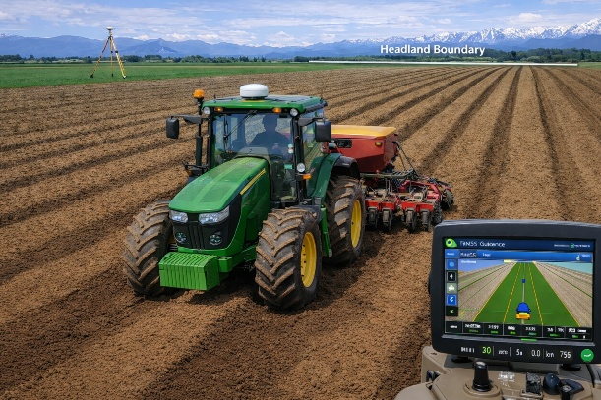
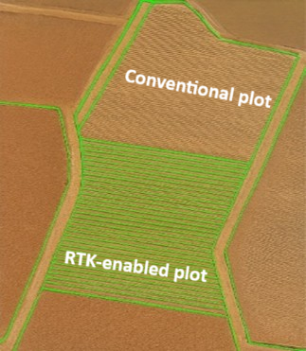
AB line
Fig.1 (b) RTK-assisted bed
and tramline layout in the CTF plot
Fig. 1(a) RTK-guided bed formation and tramline establishment
RTK base station
AB line

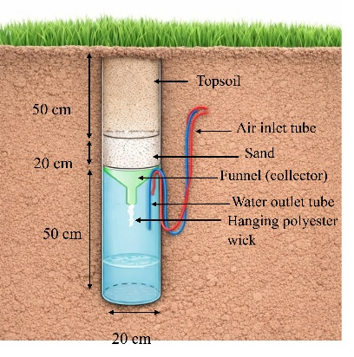
20 cm

Fig 2. Field Setup of fluxmeter system for drainage and leachate sampling

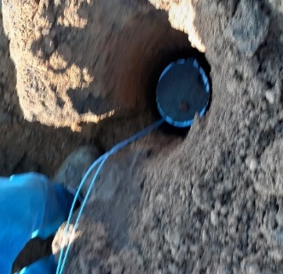
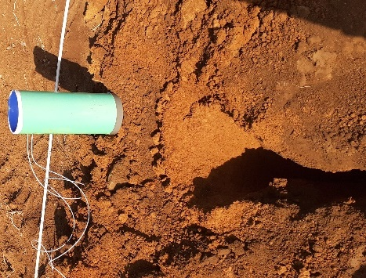
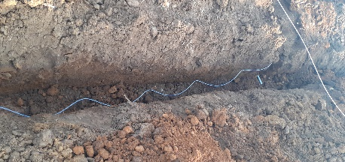
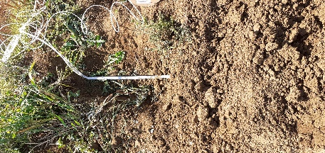
a
d
c
b

Fig 3. Stages of fluxmeter installation in Pukekohe: (a) excavation of a hole to 70 cm depth; (b) placement of the fluxmeter in the hole with a 20 cm sand column above; (c) routing of air and water flow tubes along the trench towards the sampling point; (d) encasing of water flow tubes in a PVC conduit at the sampling point.

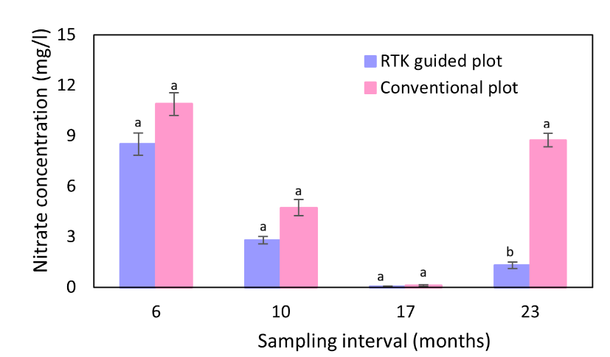
Fig 4. Fluxmeter drainage NO₃⁻ concentrations under the two traffic systems. Paired t-test was used to compare treatments at each sampling date. Significant differences are indicated by different letters (p < 0.05, n = 5).

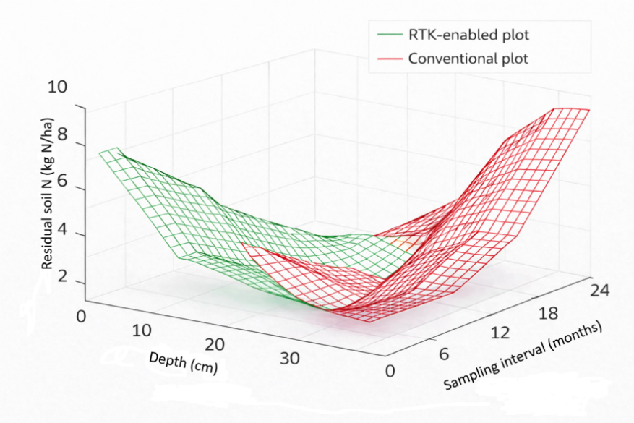

Fig 5. Temporal and depth-dependent dynamics of soil residual nitrogen under RTK-enabled and conventional traffic systems

Table 1. Variation in soil physical properties over the grass growing period

Soil Property | At 6 Months |  |  | At 10 Months
Soil Property | 0–10 cm | 10–20 cm | 20–30 cm | 0–10 cm | 10–20 cm | 20–30 cm
Bulk density (g·cm⁻³)
RTK guided plot | 0.96 b | 1.03 b | 0.97 b | 0.93 b | 1.08 a | 1.08 a
Conventional plot | 1.11 a | 1.19 a | 1.3 a | 0.93 b | 1.04 a | 1.09 a
Gravimetric MC (g.g⁻¹)
RTK guided plot | 0.39 a | 0.46 a | 0.50 a | 0.41 a | 0.43 a | 0.45 a
Conventional plot | 0.41 a | 0.40 b | 0.51 a | 0.36 b | 0.38 b | 0.39 a
Volumetric water content (cm³·cm⁻³)
RTK guided plot | 0.37 b | 0.48 a | 0.49 ab | 0.41 a | 0.46 a | 0.48 a
Conventional plot | 0.46 a | 0.49 a | 0.50 a | 0.33 c | 0.40 b | 0.42 b
Total porosity (cm³∙cm⁻³)
RTK guided plot | 0.62 a | 0.60 a | 0.62 a | 0.63 a | 0.57 a | 0.57 a
Conventional plot | 0.57 b | 0.55 b | 0.57 b | 0.63 a | 0.58 a | 0.57 a
Water-filled pore space (%)
RTK guided plot | 59.6 b | 80.0 b | 79.0 b | 65.0 b | 75.4 a | 78.9 a
Conventional plot | 80.7 a | 89.0 a | 87.7 a | 53.9 b | 68.9 b | 73.6 b
Plant available water (%)
RTK guided plot | 5.7b | 7.9b | 5.3b | 10.6a | 14.7a | 14.2a
Conventional plot | 10.1a | 13.6a | 8.4a | 6.6b | 7.9b | 8.4b
Air filled porosity (cm³∙cm⁻³)
RTK guided plot | 25a | 12a | 13a | 22a | 14a | 12a
Conventional plot | 11b | 6b | 7b | 29b | 18a | 15a
Significant differences between treatments within a column are indicated by distinct letters at p < 0.05 (n = 5). Adapted from: Bawatharani et al. (2026), licensed under CC BY 4.0.

Table 2. Average soil residual NO₃⁻-N (kg N/ha) across RTK-enabled and conventional plots in year two.

Depth (cm) | RTK-enabled plot | Conventional plot | P value
0-10 | 1.01 ±0.05 | 3.09 ±0.24 | < 0.0001
10-20 | 1.19 ±0.11 | 6.1 ±1.4 | < 0.012
20-30 | 1.14 ±0.1 | 5.5 ±0.39 | < 0.0001

Data are mean ± SE (n = 5). Statistical comparisons were made using a paired t-test.

References

- Al-Enezy, A. F. M., Zaidan, B. A., Almehemdi, A. F., Hussein, A. A. and Salih, M. A. J. (2023). Tillage systems affect soil nitrogen availability and interact growth parameters of different faba bean cultivars. Biodiversitas, 24(10), 5558–5564. https://doi.org/10.13057/biodiv/d241037.
- Alakukku, L. (1999). Subsoil compaction due to wheel traffic. Agricultural and Food Science in Finland, 8, 333–351. https://doi.org/10.23986/afsci.5634.
- Alaoui, A., Lipiec, J. and Gerke, H. H. (2011). A review of the changes in the soil pore system due to soil deformation: A hydrodynamic perspective. Soil and Tillage Research, 115–116, 1–15. https://doi.org/10.1016/j.still.2011.06.002.
- Antille, D. L., Peets, S., Galambošova, J., Botta, G. F., Rataj, V., Macak, M., Tullberg, J. N., Chamen, W. C. T., White, D. R., Misiewicz, P. A., Hargreaves, P.R., Bienvenido, J.F. and Godwin, R.J. (2019). Soil compaction and controlled traffic farming in arable and grass cropping systems. Agronomy Research, 17(3), 653–682. https://doi.org/10.15159/ar.19.133.
- Ausseil, A. G., Manderson, A. and Herzig, A. (2018). Spatial nitrate leaching extent: An update for environmental reporting. Manaaki Whenua – Landcare Research. Available online: https://environment.govt.nz/assets/Publications/Files/spatial-nitrate-leaching-extent.pdf (accessed on 23 February 2026).
- Avendaño, F., Horne, D., Singh, R., Palmer, A., Cichota, R. and Bloomer, D. (2025). Quantification of nitrate N losses under intensive vegetable production systems in New Zealand. New Zealand Journal of Crop and Horticultural Science. https://doi.org/10.1080/01140671.2025.2526836.
- Ball, B. C. (2013). Soil structure and greenhouse gas emissions: A synthesis of 20 years of experimentation. European Journal of Soil Science, 64(3), 357–373. https://doi.org/10.1111/ejss.12013.
- Bawatharani, R., Grafton, M., Jeyakumar, P., Bishop, P. and Davies, C. (2026). An investigation of the impacts of controlled traffic farming on soil properties. AgriEngineering, 8(2), 54. https://doi.org/10.3390/agriengineering8020054.
- Blackmer, A. M. and Green, C. J. (1995). Nitrogen turnover by sequential immobilization and mineralization during residue decomposition in soils. Soil Science Society of America Journal, 59(4), 1052–1058. https://doi.org/10.2136/sssaj1995.03615995005900040014x.
- Blake, G. R. and Hartge, K. H. (1986). Bulk density. In A. Klute (Ed.), Methods of Soil Analysis: Part 1—Physical and Mineralogical Methods (2nd ed., pp. 363–375). ASA & SSSA. https://doi.org/10.2136/sssabookser5.1.2ed.
- Blakemore, L., Searle, P. and Daly, B. (1987). Methods for chemical soil analysis. New Zealand Soil Bureau Scientific Report 80. Department of Scientific and Industrial Research, Lower Hutt, New Zealand.
- Bochtis, D. D., Sørensen, C. G. and Green, O. (2012). A DSS for planning of soil-sensitive field operations. Decision Support Systems, 53(1), 66–75. https://doi.org/10.1016/j.dss.2011.12.005.
- Börjesson, T., Stenberg, B., Lindén, B. and Jonsson, A. (1999). NIR spectroscopy, mineral nitrogen analysis and soil incubations for the prediction of crop uptake of nitrogen during the growing season. Plant and Soil, 214, 75–83. https://doi.org/10.1023/A:1004775524189
- Celik, I., Günal, H., Acara, M., Göka, M., Barut, Z. B. and Pamiralan, H. (2017). Long-term tillage and residue management effect on soil compaction and nitrate leaching in a Typic Haploxerert soil. International Journal of Plant Production, 11(1), 131–149.
- Chamen, W. C. T., Moxey, A. P., Towers, W., Balana, B. and Hallett, P. D. (2015). Mitigating arable soil compaction: A review and analysis of available cost and benefit data. Soil and Tillage Research, 146, 10–25. https://doi.org/10.1016/j.still.2014.09.011
- DairyNZ. (2025). Forages for reduced nitrate leaching programme. Available online: https://www.dairynz.co.nz/media/rvrll3qo/frnl-arable-end-of-project-report-july-2019-vs3.pdf (accessed on 9 February, 2026).
- Dawson, A. and Knowles, O. To Grid or Not to Grid: A Review of Current Soil Sampling Methods. In Farm Environmental Planning—Science, Policy and Practice; Currie, L.D. and Christensen, C.L. (Eds). Massey University: Palmerston North, New Zealand,2018. Available online: https://www.massey.ac.nz/flrc/workshops/18/Manuscripts/Paper_Knowles_2018.pdf. (accessed on 25 January 2026).
- Douglas, C. L. and Rickman, R. W. (1992). Estimating crop residue decomposition from air temperature, initial nitrogen content, and residue placement. Soil Science Society of America Journal, 56(1), 272–278. https://doi.org/10.2136/sssaj1992.03615995005600010042x.
- Gasso, V., Sørensen, C. A. G., Oudshoorn, F. W. and Green, O. (2013). Controlled traffic farming: A review of the environmental impacts. European Journal of Agronomy, 48, 66–73. https://doi.org/10.1016/j.eja.2013.02.002.
- Gee, G. W., Newman, B. D., Green, S. R., Meissner, R., Rupp, H., Zhang, Z.F., Keller, J.M., Waugh, W.J., van der Velde, M. and Salazar, J. (2009). Passive wick fluxmeters: Design considerations and field applications. Water Resources Research, 45(4). https://doi.org/10.1029/2008WR007088.
- Gee, G. W., Ward, A. L., Caldwell, T. G. and Ritter, J. C. (2002). A vadose zone fluxmeter with divergence control. Water Resources Research, 38(8). https://doi.org/10.1029/2001WR000816.
- Gurr, A. (2018). A look at the impact of a controlled traffic farming system on crop yields and soil physical properties. Master Thesis, Iowa State University. https://doi.org/10.31274/cc-20240624-52.
- Habtegebrial, K., Singh, B. R. and Haile, M. (2007). Impact of tillage and nitrogen fertilization on yield and nitrogen use efficiency of tef. Soil and Tillage Research, 94(1), 55–63. https://doi.org/10.1016/j.still.2006.07.002.
- Håkansson, I. (1994). Subsoil compaction caused by heavy vehicles – A long-term threat to soil productivity. Soil and Tillage Research, 29, 105–110. https://doi.org/10.1016/0167-1987(94)90052-5.
- Heinonen, R. (1977). Towards “normal” soil bulk density. Soil Science Society of America Journal, 41, 1214–1215. https://doi.org/10.2136/sssaj1977.03615995004100060045x.
- Huang, Y., Ren, W., Lindsey, L. E., Wang, L., Hui, D., Tao, B., Jacinthe, P. and Tian, H. (2024). No-tillage farming enhances widespread nitrate leaching in the US Midwest. Environmental Research Letters, 19(10), 104062. https://doi.org/10.1088/1748-9326/ad751d.
- Hulugalle, N. R. and Weaver, T. B. (2005). Short‐Term Variations in Chemical Properties of Vertisols as Affected by Amounts, Carbon/Nitrogen Ratio, and Nutrient Concentration of Crop Residues. Communications in Soil Science and Plant Analysis, 36(11–12), 1449–1464. https://doi.org/10.1081/CSS-200058489.
- Kingwell, R. and Fuchsbichler, A. (2011). The whole-farm benefits of controlled traffic farming: An Australian appraisal. Agricultural Systems, 104(7), 513–521. https://doi.org/10.1016/j.agsy.2011.04.001.
- Klute, A. (Ed.). (1986). Methods of Soil Analysis: Part 1—Physical and Mineralogical Methods (2nd ed.). ASA & SSSA. https://doi.org/10.2136/sssabookser5.1.2ed.
- Li, Y. X., Tullberg, J. N. and Freebairn, D. M. (2007). Wheel traffic and tillage effects on runoff and crop yield. Soil and Tillage Research, 97, 282–292. https://doi.org/10.1016/j.still.2005.10.001.
- Matthews, R. B., Wassmann, R. and Arah, J. (2000). Using a crop/soil simulation model and GIS techniques to assess methane emissions from rice fields in Asia. Nutrient Cycling in Agroecosystems, 58, 141–159. https://doi.org/10.1023/A:1009894619446.
- McPhee, J. E., Aird, P. L., Hardie, M. A. and Corkey, S. R. (2015). The effect of controlled traffic on soil physical properties and tillage requirements for vegetable production. Soil and Tillage Research, 149, 33–45. https://doi.org/10.1016/j.still.2014.12.018.
- Ministry for Primary Industries. (2021). Refining estimates of nitrate leaching for the New Zealand agricultural greenhouse gas inventory. MPI Technical Paper No: 2022/05. Available online: https://www.mpi.govt.nz/dmsdocument/50431-Refining-estimates-of-N-leaching-for-the-New-Zealand-agricultural-greenhouse-gas-inventory-Report. (accessed on 02 March 2026).
- Mühlbachová, G., Růžek, P., Kusá, H., Vavera, R. and Káš, M. (2024). Nutrient distribution in the soil profile under different tillage practices during a long-term field trial. Agronomy, 14(2), 3017. https://doi.org/10.3390/agronomy14123017.
- Nyfeler, D., Huguenin-Elie, O., Frossard, E. and Lüscher, A. (2024). Effects of legumes and fertiliser on nitrogen balance and nitrate leaching. Agriculture, Ecosystems & Environment, 360, 108776. https://doi.org/10.1016/j.agee.2023.108776.
- Snelder, T.H., McDowell, R.W., and Fraser, C.E. (2017). Estimation of Catchment Nutrient Loads in New Zealand Using Monthly Water Quality Monitoring Data. Journal of the American Water Resources Association (JAWRA)53(1):158–178. https://doi.org/10.1111/1752-1688.12492.
- Pramanick, B., Kumar, M., Naik, B. M., Kumar,M., Singh, S.K., Naik, B.S.S.S., Rajput, V.D. and Minkina, T. (2022). Long-term conservation tillage and precision nutrient management in maize–wheat systems: Effect on Soil Properties, Crop Production, and Economics. Agronomy, 12, 2766. https://doi.org/10.3390/agronomy12112766.
- Qingjie, W., Hao, C., Hongwen, L., Wenying, L., Xiaoyan, W., McHugh, A. D., Jin, H. and Huanwen, G. (2009). Controlled traffic farming with no tillage for improved fallow water storage and crop yield on the Chinese Loess Plateau. Soil and Tillage Research, 104, 192–197. https://doi.org/10.1016/j.still.2008.10.012.
- SAS Institute. (2016). Statistical Analysis Software for Windows, Version 9.4. SAS Institute, Cary, NC, USA.
- Singh, N., Dhaliwal, J. K., Sekaran, U. and Kumar, S. (2019). Soil hydrological properties influenced by long-term nitrogen application. Global Change Biology Bioenergy, 11(9), 1026–1040. https://doi.org/10.1111/gcbb.12611.
- Tullberg, J. N., Antille, D. L., Bluett, C., Eberhard, J. and Scheer, C. (2018). Controlled traffic farming effects on soil emissions of nitrous oxide and methane. Soil and Tillage Research, 176, 18–25. https://doi.org/10.1016/j.still.2017.09.014.
- Tullberg, J. N., Yule, D. F. and McGarry, D. (2007). Controlled traffic farming—from research to adoption in Australia. Soil and Tillage Research, 97(2), 272–281. https://doi.org/10.1016/j.still.2007.09.007.
- Vermeulen, G.D., Tullberg, J.N. and Chamen, W.C.T. (2010). Controlled Traffic Farming. In: Dedousis, A., Bartzanas, T. (eds) Soil Engineering. Soil Biology, vol 20. Springer, Berlin, Heidelberg. https://doi.org/10.1007/978-3-642-03681-1_8.
- Yadav, S.P., Kumar, S., Das, T.K., Purakayastha, T.J., Sharma, V.K., Bhattacharyya, R., Bandyopadhyay, K.K., Rosin, K.G. and Vishwanath, V. (2021). Nitrogen availability under conventional and conservation tillage in semiarid Inceptisol. Indian Journal of Agricultural Sciences, 91(8), 1194–1198. https://doi.org/10.56093/ijas.v91i8.115874.
- Zia, N., Iqbal, M., Sarwar, N., Nawaz, M., Imran, M., Shaheen, M.R., Rehman, A., Shehzad, S. and Jawad, Y. (2018). Impact of tillage methods and nitrogen application rates on Soil physical health indices, NO3 Content and yield related traits of wheat. International Journal of Biosciences, 12(5), 72–80. http://dx.doi.org/10.12692/ijb/12.5.72-80.
- Zulu, S. G., Motsa, N. M., Magwaza, L. S., Ncama, K. and Sithole, N. J. (2023). Effects of different tillage practices and nitrogen fertiliser application rates on soil-available nitrogen. Agronomy, 13(3), 785. https://doi.org/10.3390/agronomy13030785.

