ANTIFUNGAL ACTIVITY OF SELECTED PLANT EXTRACTS AGAINST Colletotrichum gloeosporioides, A CAUSAL AGENT OF BANANA ANTHRACNOSE

A. R. F. Lufna, Department of Agricultural Biology, Faculty of Agriculture, Eastern University, Sri Lanka
lufnaaaauytt@gmail.com
K. Prasannath, Department of Agricultural Biology, Faculty of Agriculture, Eastern University, Sri Lanka
prasannathk@esn.ac.lk
V. Prasannath, Department of Biosystems Technology, Faculty of Technology, Eastern University, Sri Lanka]
vanithap@esn.ac.lk

ABSTRACT
The increasing emphasis on environmentally sustainable agricultural systems has accelerated efforts to enhance the production of safe, nutritious, and high-quality food using ecologically sound management practices. One promising approach involves reducing reliance on synthetic fungicides by employing organic alternatives derived from natural resources. This study investigated the antifungal potential of selected botanical extracts against Colletotrichum gloeosporioides, the causal agent of banana anthracnose. Extracts from Piper longum (long pepper), Acorus calamus (sweet flag), garlic, and lemon were tested alongside a control treatment using the banana cultivar ‘Kathali’ under a Completely Randomized Design. Inhibition of mycelial growth was assessed eight days post-inoculation. Among the treatments, A. calamus demonstrated complete suppression of fungal growth (100% inhibition). The minimum inhibitory concentration of methanolic Acorus calamus extract required to achieve complete suppression of fungal growth was determined to be 2%, while the aqueous extract achieved complete inhibition at 10%. These findings suggest that A. calamus represents a viable, eco-friendly alternative to synthetic fungicides for managing postharvest anthracnose in bananas. Adoption of such botanically based treatments could contribute to sustainable disease management strategies in tropical fruit production systems.

KEYWORDS: Biopesticides, Botanical fungicides, Eco-friendly disease management, Fungal phytopathogen, Postharvest disease

INTRODUCTION
Banana represents one of the most significant fruit crops cultivated widely across Sri Lanka. It contributes almost 16% of the world's fruit supply, making it the second-largest stable food producer after major cereals (Acevedo et al., 2021). The minerals in bananas are extremely abundant, particularly potassium (Kanazawa and Sakakibara, 2000). Banana production currently occupies over 60,000 ha of land in Sri Lanka (Perera, 2017). Typically, bananas are harvested before they ripen and kept at relatively low temperatures throughout transportation and market processes. They may be more susceptible to diseases due to long-distance transport and market storage times. The genus Colletotrichum includes fungal species that are responsible for anthracnose diseases in a variety of vegetable and fruit crops, including banana (Cannon et al., 2012). The primary causative agent of banana anthracnose is Colletotrichum musae. Because of anthracnose and crown rot disease, Sri Lanka's annual banana production is reduced by 20%, or about 80,964 metric tons (Anthony et al., 2004). Despite the fact that Sri Lanka has 29 cultivars of banana (Chamara et al., 2000), the majority of commercial banana varieties are susceptible to postharvest losses due to anthracnose (Adikaram, 1986; Perera et al., 1999). Whereas "Seeni kathali" or "Seeni kesel" is anthracnose resistant, varieties such as “Ambon” (De Costa et al., 1997) and “Puli kathali” or “Ambul kesel” (Abayasekara et al., 2013) are highly vulnerable to the disease. However, C. gloeosporioides, C. acutatum, and C. siamense have also been linked to banana anthracnose. Several strategies have been used to reduce the incidence of anthracnose in banana fruits and plants. Among them are agricultural techniques like crop rotation, burning infected fruits to lower inoculum levels, applying suitable fungicides, keeping fields clean, and using resistant varieties (Oliveira et al., 2016). Fruit postharvest diseases are typically treated with chemical fungicides, such as sorbic acid, benlate (benomyl), thiabendazole, chlorothalonil, triazoles, strobilurin, and imidazoles, applied by spraying or dipping techniques (Jinasena et al., 2011). According to the benomyl fact sheet, the United States Environmental Protection Agency designates benomyl as a possible human carcinogen, with additional classification as a chronic and reproductive toxicant (Rouabhi, 2010). Though postharvest fruit diseases are controlled commercially with fungicides like imidazole and carbendazim, there is a growing global trend to minimize these diseases as much as possible. This is mostly because of their negative effects and the development of resistant mutants during long-term, indiscriminate use among the pathogens against these compounds (Perera and Karunaratne, 2000). Several fungicides leave a significant amount of non-selective residue that lowers the quality of the fruit (Lopez-Fernandez et al., 2012). Additionally, fungicides have the potential to destroy a variety of beneficial organisms, and their poisonous forms may remain in the soil (Hayes and Laws, 1991). Consequently, there is a growing preference among consumers for fruit treated with non-chemical methods to control postharvest pathogens (De Costa and Erabadupitiya, 2005). As a result, there is strong resistance from consumers who are concerned about these residues and their possible harmful effects on humans.
Managing postharvest disease in bananas has become fairly challenging, and there is an increasing imperative to devise promising strategies to reduce the prevalence of diseases using safe agents that don't endanger human health, safety, or the environment. Natural plant extracts are becoming more and more popular among scientists worldwide due to their biodegradability, ease of handling, affordability, accessibility, safety for human health, and environmental friendliness. Botanical extracts such as Piper longum (long pepper), Acorus calamus (sweet flag), garlic, and lemon are known for their strong antifungal activity. Accordingly, this research was designed to evaluate the efficacy of these plant-derived substances—specifically P. longum, A. calamus, garlic, and lemon—in suppressing banana anthracnose under controlled in vitro conditions.

MATERIALS AND METHODS
Experimental site
The study was conducted in the Agricultural Biology Laboratory of the Faculty of Agriculture at Eastern University, Sri Lanka during the period from August to November 2023 to assess the effectiveness of some locally available plant extracts against C. gloeosporioides, which causes banana anthracnose. These extracts were made from P. longum rhizome, A. calamus rhizome, lemon peels, and garlic cloves.
Collection of banana samples
Anthracnose-infected banana samples (variety Kathali) were collected from different shops.
Microscopic observation of C. gloeosporioides
A thin layer of anthracnose-infected lesion was prepared on the slide before being examined under a microscope. A few drops of lactophenol cotton blue stain were then added to the thin layer of anthracnose lesion. The slide was then examined under a microscope. A high-power microscope was utilized for clear observation. According to the observed conidial morphology, C. gloeosporioides was identified.
Isolation of fungal pathogen
Anthracnose lesions of banana peel were selected and cut into small pieces. Five pieces were taken. The tissue segments were surface-sterilized by immersion in 70% ethanol for one minute and subsequently rinsed with sterile distilled water to eliminate residual ethanol prior to further processing. Then, they were air-dried. The dried specimens were positioned on the surface of potato dextrose agar (PDA) plates using sterile forceps. Plates were kept at ambient temperature (28–30 ℃).
Pure culturing of C. gloeosporioides
Subculturing was carried out to get pure cultures of C. gloeosporioides. For that purpose, a scalpel was dipped in 70% ethanol and heated. After air drying the scalpel, a piece of fungal culture from the edge of the fastest-growing mycelia of the mother culture was taken. The culture was transferred onto fresh potato dextrose agar (PDA) plates, which were subsequently incubated at ambient laboratory conditions (28–30 ℃).
Experiment 1 - Determination of the best plant extract
Treatment structure
T1 – Piper longum extract
T2 – Acorus calamus extract
T3 – Garlic extract
T4 – Lemon extract
T5 – Control
Experimental design
The experiment was laid following a Completely Randomized Design (CRD), incorporating five treatments with four replications each (a total of 20 PDA plates were used) under in vitro conditions.
Preparation of methanolic plant extracts
To prepare the plant extracts, the necessary amount of healthy parts of each plant (long pepper, sweet flag, garlic, and lemon) was taken. Plant pieces were dried in the sun until they reached a constant weight. To make dry powders, the dried parts were chopped and ground using a grinder. Then the dry powders were sieved. Thirty grams of each dried plant material were weighed, and the powders were extracted with 350 ml of absolute methanol using a Soxhlet apparatus for eight hours. The resulting methanolic extracts were then concentrated through rotary evaporation. After that, the extracts were shade-dried until completely dry and kept in airtight bottles at room temperature.
Culturing of C. gloeosporioides on PDA medium amended with different plant extracts
One millilitre of plant extract concentrate was volumerized up to 100 ml with distilled water. Plant extracts were mixed at 10% concentration with PDA media. Approximately 20 ml of PDA medium was dispensed into each Petri dish and allowed to solidify. After that, C. gloeosporioides disc was placed on the PDA medium.
Experiment 2 – Determining the least concentration of methanolic extract of A. calamus
Treatment structure
T1 – 10% A. calamus methanolic extract
T2 – 8% A. calamus methanolic extract
T3 – 6% A. calamus methanolic extract
T4 – 4% A. calamus methanolic extract
T5 – 2% A. calamus methanolic extract
T6 – 1% A. calamus methanolic extract
T7 – 0.5% A. calamus methanolic extract
T8 – Control
Experimental design
The experiment was arranged following a CRD, incorporating eight treatments with three replications each (a total of 24 PDA plates were used) under in vitro conditions.
Culturing of C. gloeosporioides on PDA medium supplemented with varying concentrations of A. calamus methanolic extract
One millilitre of A. calamus methanolic extract concentrate was volumerized up to 100 ml with sterile distilled water. The resultant solution was mixed with PDA media at concentrations of 10%, 8%, 6%, 4%, 2%, 1%, and 0.5%. After 20 ml of PDA mixture was poured into each Petri dish, it was allowed to solidify. After that, C. gloeosporioides disc was placed on the PDA medium.
Experiment 3 – Determining the least concentration of aqueous extract of A. calamus
Treatment structure
T1 – 10% A. calamus aqueous extract
T2 – 8% A. calamus aqueous extract
T3 – 6% A. calamus aqueous extract
T4 – 4% A. calamus aqueous extract
T5 – 2% A. calamus aqueous extract
T6 – 1% A. calamus aqueous extract
T7 – 0.5% A. calamus aqueous extract
T8 – Control
Experimental design
The experiment was arranged following a CRD, incorporating eight treatments with three replications each (a total of 24 PDA plates were used) under in vitro conditions.
Culturing of C. gloeosporioides on PDA medium supplemented with varying concentrations of A. calamus aqueous extract
One millilitre of A. calamus aqueous extract concentrate was volumerized up to 100 ml with sterile distilled water. The resultant solution was mixed with PDA media at concentrations of 10%, 8%, 6%, 4%, 2%, 1%, and 0.5%. After 20 ml of PDA mixture was poured into each Petri dish, it was allowed to solidify. After that, C. gloeosporioides disc was placed on the PDA medium.
Data collection and analysis
In the above three experiments, when the growth of the control treatment reached the periphery, the horizontal and vertical diameters of C. gloeosporioides in all treatments were measured. The following equation (Singh and Tripathi, 1999) was used to estimate the percentage of mycelial growth inhibition.
Percentage of mycelial growth inhibition = $\frac{\text{dc-dt}}{\text{dc}}\text{ × 100}$
Where, dc refers to the average diameter of the colony observed in the control plates, and dt denotes the average diameter of the colony recorded under treatment conditions.
An arcsine square root transformation was applied to the data on mycelial inhibition percentage to achieve variance stabilization. Using Minitab 19 statistical software, analysis of variance (ANOVA) was employed to evaluate the statistical significance of treatment effects on the variables measured. Tukey’s test was used at 5% significant level to compare the treatment means with the control group.

RESULTS AND DISCUSSION
Morphological identification of the isolated fungal pathogen
The culture of the fungal isolate showed greyish-white, dense aerial colonies on PDA, producing slimy salmon conidial masses. The conidia were cylindrical and hyaline with obtuse ends. These morphological features corresponded to those typically associated with C. gloeosporioides (Prihastuti et al., 2009).
Effects of various methanolic plant extracts on the inhibition of C. gloeosporioides mycelial growth
The effects of methanolic extracts of P. longum, A. calamus, garlic and lemon, on mycelial inhibition of C. gloeosporioides at 8th day after inoculation were summarized in Table 1. Results revealed a significant (P<0.05) variation in mycelial inhibition percentage among the botanical extracts. Among the tested treatments, A. calamus produced the highest level of mycelial suppression, with complete (100%) inhibition, and P. longum showed the lowest mycelial inhibition percentage. Further, the garlic extract showed a higher mycelial inhibition percentage (45.3%) next to A. calamus extract. Figure 1 shows the mycelial growth of C. gloeosporioides cultured on the media amended with various methanolic plant extracts.
Table 1: Effect of treatments on the mycelial inhibition percentage
Treatments | Mycelial inhibition (%) at day 8
T1 | 16.2 ± 5.55^{d}
T2 | 100.0 ± 0.0ª
T3 | 45.3 ± 8.65^{b}
T4 | 32.5 ± 5.14^{c}
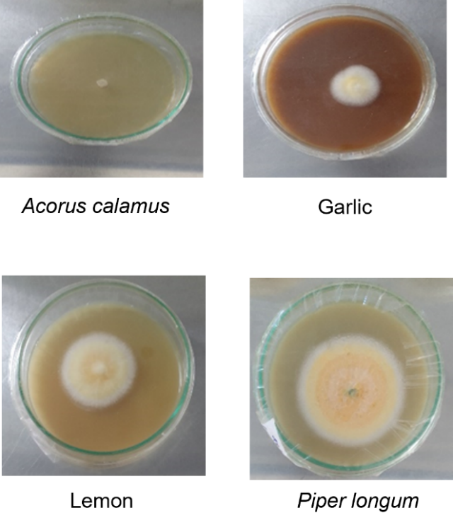
Figure 1. Colony growth of C. gloeosporioides on the culture media incorporated with methanolic extracts of various plants.
Effects of various concentrations of A. calamus methanolic extract on the inhibition of C. gloeosporioides mycelial growth
The effects of different concentrations, 10%, 8%, 6%, 4%, 2%, 1% and 0.5% of A. calamus methanolic extract on mycelial inhibition of C. gloeosporioides at 8th day after inoculation were summarized in Table 2. Results showed that there was a significant (P<0.05) difference in mycelial inhibition percentage among the concentrations. Further, there were no significant (P˃0.05) differences between 10%, 8%, 6%, 4% and 2% of A. calamus extract. Among the treatments, 10%, 8%, 6%, 4% and 2% extracts showed the highest mycelial inhibition percentage (100%), whereas 0.5% extract showed the lowest mycelial inhibition percentage.
According to the results, complete inhibition of C. gloeosporioides was achieved with the methanolic extract of A. calamus at a concentration as low as 2%. Figure 2 shows mycelial growth of C. gloeosporioides cultured on the media incorporated with various concentrations of the methanolic extract of A. calamus.
Table 2: Impact of varying concentrations of A. calamus methanolic extract on mycelial inhibition percentage of C. gloeosporioides
Treatments | Mycelial inhibition (%) at day 8
10% | 100.0 ± 0.0ª
8% | 100.0 ± 0.0ª
6% | 100.0 ± 0.0ª
4% | 100.0 ± 0.0ª
2% | 100.0 ± 0.0ª
1% | 46.6 ± 7.44^{b}
0.5% | 39.4 ± 6.00^{b}
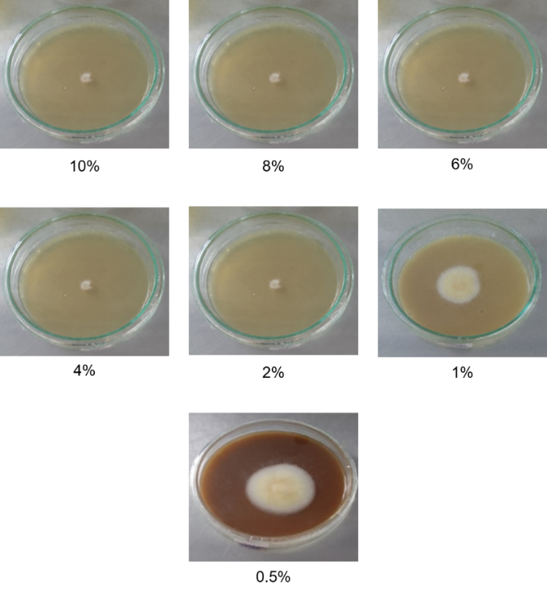

Figure 2. Colony growth of C. gloeosporioides on the culture media incorporated with various concentrations of methanolic extract of A. calamus.
Effects of various concentrations of A. calamus aqueous extract on mycelial inhibition percentage of C. gloeosporioides
The effects of various concentrations, 10%, 8%, 6%, 4%, 2%, 1% and 0.5% of A. calamus aqueous extract on mycelial inhibition percentage of C. gloeosporioides at 8th day after inoculation were presented in Table 3. The results indicated a statistically significant (P<0.05) variation in mycelial inhibition among the different concentration levels. Among the treatments, 10% extract showed the highest mycelial inhibition percentage (100%), whereas 0.5% extract showed the lowest mycelial inhibition percentage. Figure 3 shows mycelial growth of C. gloeosporioides cultured on the media incorporated with various concentrations of the aqueous extract of A. calamus.
Table 3: Impact of varying concentrations of A. calamus aqueous extract on mycelial inhibition percentage of C. gloeosporioides
Treatments | Mycelial inhibition (%) at day 8
10% | 100.0 ± 0.0ª
8% | 76.7 ± 2.94^{b}
6% | 70.3 ± 2.80^{bc}
4% | 64.0 ± 1.07^{cd}
2% | 59.6 ± 1.35^{cd}
1% | 53.1 ± 3.00^{d}
0.5% | 38.5 ± 10.78e
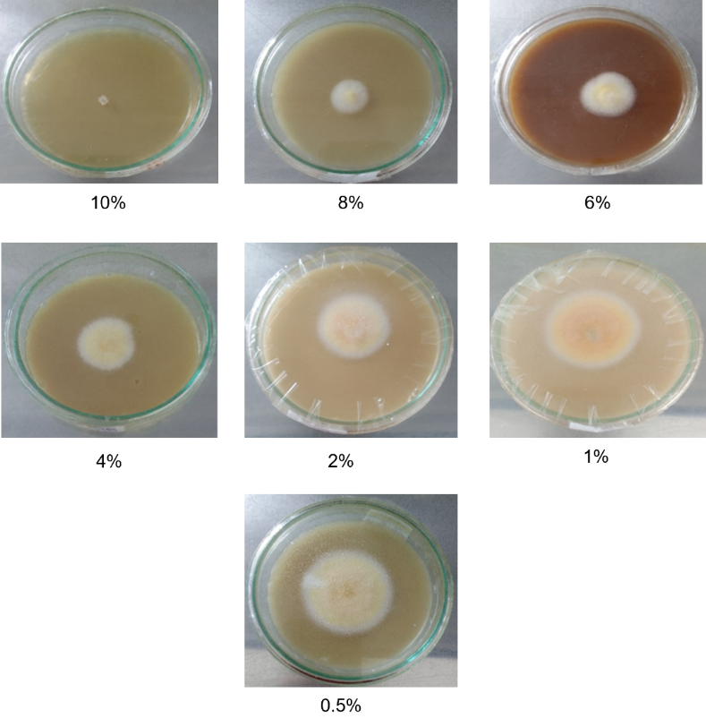
Figure 3. Colony growth of C. gloeosporioides on the culture media incorporated with various concentrations of aqueous extract of A. calamus.
According to the results of the above three experiments, A. calamus demonstrated a greater percentage of mycelial growth inhibition compared to the other plant extracts. Pharmacological investigations have reported multiple properties of A. calamus, including antibacterial, insecticidal, and antiulcer activities (Pandit et al., 2011). It is also recognized as a potent adaptogenic agent. Patra and Mitra (1981) identified the principal bioactive constituents in A. calamus, which include β-asarone, flavonoids, monoterpenes, quinones, sesquiterpenes, and phenylpropanoids. The rhizomes of A. calamus are known to synthesize heme peroxidase, an enzyme that contributes to its antifungal activity (Ghosh, 2006). Consequently, the presence of these compounds and enzymatic activity explains the higher level of mycelial inhibition observed for A. calamus.
Natural products derived from Thai medicinal plants have been widely recognized as promising sources of bioactive compounds for the development of alternative disease management strategies to conventional fungicides, as several plant-derived secondary metabolites exhibit antimicrobial activity against a broad spectrum of plant and human pathogens (Divya et al., 2011). Although synthetic fungicides are extensively used by farmers for the management of plant diseases, their repeated and indiscriminate application has contributed to the development of fungicide resistance in pathogen populations (Thind, 2012). Therefore, there is an urgent need to identify effective, safe, and environmentally sustainable plant-based alternatives to reduce reliance on synthetic fungicides within integrated disease management programmes.
Metabolites derived from A. calamus have been reported to exhibit a wide range of biological activities (Kumar et al., 2015). Owing to these diverse bioactivities, several studies have investigated and characterized metabolites obtained from both the leaves and rhizomes of this species (Dong et al., 2011). Crude extracts of A. calamus have demonstrated broad-spectrum antimicrobial activity against numerous plant and human pathogens (Bhuvaneswari and Balasundaram, 2006). In addition, plant-derived extracts from this species are generally considered environmentally compatible due to their biodegradability, multiple modes of antifungal action, comparatively low mammalian toxicity, and ready availability from natural sources. Furthermore, Phongpaichit et al. (2005) found that A. calamus possesses antifungal properties against several fungi, including Microsporum gypseum, Trichophyton rubrum, and Penicillium marneffei, highlighting its potential utility as a botanical resource for developing alternative disease management strategies in plant pathology.
Further, the results indicate that garlic extract can also be considered an alternative for managing banana anthracnose. Allicin, diallyl disulfide, and diallyl trisulfide are among the main organosulfur compounds found in garlic extracts, exhibiting strong antifungal activity by disrupting fungal cell walls and inhibiting growth (Yousuf et al., 2010). Garlic extract is highly effective against various fungi, including Fusarium spp. and Rhizopus spp., with higher concentrations (e.g., 75% extract) (Kutawa et al., 2018).
According to the results, methanolic extracts are more efficient than water extracts. Methanol is widely recognized as an effective extraction solvent in biological studies due to its high polarity, which enables the recovery of both lipophilic and hydrophilic bioactive compounds (Qu et al., 2019). An additional advantage of methanol is its high volatility, allowing easy removal at ambient temperature following extraction. In the present context, complete inhibition of C. gloeosporioides was achieved at a minimum concentration of 2% methanolic extract, indicating its comparatively higher extraction efficiency of antifungal constituents. In contrast, aqueous extraction was less effective than methanolic extraction. Although water is considered an environmentally benign solvent, the limited solubility of many plant-derived secondary metabolites restricts its effectiveness for extracting bioactive compounds (Lajoie et al., 2022). Consequently, a higher concentration (10%) of aqueous extract was required to obtain complete inhibition of C. gloeosporioides, suggesting lower recovery of antifungal metabolites under aqueous extraction conditions.
CONCLUSIONS
The study was performed to determine the efficacy of botanical extracts against postharvest diseases in the banana variety Kathali. The overall results revealed that the A. calamus methanolic extract was significantly effective for inhibiting the banana anthracnose fungus, C. gloeosporioides. Further, a concentration of 2% represented the minimum level of A. calamus methanolic extract required to achieve complete inhibition of C. gloeosporioides. As well as, 10% was the lowest concentration of A. calamus aqueous extract for completely inhibiting the growth of C. gloeosporioides. These findings highlight the potential of A. calamus as an eco-compatible substitute for chemical fungicides in controlling banana anthracnose, thereby supporting the development of sustainable approaches to disease management in tropical horticulture.
ACKNOWLEDGEMENT
The authors wish to acknowledge the Agricultural Revitalization in Higher Education Institutions of Asian Countries (AGRHI) project, co-funded by the Erasmus+ Programme of the European Union for financial support of the publication of this research article.

REFERENCES
Abayasekara, C. L., Adikaram, N. K. B., Wanigasekara, U. W. N. P. and Bandara, B. M. R. (2013). Phyllosticta musarum infection-induced defences suppress anthracnose disease caused by Colletotrichum musae in banana fruits cv. ‘Embul’. Plant Pathol. J. 29(1):77.
Acevedo, S. A., Carrillo, Á. J. D., Flórez-López, E. and Grande-Tovar, C. D. (2021). Recovery of banana waste-loss from production and processing: A contribution to a circular economy. Molecules. 26(17):5282.
Adikaram, N. K. B. (1986). A survey of postharvest losses in some fruits and vegetables and the fungi associated with them. Cey. J. Sci. (Bio. Sci.). 19:1-10.
Anthony, S., Abeywickrama, K., Dayananda, R., Wijeratnam, S. and Arambewela, L. (2004). Fungal pathogens associated with banana fruit in Sri Lanka, and their treatment with essential oils. Mycopathologia. 157:91-97.
Bhuvaneswari, R. and Balasundaram, C. (2006). Traditional Indian herbal extracts used in vitro against growth of the pathogenic bacteria Aeromonas hydrophila. Islrle J. Aquac. 58:89-96.
Cannon, P. F., Damm, U., Johnston, P. R. and Weir, B. S. (2012). Colletotrichum: current status and future directions. Stud. Mycol. 73(1):181-213.
Chamara, D., Illeperuma, K., Galappatty, P. T. and Sarananda, K. H. (2000). Modified atmosphere packaging of Kolikuttu banana at low temperature. J. Hortic. Sci. Biotechnol. 75(1):92-96.
De Costa, D. M. and Erabadupitiya, H. R. U. T. (2005). An integrated method to control postharvest diseases of banana using a member of the Burkholderia cepacia complex. Postharvest Biol. Technol. 36:31-39.
De Costa, D. M., Amaradasa, B. S. and Wegiriya, R. N. B. P. M. R. C. L. (1997). Antagonists of Colletotrichum musae associated with banana fruit skin. J. Natl. Sci. Found. Sri. 25(2):95-104.
Divya, G., Gajalakshmi, S., Mythili, S. and Sathiavelu, A. (2011). Pharmacological Activities of Acorus calamus: A review. Asian J. Biochem. Pharm. Res. 1(4):57-64.
Dong, C., Zhu, W., Gao, M., Zhao, L. F., Huang, J. Y. and Zhao, Y. Q. (2011). Diurnal fluctuations in oxygen release from roots of Acorus calamus Linn in a modeled constructed wetland. J. Environ. Sci. Health A. 46(3):224-229.
Ghosh, M. (2006). Antifungal properties of haem peroxidase from Acorus calamus. Ann. Bot. 98(6):1145-1153.
Hayes, W. J. and Laws, E. R. (1991). Handbook of Pesticide Toxicology. Academic Press Inc., New Delhi, pp. 25-30.
Jinasena, D., Pathirathna, P., Wickramarachchi, S. and Marasinghe, E. (2011). Use of chitosan to control anthracnose on “Embul” banana. In: International Conference on Asia Agriculture and Animal. Vol. 13, pp. 56-60.
Kanazawa, K. and Sakakibara, H. (2000). High content of dopamine, a strong antioxidant, in cavendish banana. J. Agric. Food Chem. 48(3):844-848.
Kumar, A., Sharma, S. and Verma, G. (2015). Insecticidal and genotoxic potential of Acorus calamus rhizome extract against Drosophila melanogaster. Asian J. Pharm. Clin. Res. 8(4):113-116.
Kutawa, A. B., Danladi, M. D. and Haruna, A. (2018). Antifungal activity of garlic (Allium sativum) extract on some selected fungi. J. Med. Herbs Ethnomed. 4(12):14.
Lajoie, L., Fabiano-Tixier, A. S. and Chemat, F. (2022). Water as Green Solvent: Methods of Solubilisation and Extraction of Natural Products-Past, Present and Future Solutions. Pharmaceuticals. 15(12):1507.
López-Fernández, O., Rial-Otero, R., González-Barreiro, C. and Simal-Gándara, J. (2012). Surveillance of fungicidal dithiocarbamate residues in fruits and vegetables. Food Chem. 134(1):366-374.
Oliveira, T. Í. S., Rosa, M. F., Cavalcante, F. L., Pereira, P. H. F., Moates, G. K., Wellner, N., Mazzetto, S. E., Waldron, K. W. and Azeredo, H. M. (2016). Optimization of pectin extraction from banana peels with citric acid by using response surface methodology. Food Chem. 198:113-118.
Pandit, S., Mukherjee, P. K., Ponnusankar, S., Venkatesh, M. and Srikanth, N. (2011). Metabolism mediated interaction of α-asarone and Acorus calamus with CYP3A4 and CYP2D6. Fitoterapia. 82(3):369-374.
Patra, A. and Mitra, A. K. (1981). Constituents of Acorus calamus: structure of acoramone. Carbon-13 NMR spectra of cis-and trans-asarone. J. Nat. Prod. 44(6):668-669.
Perera, O. D. A. and Karunaratne, A. M. (2000). Response of bananas to postharvest acid treatments. J. Hortic. Sci. Biotechnol. 76(1):70-76.
Perera, T. (2017). Sri Lankan fresh fruit and vegetable sector, Sri Lanka. Sri Lanka Export Development Board (EDB).
Phongpaichit, S., Pujenjob, N., Rukachaisirikul, V. and Ongsakul, M. (2005). Antimicrobial activities of the crude methanol extract of Acorus calamus Linn. Songklanrimpangin J. Sci. Technol. 27(Suppl. 2):517-523.
Prihastuti, H., Cai, L., Chen, H., McKenzie, E. H. C. and Hyde, K.D. (2009). Characterization of Colletotrichum species associated with coffee berries in northern Thailand. Fungal Divers. 39: 89-109.
Qu, H., He, S. and Su, H. (2019). Efficient preparation of kaolinite/methanol intercalation composite by using a Soxhlet extractor. Sci. Rep. 9(1). 8351.
Rouabhi, R. (2010). Introduction and toxicology of fungicides. In: O. Carisse, ed. Fungicides. London: IntechOpen. pp. 363-382.
Singh, J. and Tripathi, N.N. (1999). Inhibition of storage fungi of black gram (Vigna mungo) by some essential oils. Flavour Fragrance J. 14:1-4.
Thind, T. S. (2012). Fungicide resistance in crop protection: Risk and management. CABI. 284 pp.
Yousuf, S., Ahmad, A., Khan, A., Manzoor, N. and Khan, L. A. (2010). Effect of diallyldisulphide on an antioxidant enzyme system in Candida species. Can. J. Microbiol. 56(10):816–821.

